  ТРАНСАГЕНТСТВО |  |  |  |  |  |  |  |  | А
По регулируемым тарифам
Номер маршрута | Конечный остановочный пункт | ДНИ | Время начала и окончания движения | Временной график отправления транспортных средств от остановочного пункта
1 | ОМК | Будни | 6:50-23:15 | 6:50, 7:35, 7:55, 8:25, 8:48, 9:15, 9:30, 10:10, 10:50, 11:05, 11:50, 12:50, 13:55, 14:55, 15:30, 16:20, 17:20, 18:05, 18:20, 19:05, 19:45, 20:05, 20:45, 21:20, 21:45, 22:20, 23:15
 |  | Выходные | 7:05-22:20 | 7:05, 8:05, 8:45, 9:45, 10:25, 11:25, 12:25, 13:25, 14:05, 15:05, 15:45, 16:45, 17:25, 18:05, 18:25, 19:05, 19:45, 20:45, 21:20, 22:20
1А | ОМК | Будни | 6:15-21:52 | 6:15, 7:02, 8:02, 8:47, 9:22, 9:42, 10:22, 11:32, 12:17, 13:22, 14:02, 15:02, 16:02, 17:22, 17:47, 18:22, 19:17, 19:22, 20:22, 20:52, 21:07, 21:52
 |  | Выходные | 7:47-21:42 | 7:47, 8:22, 9:22, 10:02, 11:02, 11:42, 12:42, 13:42, 14:22, 15:22, 16:12, 17:02, 17:47, 18:12, 18:42, 19:32, 20:02, 21:07, 21:42
2 | Мелиораторов | ежедневно | 7:10-19:30 | 7:10, 8:18, 9:18, 10:10, 12:10, 13:10, 14:10, 15:10, 17:20, 18:30, 19:30
4 | ОМК | Будни | 6:34-22:34 | 6:34, 6:54, 7:14, 7:34, 7:59, 8:14, 8:34, 8:54, 9:14, 9:34, 9:54, 10:34, 10:54, 11:34, 12:34, 12:54, 13:34, 14:04, 14:54, 15:34, 16:14, 16:34, 16:54, 17:14, 17:34, 17:54, 18:14, 18:34, 18:59, 19:14, 19:54, 20:34, 20:54, 21:24, 21:54, 22:34
 |  | Выходные | 6:34-22:34 | 6:34, 7:34, 8:34, 9:34, 10:34, 11:34, 12:34, 13:34, 14:34, 15:04, 15:34, 16:34, 17:04, 17:34, 18:34, 19:34, 20:34, 21:34, 22:34
5 | Мкр. Восточный | Будни  с 01.06 по 31.08 | 6:04-23:09 | 6:04, 6:44, 7:04, 7:36, 7:46, 8:06, 8:14, 8:24, 8:34, 8:44, 9:04, 9:29, 9:39, 9:54, 10:04, 10:24, 10:39, 10:54, 11:04, 11:14, 11:24, 11:44, 12:04, 12:24, 12:44, 13:04, 13:24, 13:44, 14:04, 14:24, 14:44, 15:04, 15:24, 15:44, 16:04, 16:24, 16:44, 17:04, 17:24, 17:39, 17:54, 18:09, 18:29, 18:39, 18:54, 19:09, 19:24, 19:39, 19:54, 20:09, 20:24, 20:44, 21:04, 21:24, 21:39, 21:54, 22:24, 22:54, 23:09
 |  | Выходные  с 01.06 по 31.08 | 6:04-23:09 | 6:04, 6:44, 7:04, 7:36, 8:06, 8:24, 8:44, 9:04, 9:24, 9:44, 10:04, 10:24, 10:44, 11:04, 11:24, 11:44, 12:04, 12:24, 12:44, 13:04, 13:24, 13:44, 14:04, 14:24, 14:44, 15:04, 15:24, 15:44, 16:04, 16:24, 16:44, 17:04, 17:24, 17:44, 18:04, 18:24, 18:44, 19:04, 19:24, 19:44, 20:04, 20:24, 20:44, 21:04, 21:24, 21:39, 22:04, 22:24, 22:54, 23:39
 |  | Будни  с 01.09 по 31.05 | 6:04-00:09 | 6:04, 6:44, 7:04, 7:36, 7:46, 8:04, 8:14, 8:24, 8:34, 8:44, 9:04, 9:14, 9:29, 9:39, 9:49, 10:04, 10:24, 10:44, 11:04, 11:14, 11:24, 11:44, 12:04, 12:24, 12:44, 13:04, 13:24, 13:39, 13:54, 14:09, 14:24, 14:44, 15:04, 15:24, 15:44, 16:04, 16:24, 16:39, 16:54, 17:09, 17:24, 17:39, 17:54, 18:09, 18:24, 18:39, 18:54, 19:09, 19:24, 19:39, 19:54, 20:09, 20:24, 20:44, 21:04, 21:24, 21:39, 21:54, 22:09, 22:24, 22:39, 22:54, 23:39, 23:54, 0:09
 |  | Выходные с 01.09 по 31.05 | 6:44-00:09 | 6:44, 7:04, 7:36, 7:46, 8:06, 8:24, 8:44, 9:04, 9:29, 9:39, 9:49, 10:04, 10:24, 10:39, 10:54, 11:04, 11:14, 11:24, 11:44, 12:04, 12:24, 12:44, 13:04, 13:24, 13:44, 14:04, 14:24, 14:44, 15:04, 15:24, 16:04, 16:04, 16:24, 16:44, 17:04, 17:24, 17:39, 17:54, 18:09, 18:24, 18:39, 18:54, 19:09, 19:24, 19:39, 19:54, 20:09, 20:24, 20:44, 21:04, 21:24, 21:39, 21:54, 22:24, 22:54, 23:09, 23:39, 0:09
8 | ОМК | Будни | 6:19-22:59 | 6:19, 6:49, 7:24, 7:54, 8:19, 8:29, 8:59, 9:19, 9:44, 10:39, 11:29, 12:29, 12:59, 13:39, 14:09, 15:19, 16:19, 16:34, 16:59, 17:34, 17:59, 18:34, 18:59, 19:39, 19:59, 21:29, 22:59
 |  | Выходные | 6:49-22:39 | 6:49, 7:59, 8:29, 8:59, 9:39, 10:39, 11:29, 11:59, 12:29, 12:59, 13:59, 14:59, 15:59, 16:59, 17:59, 18:44, 19:19, 21:27, 21:29,22:39
21 | Теннисный центр | Будни | 6:40-22:10 | 6:40, 7:00, 7:20, 7:40, 8:00, 8:20, 8:40, 9:00, 9:20, 9:50, 10:20, 10:55, 11:20, 11:50, 12:50, 13:25, 14:25, 15:00, 15:20, 16:00, 16:20, 16:40, 17:00, 17:20, 17:40, 18:00, 18:20, 18:40, 19:00, 19:20, 19:40, 20:20, 20:35, 21:20, 22:10
 |  | Выходные | 6:40-22:10 | 6:40, 7:20, 8:20, 9:00, 9:20, 10:55, 11:50, 12:50, 13:25, 14:25, 15:00, 16:00, 16:40, 17:20, 17:40, 18:20, 19:00, 19:20, 20:35,22:10
77 | Сельхозтехника | Будни | 7:40-22:10 | 7:40, 8:25, 8:35, 9:12, 9:40, 10:35, 11:10, 12:00, 13:25, 14:07, 14:52, 15:45, 16:15, 17:05, 17:45, 18:15, 18:50, 19:00, 19:55, 20:05, 20:55, 21:10, 22:10
 |  | Выходные | 7:40-22:10 | 7:45, 8:15, 8:35, 9:12, 9:45, 10:35, 11:10, 12:00, 13:05, 14:00, 14:32, 15:35, 16:15, 17:05, 17:35, 18:05, 18:37, 19:00, 19:30, 20:05, 20:45, 21:10, 22:10
77А | Районная поликлиника | Будни | 6:36-21:36 | 6:36, 6:56, 7:26, 7:56, 8:16, 8:41, 9:01, 9:16, 9:36, 9:56, 10:16, 10:56, 11:56, 12:56, 13:36, 14:36, 15:16, 16:16, 16:56, 17:16, 17:36, 17:56, 18:16, 18:36, 18:56, 19:16, 19:36, 19:56, 20:36, 20:56, 21:36
 |  | Выходные | 7:56-22:26 | 7:56, 8:56, 9:36, 10:36, 11:16, 12:16, 12:56, 13:56, 14:56, 16:36, 16:56, 18:16, 18:36, 18:56, 19:56, 20:26, 20:56, 22:26
По нерегулируемым тарифам
Номер маршрута | Конечный остановочный пункт | ДНИ | Время начала и окончания движения | Интервал отправления транспортных средств от остановочного пункта
7К | Назымская экспедиция |  |  | до 10:00 | 10:00 -11:00 | 11:00 -15:00 | 15:00 -16:00 | 16:00 – 20:00 |  | после 20:00
 |  | Будни | 6:30-22:00 | 15 | 20 | 15 | 20 | 15 |  | 20
 |  | Суббота | 6:30-22:00 | 20 | 25 | 20 | 25 | 20 |  | 25
 |  | Воскресенье | 6:30-21:00 | 20 | 25 | 25 | 25 | 25 |  | 30
8К | ОМК |  |  | до 10:00 | 10:00 -11:00 | 11:00 -15:00 | 15:00 -16:00 | 16:00 – 20:00 |  | после 20:00
 |  | Будни | 6:30-22:00 | 15 | 20 | 15 | 20 | 15 |  | 20
 |  | Суббота | 6:30-22:00 | 20 | 25 | 20 | 25 | 20 |  | 25
 |  | Воскресенье | 6:30-21:00 | 20 | 25 | 25 | 25 | 25 |  | 30
9К | Аэропорт |  |  | до 10:00 | 10:00 -11:00 | 11:00 -15:00 | 15:00 -16:00 | 16:00 – 20:00 |  | после 20:00
 |  | Будни | 6:30-22:00 | 15 | 20 | 15 | 20 | 15 |  | 20
 |  | Суббота | 6:30-22:00 | 20 | 25 | 20 | 25 | 20 |  | 25
 |  | Воскресенье | 6:30-21:00 | 20 | 25 | 25 | 25 | 25 |  | 30
  26К | Теннисный центр |  |  | до 10:00 | 10:00 -11:00 | 11:00 -15:00 | 15:00 -16:00 | 16:00 – 20:00 |  | после 20:00
 |  | Будни | 6:30-22:00 | 15 | 20 | 15 | 20 | 15 |  | 20
 |  | Суббота | 6:30-22:00 | 20 | 25 | 20 | 25 | 20 |  | 25
 |  |   Воскресенье  Прогноз прибытия пассажирского транспорта  в вашем мобильном телефоне | 6:30-21:00 | 20 | 25 | 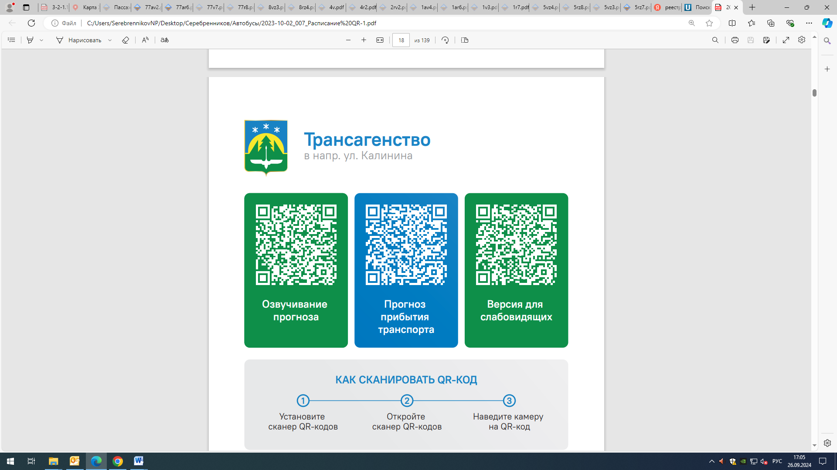  25 | 25 | 25 |  | 30
Контроль за осуществлением регулярных перевозок обеспечивает:
- управление транспорта, связи и дорог Администрации города Ханты-Мансийска, г: Ханты-Мансийск, ул Мира, 13, тел: 8 (3467) 39-39-07;
- отдел государственного автодорожного надзора по ХМАО – Югре, г: Ханты-Мансийск, ул: Шевченко 36А, тел: (3467) 32-64-60;
- МО МВД России «Ханты-Мансийский» г: Ханты-Мансийск, ул: Дзержинского дом 11, телефоны дежур ной части (3467) 398-104, 398-103, 102 и 112

