  Лермонтова |  |  |  |  |  |  |  |  | А
По регулируемым тарифам
Номер маршрута | Конечный остановочный пункт | ДНИ | Время начала и окончания движения | Временной график отправления транспортных средств от остановочного пункта
1 | Авторечвокзал  (по Гагарина) | Будни | 6:26-22:51 | 6:26, 7:11, 7:31, 8:01, 8:24, 8:51, 9:06, 9:46, 10:26, 10:41, 11:26, 12:26, 13:31, 14:31, 15:06,  15:56, 16:56, 17:41, 17:56, 18:41, 19:21, 19:41, 20:21, 20:56, 21:21, 21:56, 22:51
 |  | Выходные | 6:41-21:56 | 6:41, 7:41, 8:21, 9:21, 10:01, 11:01, 12:01, 13:01, 13:41, 14:41, 15:21, 16:21, 17:01, 17:41, 18:01,  18:41, 19:21, 20:21, 20:56, 21:56
4 | мкр. Береговая зона | Будни | 6:57-22:47 | 6:57, 7:27, 7:57, 8:17, 8:42, 9:02, 9:22, 9:57, 10:17, 11:02, 11:57, 12:17, 12:57, 13:12, 13:37, 14:07, 14:27, 14:57, 15:32, 15:52, 16:17, 16:57, 17:22, 17:37, 17:57, 18:27, 18:37, 18:57, 19:22, 20:02, 20:22, 20:42, 21:17, 21:57, 22:47
 |  | Выходные | 6:57-22:47 | 6:57, 7:57, 8:17, 9:02, 9:57, 11:02, 11:57, 12:57, 13:12, 14:07, 14:57, 15:52, 16:57, 17:57, 18:57, 20:02, 20:42, 21:57, 22:47
5 | Ледовый дворец | Будни  с 01.06 по 31.08 | 5:44-00:09 | 5:44, 6:19, 6:59, 7:09, 7:29, 7:59, 8:19, 8:49, 8:59, 9:09, 9:24, 9:39, 9:59, 10:19, 10:29, 10:39, 10:59, 11:19, 11:39, 11:59, 12:19, 12:39, 12:59, 13:19, 13:39, 13:59, 14:19, 14:39, 14:59, 15:19, 15:39, 15:59, 16:19, 16:39, 16:59, 17:14, 17:29, 17:44, 17:59, 18:14, 18:29, 18:44, 18:59, 19:14, 19:29, 19:44, 19:59, 20:19, 20:39, 20:59, 21:14, 21:39, 21:59, 22:14, 22:29, 22:59, 23:29, 0:09
 |  | Выходные  с 01.06 по 31.08 | 5:44-00:09 | 5:44, 6:19, 6:59, 7:29, 7:59, 8:19, 8:59, 9:19, 9:39, 9:59, 10:19, 10:39, 10:59, 11:19, 11:39, 11:59, 12:19, 12:39, 12:59, 13:19, 13:39, 13:59, 14:19, 14:39, 14:59, 15:19, 15:39, 15:59, 16:19, 16:39, 16:59, 17:19, 17:39, 17:59, 18:19, 18:39, 18:59, 19:19, 19:39, 19:59, 20:19, 20:39, 20:59, 21:19, 21:39, 21:59, 22:14, 22:29, 22:59, 23:29, 0:09
 |  | Будни  с 01.09 по 31.05 | 5:44-00:09 | 5:44, 6:19, 6:59, 7:09, 7:19, 7:29, 7:39, 7:49, 7:59, 8:19, 8:29, 8:49, 8:59, 9:09, 9:24, 9:39, 9:59, 10:19, 10:39, 10:59, 11:19, 11:39, 11:59, 12:19, 12:39, 12:59, 13:14, 13:29, 13:44, 13:59, 14:19, 14:39, 14:59, 15:19, 15:39, 15:59, 16:14, 16:29, 16:44, 16:59, 17:14, 17:29, 17:44, 17:59, 18:14, 18:29, 18:44, 18:59, 19:14, 19:29, 19:44, 19:59, 20:19, 20:39, 20:59, 21:14, 21:29, 21:44, 21:59, 22:14, 22:29, 22:59, 23:29, 0:09
 |  | Выходные  с 01.09 по 31.05 | 5:44-00:09 | 5:44, 6:19, 6:59, 7:09, 7:29, 7:59, 8:19, 8:49, 8:59, 9:09, 9:24, 9:39, 9:59, 10:19, 10:29, 10:39, 10:59, 11:19, 11:39, 11:59, 12:19, 12:39, 12:59, 13:19, 13:39, 13:59, 14:19, 14:39, 14:59, 15:19, 15:39, 15:59, 16:19, 16:39, 16:59, 17:14, 17:29, 17:44, 17:59, 18:14, 18:29, 18:44, 18:59, 19:14, 19:29, 19:39, 19:59, 20:19, 20:39, 20:59, 21:14, 21:39, 21:59, 22:14, 22:29, 22:59, 23:29, 0:09
77 | Гимназия №1 | Будни | 6:53-21:43 | 6:53, 7:30, 7:43, 8:25, 9:03, 9:13, 9:50, 10:23, 11:23, 12:38, 13:03, 13:33, 14:03, 14:37, 14:48, 15:30, 15:57,  16:30, 17:50, 18:20, 18:43, 19:40, 20:13, 21:03, 21:23, 21:43
 |  | Выходные | 6:53-21:43 | 6:53, 7:23, 8:25, 8:56, 9:50, 10:23, 11:23, 12:38, 13:40, 14:23, 15:10, 15:43, 16:23, 17:03, 17:50, 18:23, 18:50,  19:43, 20:13, 21:03, 21:43
По нерегулируемым тарифам
Номер маршрута | Конечный остановочный пункт | ДНИ | Время начала и окончания движения | Интервал отправления транспортных средств от остановочного пункта
7К | ТД «Сатурн» |  |  | до 10:00 | 10:00 -11:00 | 11:00 -15:00 | 15:00 -16:00 | 16:00 – 20:00 |  | после 20:00
 |  | Будни | 6:30-22:00 | 15 | 20 | 15 | 20 | 15 |  | 20
 |  | Суббота | 6:30-22:00 | 20 | 25 | 20 | 25 | 20 |  | 25
 |  | Воскресенье | 6:30-21:00 | 20 | 25 | 25 | 25 | 25 |  | 30
8К | Гимназия №1 |  |  | до 10:00 | 10:00 -11:00 | 11:00 -15:00 | 15:00 -16:00 | 16:00 – 20:00 |  | после 20:00
 |  | Будни | 6:30-22:00 | 15 | 20 | 15 | 20 | 15 |  | 20
 |  | Суббота | 6:30-22:00 | 20 | 25 | 20 | 25 | 20 |  | 25
 |  | Воскресенье | 6:30-21:00 | 20 | 25 | 25 | 25 | 25 |  | 30
13К | мкр. Береговая зона |  |  | до 10:00 | 10:00 -11:00 | 11:00 -15:00 | 15:00 -16:00 | 16:00 – 20:00 |  | после 20:00
 |  | Будни | 6:30-22:00 | 15 | 20 | 15 | 20 | 15 |  | 20
 |  | Суббота | 6:30-22:00 | 20 | 25 | 20 | 25 | 20 |  | 25
 |  | Воскресенье | 6:30-21:00 | 20 | 25 | 25 | 25 | 25 |  | 30
  26К | Гимназия №1 |  |  | до 10:00 | 10:00 -11:00 | 11:00 -15:00 | 15:00 -16:00 | 16:00 – 20:00 |  | после 20:00
 |  | Будни | 6:30-22:00 | 15 | 20 | 15 | 20 | 15 |  | 20
 |  | Суббота | 6:30-22:00 | 20 | 25 | 20 | 25 | 20 |  | 25
 |  |   Воскресенье  Прогноз прибытия пассажирского транспорта  в вашем мобильном телефоне | 6:30-21:00 | 20 | 25 | 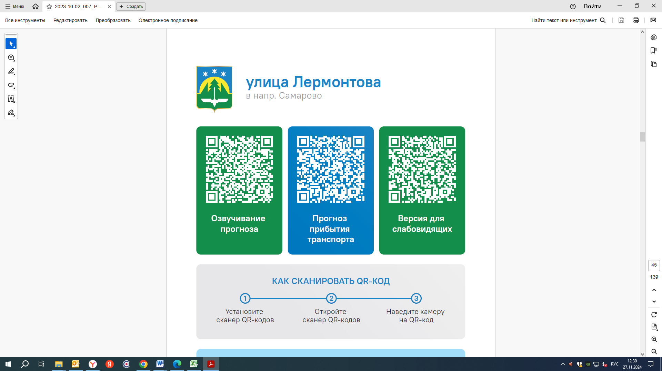  25 | 25 | 25 |  | 30
Контроль за осуществлением регулярных перевозок обеспечивает:
- управление транспорта, связи и дорог Администрации города Ханты-Мансийска, г: Ханты-Мансийск, ул Мира, 13, тел: 8 (3467) 39-39-07;
- отдел государственного автодорожного надзора по ХМАО – Югре, г: Ханты-Мансийск, ул: Шевченко 36А, тел: 8 (3467) 32-64-60;
- МО МВД России «Ханты-Мансийский» г: Ханты-Мансийск, ул: Дзержинского дом 11, телефоны дежур ной части 8 (3467) 398-104, 398-103, 102 и 112

