  Микрорайон |  |  |  |  |  |  |  |  | А
По регулируемым тарифам
Номер маршрута | Конечный остановочный пункт | ДНИ | Время начала и окончания движения | Временной график отправления транспортных средств от остановочного пункта
2 | Мелиораторов | ежедневно | 7:21-19:41 | 7:21, 8:29, 9:29, 10:21, 12:21, 13:21, 14:21, 15:21, 17:31, 18:41, 19:41,
4 | ОМК | Будни | 6:47-22:47 | 6:47, 7:07, 7:27, 7:47, 8:12, 8:27, 8:47, 9:07, 9:27, 9:47, 10:07, 10:47, 11:07, 11:47, 12:47, 13:07, 13:47, 14:17, 15:07, 15:47, 16:27, 16:47, 17:07, 17:27, 17:47, 18:07, 18:27, 18:47, 19:12, 19:27, 20:07, 20:47, 21:07, 21:37, 22:07, 22:47
 |  | Выходные | 6:47-22:47 | 6:47, 7:47, 8:47, 9:47, 10:47, 11:47, 12:47, 13:47, 14:47, 15:17, 15:47, 16:47, 17:17, 17:47, 18:47, 19:47, 20:47, 21:47, 22:47
5 | Мкр. Восточный | Будни  с 01.06 по 31.08 | 6:18-23:23 | 6:18, 6:58, 7:18, 7:50, 8:00, 8:20, 8:28, 8:38, 8:48, 8:58, 9:18, 9:43, 9:53, 10:08, 10:18, 10:38, 10:53, 11:08, 11:18, 11:28, 11:38, 11:58, 12:18, 12:38, 12:58, 13:18, 13:38, 13:58, 14:18, 14:38, 14:58, 15:18, 15:38, 15:58, 16:18, 16:38, 16:58, 17:18, 17:38, 17:53, 18:08, 18:23, 18:43, 18:53, 19:08, 19:23, 19:38, 19:53, 20:08, 20:23, 20:38,  20:58, 21:18, 21:38, 21:53, 22:08, 22:38, 23:08, 23:23
 |  | Выходные  с 01.06 по 31.08 | 6:18-23:53 | 6:18, 6:58, 7:18, 7:50, 8:20, 8:38, 8:58, 9:18, 9:38, 9:58, 10:18, 10:38, 10:58, 11:18, 11:38, 11:58, 12:18, 12:38, 12:58, 13:18, 13:38, 13:58, 14:18, 14:38, 14:58, 15:18, 15:38, 15:58, 16:18, 16:38, 16:58, 17:18, 17:38, 17:58, 18:18, 18:38, 18:58, 19:18, 19:38, 19:58, 20:18, 20:38, 20:58, 21:18, 21:38, 21:53, 22:18, 22:38, 23:08, 23:53
 |  | Будни  с 01.09 по 31.05 | 6:18-00:23 | 6:18, 6:58, 7:18, 7:50, 8:00, 8:18, 8:28, 8:38, 8:48, 8:58, 9:18, 9:28, 9:43, 9:53, 10:03, 10:18, 10:38, 10:58, 11:18, 11:28, 11:38, 11:58, 12:18, 12:38, 12:58, 13:18, 13:38, 13:53, 14:08, 14:23, 14:38, 14:58, 15:18, 15:38, 15:58, 16:18, 16:38, 16:53, 17:08, 17:23, 17:38, 17:53, 18:08, 18:23, 18:38, 18:53, 19:08, 19:23, 19:38, 19:53, 20:08,  20:23, 20:38, 20:58, 21:18, 21:38, 21:53, 22:08, 22:23, 22:38, 22:53, 23:08, 23:53, 0:08, 0:23
 |  | Выходные с 01.09 по 31.05 | 6:58-00:23 | 6:58, 7:18, 7:50, 8:00, 8:20, 8:38, 8:58, 9:18, 9:43, 9:53, 10:03, 10:18, 10:38, 10:53, 11:08, 11:18, 11:28, 11:38, 11:58, 12:18, 12:38, 12:58, 13:18, 13:38, 13:58, 14:18, 14:38, 14:58, 15:18, 15:38, 16:18, 16:18, 16:38, 16:58,  17:18, 17:38, 17:53, 18:08, 18:23, 18:38, 18:53, 19:08, 19:23, 19:38, 19:53, 20:08, 20:23, 20:38, 20:58, 21:18, 21:38, 21:53, 22:08, 22:38, 23:08, 23:23, 23:53, 0:23
21 | Теннисный центр | Будни | 6:52-22:22 | 6:52, 7:12, 7:32, 7:52, 8:12, 8:32, 8:52, 9:12, 9:32, 10:02, 10:32, 11:07, 11:32, 12:02, 13:02, 13:37, 14:37, 15:12, 15:32, 16:12, 16:32, 16:52, 17:12, 17:32, 17:52, 18:12, 18:32, 18:52, 19:12, 19:32, 19:52, 20:32, 20:47, 21:32, 22:22
 |  | Выходные | 6:52-22:22 | 6:52, 7:32, 8:32, 9:12, 9:32, 11:07, 12:02, 13:02, 13:37, 14:37, 15:12, 16:12, 16:52, 17:32, 17:52, 18:32, 19:12, 19:32, 20:47, 22:22
77А | Районная поликлиника | Будни | 6:49-21:49 | 6:49, 7:09, 7:39, 8:09, 8:29, 8:54, 9:14, 9:29, 9:49, 10:09, 10:29, 11:09, 12:09, 13:09, 13:49, 14:49, 15:29, 16:29, 17:09, 17:29, 17:49, 18:09, 18:29, 18:49, 19:09, 19:29, 19:49, 20:09, 20:49, 21:09, 21:49
 |  | Выходные | 8:09-22:39 | 8:09, 9:09, 9:49, 10:49, 11:29, 12:29, 13:09, 14:09, 15:09, 16:49, 17:09, 18:29, 18:49, 19:09, 20:09, 20:39, 21:09, 22:39
По нерегулируемым тарифам
Номер маршрута | Конечный остановочный пункт | ДНИ | Время начала и окончания движения | Интервал отправления транспортных средств от остановочного пункта
9К | Аэропорт |  |  | до 10:00 | 10:00 -11:00 | 11:00 -15:00 | 15:00 -16:00 | 16:00 – 20:00 |  | после 20:00
 |  | Будни | 6:30-22:00 | 15 | 20 | 15 | 20 | 15 |  | 20
 |  | Суббота | 6:30-22:00 | 20 | 25 | 20 | 25 | 20 |  | 25
 |  | Воскресенье | 6:30-21:00 | 20 | 25 | 25 | 25 | 25 |  | 30
13 | База Ханты-Мансийскгаз |  |  | до 10:00 | 10:00 -11:00 | 11:00 -15:00 | 15:00 -16:00 | 16:00 – 20:00 |  | после 20:00
 |  | Будни | 6:30-22:00 | 15 | 20 | 15 | 20 | 15 |  | 20
 |  | Суббота | 6:30-22:00 | 20 | 25 | 20 | 25 | 20 |  | 25
 |  | Воскресенье | 6:30-21:00 | 20 | 25 | 25 | 25 | 25 |  | 30
26К | Теннисный центр |  |  | до 10:00 | 10:00 -11:00 | 11:00 -15:00 | 15:00 -16:00 | 16:00 – 20:00 |  | после 20:00
 |  | Будни | 6:30-22:00 | 15 | 20 | 15 | 20 | 15 |  | 20
 |  | Суббота | 6:30-22:00 | 20 | 25 | 20 | 25 | 20 |  | 25
 |  | Воскресенье | 6:30-21:00 | 20 | 25 | 25 | 25 | 25 |  | 30
Прогноз прибытия пассажирского транспорта
в вашем мобильном телефоне

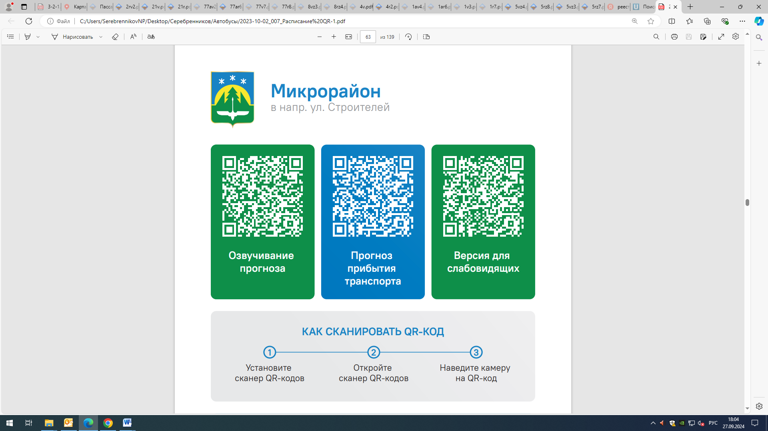



Контроль за осуществлением регулярных перевозок обеспечивает:
- управление транспорта, связи и дорог Администрации города Ханты-Мансийска, г: Ханты-Мансийск, ул Мира, 13, тел: 8 (3467) 39-39-07;
- отдел государственного автодорожного надзора по ХМАО – Югре, г: Ханты-Мансийск, ул: Шевченко 36А, тел: (3467) 32-64-60;
- МО МВД России «Ханты-Мансийский» г: Ханты-Мансийск, ул: Дзержинского дом 11, телефоны дежурной части (3467) 398-104, 398-103, 102 и 112

