  Телецентр |  |  |  |  |  |  |  |  | А
По регулируемым тарифам
Номер маршрута | Конечный остановочный пункт | ДНИ | Время начала и окончания движения | Временной график отправления транспортных средств от остановочного пункта
1А | ОМК | Будни | 6:06-21:43 | 6:06, 6:53, 7:53, 8:38, 9:13, 9:33, 10:13, 11:23, 12:08, 13:13, 13:53, 14:53, 15:53, 17:13, 17:38,  18:13, 19:08, 19:13, 20:13, 20:43, 20:58, 21:43
 |  | Выходные | 7:38-21:33 | 7:38, 8:13, 9:13, 9:53, 10:53, 11:33, 12:33, 13:33, 14:13, 15:13, 16:03, 16:53, 17:38, 18:03, 18:33,  19:23, 19:53, 20:58, 21:33
4 | ОМК | Будни | 6:17-22:23 | 6:17, 6:37, 6:57, 7:23, 7:53, 8:23, 8:43, 9:08, 9:28, 9:48, 10:23, 10:43, 11:33, 12:23, 12:43, 13:23, 13:38, 14:03, 14:33, 14:53, 15:23, 15:58, 16:18, 16:43, 17:23, 17:48, 18:03, 18:23, 18:53, 19:03, 19:23, 19:48, 20:28, 21:08, 21:43, 22:23
 |  | Выходные | 6:37-22:23 | 6:37, 7:23, 8:23, 8:43, 9:28, 10:23, 11:33, 12:23, 13:23, 13:38, 14:33, 15:23, 16:18, 17:23, 18:23, 19:23, 20:28, 21:08, 22:23
5 | Мкр. Восточный | Будни  с 01.06 по 31.08 | 5:55-23:00 | 5:55, 6:35, 6:55, 7:27, 7:37, 7:57, 8:05, 8:15, 8:25, 8:35, 8:55, 9:20, 9:30, 9:45, 9:55, 10:15, 10:30, 10:45, 10:55, 11:05, 11:15, 11:35, 11:55, 12:15, 12:35, 12:55, 13:15, 13:35, 13:55, 14:15, 14:35, 14:55, 15:15, 15:35, 15:55, 16:15, 16:35, 16:55, 17:15, 17:30, 17:45, 18:00, 18:20, 18:30, 18:45, 19:00, 19:15, 19:30, 19:45, 20:00, 20:15, 20:35, 20:55, 21:15, 21:30, 21:45, 22:15, 22:45, 23:00
 |  | Выходные  с 01.06 по 31.08 | 5:55-23:30 | 5:55, 6:35, 6:55, 7:27, 7:57, 8:15, 8:35, 8:55, 9:15, 9:35, 9:55, 10:15, 10:35, 10:55, 11:15, 11:35, 11:55, 12:15, 12:35, 12:55, 13:15, 13:35, 13:55, 14:15, 14:35, 14:55, 15:15, 15:35, 15:55, 16:15, 16:35, 16:55, 17:15, 17:35, 17:55, 18:15, 18:35, 18:55, 19:15, 19:35, 19:55, 20:15, 20:35, 20:55, 21:15, 21:30, 21:55, 22:15, 22:45, 23:30
 |  | Будни  с 01.09 по 31.05 | 5:55-00:00 | 5:55, 6:35, 6:55, 7:27, 7:37, 7:55, 8:05, 8:15, 8:25, 8:35, 8:55, 9:05, 9:20, 9:30, 9:40, 9:55, 10:15, 10:35, 10:55, 11:05, 11:15, 11:35, 11:55, 12:15, 12:35, 12:55, 13:15, 13:30, 13:45, 14:00, 14:15, 14:35, 14:55, 15:15, 15:35, 15:55, 16:15, 16:30, 16:45, 17:00, 17:15, 17:30, 17:45, 18:00, 18:15, 18:30, 18:45, 19:00, 19:15, 19:30, 19:45, 20:00, 20:15, 20:35, 20:55, 21:15, 21:30, 21:45, 22:00, 22:15, 22:30, 22:45, 23:30, 23:45, 0:00
 |  | Выходные  с 01.09 по 31.05 | 6:35-00:00 | 6:35, 6:55, 7:27, 7:37, 7:57, 8:15, 8:35, 8:55, 9:20, 9:30, 9:40, 9:55, 10:15, 10:30, 10:45, 10:55, 11:05, 11:15, 11:35, 11:55, 12:15, 12:35, 12:55, 13:15, 13:35, 13:55, 14:15, 14:35, 14:55, 15:15, 15:55, 15:55, 16:15, 16:35, 16:55, 17:15, 17:30, 17:45, 18:00, 18:15, 18:30, 18:45, 19:00, 19:15, 19:30, 19:45, 20:00, 20:15, 20:35, 20:55, 21:15,  21:30, 21:45, 22:15, 22:45, 23:00, 23:30, 0:00
77 | Сельхозтехника | Будни | 6:37-22:02 | 6:37, 7:32, 8:17, 8:27, 9:04, 9:37, 10:37, 11:52, 12:17, 12:47, 13:17, 13:44, 14:02, 14:44, 15:11, 15:37, 16:57,  17:27, 17:53, 18:54, 19:23, 20:17, 20:53, 20:37, 22:02
 |  | Выходные | 6:37-22:02 | 6:37, 7:32, 8:10, 9:04, 9:37, 10:37, 11:52, 12:47, 13:37, 14:24, 14:57, 15:37, 16:57, 16:17, 17:37, 18:04, 18:57,  19:27, 20:17, 20:57, 22:02
По нерегулируемым тарифам
Номер маршрута | Конечный остановочный пункт | ДНИ | Время начала и окончания движения | Интервал отправления транспортных средств от остановочного пункта
7К | Назымская экспедиция |  |  | до 10:00 | 10:00 -11:00 | 11:00 -15:00 | 15:00 -16:00 | 16:00 – 20:00 |  | после 20:00
 |  | Будни | 6:30-22:00 | 15 | 20 | 15 | 20 | 15 |  | 20
 |  | Суббота | 6:30-22:00 | 20 | 25 | 20 | 25 | 20 |  | 25
 |  | Воскресенье | 6:30-21:00 | 20 | 25 | 25 | 25 | 25 |  | 30
8К | ОМК |  |  | до 10:00 | 10:00 -11:00 | 11:00 -15:00 | 15:00 -16:00 | 16:00 – 20:00 |  | после 20:00
 |  | Будни | 6:30-22:00 | 15 | 20 | 15 | 20 | 15 |  | 20
 |  | Суббота | 6:30-22:00 | 20 | 25 | 20 | 25 | 20 |  | 25
 |  | Воскресенье | 6:30-21:00 | 20 | 25 | 25 | 25 | 25 |  | 30
13К | База Ханты-Мансийскгаз |  |  | до 10:00 | 10:00 -11:00 | 11:00 -15:00 | 15:00 -16:00 | 16:00 – 20:00 |  | после 20:00
 |  | Будни | 6:30-22:00 | 15 | 20 | 15 | 20 | 15 |  | 20
 |  | Суббота | 6:30-22:00 | 20 | 25 | 20 | 25 | 20 |  | 25
 |  | Воскресенье | 6:30-21:00 | 20 | 25 | 25 | 25 | 25 |  | 30
  26К | Теннисный центр |  |  | до 10:00 | 10:00 -11:00 | 11:00 -15:00 | 15:00 -16:00 | 16:00 – 20:00 |  | после 20:00
 |  | Будни | 6:30-22:00 | 15 | 20 | 15 | 20 | 15 |  | 20
 |  | Суббота | 6:30-22:00 | 20 | 25 | 20 | 25 | 20 |  | 25
 |  |   Воскресенье  Прогноз прибытия пассажирского транспорта  в вашем мобильном телефоне | 6:30-21:00 | 20 | 25 | 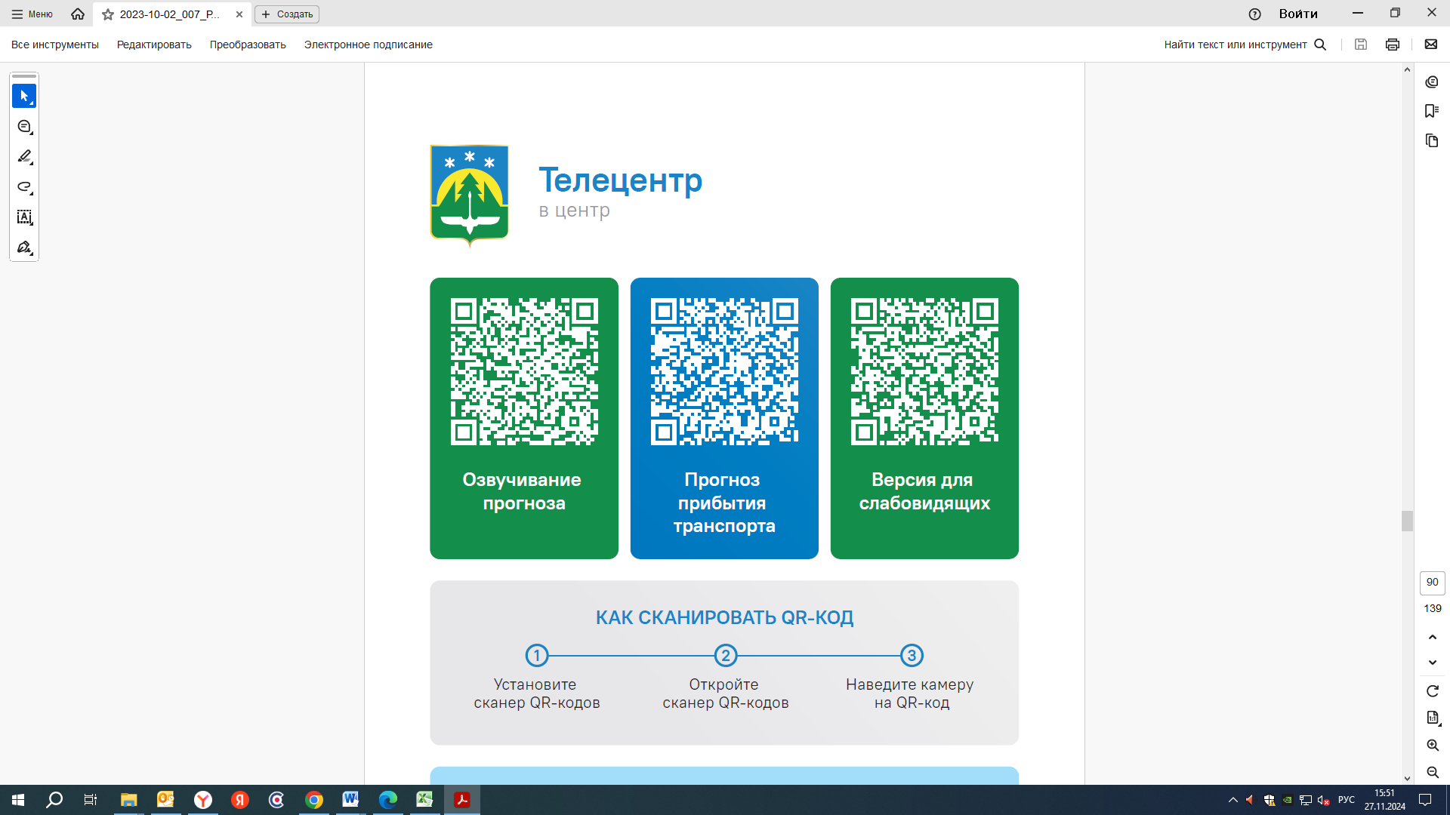  25 | 25 | 25 |  | 30
Контроль за осуществлением регулярных перевозок обеспечивает:
- управление транспорта, связи и дорог Администрации города Ханты-Мансийска, г: Ханты-Мансийск, ул Мира, 13, тел: 8 (3467) 39-39-07;
- отдел государственного автодорожного надзора по ХМАО – Югре, г: Ханты-Мансийск, ул: Шевченко 36А, тел: 8 (3467) 32-64-60;
- МО МВД России «Ханты-Мансийский» г: Ханты-Мансийск, ул: Дзержинского дом 11, телефоны дежур ной части 8 (3467) 398-104, 398-103, 102 и 112

