  Школа №7 |  |  |  |  |  |  |  |  | А
По регулируемым тарифам
Номер маршрута | Конечный остановочный пункт | ДНИ | Время начала и окончания движения | Временной график отправления транспортных средств от остановочного пункта
2 | Мелиораторов | ежедневно | 7:29-19:49 | 7:29, 8:37, 9:37, 10:29, 12:29, 13:29, 14:29, 15:29, 17:39, 18:49, 19:49
4 | ОМК | Будни | 6:49-22:49 | 6:49, 7:09, 7:29, 7:49, 8:14, 8:29, 8:49, 9:09, 9:29, 9:49, 10:09, 10:49, 11:09, 11:49, 12:49, 13:09, 13:49, 14:19, 15:09, 15:49, 16:29, 16:49, 17:09, 17:29, 17:49, 18:09, 18:29, 18:49, 19:14, 19:29, 20:09, 20:49, 21:09, 21:39, 22:09, 22:49
 |  | Выходные | 6:49-22:49 | 6:49, 7:49, 8:49, 9:49, 10:49, 11:49, 12:49, 13:49, 14:49, 15:19, 15:49, 16:49, 17:19, 17:49, 18:49, 19:49, 20:49, 21:49, 22:49
5 | Мкр. Восточный | Будни  с 01.06 по 31.08 | 6:18-23:23 | 6:20, 7:00, 7:20, 7:52, 8:02, 8:22, 8:30, 8:40, 8:50, 9:00, 9:20, 9:45, 9:55, 10:10, 10:20, 10:40, 10:55, 11:10, 11:20, 11:30, 11:40, 12:00, 12:20, 12:40, 13:00, 13:20, 13:40, 14:00, 14:20, 14:40, 15:00, 15:20, 15:40, 16:00, 16:20, 16:40, 17:00, 17:20, 17:40, 17:55, 18:10, 18:25, 18:45, 18:55, 19:10, 19:25, 19:40, 19:55, 20:10, 20:25, 20:40,  21:00, 21:20, 21:40, 21:55, 22:10, 22:40, 23:10, 23:25
 |  | Выходные  с 01.06 по 31.08 | 6:20-23:55 | 6:20, 7:00, 7:20, 7:52, 8:22, 8:40, 9:00, 9:20, 9:40, 10:00, 10:20, 10:40, 11:00, 11:20, 11:40, 12:00, 12:20, 12:40, 13:00, 13:20, 13:40, 14:00, 14:20, 14:40, 15:00, 15:20, 15:40, 16:00, 16:20, 16:40, 17:00, 17:20, 17:40, 18:00, 18:20, 18:40, 19:00, 19:20, 19:40, 20:00, 20:20, 20:40, 21:00, 21:20, 21:40, 21:55, 22:20, 22:40, 23:10, 23:55
 |  | Будни  с 01.09 по 31.05 | 6:20-00:25 | 6:20, 7:00, 7:20, 7:52, 8:02, 8:20, 8:30, 8:40, 8:50, 9:00, 9:20, 9:30, 9:45, 9:55, 10:05, 10:20, 10:40, 11:00, 11:20, 11:30, 11:40, 12:00, 12:20, 12:40, 13:00, 13:20, 13:40, 13:55, 14:10, 14:25, 14:40, 15:00, 15:20, 15:40, 16:00, 16:20, 16:40, 16:55, 17:10, 17:25, 17:40, 17:55, 18:10, 18:25, 18:40, 18:55, 19:10, 19:25, 19:40, 19:55, 20:10,  20:25, 20:40, 21:00, 21:20, 21:40, 21:55, 22:10, 22:25, 22:40, 22:55, 23:10, 23:55, 0:10, 0:25
 |  | Выходные с 01.09 по 31.05 | 7:00-00:25 | 7:00, 7:20, 7:52, 8:02, 8:22, 8:40, 9:00, 9:20, 9:45, 9:55, 10:05, 10:20, 10:40, 10:55, 11:10, 11:20, 11:30, 11:40, 12:00, 12:20, 12:40, 13:00, 13:20, 13:40, 14:00, 14:20, 14:40, 15:00, 15:20, 15:40, 16:20, 16:20, 16:40, 17:00,  17:20, 17:40, 17:55, 18:10, 18:25, 18:40, 18:55, 19:10, 19:25, 19:40, 19:55, 20:10, 20:25, 20:40, 21:00, 21:20, 21:40, 21:55, 22:10, 22:40, 23:10, 23:25, 23:55, 0:25
21 | Теннисный центр | Будни | 6:52-22:24 | 6:54, 7:14, 7:34, 7:54, 8:14, 8:34, 8:54, 9:14, 9:34, 10:04, 10:34, 11:09, 11:34, 12:04, 13:04, 13:39, 14:39, 15:14, 15:34, 16:14, 16:34, 16:54, 17:14, 17:34, 17:54, 18:14, 18:34, 18:54, 19:14, 19:34, 19:54, 20:34, 20:49, 21:34, 22:24
 |  | Выходные | 6:54-22:24 | 6:54, 7:34, 8:34, 9:14, 9:34, 11:09, 12:04, 13:04, 13:39, 14:39, 15:14, 16:14, 16:54, 17:34, 17:54, 18:34, 19:14, 19:34, 20:49, 22:24
По нерегулируемым тарифам
Номер маршрута | Конечный остановочный пункт | ДНИ | Время начала и окончания движения | Интервал отправления транспортных средств от остановочного пункта
9К | Аэропорт |  |  | до 10:00 | 10:00 -11:00 | 11:00 -15:00 | 15:00 -16:00 | 16:00 – 20:00 |  | после 20:00
 |  | Будни | 6:30-22:00 | 15 | 20 | 15 | 20 | 15 |  | 20
 |  | Суббота | 6:30-22:00 | 20 | 25 | 20 | 25 | 20 |  | 25
 |  | Воскресенье | 6:30-21:00 | 20 | 25 | 25 | 25 | 25 |  | 30
13 | База Ханты-Мансийскгаз |  |  | до 10:00 | 10:00 -11:00 | 11:00 -15:00 | 15:00 -16:00 | 16:00 – 20:00 |  | после 20:00
 |  | Будни | 6:30-22:00 | 15 | 20 | 15 | 20 | 15 |  | 20
 |  | Суббота | 6:30-22:00 | 20 | 25 | 20 | 25 | 20 |  | 25
 |  | Воскресенье | 6:30-21:00 | 20 | 25 | 25 | 25 | 25 |  | 30
26К | Теннисный центр |  |  | до 10:00 | 10:00 -11:00 | 11:00 -15:00 | 15:00 -16:00 | 16:00 – 20:00 |  | после 20:00
 |  | Будни | 6:30-22:00 | 15 | 20 | 15 | 20 | 15 |  | 20
 |  | Суббота | 6:30-22:00 | 20 | 25 | 20 | 25 | 20 |  | 25
 |  | Воскресенье | 6:30-21:00 | 20 | 25 | 25 | 25 | 25 |  | 30
Прогноз прибытия пассажирского транспорта
в вашем мобильном телефоне

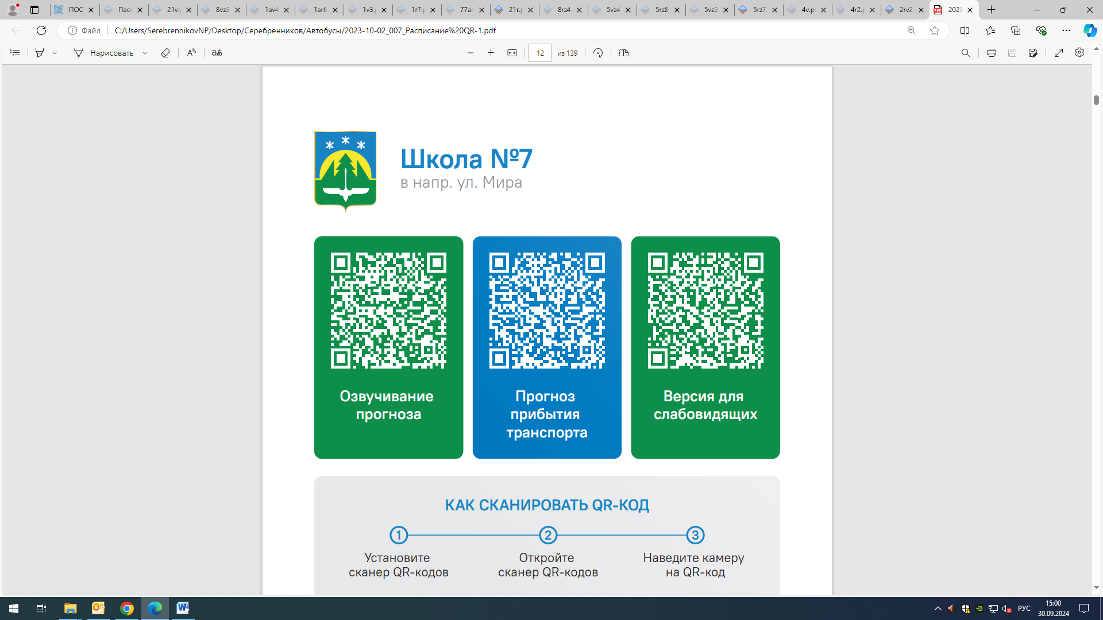



Контроль за осуществлением регулярных перевозок обеспечивает:
- управление транспорта, связи и дорог Администрации города Ханты-Мансийска, г: Ханты-Мансийск, ул Мира, 13, тел: 8 (3467) 39-39-07;
- отдел государственного автодорожного надзора по ХМАО – Югре, г: Ханты-Мансийск, ул: Шевченко 36А, тел: (3467) 32-64-60;
- МО МВД России «Ханты-Мансийский» г: Ханты-Мансийск, ул: Дзержинского дом 11, телефоны дежурной части (3467) 398-104, 398-103, 102 и 112

