  Югорская звезда |  |  |  |  |  |  |  |  | А
По регулируемым тарифам
Номер маршрута | Конечный остановочный пункт | ДНИ | Время начала и окончания движения | Временной график отправления транспортных средств от остановочного пункта
1 | ОМК | Будни | 7:01-23:26 | 7:01, 7:46, 8:06, 8:36, 8:59, 9:26, 9:41, 10:21, 11:01, 11:16, 12:01, 13:01, 14:06, 15:06, 15:41, 16:31, 17:31, 18:16, 18:31, 19:16, 19:56, 20:16, 20:56, 21:31, 21:56, 22:31, 23:26
 |  | Выходные | 7:16-22:31 | 7:16, 8:16, 8:56, 9:56, 10:36, 11:36, 12:36, 13:36, 14:16, 15:16, 15:56, 16:56, 17:36, 18:16, 18:36, 19:16, 19:56, 20:56, 21:31, 22:31
1А | ОМК | Будни | 6:26-22:03 | 6:26, 7:13, 8:13, 8:58, 9:33, 9:53, 10:33, 11:43, 12:28, 13:33, 14:13, 15:13, 16:13, 17:33, 17:58, 18:33, 19:28, 19:33, 20:33, 21:03, 21:18, 22:03
 |  | Выходные | 7:58-21:53 | 7:58, 8:33, 9:33, 10:13, 11:13, 11:53, 12:53, 13:53, 14:33, 15:33, 16:23, 17:13, 17:58, 18:23, 18:53, 19:43, 20:13, 21:18, 21:53
4 | ОМК | Будни | 6:51-22:51 | 6:51, 7:11, 7:31, 7:51, 8:16, 8:31, 8:51, 9:11, 9:31, 9:51, 10:11, 10:51, 11:11, 11:51, 12:51, 13:11, 13:51, 14:21, 15:11, 15:51, 16:31, 16:51, 17:11, 17:31, 17:51, 18:11, 18:31, 18:51, 19:16, 19:31, 20:11, 20:51, 21:11, 21:41, 22:11, 22:51
 |  | Выходные | 6:51-22:51 | 6:51, 7:51, 8:51, 9:51, 10:51, 11:51, 12:51, 13:51, 14:51, 15:21, 15:51, 16:51, 17:21, 17:51, 18:51, 19:51, 20:51, 21:51, 22:51
5 | Мкр. Восточный | Будни  с 01.06 по 31.08 | 6:23-23:28 | 6:23, 7:03, 7:23, 7:55, 8:05, 8:25, 8:33, 8:43, 8:53, 9:03, 9:23, 9:48, 9:58, 10:13, 10:23, 10:43, 10:58, 11:13, 11:23, 11:33, 11:43, 12:03, 12:23, 12:43, 13:03, 13:23, 13:43, 14:03, 14:23, 14:43, 15:03, 15:23, 15:43, 16:03, 16:23, 16:43, 17:03, 17:23, 17:43, 17:58, 18:13, 18:28, 18:48, 18:58, 19:13, 19:28, 19:43, 19:58, 20:13, 20:28, 20:43,  21:03, 21:23, 21:43, 21:58, 22:13, 22:43, 23:13, 23:28
 |  | Выходные  с 01.06 по 31.08 | 6:23-23:58 | 6:23, 7:03, 7:23, 7:55, 8:25, 8:43, 9:03, 9:23, 9:43, 10:03, 10:23, 10:43, 11:03, 11:23, 11:43, 12:03, 12:23, 12:43, 13:03, 13:23, 13:43, 14:03, 14:23, 14:43, 15:03, 15:23, 15:43, 16:03, 16:23, 16:43, 17:03, 17:23, 17:43, 18:03, 18:23, 18:43, 19:03, 19:23, 19:43, 20:03, 20:23, 20:43, 21:03, 21:23, 21:43, 21:58, 22:23, 22:43, 23:13, 23:58
 |  | Будни  с 01.09 по 31.05 | 6:23-00:28 | 6:23, 7:03, 7:23, 7:55, 8:05, 8:23, 8:33, 8:43, 8:53, 9:03, 9:23, 9:33, 9:48, 9:58, 10:08, 10:23, 10:43, 11:03, 11:23, 11:33, 11:43, 12:03, 12:23, 12:43, 13:03, 13:23, 13:43, 13:58, 14:13, 14:28, 14:43, 15:03, 15:23, 15:43, 16:03, 16:23, 16:43, 16:58, 17:13, 17:28, 17:43, 17:58, 18:13, 18:28, 18:43, 18:58, 19:13, 19:28, 19:43, 19:58, 20:13,  20:28, 20:43, 21:03, 21:23, 21:43, 21:58, 22:13, 22:28, 22:43, 22:58, 23:13, 23:58, 0:13, 0:28
 |  | Выходные с 01.09 по 31.05 | 7:03-00:28 | 7:03, 7:23, 7:55, 8:05, 8:25, 8:43, 9:03, 9:23, 9:48, 9:58, 10:08, 10:23, 10:43, 10:58, 11:13, 11:23, 11:33, 11:43 12:03, 12:23, 12:43, 13:03, 13:23, 13:43, 14:03, 14:23, 14:43, 15:03, 15:23, 15:43, 16:23, 16:23, 16:43, 17:03,  17:23, 17:43, 17:58, 18:13, 18:28, 18:43, 18:58, 19:13, 19:28, 19:43, 19:58, 20:13, 20:28, 20:43, 21:03, 21:23, 21:43, 21:58, 22:13, 22:43, 23:13, 23:28, 23:58, 0:28
8 | ОМК | Будни | 6:30-23:10 | 6:30, 7:00, 7:35, 8:05, 8:30, 8:40, 9:10, 9:30, 9:55, 10:50, 11:40, 12:40, 13:10, 13:50, 14:20, 15:30, 16:30, 16:45, 17:10, 17:45, 18:10, 18:45, 19:10, 19:50, 20:10, 21:40, 23:10
 |  | Выходные | 7:00-22:50 | 7:00, 8:10, 8:40, 9:10, 9:50, 10:50, 11:40, 12:10, 12:40, 13:10, 14:10, 15:10, 16:10, 17:10, 18:10, 18:55, 19:30, 21:38, 21:40, 22:50
21 | Теннисный центр | Будни | 6:57-22:27 | 6:57, 7:17, 7:37, 7:57, 8:17, 8:37, 8:57, 9:17, 9:37, 10:07, 10:37, 11:12, 11:37, 12:07, 13:07, 13:42, 14:42, 15:17, 15:37, 16:17, 16:37, 16:57, 17:17, 17:37, 17:57, 18:17, 18:37, 18:57, 19:17, 19:37, 19:57, 20:37, 20:52, 21:37, 22:27
 |  | Выходные | 6:57-22:27 | 6:57, 7:37, 8:37, 9:17, 9:37, 11:12, 12:07, 13:07, 13:42, 14:42, 15:17, 16:17, 16:57, 17:37, 17:57, 18:37, 19:17, 19:37, 20:52, 22:27
По нерегулируемым тарифам
Номер маршрута | Конечный остановочный пункт | ДНИ | Время начала и окончания движения | Интервал отправления транспортных средств от остановочного пункта
8К | ОМК |  |  | до 10:00 | 10:00 -11:00 | 11:00 -15:00 | 15:00 -16:00 | 16:00 – 20:00 |  | после 20:00
 |  | Будни | 6:30-22:00 | 15 | 20 | 15 | 20 | 15 |  | 20
 |  | Суббота | 6:30-22:00 | 20 | 25 | 20 | 25 | 20 |  | 25
 |  | Воскресенье | 6:30-21:00 | 20 | 25 | 25 | 25 | 25 |  | 30
9К | Аэропорт |  |  | до 10:00 | 10:00 -11:00 | 11:00 -15:00 | 15:00 -16:00 | 16:00 – 20:00 |  | после 20:00
 |  | Будни | 6:30-22:00 | 15 | 20 | 15 | 20 | 15 |  | 20
 |  | Суббота | 6:30-22:00 | 20 | 25 | 20 | 25 | 20 |  | 25
 |  | Воскресенье | 6:30-21:00 | 20 | 25 | 25 | 25 | 25 |  | 30
13К | База Ханты-Мансийскгаз |  |  | до 10:00 | 10:00 -11:00 | 11:00 -15:00 | 15:00 -16:00 | 16:00 – 20:00 |  | после 20:00
 |  | Будни | 6:30-22:00 | 15 | 20 | 15 | 20 | 15 |  | 20
 |  | Суббота | 6:30-22:00 | 20 | 25 | 20 | 25 | 20 |  | 25
 |  | Воскресенье | 6:30-21:00 | 20 | 25 | 25 | 25 | 25 |  | 30
26К | Теннисный центр |  |  | до 10:00 | 10:00 -11:00 | 11:00 -15:00 | 15:00 -16:00 | 16:00 – 20:00 |  | после 20:00
 |  | Будни | 6:30-22:00 | 15 | 20 | 15 | 20 | 15 |  | 20
 |  | Суббота | 6:30-22:00 | 20 | 25 | 20 | 25 | 20 |  | 25
 |  | Воскресенье | 6:30-21:00 | 20 | 25 | 25 | 25 | 25 |  | 30
Прогноз прибытия пассажирского транспорта
в вашем мобильном телефоне

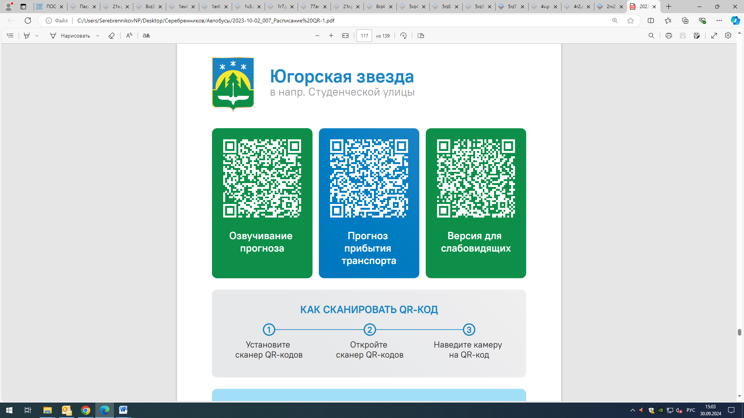



Контроль за осуществлением регулярных перевозок обеспечивает:
- управление транспорта, связи и дорог Администрации города Ханты-Мансийска, г: Ханты-Мансийск, ул Мира, 13, тел: 8 (3467) 39-39-07;
- отдел государственного автодорожного надзора по ХМАО – Югре, г: Ханты-Мансийск, ул: Шевченко 36А, тел: (3467) 32-64-60;
- МО МВД России «Ханты-Мансийский» г: Ханты-Мансийск, ул: Дзержинского дом 11, телефоны дежурной части (3467) 398-104, 398-103, 102 и 112

