  Выставочный центр |  |  |  |  |  |  |  |  | А
По регулируемым тарифам
Номер маршрута | Конечный остановочный пункт | ДНИ | Время начала и окончания движения | Временной график отправления транспортных средств от остановочного пункта
1 | Авторечвокзал (по Гагарина) | Будни | 5:59-22:24 | 5:59, 6:44, 7:04, 7:34, 7:57, 8:24, 8:39, 9:19, 9:59, 10:14, 10:59, 11:59, 13:04, 14:04, 14:39, 15:29, 16:29, 17:14, 17:29, 18:14, 18:54, 19:14, 19:54, 20:29, 20:54, 21:29, 22:24
 |  | Выходные | 6:14-21:29 | 6:14, 7:14, 7:54, 8:54, 9:34, 10:34, 11:34, 12:34, 13:14, 14:14, 14:54, 15:54, 16:34, 17:14, 17:34, 18:14, 18:54, 19:54, 20:29, 21:29
5 | Мкр. Восточный | Будни  с 01.06 по 31.08 | 6:25-23:30 | 6:25, 7:05, 7:25, 7:57, 8:07, 8:27, 8:35, 8:45, 8:55, 9:05, 9:25, 9:50, 10:00, 10:15, 10:25, 10:45, 11:00, 11:15, 11:25, 11:35, 11:45, 12:05, 12:25, 12:45, 13:05, 13:25, 13:45, 14:05, 14:25, 14:45, 15:05, 15:25, 15:45, 16:05, 16:25, 16:45, 17:05, 17:25, 17:45, 18:00, 18:15, 18:30, 18:50, 19:00, 19:15, 19:30, 19:45, 20:00, 20:15, 20:30, 20:45, 21:05, 21:25, 21:45, 22:00, 22:15, 22:45, 23:15, 23:30
 |  | Выходные  с 01.06 по 31.08 | 6:25-0:00 | 6:25, 7:05, 7:25, 7:57, 8:27, 8:45, 9:05, 9:25, 9:45, 10:05, 10:25, 10:45, 11:05, 11:25, 11:45, 12:05, 12:25, 12:45, 13:05, 13:25, 13:45, 14:05, 14:25, 14:45, 15:05, 15:25, 15:45, 16:05, 16:25, 16:45, 17:05, 17:25, 17:45, 18:05, 18:25, 18:45, 19:05, 19:25, 19:45, 20:05, 20:25, 20:45, 21:05, 21:25, 21:45, 22:00, 22:25, 22:45, 23:15, 0:00
 |  | Будни  с 01.09 по 31.05 | 6:25-0:30 | 6:25, 7:05, 7:25, 7:57, 8:07, 8:25, 8:35, 8:45, 8:55, 9:05, 9:25, 9:35, 9:50, 10:00, 10:10, 10:25, 10:45, 11:05, 11:25, 11:35, 11:45, 12:05, 12:25, 12:45, 13:05, 13:25, 13:45, 14:00, 14:15, 14:30, 14:45, 15:05, 15:25, 15:45, 16:05, 16:25, 16:45, 17:00, 17:15, 17:30, 17:45, 18:00, 18:15, 18:30, 18:45, 19:00, 19:15, 19:30, 19:45, 20:00, 20:15, 20:30, 20:45, 21:05, 21:25, 21:45, 22:00, 22:15, 22:30, 22:45, 23:00, 23:15, 0:00, 0:15, 0:30
 |  | Выходные с 01.09 по 31.05 | 7:05-0:30 | 7:05, 7:25, 7:57, 8:07, 8:27, 8:45, 9:05, 9:25, 9:50, 10:00, 10:10, 10:25, 10:45, 11:00, 11:15, 11:25, 11:35, 11:45 12:05, 12:25, 12:45, 13:05, 13:25, 13:45, 14:05, 14:25, 14:45, 15:05, 15:25, 15:45, 16:25, 16:45, 17:05, 17:25, 17:45, 18:00, 18:15, 18:30, 18:45, 19:00, 19:15, 19:30, 19:45, 20:00, 20:15, 20:30, 20:45, 21:05, 21:25, 21:45, 22:00, 22:15, 22:45, 23:15, 23:30, 0:00, 0:30
8 | Мелиораторов | Будни | 6:04-22:44 | 6:04, 6:34, 7:09, 7:39, 8:04, 8:14, 8:44, 9:04, 9:29, 10:24, 11:14, 12:14, 12:44, 13:24, 13:54, 15:04, 16:04, 16:19, 16:44, 17:19, 17:44, 18:19, 18:44, 19:24, 19:44, 21:14, 22:44
 |  | Выходные | 6:34-22:24 | 6:34, 7:44, 8:14, 8:44, 9:24, 10:24, 11:14, 11:44, 12:14, 12:44, 13:44, 14:44, 15:44, 16:44, 17:44, 18:29, 19:04, 21:12, 21:14, 22:24
По нерегулируемым тарифам
Номер маршрута | Конечный остановочный пункт | ДНИ | Время начала и окончания движения | Интервал отправления транспортных средств от остановочного пункта
9К | Аэропорт |  |  | до 10:00 | 10:00 -11:00 | 11:00 -15:00 | 15:00 -16:00 | 16:00 – 20:00 |  | после 20:00
 |  | Будни | 6:30-22:00 | 15 | 20 | 15 | 20 | 15 |  | 20
 |  | Суббота | 6:30-22:00 | 20 | 25 | 20 | 25 | 20 |  | 25
 |  | Воскресенье | 6:30-21:00 | 20 | 25 | 25 | 25 | 25 |  | 30
13К | База Ханты-Мансийскгаз |  |  | до 10:00 | 10:00 -11:00 | 11:00 -15:00 | 15:00 -16:00 | 16:00 – 20:00 |  | после 20:00
 |  | Будни | 6:30-22:00 | 15 | 20 | 15 | 20 | 15 |  | 20
 |  | Суббота | 6:30-22:00 | 20 | 25 | 20 | 25 | 20 |  | 25
 |  | Воскресенье | 6:30-21:00 | 20 | 25 | 25 | 25 | 25 |  | 30
26К | Гимназия№1 |  |  | до 10:00 | 10:00 -11:00 | 11:00 -15:00 | 15:00 -16:00 | 16:00 – 20:00 |  | после 20:00
 |  | Будни | 6:30-22:00 | 15 | 20 | 15 | 20 | 15 |  | 20
 |  | Суббота | 6:30-22:00 | 20 | 25 | 20 | 25 | 20 |  | 25
 |  | Воскресенье | 6:30-21:00 | 20 | 25 | 25 | 25 | 25 |  | 30
Прогноз прибытия пассажирского транспорта
в вашем мобильном телефоне


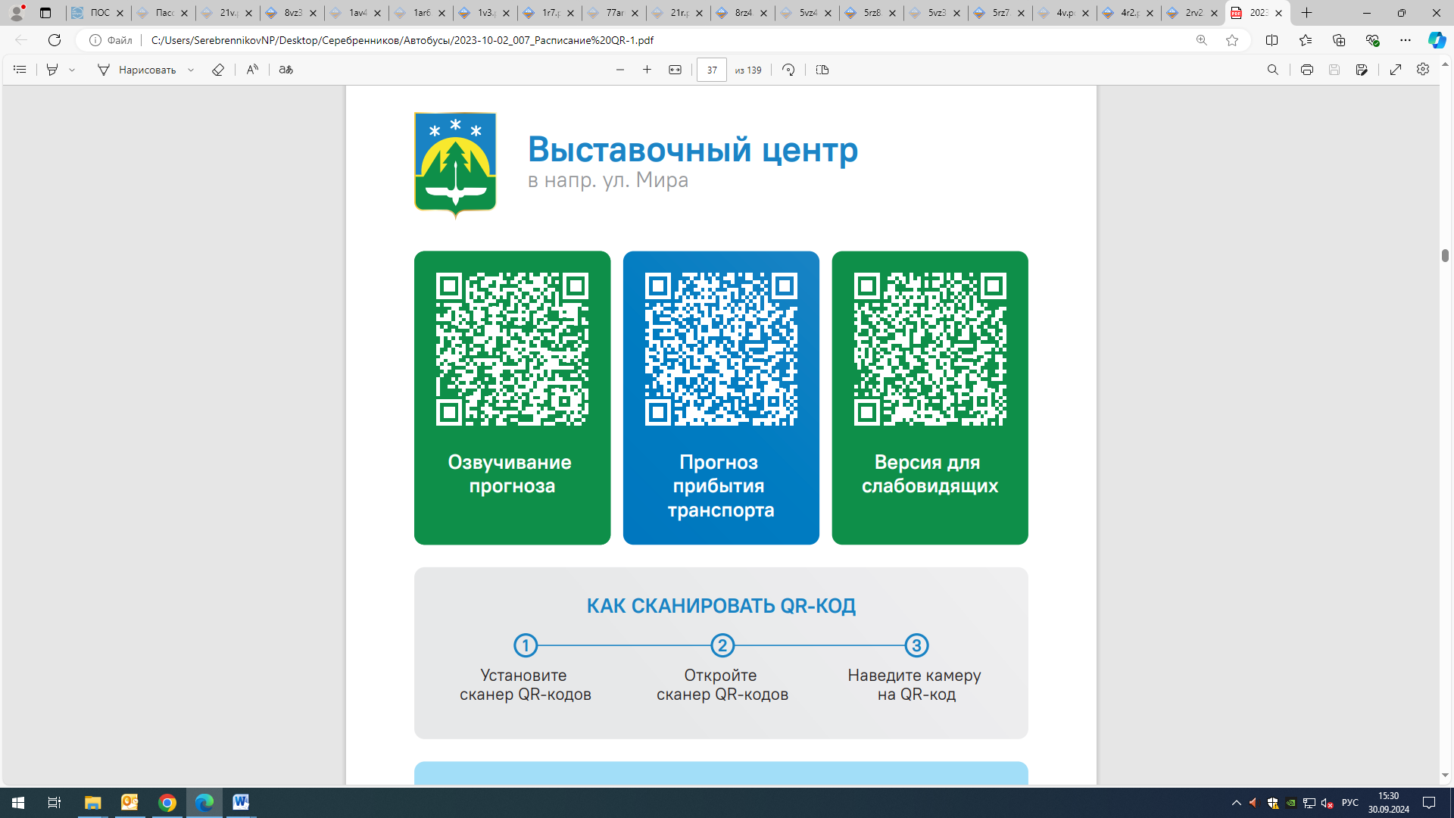


Контроль за осуществлением регулярных перевозок обеспечивает:
- управление транспорта, связи и дорог Администрации города Ханты-Мансийска, г: Ханты-Мансийск, ул. Мира, 13, тел: 8 (3467) 39-39-07;
- отдел государственного автодорожного надзора по ХМАО – Югре, г: Ханты-Мансийск, ул. Шевченко 36А, тел: (3467) 32-64-60;
- МО МВД России «Ханты-Мансийский» г: Ханты-Мансийск, ул: Дзержинского дом 11, телефоны дежурной части 8 (3467) 398-104, 398-103, 102 и 112

