  Городок Геологов |  |  |  |  |  |  |  |  | А
По регулируемым тарифам
Номер маршрута | Конечный остановочный пункт | ДНИ | Время начала и окончания движения | Временной график отправления транспортных средств от остановочного пункта
1А | ОМК | Будни | 6:08-21:45 | 6:08, 6:55, 7:55, 8:40, 9:15, 9:35, 10:15, 11:25, 12:10, 13:15, 13:55, 14:55, 15:55, 17:15, 17:40,  18:15, 19:10, 19:15, 20:15, 20:45, 21:00, 21:45
 |  | Выходные | 7:40-21:35 | 7:40, 8:15, 9:15, 9:55, 10:55, 11:35, 12:35, 13:35, 14:15, 15:15, 16:05, 16:55, 17:40, 18:05, 18:35,  19:25, 19:55, 21:00, 21:35
4 | ОМК | Будни | 6:19-22:25 | 6:19, 6:39, 6:59, 7:25, 7:55, 8:25, 8:45, 9:10, 9:30, 9:50, 10:25, 10:45, 11:35, 12:25, 12:45, 13:25, 13:40, 14:05, 14:35, 14:55, 15:25, 16:00, 16:20, 16:45, 17:25, 17:50, 18:05, 18:25, 18:55, 19:05, 19:25, 19:50, 20:30, 21:10, 21:45, 22:25
 |  | Выходные | 6:39-22:25 | 6:39, 7:25, 8:25, 8:45, 9:30, 10:25, 11:35, 12:25, 13:25, 13:40, 14:35, 15:25, 16:20, 17:25, 18:25,  19:25, 20:30, 21:10, 22:25
5 | Мкр. Восточный | Будни  с 01.06 по 31.08 | 5:57-23:02 | 5:57, 6:37, 6:57, 7:29, 7:39, 7:59, 8:07, 8:17, 8:27, 8:37, 8:57, 9:22, 9:32, 9:47, 9:57, 10:17, 10:32, 10:47, 10:57, 11:07, 11:17, 11:37, 11:57, 12:17, 12:37, 12:57, 13:17, 13:37, 13:57, 14:17, 14:37, 14:57, 15:17, 15:37, 15:57, 16:17, 16:37, 16:57, 17:17, 17:32, 17:47, 18:02, 18:22, 18:32, 18:47, 19:02, 19:17, 19:32, 19:47, 20:02, 20:17, 20:37, 20:57, 21:17, 21:32,  21:47, 22:17, 22:47, 23:02
 |  | Выходные  с 01.06 по 31.08 | 5:57-23:32 | 5:57, 6:37, 6:57, 7:29, 7:59, 8:17, 8:37, 8:57, 9:17, 9:37, 9:57, 10:17, 10:37, 10:57, 11:17, 11:37, 11:57, 12:17, 12:37, 12:57, 13:17, 13:37, 13:57, 14:17, 14:37, 14:57, 15:17, 15:37, 15:57, 16:17, 16:37, 16:57, 17:17, 17:37, 17:57, 18:17, 18:37, 18:57, 19:17, 19:37, 19:57, 20:17, 20:37, 20:57, 21:17, 21:32, 21:57, 22:17, 22:47, 23:32
 |  | Будни  с 01.09 по 31.05 | 5:57-00:02 | 5:57, 6:37, 6:57, 7:29, 7:39, 7:57, 8:07, 8:17, 8:27, 8:37, 8:57, 9:07, 9:22, 9:32, 9:42, 9:57, 10:17, 10:37, 10:57, 11:07, 11:17, 11:37, 11:57, 12:17, 12:37, 12:57, 13:17, 13:32, 13:47, 14:02, 14:17, 14:37, 14:57, 15:17, 15:37, 15:57, 16:17, 16:32, 16:47, 17:02, 17:17, 17:32, 17:47, 18:02, 18:17, 18:32, 18:47, 19:02, 19:17, 19:32, 19:47, 20:02, 20:17, 20:37, 20:57, 21:17, 21:32, 21:47, 22:02, 22:17, 22:32, 22:47, 23:32, 23:47, 0:02
 |  | Выходные  с 01.09 по 31.05 | 6:37-00:02 | 6:37, 6:57, 7:29, 7:39, 7:59, 8:17, 8:37, 8:57, 9:22, 9:32, 9:42, 9:57, 10:17, 10:32, 10:47, 10:57, 11:07, 11:17, 11:37, 11:57, 12:17, 12:37, 12:57, 13:17, 13:37, 13:57, 14:17, 14:37, 14:57, 15:17, 15:57, 15:57, 16:17, 16:37, 16:57, 17:17, 17:32, 17:47, 18:02, 18:17, 18:32, 18:47, 19:02, 19:17, 19:32, 19:47, 20:02, 20:17, 20:37, 20:57, 21:17, 21:32, 21:47,  22:17, 22:47, 23:02, 23:32, 0:02
21 | Теннисный центр | Будни | 6:35-22:05 | 6:35, 6:55, 7:15, 7:35, 7:55, 8:15, 8:35, 8:55, 9:15, 9:55, 10:15, 10:55, 11:45, 12:45, 13:15, 13:35, 14:20, 14:55, 15:15, 15:45, 16:15, 16:35, 16:55, 17:15, 17:35, 17:55, 18:15, 18:35, 18:55, 19:15, 19:35, 20:15, 20:35, 21:15, 22:05
 |  | Выходные | 6:35-22:05 | 6:35, 7:15, 8:15, 8:55, 9:55, 10:55, 11:45, 12:45, 13:35, 14:20, 14:55, 15:15, 16:35, 17:15, 17:35, 18:15,  18:55, 19:15, 20:35, 21:15, 22:05
77 | Сельхозтехника | Будни | 6:39-22:04 | 6:39, 7:34, 8:19, 8:29, 9:06, 9:39, 10:39, 11:54, 12:19, 12:49, 13:19, 13:46, 14:04, 14:46, 15:13, 15:39, 16:59,  17:29, 17:55, 18:56, 19:25, 20:19, 20:55, 20:39, 22:04
 |  | Выходные | 6:39-22:04 | 6:39, 7:34, 8:12, 9:06, 9:39, 10:39, 11:54, 12:49, 13:39, 14:26, 14:59, 15:39, 16:59, 16:19, 17:39, 18:06, 18:59,  19:29, 20:19, 20:59, 22:04
По нерегулируемым тарифам
Номер маршрута | Конечный остановочный пункт | ДНИ | Время начала и окончания движения | Интервал отправления транспортных средств от остановочного пункта
7К | Назымская экспедиция |  |  | до 10:00 | 10:00 -11:00 | 11:00 -15:00 | 15:00 -16:00 | 16:00 – 20:00 |  | после 20:00
 |  | Будни | 6:30-22:00 | 15 | 20 | 15 | 20 | 15 |  | 20
 |  | Суббота | 6:30-22:00 | 20 | 25 | 20 | 25 | 20 |  | 25
 |  | Воскресенье | 6:30-21:00 | 20 | 25 | 25 | 25 | 25 |  | 30
8К | ОМК |  |  | до 10:00 | 10:00 -11:00 | 11:00 -15:00 | 15:00 -16:00 | 16:00 – 20:00 |  | после 20:00
 |  | Будни | 6:30-22:00 | 15 | 20 | 15 | 20 | 15 |  | 20
 |  | Суббота | 6:30-22:00 | 20 | 25 | 20 | 25 | 20 |  | 25
 |  | Воскресенье | 6:30-21:00 | 20 | 25 | 25 | 25 | 25 |  | 30
13К | База Ханты-Мансийскгаз |  |  | до 10:00 | 10:00 -11:00 | 11:00 -15:00 | 15:00 -16:00 | 16:00 – 20:00 |  | после 20:00
 |  | Будни | 6:30-22:00 | 15 | 20 | 15 | 20 | 15 |  | 20
 |  | Суббота | 6:30-22:00 | 20 | 25 | 20 | 25 | 20 |  | 25
 |  | Воскресенье | 6:30-21:00 | 20 | 25 | 25 | 25 | 25 |  | 30
  26К | Теннисный центр |  |  | до 10:00 | 10:00 -11:00 | 11:00 -15:00 | 15:00 -16:00 | 16:00 – 20:00 |  | после 20:00
 |  | Будни | 6:30-22:00 | 15 | 20 | 15 | 20 | 15 |  | 20
 |  | Суббота | 6:30-22:00 | 20 | 25 | 20 | 25 | 20 |  | 25
 |  |   Воскресенье  Прогноз прибытия пассажирского транспорта  в вашем мобильном телефоне | 6:30-21:00 | 20 | 25 | 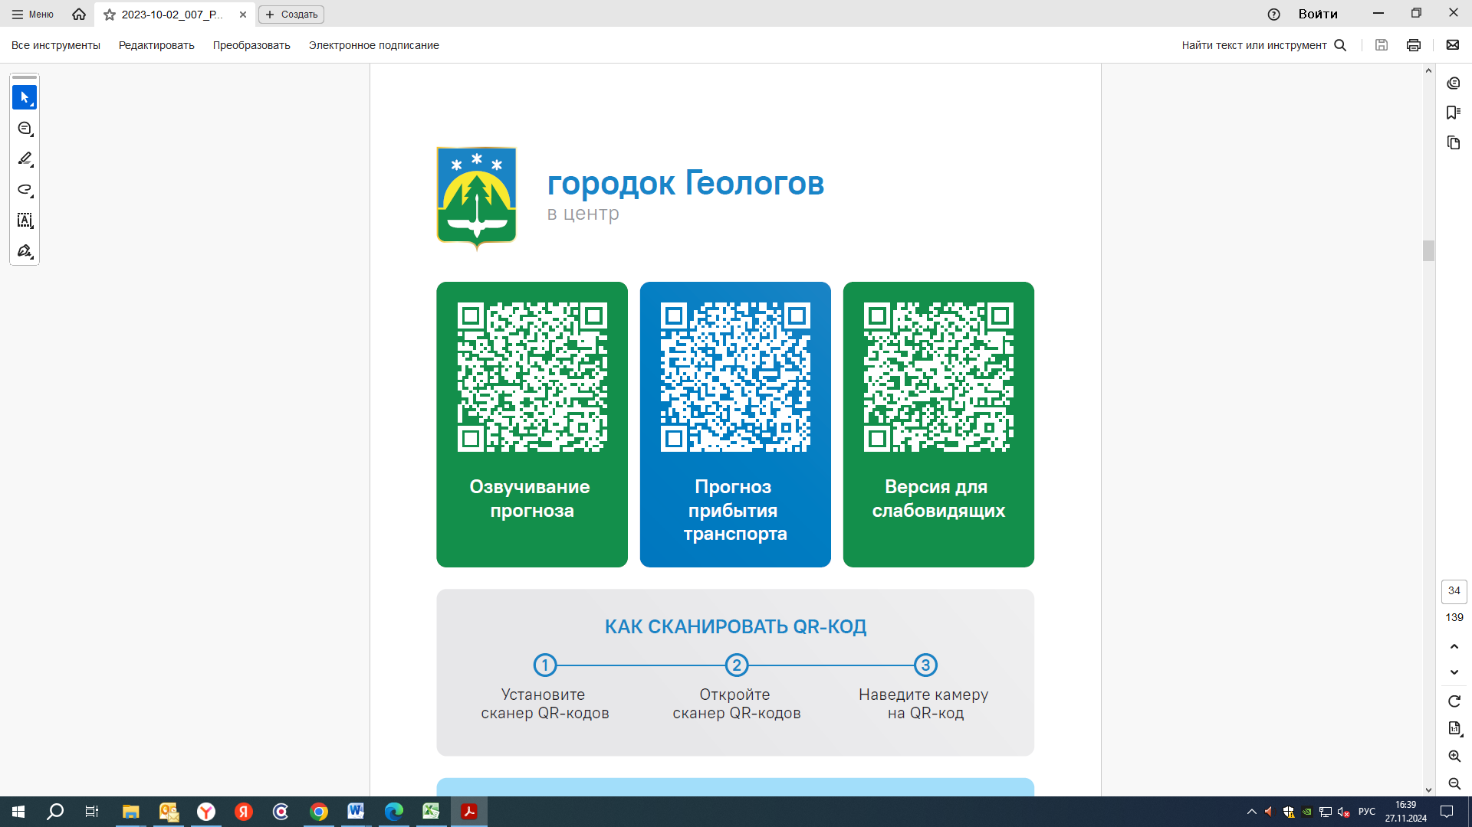  25 | 25 | 25 |  | 30
Контроль за осуществлением регулярных перевозок обеспечивает:
- управление транспорта, связи и дорог Администрации города Ханты-Мансийска, г: Ханты-Мансийск, ул Мира, 13, тел: 8 (3467) 39-39-07;
- отдел государственного автодорожного надзора по ХМАО – Югре, г: Ханты-Мансийск, ул: Шевченко 36А, тел: 8 (3467) 32-64-60;
- МО МВД России «Ханты-Мансийский» г: Ханты-Мансийск, ул: Дзержинского дом 11, телефоны дежур ной части 8 (3467) 398-104, 398-103, 102 и 112

