  Гагарина |  |  |  |  |  |  |  |  | А
По регулируемым тарифам
Номер маршрута | Конечный остановочный пункт | ДНИ | Время начала и окончания движения | Временной график отправления транспортных средств от остановочного пункта
1А | ОМК | Будни | 6:10-21:47 | 6:10, 6:57, 7:57, 8:42, 9:17, 9:37, 10:17, 11:27, 12:12, 13:17, 13:57, 14:57, 15:57, 17:17, 17:42,  18:17, 19:12, 19:17, 20:17, 20:47, 21:02, 21:47
 |  | Выходные | 7:42-21:37 | 7:42, 8:17, 9:17, 9:57, 10:57, 11:37, 12:37, 13:37, 14:17, 15:17, 16:07, 16:57, 17:42, 18:07, 18:37,  19:27, 19:57, 21:02, 21:37
4 | ОМК | Будни | 6:21-22:27 | 6:21, 6:41, 7:01, 7:27, 7:57, 8:27, 8:47, 9:12, 9:32, 9:52, 10:27, 10:47, 11:37, 12:27, 12:47, 13:27, 13:42, 14:07, 14:37, 14:57, 15:27, 16:02, 16:22, 16:47, 17:27, 17:52, 18:07, 18:27, 18:57, 19:07, 19:27, 19:52, 20:32, 21:12, 21:47, 22:27
 |  | Выходные | 6:41-22:27 | 6:41, 7:27, 8:27, 8:47, 9:32, 10:27, 11:37, 12:27, 13:27, 13:42, 14:37, 15:27, 16:22, 17:27, 18:27,  19:27, 20:32, 21:12, 22:27
5 | Мкр. Восточный | Будни  с 01.06 по 31.08 | 5:59-23:04 | 5:59, 6:39, 6:59, 7:31, 7:41, 8:01, 8:09, 8:19, 8:29, 8:39, 8:59, 9:24, 9:34, 9:49, 9:59, 10:19, 10:34, 10:49, 10:59, 11:09, 11:19, 11:39, 11:59, 12:19, 12:39, 12:59, 13:19, 13:39, 13:59, 14:19, 14:39, 14:59, 15:19, 15:39, 15:59, 16:19, 16:39, 16:59, 17:19, 17:34, 17:49, 18:04, 18:24, 18:34, 18:49, 19:04, 19:19, 19:34, 19:49, 20:04, 20:19, 20:39, 20:59, 21:19,  21:34, 21:49, 22:19, 22:49, 23:04
 |  | Выходные  с 01.06 по 31.08 | 5:59-23:34 | 5:59, 6:39, 6:59, 7:31, 8:01, 8:19, 8:39, 8:59, 9:19, 9:39, 9:59, 10:19, 10:39, 10:59, 11:19, 11:39, 11:59, 12:19, 12:39, 12:59, 13:19, 13:39, 13:59, 14:19, 14:39, 14:59, 15:19, 15:39, 15:59, 16:19, 16:39, 16:59, 17:19, 17:39, 17:59, 18:19, 18:39, 18:59, 19:19, 19:39, 19:59, 20:19, 20:39, 20:59, 21:19, 21:34, 21:59, 22:19, 22:49, 23:34
 |  | Будни  с 01.09 по 31.05 | 5:59-00:04 | 5:59, 6:39, 6:59, 7:31, 7:41, 7:59, 8:09, 8:19, 8:29, 8:39, 8:59, 9:09, 9:24, 9:34, 9:44, 9:59, 10:19, 10:39, 10:59, 11:09, 11:19, 11:39, 11:59, 12:19, 12:39, 12:59, 13:19, 13:34, 13:49, 14:04, 14:19, 14:39, 14:59, 15:19, 15:39, 15:59, 16:19, 16:34, 16:49, 17:04, 17:19, 17:34, 17:49, 18:04, 18:19, 18:34, 18:49, 19:04, 19:19, 19:34, 19:49, 20:04, 20:19, 20:39, 20:59, 21:19, 21:34, 21:49, 22:04, 22:19, 22:34, 22:49, 23:34, 23:49, 0:04
 |  | Выходные  с 01.09 по 31.05 | 6:39-00:04 | 6:39, 6:59, 7:31, 7:41, 8:01, 8:19, 8:39, 8:59, 9:24, 9:34, 9:44, 9:59, 10:19, 10:34, 10:49, 10:59, 11:09, 11:19, 11:39, 11:59, 12:19, 12:39, 12:59, 13:19, 13:39, 13:59, 14:19, 14:39, 14:59, 15:19, 15:59, 15:59, 16:19, 16:39, 16:59, 17:19, 17:34, 17:49, 18:04, 18:19, 18:34, 18:49, 19:04, 19:19, 19:34, 19:49, 20:04, 20:19, 20:39, 20:59, 21:19, 21:34, 21:49,  22:19, 22:49, 23:04, 23:34, 0:04
21 | Теннисный центр | Будни | 6:36-22:06 | 6:36, 6:56, 7:16, 7:36, 7:56, 8:16, 8:36, 8:56, 9:16, 9:56, 10:16, 10:56, 11:46, 12:46, 13:16, 13:36, 14:21, 14:56, 15:16, 15:46, 16:16, 16:36, 16:56, 17:16, 17:36, 17:56, 18:16, 18:36, 18:56, 19:16, 19:36, 20:16, 20:36, 21:16, 22:06
 |  | Выходные | 6:36-22:06 | 6:36, 7:16, 8:16, 8:56, 9:56, 10:56, 11:46, 12:46, 13:36, 14:21, 14:56, 15:16, 16:36, 17:16, 17:36, 18:16,  18:56, 19:16, 20:36, 21:16, 22:06
77 | Сельхозтехника | Будни | 6:41-22:06 | 6:41, 7:36, 8:21, 8:31, 9:08, 9:41, 10:41, 11:56, 12:21, 12:51, 13:21, 13:48, 14:06, 14:48, 15:15, 15:41, 17:01,  17:31, 17:57, 18:58, 19:27, 20:21, 20:57, 20:41, 22:06
 |  | Выходные | 6:41-22:06 | 6:41, 7:36, 8:14, 9:08, 9:41, 10:41, 11:56, 12:51, 13:41, 14:28, 15:01, 15:41, 17:01, 16:21, 17:41, 18:08, 19:01,  19:31, 20:21, 21:01, 22:06
По нерегулируемым тарифам
Номер маршрута | Конечный остановочный пункт | ДНИ | Время начала и окончания движения | Интервал отправления транспортных средств от остановочного пункта
7К | Назымская экспедиция |  |  | до 10:00 | 10:00 -11:00 | 11:00 -15:00 | 15:00 -16:00 | 16:00 – 20:00 |  | после 20:00
 |  | Будни | 6:30-22:00 | 15 | 20 | 15 | 20 | 15 |  | 20
 |  | Суббота | 6:30-22:00 | 20 | 25 | 20 | 25 | 20 |  | 25
 |  | Воскресенье | 6:30-21:00 | 20 | 25 | 25 | 25 | 25 |  | 30
8К | ОМК |  |  | до 10:00 | 10:00 -11:00 | 11:00 -15:00 | 15:00 -16:00 | 16:00 – 20:00 |  | после 20:00
 |  | Будни | 6:30-22:00 | 15 | 20 | 15 | 20 | 15 |  | 20
 |  | Суббота | 6:30-22:00 | 20 | 25 | 20 | 25 | 20 |  | 25
 |  | Воскресенье | 6:30-21:00 | 20 | 25 | 25 | 25 | 25 |  | 30
13К | База Ханты-Мансийскгаз |  |  | до 10:00 | 10:00 -11:00 | 11:00 -15:00 | 15:00 -16:00 | 16:00 – 20:00 |  | после 20:00
 |  | Будни | 6:30-22:00 | 15 | 20 | 15 | 20 | 15 |  | 20
 |  | Суббота | 6:30-22:00 | 20 | 25 | 20 | 25 | 20 |  | 25
 |  | Воскресенье | 6:30-21:00 | 20 | 25 | 25 | 25 | 25 |  | 30
  26К | Теннисный центр |  |  | до 10:00 | 10:00 -11:00 | 11:00 -15:00 | 15:00 -16:00 | 16:00 – 20:00 |  | после 20:00
 |  | Будни | 6:30-22:00 | 15 | 20 | 15 | 20 | 15 |  | 20
 |  | Суббота | 6:30-22:00 | 20 | 25 | 20 | 25 | 20 |  | 25
 |  |   Воскресенье  Прогноз прибытия пассажирского транспорта  в вашем мобильном телефоне | 6:30-21:00 | 20 | 25 | 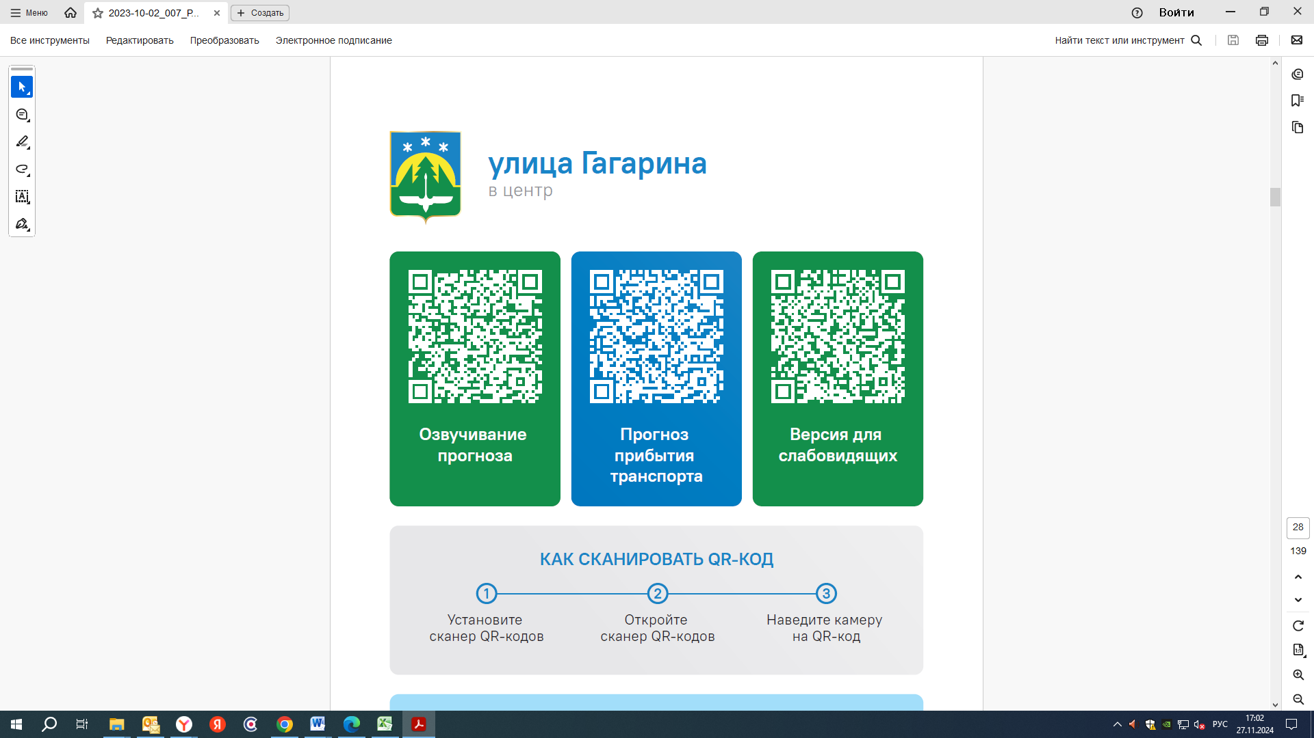  25 | 25 | 25 |  | 30
Контроль за осуществлением регулярных перевозок обеспечивает:
- управление транспорта, связи и дорог Администрации города Ханты-Мансийска, г: Ханты-Мансийск, ул Мира, 13, тел: 8 (3467) 39-39-07;
- отдел государственного автодорожного надзора по ХМАО – Югре, г: Ханты-Мансийск, ул: Шевченко 36А, тел: 8 (3467) 32-64-60;
- МО МВД России «Ханты-Мансийский» г: Ханты-Мансийск, ул: Дзержинского дом 11, телефоны дежур ной части 8 (3467) 398-104, 398-103, 102 и 112

