  ДРСУ - 5 |  |  |  |  |  |  |  |  | А
По регулируемым тарифам
Номер маршрута | Конечный остановочный пункт | ДНИ | Время начала и окончания движения | Временной график отправления транспортных средств от остановочного пункта
5 | Мкр. Восточный | Будни  с 01.06 по 31.08 | 04:30-23:31 | 04:30, 05:45, 05:55, 6:26, 7:06, 7:26, 7:58, 8:08, 8:28, 8:36, 8:46, 8:56, 9:06, 9:26, 9:51, 10:01, 10:16, 10:26, 10:46, 11:01, 11:16, 11:26, 11:36, 11:46, 12:06, 12:26, 12:46, 13:06, 13:26, 13:46, 14:06, 14:26, 14:46, 15:06,  15:26, 15:46, 16:06, 16:26, 16:46, 17:06, 17:26, 17:46, 18:01, 18:16, 18:31, 18:51, 19:01, 19:16, 19:31, 19:46, 20:01, 20:16, 20:31, 20:46, 21:06, 21:26, 21:46, 22:01, 22:16, 22:46, 23:16, 23:31
 |  | Выходные  с 01.06 по 31.08 | 4:30-0:01 | 04:30, 6:26, 7:06, 7:26, 7:58, 8:28, 8:46, 9:06, 9:26, 9:46, 10:06, 10:26, 10:46, 11:06, 11:26, 11:46, 12:06, 12:26, 12:46, 13:06, 13:26, 13:46, 14:06, 14:26, 14:46, 15:06, 15:26, 15:46, 16:06, 16:26, 16:46, 17:06, 17:26, 17:46, 18:06, 18:26, 18:46, 19:06, 19:26, 19:46, 20:06, 20:26, 20:46, 21:06, 21:26, 21:46, 22:01, 22:26, 22:46, 23:16, 0:01
 |  | Будни  с 01.09 по 31.05 | 4:30-0:31 | 4:30, 5:45, 5:55, 6:26, 7:06, 7:26, 7:58, 8:08, 8:26, 8:36, 8:46, 8:56, 9:06, 9:26, 9:36, 9:51, 10:01, 10:11, 10:26, 10:46, 11:06, 11:26, 11:36, 11:46, 12:06, 12:26, 12:46, 13:06, 13:26, 13:46, 14:01, 14:16, 14:31, 14:46, 15:06, 15:26, 15:46, 16:06, 16:26, 16:46, 17:01, 17:16, 17:31, 17:46, 18:01, 18:16, 18:31, 18:46, 19:01, 19:16, 19:31,  19:46, 20:01, 20:16, 20:31, 20:46, 21:06, 21:26, 21:46, 22:01, 22:16, 22:31, 22:46, 23:01, 23:16, 0:01, 0:16, 0:31
 |  | Выходные с 01.09 по 31.05 | 4:30-0:31 | 4:30, 7:06, 7:26, 7:58, 8:08, 8:28, 8:46, 9:06, 9:26, 9:51, 10:01, 10:11, 10:26, 10:46, 11:01, 11:16, 11:26, 11:36, 11:46, 12:06, 12:26, 12:46, 13:06, 13:26, 13:46, 14:06, 14:26, 14:46, 15:06, 15:26, 15:46, 16:26, 16:26, 16:46,  17:06, 17:26, 17:46, 18:01, 18:16, 18:31, 18:46, 19:01, 19:16, 19:31, 19:46, 20:01, 20:16, 20:31, 20:46, 21:06, 21:26, 21:46, 22:01, 22:16, 22:46, 23:16, 23:31, 0:01, 0:31
По нерегулируемым тарифам
Номер маршрута | Конечный остановочный пункт | ДНИ | Время начала и окончания движения | Интервал отправления транспортных средств от остановочного пункта
9К | Аэропорт |  |  | до 10:00 | 10:00 -11:00 | 11:00 -15:00 | 15:00 -16:00 | 16:00 – 20:00 |  | после 20:00
 |  | Будни | 6:30-22:00 | 15 | 20 | 15 | 20 | 15 |  | 20
 |  | Суббота | 6:30-22:00 | 20 | 25 | 20 | 25 | 20 |  | 25
 |  | Воскресенье | 6:30-21:00 | 20 | 25 | 25 | 25 | 25 |  | 30
13К | База Ханты-Мансийскгаз |  |  | до 10:00 | 10:00 -11:00 | 11:00 -15:00 | 15:00 -16:00 | 16:00 – 20:00 |  | после 20:00
 |  | Будни | 6:30-22:00 | 15 | 20 | 15 | 20 | 15 |  | 20
 |  | Суббота | 6:30-22:00 | 20 | 25 | 20 | 25 | 20 |  | 25
 |  | Воскресенье | 6:30-21:00 | 20 | 25 | 25 | 25 | 25 |  | 30
Прогноз прибытия пассажирского транспорта
в вашем мобильном телефоне

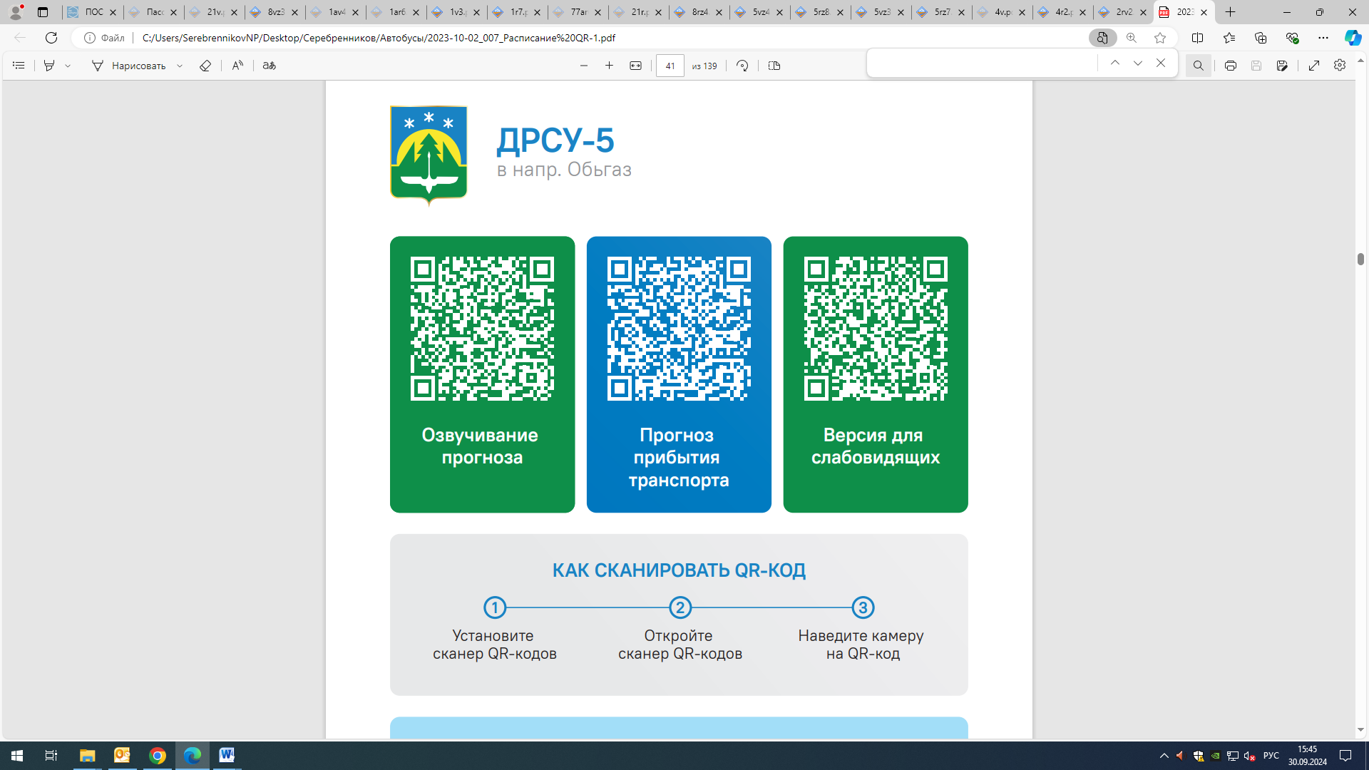



Контроль за осуществлением регулярных перевозок обеспечивает:
- управление транспорта, связи и дорог Администрации города Ханты-Мансийска, г: Ханты-Мансийск, ул Мира, 13, тел: 8 (3467) 39-39-07;
- отдел государственного автодорожного надзора по ХМАО – Югре, г: Ханты-Мансийск, ул: Шевченко 36А, тел: (3467) 32-64-60;
- МО МВД России «Ханты-Мансийский» г: Ханты-Мансийск, ул: Дзержинского дом 11, телефоны дежурной части (3467) 398-104, 398-103, 102 и 112

