  Обьгаз |  |  |  |  |  |  |  |  | А
По регулируемым тарифам
Номер маршрута | Конечный остановочный пункт | ДНИ | Время начала и окончания движения | Временной график отправления транспортных средств от остановочного пункта
5 | Мкр. Восточный | Будни  с 01.06 по 31.08 | 04:31-23:34 | 4:31, 5:46, 5:56, 6:29, 7:09, 7:29, 8:01, 8:11, 8:31, 8:39, 8:49, 8:59, 9:09, 9:29, 9:54, 10:04, 10:19, 10:29, 10:49, 11:04, 11:19, 11:29, 11:39, 11:49, 12:09, 12:29, 12:49, 13:09, 13:29, 13:49, 14:09, 14:29, 14:49, 15:09, 15:29, 15:49, 16:09, 16:29, 16:49, 17:09, 17:29, 17:49, 18:04, 18:19, 18:34, 18:54, 19:04, 19:19, 19:34, 19:49, 20:04,  20:19, 20:34, 20:49, 21:09, 21:29, 21:49, 22:04, 22:19, 22:49, 23:19, 23:34
 |  | Выходные  с 01.06 по 31.08 | 4:31-0:04 | 4:31, 6:29, 7:09, 7:29, 8:01, 8:31, 8:49, 9:09, 9:29, 9:49, 10:09, 10:29, 10:49, 11:09, 11:29, 11:49, 12:09, 12:29, 12:49, 13:09, 13:29, 13:49, 14:09, 14:29, 14:49, 15:09, 15:29, 15:49, 16:09, 16:29, 16:49, 17:09, 17:29, 17:49, 18:09, 18:29, 18:49, 19:09, 19:29, 19:49, 20:09, 20:29, 20:49, 21:09, 21:29, 21:49, 22:04, 22:29, 22:49, 23:19, 0:04
 |  | Будни  с 01.09 по 31.05 | 4:30-0:31 | 4:31, 5:46, 5:56, 6:29, 7:09, 7:29, 8:01, 8:11, 8:29, 8:39, 8:49, 8:59, 9:09, 9:29, 9:39, 9:54, 10:04, 10:14, 10:29, 10:49, 11:09, 11:29, 11:39, 11:49, 12:09, 12:29, 12:49, 13:09, 13:29, 13:49, 14:04, 14:19, 14:34, 14:49, 15:09, 15:29, 15:49, 16:09, 16:29, 16:49, 17:04, 17:19, 17:34, 17:49, 18:04, 18:19, 18:34, 18:49, 19:04, 19:19, 19:34,  19:49, 20:04, 20:19, 20:34, 20:49, 21:09, 21:29, 21:49, 22:04, 22:19, 22:34, 22:49, 23:04, 23:19, 0:04, 0:19, 0:34
 |  | Выходные с 01.09 по 31.05 | 4:31-0:34 | 4:31, 7:09, 7:29, 8:01, 8:11, 8:31, 8:49, 9:09, 9:29, 9:54, 10:04, 10:14, 10:29, 10:49, 11:04, 11:19, 11:29, 11:39, 11:49, 12:09, 12:29, 12:49, 13:09, 13:29, 13:49, 14:09, 14:29, 14:49, 15:09, 15:29, 15:49, 16:29, 16:29, 16:49,  17:09, 17:29, 17:49, 18:04, 18:19, 18:34, 18:49, 19:04, 19:19, 19:34, 19:49, 20:04, 20:19, 20:34, 20:49, 21:09, 21:29, 21:49, 22:04, 22:19, 22:49, 23:19, 23:34, 0:04, 0:34
По нерегулируемым тарифам
Номер маршрута | Конечный остановочный пункт | ДНИ | Время начала и окончания движения | Интервал отправления транспортных средств от остановочного пункта
9К | Аэропорт |  |  | до 10:00 | 10:00 -11:00 | 11:00 -15:00 | 15:00 -16:00 | 16:00 – 20:00 |  | после 20:00
 |  | Будни | 6:30-22:00 | 15 | 20 | 15 | 20 | 15 |  | 20
 |  | Суббота | 6:30-22:00 | 20 | 25 | 20 | 25 | 20 |  | 25
 |  | Воскресенье | 6:30-21:00 | 20 | 25 | 25 | 25 | 25 |  | 30
13К | База Ханты-Мансийскгаз |  |  | до 10:00 | 10:00 -11:00 | 11:00 -15:00 | 15:00 -16:00 | 16:00 – 20:00 |  | после 20:00
 |  | Будни | 6:30-22:00 | 15 | 20 | 15 | 20 | 15 |  | 20
 |  | Суббота | 6:30-22:00 | 20 | 25 | 20 | 25 | 20 |  | 25
 |  | Воскресенье | 6:30-21:00 | 20 | 25 | 25 | 25 | 25 |  | 30
Прогноз прибытия пассажирского транспорта
в вашем мобильном телефоне

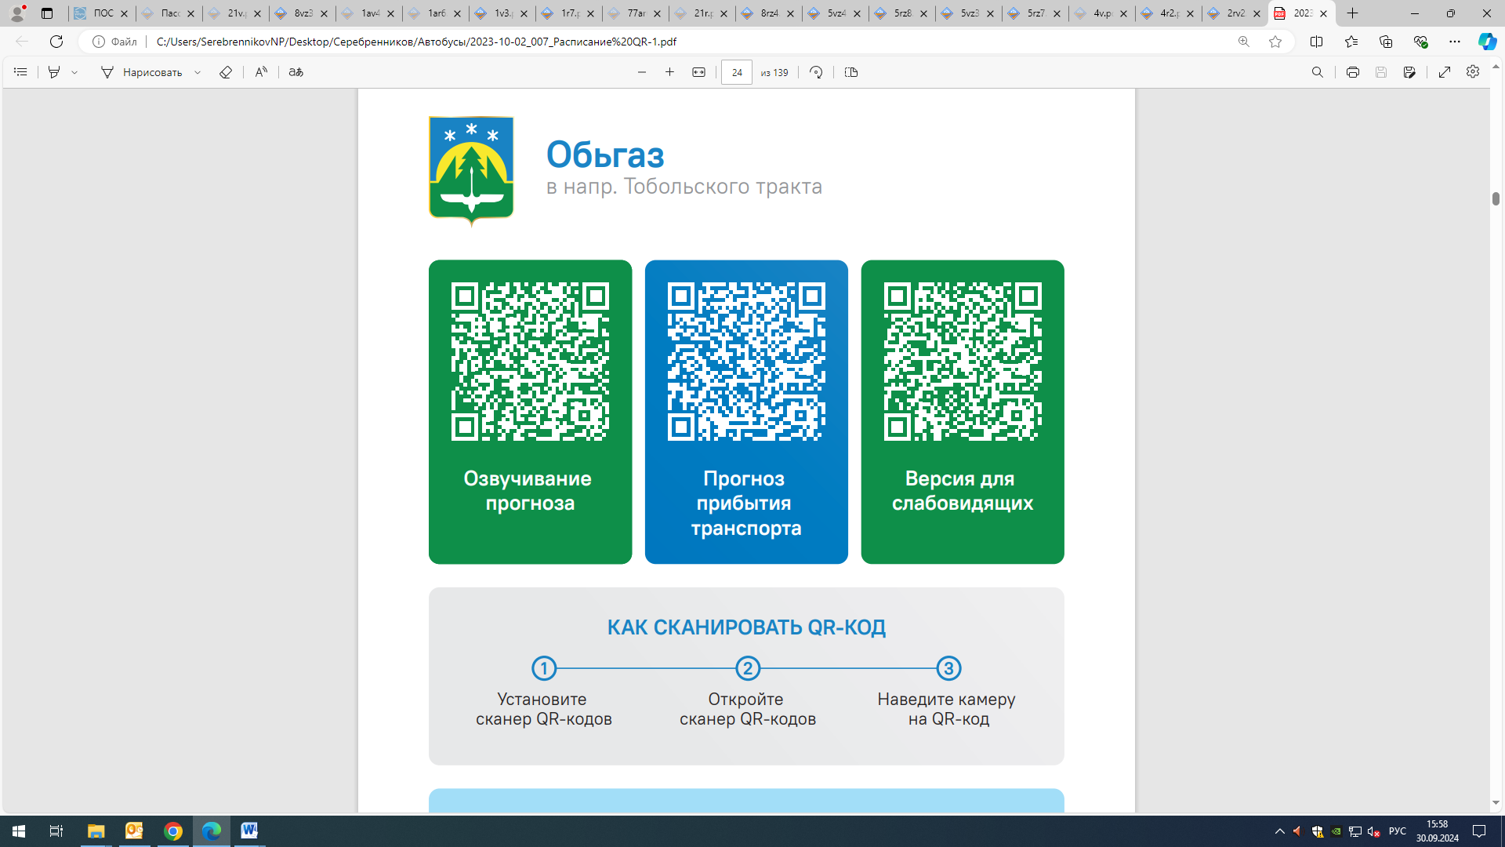



Контроль за осуществлением регулярных перевозок обеспечивает:
- управление транспорта, связи и дорог Администрации города Ханты-Мансийска, г: Ханты-Мансийск, ул Мира, 13, тел: 8 (3467) 39-39-07;
- отдел государственного автодорожного надзора по ХМАО – Югре, г: Ханты-Мансийск, ул: Шевченко 36А, тел: (3467) 32-64-60;
- МО МВД России «Ханты-Мансийский» г: Ханты-Мансийск, ул: Дзержинского дом 11, телефоны дежурной части (3467) 398-104, 398-103, 102 и 112

