  Русский двор |  |  |  |  |  |  |  |  | А
По регулируемым тарифам
Номер маршрута | Конечный остановочный пункт | ДНИ | Время начала и окончания движения | Временной график отправления транспортных средств от остановочного пункта
5 | Мкр. Восточный | Будни  с 01.06 по 31.08 | 04:32-23:35 | 4:32, 5:47, 5:57, 6:30, 7:10, 7:30, 8:02, 8:12, 8:32, 8:40, 8:50, 9:00, 9:10, 9:30, 9:55, 10:05, 10:20, 10:30, 10:50, 11:05, 11:20, 11:30, 11:40, 11:50, 12:10, 12:30, 12:50, 13:10, 13:30, 13:50, 14:10, 14:30, 14:50, 15:10, 15:30, 15:50, 16:10, 16:30, 16:50, 17:10, 17:30, 17:50, 18:05, 18:20, 18:35, 18:55, 19:05, 19:20, 19:35, 19:50, 20:05,  20:20, 20:35, 20:50, 21:10, 21:30, 21:50, 22:05, 22:20, 22:50, 23:20, 23:35
 |  | Выходные  с 01.06 по 31.08 | 4:32-0:05 | 4:32, 6:30, 7:10, 7:30, 8:02, 8:32, 8:50, 9:10, 9:30, 9:50, 10:10, 10:30, 10:50, 11:10, 11:30, 11:50, 12:10, 12:30, 12:50, 13:10, 13:30, 13:50, 14:10, 14:30, 14:50, 15:10, 15:30, 15:50, 16:10, 16:30, 16:50, 17:10, 17:30, 17:50, 18:10, 18:30, 18:50, 19:10, 19:30, 19:50, 20:10, 20:30, 20:50, 21:10, 21:30, 21:50, 22:05, 22:30, 22:50, 23:20, 0:05
 |  | Будни  с 01.09 по 31.05 | 4:32-0:35 | 4:32, 5:47, 5:57, 6:30, 7:10, 7:30, 8:02, 8:12, 8:30, 8:40, 8:50, 9:00, 9:10, 9:30, 9:40, 9:55, 10:05, 10:15, 10:30, 10:50, 11:10, 11:30, 11:40, 11:50, 12:10, 12:30, 12:50, 13:10, 13:30, 13:50, 14:05, 14:20, 14:35, 14:50, 15:10, 15:30, 15:50, 16:10, 16:30, 16:50, 17:05, 17:20, 17:35, 17:50, 18:05, 18:20, 18:35, 18:50, 19:05, 19:20, 19:35, 19:50, 20:05, 20:20, 20:35, 20:50, 21:10, 21:30, 21:50, 22:05, 22:20, 22:35, 22:50, 23:05, 23:20, 0:05, 0:20, 0:35
 |  | Выходные с 01.09 по 31.05 | 4:32-0:35 | 4:32, 7:10, 7:30, 8:02, 8:12, 8:32, 8:50, 9:10, 9:30, 9:55, 10:05, 10:15, 10:30, 10:50, 11:05, 11:20, 11:30, 11:40, 11:50, 12:10, 12:30, 12:50, 13:10, 13:30, 13:50, 14:10, 14:30, 14:50, 15:10, 15:30, 15:50, 16:30, 16:30, 16:50,  17:10, 17:30, 17:50, 18:05, 18:20, 18:35, 18:50, 19:05, 19:20, 19:35, 19:50, 20:05, 20:20, 20:35, 20:50, 21:10, 21:30, 21:50, 22:05, 22:20, 22:50, 23:20, 23:35, 0:05, 0:35
По нерегулируемым тарифам
Номер маршрута | Конечный остановочный пункт | ДНИ | Время начала и окончания движения | Интервал отправления транспортных средств от остановочного пункта
9К | Аэропорт |  |  | до 10:00 | 10:00 -11:00 | 11:00 -15:00 | 15:00 -16:00 | 16:00 – 20:00 |  | после 20:00
 |  | Будни | 6:30-22:00 | 15 | 20 | 15 | 20 | 15 |  | 20
 |  | Суббота | 6:30-22:00 | 20 | 25 | 20 | 25 | 20 |  | 25
 |  | Воскресенье | 6:30-21:00 | 20 | 25 | 25 | 25 | 25 |  | 30
Прогноз прибытия пассажирского транспорта
в вашем мобильном телефоне

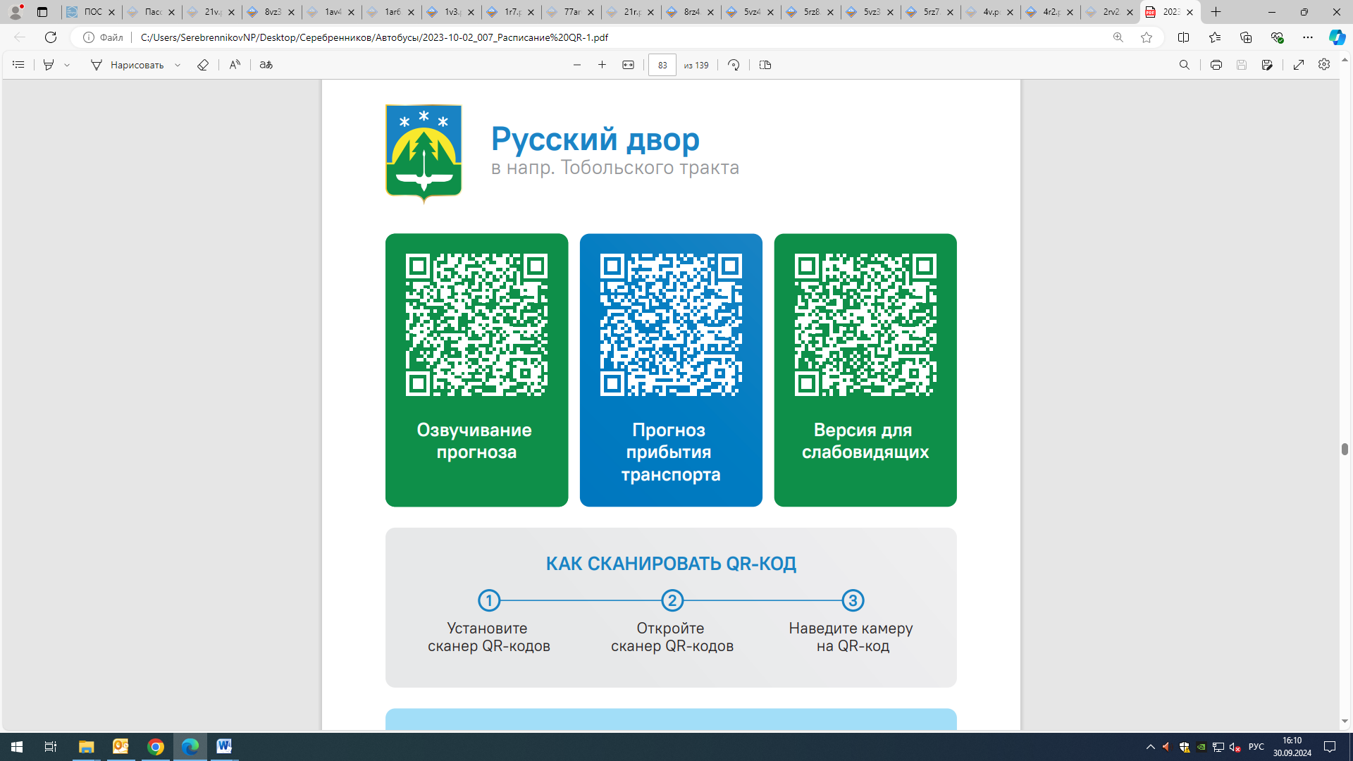



Контроль за осуществлением регулярных перевозок обеспечивает:
- управление транспорта, связи и дорог Администрации города Ханты-Мансийска, г: Ханты-Мансийск, ул Мира, 13, тел: 8 (3467) 39-39-07;
- отдел государственного автодорожного надзора по ХМАО – Югре, г: Ханты-Мансийск, ул: Шевченко 36А, тел: (3467) 32-64-60;
- МО МВД России «Ханты-Мансийский» г: Ханты-Мансийск, ул: Дзержинского дом 11, телефоны дежурной части (3467) 398-104, 398-103, 102 и 112

