  Югорская долина |  |  |  |  | А
По регулируемым тарифам
Номер маршрута | Конечный остановочный пункт | ДНИ | Время начала и окончания движения | Временной график отправления транспортных средств от остановочного пункта
5 | Мкр. Восточный | Будни  с 01.06 по 31.08 | 4:35-23:41 | 4:35, 5:50, 6:00, 6:36, 7:16, 7:36, 8:08, 8:18, 8:38, 8:46, 8:56, 9:06, 9:16, 9:36, 10:01, 10:11, 10:26, 10:36, 10:56, 11:11, 11:26, 11:36, 11:46, 11:56, 12:16, 12:36, 12:56, 13:16, 13:36, 13:56, 14:16, 14:36, 14:56, 15:16, 15:36, 15:56, 16:16, 16:36, 16:56, 17:16, 17:36, 17:56, 18:11, 18:26, 18:41, 19:01, 19:11, 19:26, 19:41, 19:56, 20:11,  20:26, 20:41, 20:56, 21:16, 21:36, 21:56, 22:11, 22:26. 22:56, 23:26, 23:41
 |  | Выходные  с 01.06 по 31.08 | 4:35-0:11 | 4:35, 6:36, 7:16, 7:36, 8:08, 8:38, 8:56, 9:16, 9:36, 9:56, 10:16, 10:36, 10:56, 11:16, 11:36, 11:56, 12:16, 12:36, 12:56, 13:16, 13:36, 13:56, 14:16, 14:36, 14:56, 15:16, 15:36, 15:56, 16:16, 16:36, 16:56, 17:16, 17:36, 17:56, 18:16, 18:36, 18:56, 19:16, 19:36, 19:56, 20:16, 20:36, 20:56, 21:16, 21:36, 21:56, 22:11, 22:36, 22:56, 23:26, 0:11
 |  | Будни  с 01.09 по 31.05 | 4:35-0:41 | 4:35, 5:50, 6:00, 6:36, 7:16, 7:36, 8:08, 8:18, 8:36, 8:46, 8:56, 9:06, 9:16, 9:36, 9:46, 10:01, 10:11, 10:21, 10:36, 10:56, 11:16, 11:36, 11:46, 11:56, 12:16, 12:36, 12:56, 13:16, 13:36, 13:56, 14:11, 14:26, 14:41, 14:56, 15:16, 15:36, 15:56, 16:16, 16:36, 16:56, 17:11, 17:26, 17:41, 17:56, 18:11, 18:26, 18:41, 18:56, 19:11, 19:26, 19:41,  19:56, 20:11, 20:26, 20:41, 20:56, 21:16, 21:36, 21:56, 22:11, 22:26, 22:41, 22:56, 23:11, 23:26, 0:11, 0:26, 0:41
 |  | Выходные с 01.09 по 31.05 | 4:35-0:41 | 4:35, 7:16, 7:36, 8:08, 8:18, 8:38, 8:56, 9:16, 9:36, 10:01, 10:11, 10:21, 10:36, 10:56, 11:11, 11:26, 11:36, 11:46, 11:56, 12:16, 12:36, 12:56, 13:16, 13:36, 13:56, 14:16, 14:36, 14:56, 15:16, 15:36, 15:56, 16:36, 16:36, 16:56,  17:16, 17:36, 17:56, 18:11, 18:26, 18:41, 18:56, 19:11, 19:26, 19:41, 19:56, 20:11, 20:26, 20:41, 20:56, 21:16, 21:36, 21:56, 22:11, 22:26, 22:56, 23:26, 23:41, 0:11, 0:41
Прогноз прибытия пассажирского транспорта
в вашем мобильном телефоне

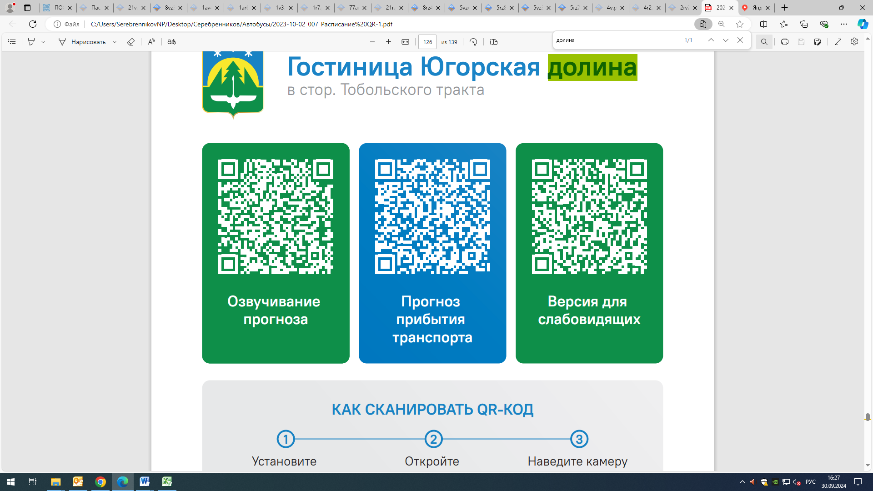
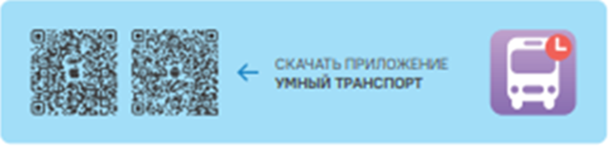


Контроль за осуществлением регулярных перевозок обеспечивает:
- управление транспорта, связи и дорог Администрации города Ханты-Мансийска, г: Ханты-Мансийск, ул Мира, 13, тел: 8 (3467) 39-39-07;
- отдел государственного автодорожного надзора по ХМАО – Югре, г: Ханты-Мансийск, ул: Шевченко 36А, тел: (3467) 32-64-60;
- МО МВД России «Ханты-Мансийский» г: Ханты-Мансийск, ул: Дзержинского дом 11, телефоны дежурной части (3467) 398-104, 398-103, 102 и 112

