  Школа №3 |  |  |  |  |  |  |  |  | А
По регулируемым тарифам
Номер маршрута | Конечный остановочный пункт | ДНИ | Время начала и окончания движения | Временной график отправления транспортных средств от остановочного пункта
4 | мкр. Береговая зона | Будни | 6:35-22:25 | 6:35, 7:05, 7:35, 7:55, 8:20, 8:40, 9:00, 9:20, 9:35, 9:55, 10:40, 11:35, 11:55, 12:35, 13:05, 13:45, 13:55, 14:35, 15:05, 15:55, 16:10, 16:35, 17:00, 17:15, 17:35, 18:05, 18:15, 18:35, 19:00, 19:40, 20:00, 20:20, 20:55, 21:35, 22:25
 |  | Выходные | 6:35-21:35 | 6:35, 7:35, 8:35, 9:35, 10:35, 11:35, 12:35, 13:35, 14:05, 14:35, 15:35, 16:05, 16:35, 17:35, 18:35, 19:35, 20:35, 21:35
5 | Ледовый дворец | Будни  с 01.06 по 31.08 | 5:20-23:45 | 5:20, 5:55, 6:35, 6:45, 7:05, 7:35, 7:55, 8:25, 8:35, 8:45, 9:00, 9:15, 9:35, 9:55, 10:05, 10:15, 10:35, 10:55, 11:15, 11:35, 11:55, 12:15, 12:35, 12:55, 13:15, 13:35, 13:55, 14:15, 14:35, 14:55, 15:15, 15:35, 15:55, 16:15, 16:35, 16:50, 17:05, 17:20, 17:35, 17:50, 18:05, 18:20, 18:35, 18:50, 19:05, 19:20, 19:35, 19:55, 20:15, 20:35, 20:50, 21:15, 21:35, 21:50, 22:05, 22:35, 23:05, 23:45
 |  | Выходные  с 01.06 по 31.08 | 5:20-23:45 | 5:20, 5:55, 6:35, 7:05, 7:35, 7:55, 8:35, 8:55, 9:15, 9:35, 9:55, 10:15, 10:35, 10:55, 11:15, 11:35, 11:55, 12:15, 12:35, 12:55, 13:15, 13:35, 13:55, 14:15, 14:35, 14:55, 15:15, 15:35, 15:55, 16:15, 16:35, 16:55, 17:15, 17:35, 17:55, 18:15, 18:35, 18:55, 19:15, 19:35, 19:55, 20:15, 20:35, 20:55, 21:15, 21:35, 21:50, 22:05, 22:35, 23:05, 23:45
 |  | Будни  с 01.09 по 31.05 | 5:20-23:45 | 5:20, 5:55, 6:35, 6:45, 6:55, 7:05, 7:15, 7:25, 7:35, 7:55, 8:05, 8:25, 8:35, 8:45, 9:00, 9:15, 9:35, 9:55, 10:15, 10:35, 10:55, 11:15, 11:35, 11:55, 12:15, 12:35, 12:50, 13:05, 13:20, 13:35, 13:55, 14:15, 14:35, 14:55, 15:15, 15:35, 15:50, 16:05, 16:20, 16:35, 16:50, 17:05, 17:20, 17:35, 17:50, 18:05, 18:20, 18:35, 18:50, 19:05, 19:20, 19:35, 19:55, 20:15, 20:35, 20:50, 21:05, 21:20, 21:35, 21:50, 22:05, 22:35, 23:05, 23:45
 |  | Выходные  с 01.09 по 31.05 | 5:20-23:45 | 5:20, 5:55, 6:35, 6:45, 7:05, 7:35, 7:55, 8:25, 8:35, 8:45, 9:00, 9:15, 9:35, 9:55, 10:05, 10:15, 10:35, 10:55, 11:15, 11:35, 11:55, 12:15, 12:35, 12:55, 13:15, 13:35, 13:55, 14:15, 14:35, 14:55, 15:15, 15:35, 15:55, 16:15, 16:35, 16:50, 17:05, 17:20, 17:35, 17:50, 18:05, 18:20, 18:35, 18:50, 19:05, 19:15, 19:35, 19:55, 20:15, 20:35, 20:50, 21:15, 21:35, 21:50, 22:05, 22:35, 23:05, 23:45
21 | Ключевая | Будни | 7:18-22:48 | 7:18, 7:38, 7:58, 8:18, 8:38, 8:58, 9:18, 9:38, 9:58, 10:28, 10:58, 11:33, 11:58, 12:28, 13:28, 14:03, 15:03, 15:38, 15:58, 16:38, 16:58, 17:18, 17:38, 17:58, 18:18, 18:38, 18:58, 19:18, 19:38, 19:58, 20:18, 20:58, 20:18, 21:58, 22:48
 |  | Выходные | 7:18-22:48 | 7:18, 7:58, 8:58, 9:38, 9:58, 11:33, 12:28, 13:28, 14:03, 15:03, 15:38, 16:38, 17:18, 17:58, 18:18, 18:58, 19:38, 19:58, 21:13, 22:48
77А | Сельхозтехника | Будни | 6:28-21:48 | 6:28, 6:58, 7:28, 7:48, 8:13, 8:33, 8:48, 9:08, 9:28, 9:48, 10:28, 11:08, 11:28, 12:28, 13:08, 14:08, 14:48, 15:48, 16:28, 16:48, 17:08, 17:28, 17:48, 18:08, 18:28, 18:48, 19:08, 19:28, 20:08, 20:28, 21:08, 21:48
 |  | Выходные | 7:28-21:58 | 7:28, 8:28, 9:08, 10:08, 10:48, 11:48, 12:28, 13:28, 14:28, 16:08, 16:28, 17:48, 18:08, 18:28, 19:28, 19:58, 20:28, 21:58
По нерегулируемым тарифам
Номер маршрута | Конечный остановочный пункт | ДНИ | Время начала и окончания движения | Интервал отправления транспортных средств от остановочного пункта
9К | мкр. Береговая зона |  |  | до 10:00 | 10:00 -11:00 | 11:00 -15:00 | 15:00 -16:00 | 16:00 – 20:00 |  | после 20:00
 |  | Будни | 6:30-22:00 | 15 | 20 | 15 | 20 | 15 |  | 20
 |  | Суббота | 6:30-22:00 | 20 | 25 | 20 | 25 | 20 |  | 25
 |  | Воскресенье | 6:30-21:00 | 20 | 25 | 25 | 25 | 25 |  | 30
13К | мкр. Береговая зона |  |  | до 10:00 | 10:00 -11:00 | 11:00 -15:00 | 15:00 -16:00 | 16:00 – 20:00 |  | после 20:00
 |  | Будни | 6:30-22:00 | 15 | 20 | 15 | 20 | 15 |  | 20
 |  | Суббота | 6:30-22:00 | 20 | 25 | 20 | 25 | 20 |  | 25
 |  | Воскресенье | 6:30-21:00 | 20 | 25 | 25 | 25 | 25 |  | 30
  26К | Гимназия №1 |  |  | до 10:00 | 10:00 -11:00 | 11:00 -15:00 | 15:00 -16:00 | 16:00 – 20:00 |  | после 20:00
 |  | Будни | 6:30-22:00 | 15 | 20 | 15 | 20 | 15 |  | 20
 |  | Суббота | 6:30-22:00 | 20 | 25 | 20 | 25 | 20 |  | 25
 |  |   Воскресенье  Прогноз прибытия пассажирского транспорта  в вашем мобильном телефоне | 6:30-21:00 | 20 | 25 | 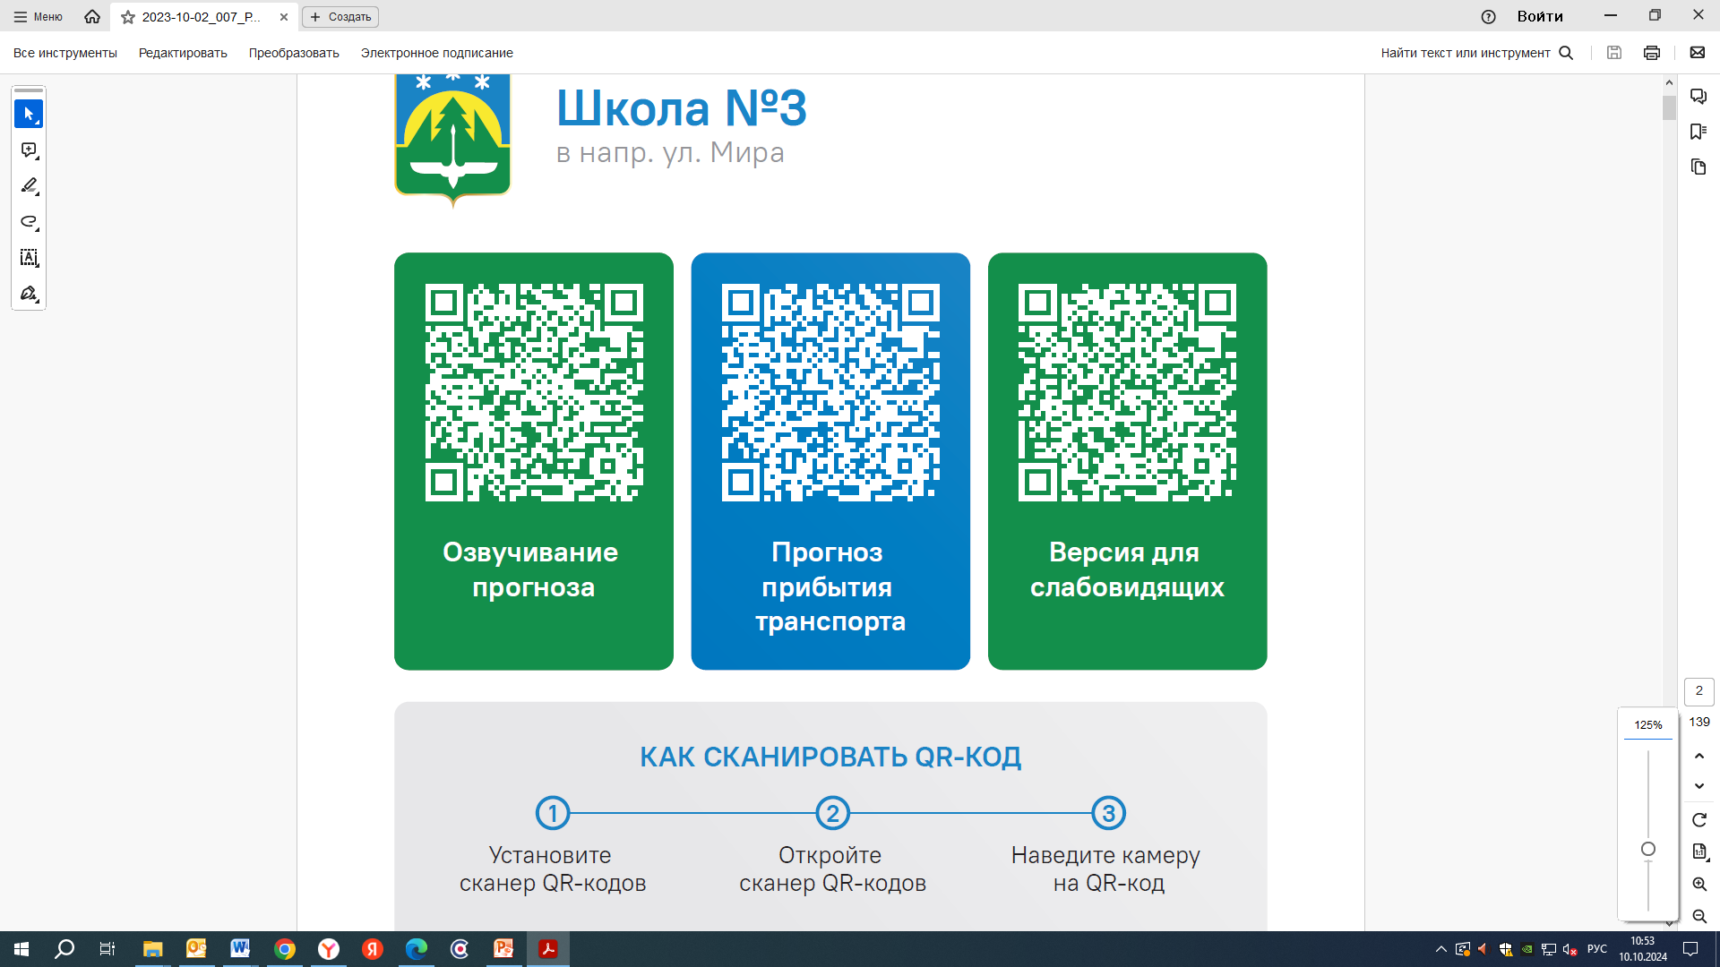  25 | 25 | 25 |  | 30
Контроль за осуществлением регулярных перевозок обеспечивает:
- управление транспорта, связи и дорог Администрации города Ханты-Мансийска, г: Ханты-Мансийск, ул Мира, 13, тел: 8 (3467) 39-39-07;
- отдел государственного автодорожного надзора по ХМАО – Югре, г: Ханты-Мансийск, ул: Шевченко 36А, тел: (3467) 32-64-60;
- МО МВД России «Ханты-Мансийский» г: Ханты-Мансийск, ул: Дзержинского дом 11, телефоны дежур ной части (3467) 398-104, 398-103, 102 и 112

