  Тихая |  |  |  |  |  |  |  |  | А
По регулируемым тарифам
Номер маршрута | Конечный остановочный пункт | ДНИ | Время начала и окончания движения | Временной график отправления транспортных средств от остановочного пункта
1 | ОМК | Будни | 7:05-23:30 | 7:05, 7:50, 8:10, 8:40, 9:03, 9:30, 9:45, 10:25, 11:05, 11:20, 12:05, 13:05, 14:10, 15:10, 15:45, 16:35, 17:35, 18:20, 18:35, 19:20, 20:00, 20:20, 21:00, 21:35, 22:00, 22:35, 23:30
 |  | Выходные | 7:20-22:35 | 7:20, 8:20, 9:00, 10:00, 10:40, 11:40, 12:40, 13:40, 14:20, 15:20, 16:00, 17:00, 17:40, 18:20, 18:40, 19:20, 20:00, 21:00, 21:35, 22:35
1А | ОМК | Будни | 6:30-22:07 | 6:30, 7:17, 8:17, 9:02, 9:37, 9:57, 10:37, 11:47, 12:32, 13:37, 14:17, 15:17, 16:17, 17:37, 18:02, 18:37, 19:32, 19:37, 20:37, 21:07, 21:22, 22:07
 |  | Выходные | 8:02-21:57 | 8:02, 8:37, 9:37, 10:17, 11:17, 11:57, 12:57, 13:57, 14:37, 15:37, 16:27, 17:17, 18:02, 18:27, 18:57, 19:47, 20:17, 21:22, 21:57
4 | ОМК | Будни | 6:56-22:56 | 6:56, 7:16, 7:36, 7:56, 8:21, 8:36, 8:56, 9:16, 9:36, 9:56, 10:16, 10:56, 11:16, 11:56, 12:56, 13:16, 13:56, 14:26, 15:16, 15:56, 16:36, 16:56, 17:16, 17:36, 17:56, 18:16, 18:36, 18:56, 19:21, 19:36, 20:16, 20:56, 21:16, 21:46, 22:16, 22:56
 |  | Выходные | 6:56-22:56 | 6:56, 7:56, 8:56, 9:56, 10:56, 11:56, 12:56, 13:56, 14:56, 15:26, 15:56, 16:56, 17:26, 17:56, 18:56, 19:56, 20:56, 21:56, 22:56
8 | ОМК | Будни | 6:34-23:14 | 6:34, 7:04, 7:39, 8:09, 8:34, 8:44, 9:14, 9:34, 9:59, 10:54, 11:44, 12:44, 13:14, 13:54, 14:24, 15:34, 16:34, 16:49, 17:14, 17:49, 18:14, 18:49, 19:14, 19:54, 20:14, 21:44, 23:14
 |  | Выходные | 7:04-22:54 | 7:04, 8:14, 8:44, 9:14, 9:54, 10:54, 11:44, 12:14, 12:44, 13:14, 14:14, 15:14, 16:14, 17:14, 18:14, 18:59, 19:34, 21:42, 21:44, 22:54
По нерегулируемым тарифам
Номер маршрута | Конечный остановочный пункт | ДНИ | Время начала и окончания движения | Интервал отправления транспортных средств от остановочного пункта
8К | ОМК |  |  | до 10:00 | 10:00 -11:00 | 11:00 -15:00 | 15:00 -16:00 | 16:00 – 20:00 |  | после 20:00
 |  | Будни | 6:30-22:00 | 15 | 20 | 15 | 20 | 15 |  | 20
 |  | Суббота | 6:30-22:00 | 20 | 25 | 20 | 25 | 20 |  | 25
 |  | Воскресенье | 6:30-21:00 | 20 | 25 | 25 | 25 | 25 |  | 30
Прогноз прибытия пассажирского транспорта
в вашем мобильном телефоне

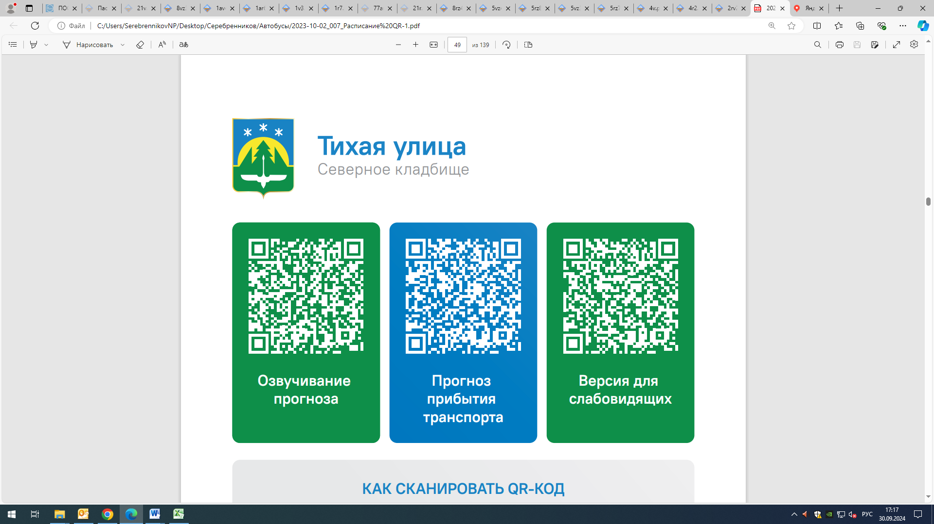



Контроль за осуществлением регулярных перевозок обеспечивает:
- управление транспорта, связи и дорог Администрации города Ханты-Мансийска, г: Ханты-Мансийск, ул Мира, 13, тел: 8 (3467) 39-39-07;
- отдел государственного автодорожного надзора по ХМАО – Югре, г: Ханты-Мансийск, ул: Шевченко 36А, тел: (3467) 32-64-60;
- МО МВД России «Ханты-Мансийский» г: Ханты-Мансийск, ул: Дзержинского дом 11, телефоны дежурной части (3467) 398-104, 398-103, 102 и 112

