  Учхоз |  |  |  |  |  |  |  |  | А
По регулируемым тарифам
Номер маршрута | Конечный остановочный пункт | ДНИ | Время начала и окончания движения | Временной график отправления транспортных средств от остановочного пункта
1 | Автореч-вокзал (по Гагарина) | Будни | 5:52-22:17 | 5:52, 6:37, 6:57, 7:27, 7:50, 8:17, 8:32, 9:12, 9:52, 10:07, 10:52, 11:52, 12:57, 13:57, 14:32, 15:22, 16:22, 17:07, 17:22, 18:07, 18:47, 19:07, 19:47, 20:22, 20:47, 21:22, 22:17
 |  | Выходные | 6:07-21:22 | 6:07, 7:07, 7:47, 8:47, 9:27, 10:27, 11:27, 12:27, 13:07, 14:07, 14:47, 15:47, 16:27, 17:07, 17:27, 18:07, 18:47, 19:47, 20:22, 21:22
1 | ОМК | Будни | 5:38-23:33 | 5:38, 6:23, 7:08, 7:53, 8:13, 8:43, 9:06, 9:33, 9:48, 10:28, 11:08, 11:23, 12:08, 13:08, 14:13, 15:13, 15:48, 16:38, 17:38, 18:23, 18:38, 19:23, 20:03, 20:23, 21:03, 21:38, 22:03, 22:38, 23:33
 |  | Выходные | 5:53-22:38 | 5:53, 6:53, 7:23, 8:23, 9:03, 10:03, 10:43, 11:43, 12:43, 13:43, 14:23, 15:23, 16:03, 17:03, 17:43, 18:23, 18:43, 19:23, 20:03, 21:03, 21:38, 22:38
1А | Автореч-вокзал (по Объездной) | Будни | 6:07-21:32 | 6:07, 7:07, 7:52, 8:27, 8:47, 9:27, 10:37, 11:22, 12:27, 13:07, 14:07, 15:07, 16:27, 16:52, 17:27, 18:22, 18:27, 19:27, 19:57, 20:12, 20:57, 21:32
 |  | Выходные | 6:52-20:47 | 6:52, 7:27, 8:27, 9:07, 10:07, 10:47, 11:47, 12:47, 13:27, 14:27, 15:17, 16:07, 16:52, 17:17, 17:47, 18:37, 19:07, 20:12, 20:47
1А | ОМК | Будни | 6:33-22:10 | 6:33, 7:20, 8:20, 9:05, 9:40, 10:00, 10:40, 11:50, 12:35, 13:40, 14:20, 15:20, 16:20, 17:40, 18:05, 18:40, 19:35, 19:40, 20:40, 21:10, 21:25, 22:10
 |  | Выходные | 8:05-22:00 | 8:05, 8:40, 9:40, 10:20, 11:20, 12:00, 13:00, 14:00, 14:40, 15:40, 16:30, 17:20, 18:05, 18:30, 19:00, 19:50, 20:20, 21:25, 22:00
4 | мкр. Береговая зона | Будни | 6:17-22:07 | 6:17, 6:47, 7:17, 7:37, 8:02, 8:22, 8:42, 9:02, 9:17, 9:37, 10:22, 11:17, 11:37, 12:17, 12:47, 13:27, 13:37, 14:17, 14:47, 15:37, 15:52, 16:17, 16:42, 16:57, 17:17, 17:47, 17:57, 18:17, 18:42, 19:22, 19:42, 20:02, 20:37, 21:17, 22:07
 |  | Выходные | 6:17-21:17 | 6:17, 7:17, 8:17, 9:17, 10:17, 11:17, 12:17, 13:17, 13:47, 14:17, 15:17, 15:47, 16:17, 17:17, 18:17, 19:17, 20:17, 21:17
4 | ОМК | Будни | 6:59-22:59 | 6:59, 7:19, 7:39, 7:59, 8:24, 8:39, 8:59, 9:19, 9:39, 9:59, 10:19, 10:59, 11:19, 11:59, 12:59, 13:19, 13:59, 14:29, 15:19, 15:59, 16:39, 16:59, 17:19, 17:39, 17:59, 18:19, 18:39, 18:59, 19:24, 19:39, 20:19, 20:59, 21:19, 21:49, 22:19, 22:59
 |  | Выходные | 6:59-22:59 | 6:59, 7:59, 8:59, 9:59, 10:59, 11:59, 12:59, 13:59, 14:59, 15:29, 15:59, 16:59, 17:29, 17:59, 18:59, 19:59, 20:59, 21:59, 22:59
8 | Мелиораторов | Будни | 5:57-22:37 | 5:57, 6:27, 7:02, 7:32, 7:57, 8:07, 8:37, 8:57, 9:22, 10:17, 11:07, 12:07, 12:37, 13:17, 13:47, 14:57, 15:57, 16:12, 16:37, 17:12, 17:37, 18:12, 18:37, 19:17, 19:37, 21:07, 22:37
 |  | Выходные | 6:27-22:17 | 6:27, 7:37, 8:07, 8:37, 9:17, 10:17, 11:07, 11:37, 12:07, 12:37, 13:37, 14:37, 15:37, 16:37, 17:37, 18:22, 18:57, 21:05, 21:07, 22:17
8 | ОМК | Будни | 6:37-23:17 | 6:37, 7:07, 7:42, 8:12, 8:37, 8:47, 9:17, 9:37, 10:02, 10:57, 11:47, 12:47, 13:17, 13:57, 14:27, 15:37, 16:37, 16:52, 17:17, 17:52, 18:17, 18:52, 19:17, 19:57, 20:17, 21:47, 23:17
 |  | Выходные | 7:07-22:57 | 7:07, 8:17, 8:47, 9:17, 9:57, 10:57, 11:47, 12:17, 12:47, 13:17, 14:17, 15:17, 16:17, 17:17, 18:17, 19:02, 19:37, 21:45, 21:47, 22:57
По нерегулируемым тарифам
Номер маршрута | Конечный остановочный пункт | ДНИ | Время начала и окончания движения | Интервал отправления транспортных средств от остановочного пункта
8К | ОМК  Гимназия №1 |  |  | до 10:00 | 10:00 -11:00 | 11:00 -15:00 | 15:00 -16:00 | 16:00 – 20:00 |  | после 20:00
 |  | Будни | 6:30-22:00 | 15 | 20 | 15 | 20 | 15 |  | 20
 |  | Суббота | 7:00-22:00 | 20 | 25 | 20 | 25 | 20 |  | 25
 |  | Воскресенье | 7:00-21:00 | 20 | 25 | 25 | 25 | 25 |  | 30
Прогноз прибытия пассажирского транспорта
в вашем мобильном телефоне

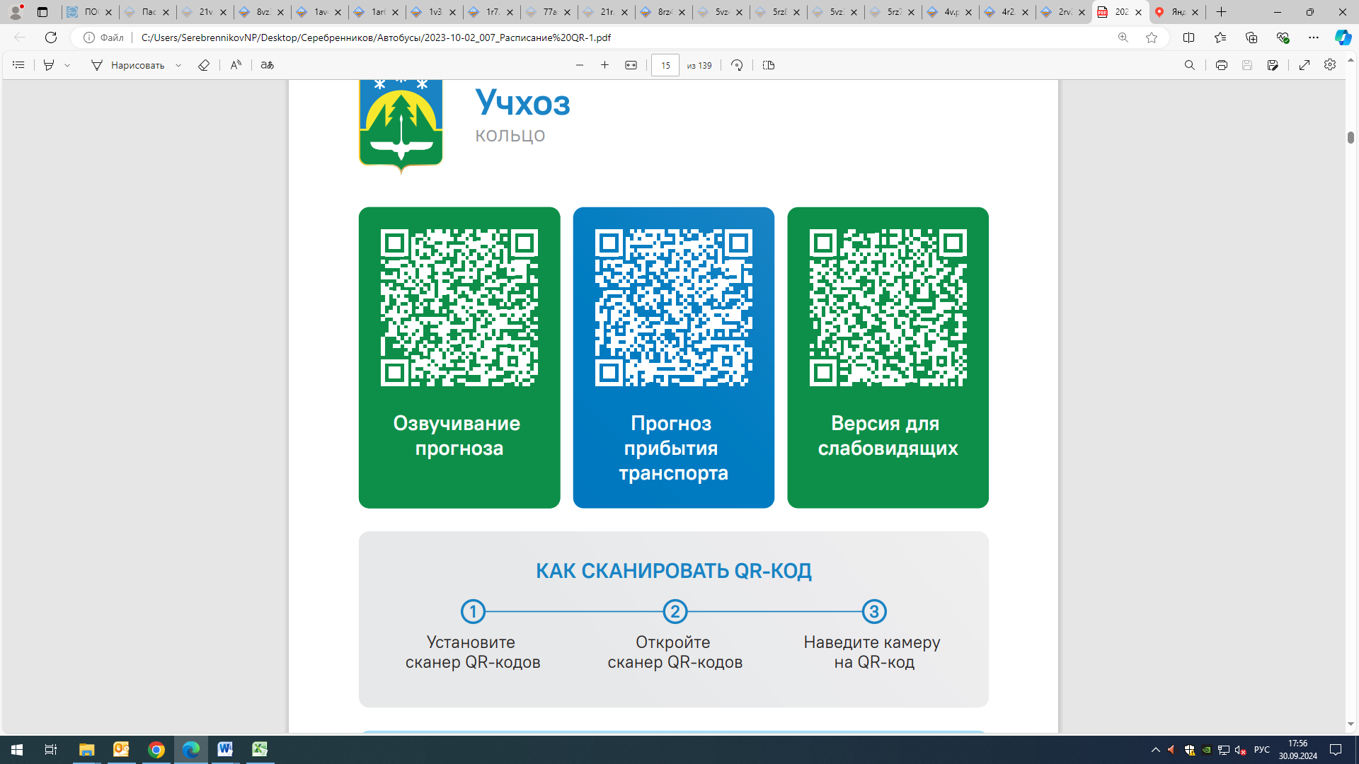



Контроль за осуществлением регулярных перевозок обеспечивает:
- управление транспорта, связи и дорог Администрации города Ханты-Мансийска, г: Ханты-Мансийск, ул. Мира, 13, тел: 8 (3467) 39-39-07;
- отдел государственного автодорожного надзора по ХМАО – Югре, г: Ханты-Мансийск, ул: Шевченко 36А, тел: (3467) 32-64-60;
- МО МВД России «Ханты-Мансийский» г: Ханты-Мансийск, ул: Дзержинского дом 11, телефоны дежурной части (3467) 398-104, 398-103, 102 и 112

