  Уральская |  |  |  |  |  |  |  |  | А
По регулируемым тарифам
Номер маршрута | Конечный остановочный пункт | ДНИ | Время начала и окончания движения | Временной график отправления транспортных средств от остановочного пункта
1 | ОМК | Будни | 5:39-23:34 | 5:39, 6:24, 7:09, 7:54, 8:14, 8:44, 9:07, 9:34, 9:49, 10:29, 11:09, 11:24, 12:09, 13:09, 14:14, 15:14, 15:49, 16:39, 17:39, 18:24, 18:39, 19:24, 20:04, 20:24, 21:04, 21:39, 22:04, 22:39, 23:34
 |  | Выходные | 5:54-22:39 | 5:54, 6:54, 7:24, 8:24, 9:04, 10:04, 10:44, 11:44, 12:44, 13:44, 14:24, 15:24, 16:04, 17:04, 17:44, 18:24, 18:44, 19:24, 20:04, 21:04, 21:39, 22:39
1А | ОМК | Будни | 6:34-22:11 | 6:34, 7:21, 8:21, 9:06, 9:41, 10:01, 10:41, 11:51, 12:36, 13:41, 14:21, 15:21, 16:21, 17:41, 18:06, 18:41, 19:36, 19:41, 20:41, 21:11, 21:26, 22:11
 |  | Выходные | 8:06-22:01 | 8:06, 8:41, 9:41, 10:21, 11:21, 12:01, 13:01, 14:01, 14:41, 15:41, 16:31, 17:21, 18:06, 18:31, 19:01, 19:51, 20:21, 21:26, 22:01
4 | ОМК | Будни | 6:19-22:09 | 6:19, 6:49, 7:19, 7:39, 8:04, 8:24, 8:44, 9:04, 9:19, 9:39, 10:24, 11:19, 11:39, 12:19, 12:49, 13:29, 13:39, 14:19, 14:49, 15:39, 15:54, 16:19, 16:44, 16:59, 17:19, 17:49, 17:59, 18:19, 18:44, 19:24, 19:44, 20:04, 20:39, 21:19, 22:09
 |  | Выходные | 7:00-23:00 | 7:00, 8:00, 9:00, 10:00, 11:00, 12:00, 13:00, 14:00, 15:00, 15:30, 16:00, 17:00, 17:30, 18:00, 19:00, 20:00, 21:00, 22:00, 23:00
8 | ОМК | Будни | 6:37-23:17 | 6:38, 7:08, 7:43, 8:13, 8:38, 8:48, 9:18, 9:38, 10:03, 10:58, 11:48, 12:48, 13:18, 13:58, 14:28, 15:38, 16:38, 16:53, 17:18, 17:53, 18:18, 18:53, 19:18, 19:58, 20:18, 21:48, 23:18
 |  | Выходные | 7:08-22:58 | 7:08, 8:18, 8:48, 9:18, 9:58, 10:58, 11:48, 12:18, 12:48, 13:18, 14:18, 15:18, 16:18, 17:18, 18:18, 19:03, 19:38, 21:46, 21:48, 22:58
По нерегулируемым тарифам
Номер маршрута | Конечный остановочный пункт | ДНИ | Время начала и окончания движения | Интервал отправления транспортных средств от остановочного пункта
8К | ОМК |  |  | до 10:00 | 10:00 -11:00 | 11:00 -15:00 | 15:00 -16:00 | 16:00 – 20:00 |  | после 20:00
 |  | Будни | 6:30-22:00 | 15 | 20 | 15 | 20 | 15 |  | 20
 |  | Суббота | 7:00-22:00 | 20 | 25 | 20 | 25 | 20 |  | 25
 |  | Воскресенье | 7:00-21:00 | 20 | 25 | 25 | 25 | 25 |  | 30
Прогноз прибытия пассажирского транспорта
в вашем мобильном телефоне

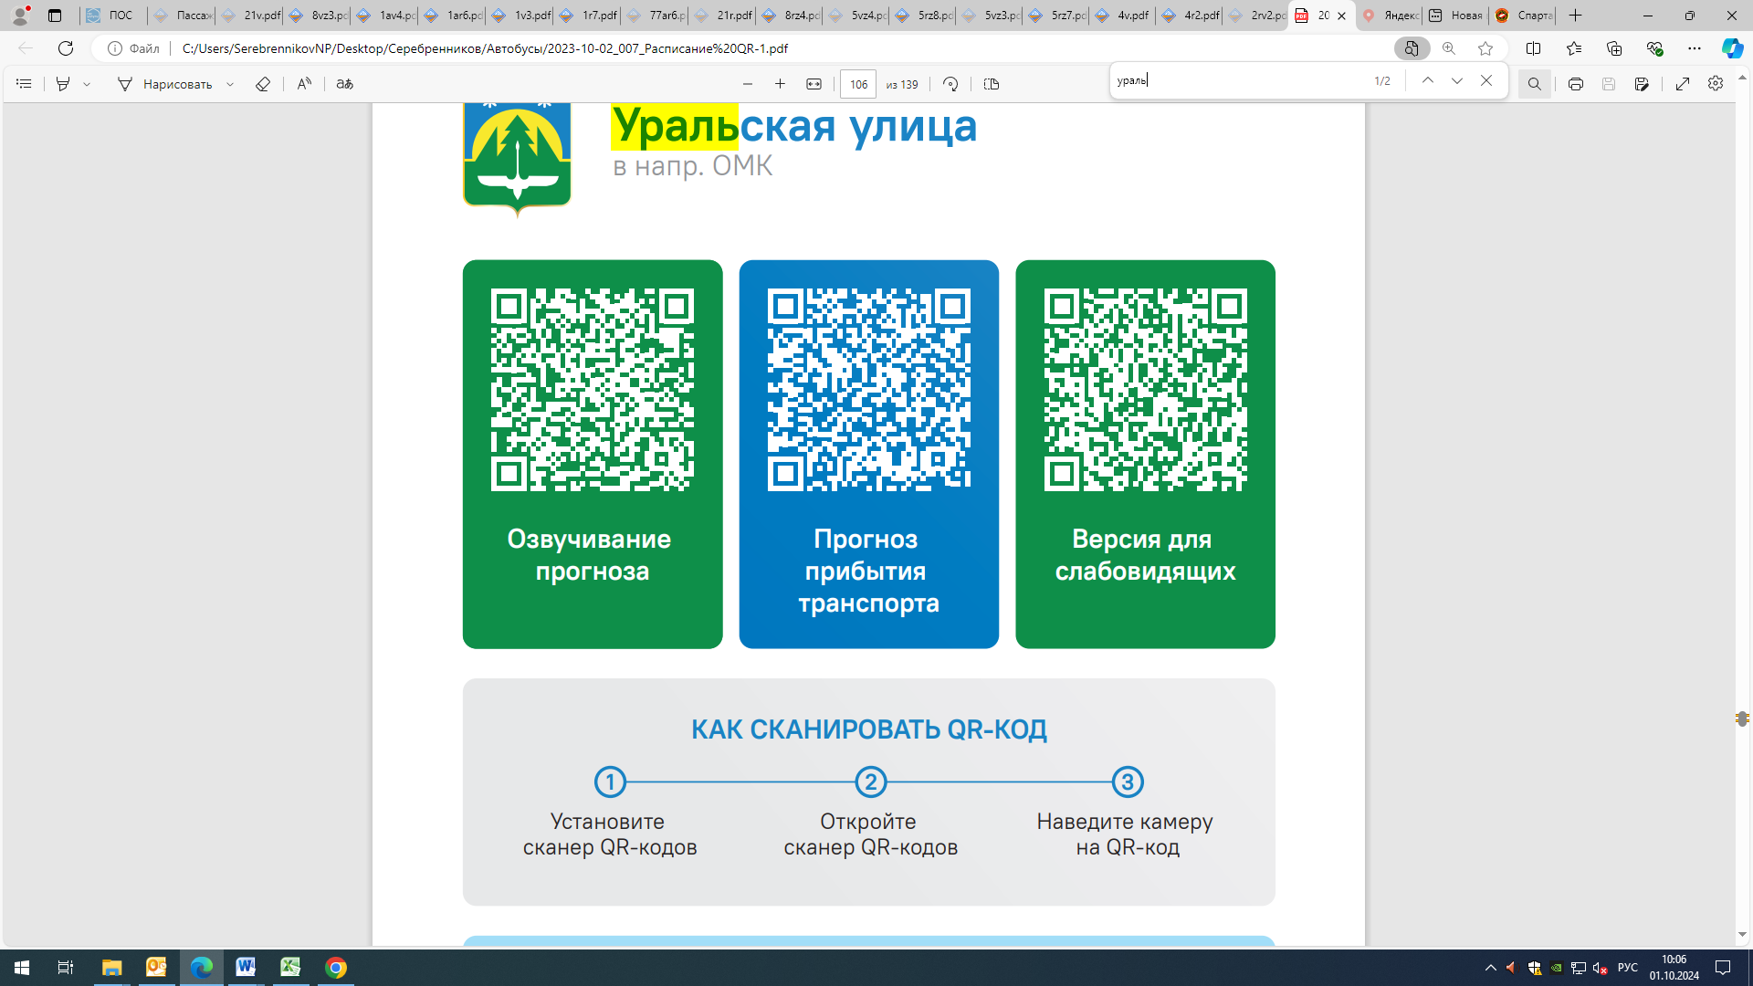



Контроль за осуществлением регулярных перевозок обеспечивает:
- управление транспорта, связи и дорог Администрации города Ханты-Мансийска, г: Ханты-Мансийск, ул. Мира, 13, тел: 8 (3467) 39-39-07;
- отдел государственного автодорожного надзора по ХМАО – Югре, г: Ханты-Мансийск, ул: Шевченко 36А, тел: (3467) 32-64-60;
- МО МВД России «Ханты-Мансийский» г: Ханты-Мансийск, ул: Дзержинского дом 11, телефоны дежурной части (3467) 398-104, 398-103, 102 и 112

