  60 лет Победы |  |  |  |  |  |  |  |  | А
По регулируемым тарифам
Номер маршрута | Конечный остановочный пункт | ДНИ | Время начала и окончания движения | Временной график отправления транспортных средств от остановочного пункта
1 | ОМК | Будни | 5:41-23:37 | 5:41, 6:26, 7:12, 7:57, 8:17, 8:47, 9:10, 9:37, 9:52, 10:32, 11:12, 11:27, 12:12, 13:12, 14:17, 15:17, 15:52, 16:42, 17:42, 18:27, 18:42, 19:27, 20:07, 20:27, 21:07, 21:42, 22:07, 22:42, 23:37
 |  | Выходные | 5:56-22:42 | 5:56, 6:56, 7:27, 8:27, 9:07, 10:07, 10:47, 11:47, 12:47, 13:47, 14:27, 15:27, 16:07, 17:07, 17:47, 18:27, 18:47, 19:27, 20:07, 21:07, 21:42, 22:42
1А | ОМК | Будни | 6:36-22:13 | 6:36, 7:23, 8:23, 9:08, 9:43, 10:03, 10:43, 11:53, 12:38, 13:43, 14:23, 15:23, 16:23, 17:43, 18:08, 18:43, 19:38, 19:43, 20:43, 21:13, 21:28, 22:13
 |  | Выходные | 8:08-22:03 | 8:08, 8:43, 9:43, 10:23, 11:23, 12:03, 13:03, 14:03, 14:43, 15:43, 16:33, 17:23, 18:08, 18:33, 19:03, 19:53, 20:23, 21:28, 22:03
4 | ОМК | Будни | 7:02-23:02 | 7:02, 7:22, 7:42, 8:02, 8:27, 8:42, 9:02, 9:22, 9:42, 10:02, 10:22, 11:02, 11:22, 12:02, 13:02, 13:22, 14:02, 14:32, 15:22, 16:02, 16:42, 17:02, 17:22, 17:42, 18:02, 18:22, 18:42, 19:02, 19:27, 19:42, 20:22, 21:02, 21:22, 21:52, 22:22, 23:02
 |  | Выходные | 7:02-23:02 | 7:02, 8:02, 9:02, 10:02, 11:02, 12:02, 13:02, 14:02, 15:02, 15:32, 16:02, 17:02, 17:32, 18:02, 19:02, 20:02, 21:02, 22:02, 23:02
8 | ОМК | Будни | 6:41-23:21 | 6:41, 7:11, 7:46, 8:16, 8:41, 8:51, 9:21, 9:41, 10:06, 11:01, 11:51, 12:51, 13:21, 14:01, 14:31, 15:41, 16:41, 16:56, 17:21, 17:56, 18:21, 18:56, 19:21, 20:01, 20:21, 21:51, 23:21
 |  | Выходные | 7:11-23:01 | 7:11, 8:21, 8:51, 9:21, 10:01, 11:01, 11:51, 12:21, 12:51, 13:21, 14:21, 15:21, 16:21, 17:21, 18:21, 19:06, 19:41, 21:49, 21:51, 23:01
По нерегулируемым тарифам
Номер маршрута | Конечный остановочный пункт | ДНИ | Время начала и окончания движения | Интервал отправления транспортных средств от остановочного пункта
8К | ОМК |  |  | до 10:00 | 10:00 -11:00 | 11:00 -15:00 | 15:00 -16:00 | 16:00 – 20:00 |  | после 20:00
 |  | Будни | 6:30-22:00 | 15 | 20 | 15 | 20 | 15 |  | 20
 |  | Суббота | 7:00-22:00 | 20 | 25 | 20 | 25 | 20 |  | 25
 |  | Воскресенье | 7:00-21:00 | 20 | 25 | 25 | 25 | 25 |  | 30
Прогноз прибытия пассажирского транспорта
в вашем мобильном телефоне

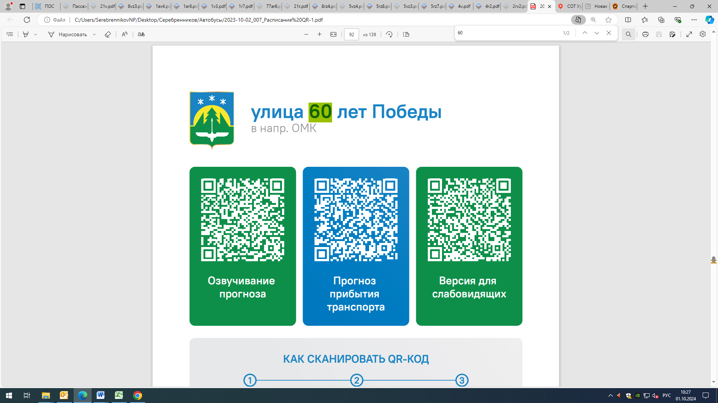



Контроль за осуществлением регулярных перевозок обеспечивает:
- управление транспорта, связи и дорог Администрации города Ханты-Мансийска, г: Ханты-Мансийск, ул. Мира, 13, тел: 8 (3467) 39-39-07;
- отдел государственного автодорожного надзора по ХМАО – Югре, г: Ханты-Мансийск, ул: Шевченко 36А, тел: (3467) 32-64-60;
- МО МВД России «Ханты-Мансийский» г: Ханты-Мансийск, ул: Дзержинского дом 11, телефоны дежурной части (3467) 398-104, 398-103, 102 и 112

