  Школа №1 |  |  |  |  |  |  |  |  | А
По регулируемым тарифам
Номер маршрута | Конечный остановочный пункт | ДНИ | Время начала и окончания движения | Временной график отправления транспортных средств от остановочного пункта
1 | ОМК | Будни | 6:52-23:17 | 6:52, 7:37, 7:57, 8:27, 8:50, 9:17, 9:32, 10:12, 10:52, 11:07, 11:52, 12:52, 13:57, 14:57, 15:32, 16:22, 17:22, 18:07, 18:22, 19:07, 19:47, 20:07, 20:47, 21:22, 21:47, 22:22, 23:17
 |  | Выходные | 7:07-22:22 | 7:07, 8:07, 8:47, 9:47, 10:27, 11:27, 12:27, 13:27, 14:07, 15:07, 15:47, 16:47, 17:27, 18:07, 18:27, 19:07, 19:47, 20:47, 21:22, 22:22
1А | ОМК | Будни | 6:17-21:54 | 6:17, 7:04, 8:04, 8:49, 9:24, 9:44, 10:24, 11:34, 12:19, 13:24, 14:04, 15:04, 16:04, 17:24, 17:49, 18:24, 19:19, 19:24, 20:24, 20:54, 21:09, 21:54
 |  | Выходные | 7:49-21:44 | 7:49, 8:24, 9:24, 10:04, 11:04, 11:44, 12:44, 13:44, 14:24, 15:24, 16:14, 17:04, 17:49, 18:14, 18:44, 19:34, 20:04, 21:09, 21:44
2 | Мелиораторов | ежедневно | 7:11-19:31 | 7:11, 8:19, 9:19, 10:11, 12:11, 13:11, 14:11, 15:11, 17:21, 18:31, 19:31
4 | ОМК | Будни | 6:36-22:36 | 6:36, 6:56, 7:16, 7:36, 8:01, 8:16, 8:36, 8:56, 9:16, 9:36, 9:56, 10:36, 10:56, 11:36, 12:36, 12:56, 13:36, 14:06, 14:56, 15:36, 16:16, 16:36, 16:56, 17:16, 17:36, 17:56, 18:16, 18:36, 19:01, 19:16, 19:56, 20:36, 20:56, 21:26, 21:56, 22:36
 |  | Выходные | 6:36-22:36 | 6:36, 7:36, 8:36, 9:36, 10:36, 11:36, 12:36, 13:36, 14:36, 15:06, 15:36, 16:36, 17:06, 17:36, 18:36, 19:36, 20:36, 21:36, 22:36,
5 | Мкр. Восточный | Будни  с 01.06 по 31.08 | 6:07-23:12 | 6:07, 6:47, 7:07, 7:39, 7:49, 8:09, 8:17, 8:27, 8:37, 8:47, 9:07, 9:32, 9:42, 9:57, 10:07, 10:27, 10:42, 10:57, 11:07, 11:17, 11:27, 11:47, 12:07, 12:27, 12:47, 13:07, 13:27, 13:47, 14:07, 14:27, 14:47, 15:07, 15:27, 15:47,  16:07, 16:27, 16:47, 17:07, 17:27, 17:42, 17:57, 18:12, 18:32, 18:42, 18:57, 19:12, 19:27, 19:42, 19:57, 20:12, 20:27, 20:47, 21:07, 21:27, 21:42, 21:57, 22:27, 22:57, 23:12
 |  | Выходные  с 01.06 по 31.08 | 6:07-23:42 | 6:07, 6:47, 7:07, 7:39, 8:09, 8:27, 8:47, 9:07, 9:27, 9:47, 10:07, 10:27, 10:47, 11:07, 11:27, 11:47, 12:07, 12:27, 12:47, 13:07, 13:27, 13:47, 14:07, 14:27, 14:47, 15:07, 15:27, 15:47, 16:07, 16:27, 16:47, 17:07,  17:27, 17:47, 18:07, 18:27, 18:47, 19:07, 19:27, 19:47, 20:07, 20:27, 20:47, 21:07, 21:27, 21:42, 22:07, 22:27,  22:57, 23:42
 |  | Будни  с 01.09 по 31.05 | 6:07-00:12 | 6:07, 6:47, 7:07, 7:39, 7:49, 8:07, 8:17, 8:27, 8:37, 8:47, 9:07, 9:17, 9:32, 9:42, 9:52, 10:07, 10:27, 10:47, 11:07, 11:17, 11:27, 11:47, 12:07, 12:27, 12:47, 13:07, 13:27, 13:42, 13:57, 14:12, 14:27, 14:47, 15:07, 15:27,  15:47, 16:07, 16:27, 16:42, 16:57, 17:12, 17:27, 17:42, 17:57, 18:12, 18:27, 18:42, 18:57, 19:12, 19:27, 19:42, 19:57, 20:12, 20:27, 20:47, 21:07, 21:27, 21:42, 21:57, 22:12, 22:27, 22:42, 22:57, 23:42, 23:57, 0:12
 |  | Выходные с 01.09 по 31.05 | 6:47-00:12 | 6:47, 7:07, 7:39, 7:49, 8:09, 8:27, 8:47, 9:07, 9:32, 9:42, 9:52, 10:07, 10:27, 10:42, 10:57, 11:07, 11:17,  11:27, 11:47, 12:07, 12:27, 12:47, 13:07, 13:27, 13:47, 14:07, 14:27, 14:47, 15:07, 15:27, 16:07, 16:07, 16:27, 16:47, 17:07, 17:27, 17:42, 17:57, 18:12, 18:27, 18:42, 18:57, 19:12, 19:27, 19:42, 19:57, 20:12, 20:27, 20:47, 21:07, 21:27, 21:42, 21:57, 22:27, 22:57, 23:12, 23:42, 0:12
8 | ОМК | Будни | 6:21-23:01 | 6:21, 6:51, 7:26, 7:56, 8:21, 8:31, 9:01, 9:21, 9:46, 10:41, 11:31, 12:31, 13:01, 13:41, 14:11, 15:21, 16:21, 16:36, 17:01, 17:36, 18:01, 18:36, 19:01, 19:41, 20:01, 21:31, 23:01
 |  | Выходные | 6:51-22:41 | 6:51, 8:01, 8:31, 9:01, 9:41, 10:41, 11:31, 12:01, 12:31, 13:01, 14:01, 15:01, 16:01, 17:01, 18:01, 18:46, 19:21, 21:29, 21:31, 22:41
21 | Теннисный центр | Будни | 6:42-22:12 | 6:42, 7:02, 7:22, 7:42, 8:02, 8:22, 8:42, 9:02, 9:22, 9:52, 10:22, 10:57, 11:22, 11:52, 12:52, 13:27, 14:27, 15:02, 15:22, 16:02, 16:22, 16:42, 17:02, 17:22, 17:42, 18:02, 18:22, 18:42, 19:02, 19:22, 19:42, 20:22, 20:37, 21:22, 22:12
 |  | Выходные | 7:39-22:12 | 7:47, 8:17, 8:37, 9:14, 9:47, 10:37, 11:12, 12:02, 13:07, 14:02, 14:34, 15:37, 16:17, 17:07, 17:37, 18:07, 18:39, 19:02, 19:32, 20:07, 20:47, 21:12, 22:12
77 | Сельхозтехника | Будни | 7:42-22:12 | 7:42, 8:27, 8:37, 9:14, 9:42, 10:37, 11:12, 12:02, 13:27, 14:09, 14:54, 15:47, 16:17, 17:07, 17:47, 18:17, 18:52,  19:02, 19:57, 20:07, 20:57, 21:12, 22:12
 |  | Выходные | 7:42-22:12 | 7:47, 8:17, 8:37, 9:14, 9:47, 10:37, 11:12, 12:02, 13:07, 14:02, 14:34, 15:37, 16:17, 17:07, 17:37, 18:07, 18:39,  19:02, 19:32, 20:07, 20:47, 21:12, 22:12
77А | Районная поликлиника | Будни | 6:38-21:38 | 6:38, 6:58, 7:28, 7:58, 8:18, 8:43, 9:03, 9:18, 9:38, 9:58, 10:18, 10:58, 11:58, 12:58, 13:38, 14:38, 15:18, 16:18, 16:58, 17:18, 17:38, 17:58, 18:18, 18:38, 18:58, 19:18, 19:38, 19:58, 20:38, 20:58, 21:38
 |  | Выходные | 7:58-22:28 | 7:58, 8:58, 9:38, 10:38, 11:18, 12:18, 12:58, 13:58, 14:58, 16:38, 16:58, 18:18, 18:38, 18:58, 19:58, 20:28, 20:58, 22:28
По нерегулируемым тарифам
Номер маршрута | Конечный остановочный пункт | ДНИ | Время начала и окончания движения | Интервал отправления транспортных средств от остановочного пункта
7К | Назымская экспедиция |  |  | до 10:00 | 10:00 -11:00 | 11:00 -15:00 | 15:00 -16:00 | 16:00 – 20:00 |  | после 20:00
 |  | Будни | 6:30-22:00 | 15 | 20 | 15 | 20 | 15 |  | 20
 |  | Суббота | 6:30-22:00 | 20 | 25 | 20 | 25 | 20 |  | 25
 |  | Воскресенье | 6:30-21:00 | 20 | 25 | 25 | 25 | 25 |  | 30
8К | ОМК |  |  | до 10:00 | 10:00 -11:00 | 11:00 -15:00 | 15:00 -16:00 | 16:00 – 20:00 |  | после 20:00
 |  | Будни | 6:30-22:00 | 15 | 20 | 15 | 20 | 15 |  | 20
 |  | Суббота | 6:30-22:00 | 20 | 25 | 20 | 25 | 20 |  | 25
 |  | Воскресенье | 6:30-21:00 | 20 | 25 | 25 | 25 | 25 |  | 30
9К | Аэропорт |  |  | до 10:00 | 10:00 -11:00 | 11:00 -15:00 | 15:00 -16:00 | 16:00 – 20:00 |  | после 20:00
 |  | Будни | 6:30-22:00 | 15 | 20 | 15 | 20 | 15 |  | 20
 |  | Суббота | 6:30-22:00 | 20 | 25 | 20 | 25 | 20 |  | 25
 |  | Воскресенье | 6:30-21:00 | 20 | 25 | 25 | 25 | 25 |  | 30
26К | Теннисный центр |  |  | до 10:00 | 10:00 -11:00 | 11:00 -15:00 | 15:00 -16:00 | 16:00 – 20:00 |  | после 20:00
 |  | Будни | 6:30-22:00 | 15 | 20 | 15 | 20 | 15 |  | 20
 |  | Суббота | 6:30-22:00 | 20 | 25 | 20 | 25 | 20 |  | 25
 |  | Воскресенье | 6:30-21:00 | 20 | 25 | 25 | 25 | 25 |  | 30
Прогноз прибытия пассажирского транспорта
в вашем мобильном телефоне
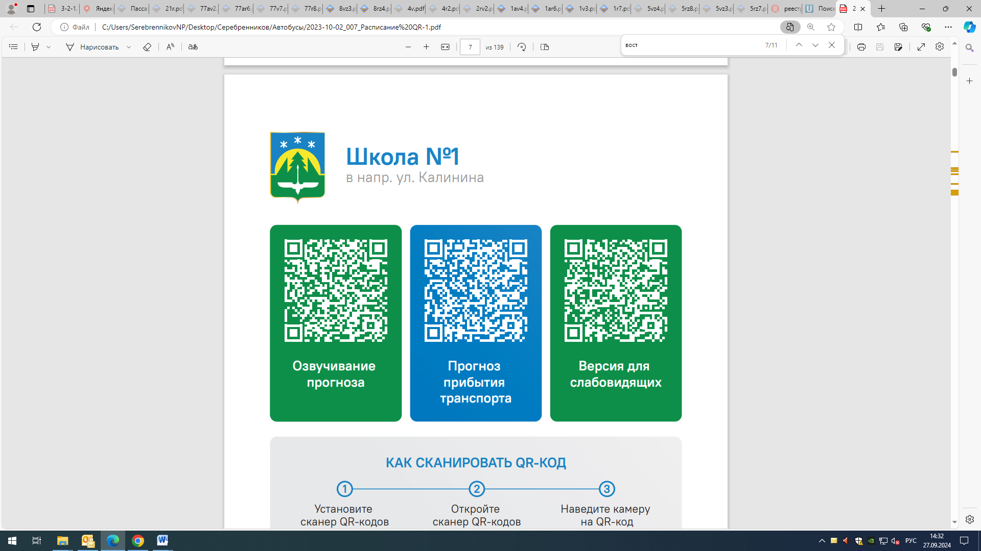



Контроль за осуществлением регулярных перевозок обеспечивает:
- управление транспорта, связи и дорог Администрации города Ханты-Мансийска, г: Ханты-Мансийск, ул Мира, 13, тел: 8 (3467) 39-39-07;
- отдел государственного автодорожного надзора по ХМАО – Югре, г: Ханты-Мансийск, ул: Шевченко 36А, тел: (3467) 32-64-60;
- МО МВД России «Ханты-Мансийский» г: Ханты-Мансийск, ул: Дзержинского дом 11, телефоны дежурной части 8 (3467) 398-104, 398-103, 102 и 112

