  Школа №7 |  |  |  |  |  |  |  |  | А
По регулируемым тарифам
Номер маршрута | Конечный остановочный пункт | ДНИ | Время начала и окончания движения | Временной график отправления транспортных средств от остановочного пункта
4 | мкр. Береговая зона | Будни | 6:28-22:18 | 6:28, 6:58, 7:28, 7:48, 8:13, 8:33, 8:53, 9:13, 9:28, 9:48, 10:33, 11:28, 11:48, 12:28, 12:58, 13:38, 13:48, 14:28, 14:58, 15:48, 16:03, 16:28, 16:53, 17:08, 17:28, 17:58, 18:08, 18:28, 18:53, 19:33, 19:53, 20:13, 20:48, 21:28, 22:18
 |  | Выходные | 6:28-21:28 | 6:28, 7:28, 8:28, 9:28, 10:28, 11:28, 12:28, 13:28, 13:58, 14:28, 15:28, 15:58, 16:28, 17:28, 18:28, 19:28, 20:28, 21:28
5 | Ледовый дворец | Будни  с 01.06 по 31.08 | 5:13-23:38 | 5:13, 5:48, 6:28, 6:38, 6:58, 7:28, 7:48, 8:18, 8:28, 8:38, 8:53, 9:08, 9:28, 9:48, 9:58, 10:08, 10:28, 10:48, 11:08, 11:28, 11:48, 12:08, 12:28, 12:48, 13:08, 13:28, 13:48, 14:08, 14:28, 14:48, 15:08, 15:28, 15:48, 16:08, 16:28, 16:43, 16:58, 17:13, 17:28, 17:43, 17:58, 18:13, 18:28, 18:43, 18:58, 19:13, 19:28, 19:48, 20:08, 20:28, 20:43, 21:08, 21:28, 21:43, 21:58, 22:28, 22:58, 23:38
 |  | Выходные  с 01.06 по 31.08 | 5:13-23:38 | 5:13, 5:48, 6:28, 6:58, 7:28, 7:48, 8:28, 8:48, 9:08, 9:28, 9:48, 10:08, 10:28, 10:48, 11:08, 11:28, 11:48, 12:08, 12:28, 12:48, 13:08, 13:28, 13:48, 14:08, 14:28, 14:48, 15:08, 15:28, 15:48, 16:08, 16:28, 16:48, 17:08, 17:28, 17:48, 18:08, 18:28, 18:48, 19:08, 19:28, 19:48, 20:08, 20:28, 20:48, 21:08, 21:28, 21:43, 21:58, 22:28, 22:58, 23:38
 |  | Будни  с 01.09 по 31.05 | 5:13-23:38 | 5:13, 5:48, 6:28, 6:38, 6:48, 6:58, 7:08, 7:18, 7:28, 7:48, 7:58, 8:18, 8:28, 8:38, 8:53, 9:08, 9:28, 9:48, 10:08, 10:28, 10:48, 11:08, 11:28, 11:48, 12:08, 12:28, 12:43, 12:58, 13:13, 13:28, 13:48, 14:08, 14:28, 14:48, 15:08, 15:28, 15:43, 15:58, 16:13, 16:28, 16:43, 16:58, 17:13, 17:28, 17:43, 17:58, 18:13, 18:28, 18:43, 18:58, 19:13, 19:28, 19:48, 20:08, 20:28, 20:43, 20:58, 21:13, 21:28, 21:43, 21:58, 22:28, 22:58, 23:38
 |  | Выходные  с 01.09 по 31.05 | 5:13-23:38 | 5:13, 5:48, 6:28, 6:38, 6:58, 7:28, 7:48, 8:18, 8:28, 8:38, 8:53, 9:08, 9:28, 9:48, 9:58, 10:08, 10:28, 10:48, 11:08, 11:28, 11:48, 12:08, 12:28, 12:48, 13:08, 13:28, 13:48, 14:08, 14:28, 14:48, 15:08, 15:28, 15:48, 16:08, 16:28, 16:43, 16:58, 17:13, 17:28, 17:43, 17:58, 18:13, 18:28, 18:43, 18:58, 19:08, 19:28, 19:48, 20:08, 20:28, 20:43, 21:08, 21:28, 21:43, 21:58, 22:28, 22:58, 23:38
8 | ОМК | Будни | 6:09-22:49 | 6:09, 6:39, 7:14, 7:44, 8:09, 8:19, 8:49, 9:09, 9:34, 10:29, 11:19, 12:19, 12:49, 13:29, 13:59, 15:09, 16:09, 16:24, 16:49, 17:24, 17:49, 18:24, 18:49, 19:29, 19:49, 21:19, 22:49
 |  | Выходные | 6:39-22:29 | 6:39, 7:49, 8:19, 8:49, 9:29, 10:29, 11:19, 11:49, 12:19, 12:49, 13:49, 14:49, 15:49, 16:49, 17:49, 18:34, 19:09, 21:17, 21:19, 22:29
21 | Ключевая | Будни | 7:12-22:44 | 7:12, 7:32, 7:52, 8:12, 8:32, 8:52, 9:12, 9:32, 9:52, 10:22, 10:52, 11:27, 11:52, 12:22, 13:22, 13:57, 14:57, 15:32, 15:52, 16:32, 16:52, 17:12, 17:32, 17:52, 18:12, 18:32, 18:52, 19:12, 19:32, 19:52, 20:12, 20:52, 20:12, 21:52, 22:42
 |  | Выходные | 7:12-22:42 | 7:12, 7:52, 8:52, 9:32, 9:52, 11:27, 12:22, 13:22, 13:57, 14:57, 15:32, 16:32, 17:12, 17:52, 18:12, 18:52, 19:32, 19:52, 21:07, 22:42
По нерегулируемым тарифам
Номер маршрута | Конечный остановочный пункт | ДНИ | Время начала и окончания движения | Интервал отправления транспортных средств от остановочного пункта
7К | ТД «Сатурн» |  |  | до 10:00 | 10:00 -11:00 | 11:00 -15:00 | 15:00 -16:00 | 16:00 – 20:00 |  | после 20:00
 |  | Будни | 6:30-22:00 | 15 | 20 | 15 | 20 | 15 |  | 20
 |  | Суббота | 6:30-22:00 | 20 | 25 | 20 | 25 | 20 |  | 25
 |  | Воскресенье | 6:30-21:00 | 20 | 25 | 25 | 25 | 25 |  | 30
9К | мкр. Береговая зона |  |  | до 10:00 | 10:00 -11:00 | 11:00 -15:00 | 15:00 -16:00 | 16:00 – 20:00 |  | после 20:00
 |  | Будни | 6:30-22:00 | 15 | 20 | 15 | 20 | 15 |  | 20
 |  | Суббота | 6:30-22:00 | 20 | 25 | 20 | 25 | 20 |  | 25
 |  | Воскресенье | 6:30-21:00 | 20 | 25 | 25 | 25 | 25 |  | 30
13К | мкр. Береговая зона |  |  | до 10:00 | 10:00 -11:00 | 11:00 -15:00 | 15:00 -16:00 | 16:00 – 20:00 |  | после 20:00
 |  | Будни | 6:30-22:00 | 15 | 20 | 15 | 20 | 15 |  | 20
 |  | Суббота | 6:30-22:00 | 20 | 25 | 20 | 25 | 20 |  | 25
 |  | Воскресенье | 6:30-21:00 | 20 | 25 | 25 | 25 | 25 |  | 30
  26К | Гимназия №1 |  |  | до 10:00 | 10:00 -11:00 | 11:00 -15:00 | 15:00 -16:00 | 16:00 – 20:00 |  | после 20:00
 |  | Будни | 6:30-22:00 | 15 | 20 | 15 | 20 | 15 |  | 20
 |  | Суббота | 6:30-22:00 | 20 | 25 | 20 | 25 | 20 |  | 25
 |  |   Воскресенье  Прогноз прибытия пассажирского транспорта  в вашем мобильном телефоне | 6:30-21:00 | 20 | 25 | 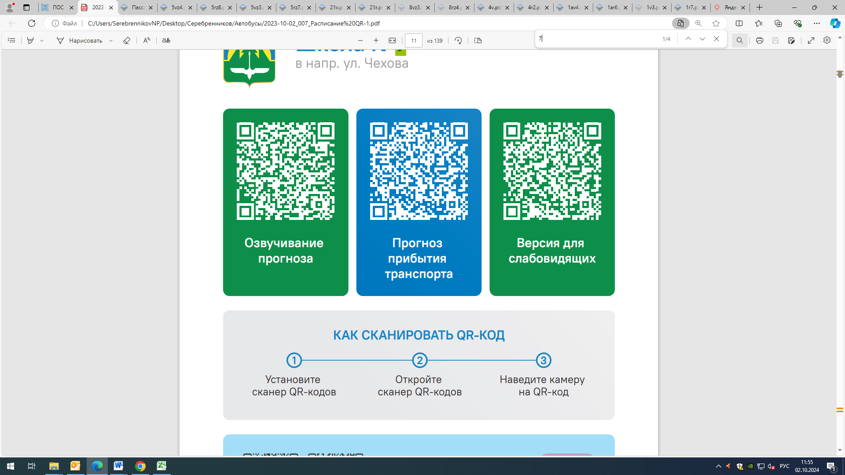  25 | 25 | 25 |  | 30
Контроль за осуществлением регулярных перевозок обеспечивает:
- управление транспорта, связи и дорог Администрации города Ханты-Мансийска, г: Ханты-Мансийск, ул Мира, 13, тел: 8 (3467) 39-39-07;
- отдел государственного автодорожного надзора по ХМАО – Югре, г: Ханты-Мансийск, ул: Шевченко 36А, тел: (3467) 32-64-60;
- МО МВД России «Ханты-Мансийский» г: Ханты-Мансийск, ул: Дзержинского дом 11, телефоны дежур ной части (3467) 398-104, 398-103, 102 и 112

