  Теннисный центр |  |  |  |  |  |  |  |  |  |  | А
По регулируемым тарифам
Номер маршрута | Конечный остановочный пункт | ДНИ | Время начала и окончания движения |  | Временной график отправления транспортных средств от остановочного пункта
1 | Авторечвокзал (по Гагарина) | Будни | 5:58-22:23 |  | 5:58, 6:43, 7:03, 7:33, 7:56, 8:23, 8:38, 9:18, 9:58, 10:13, 10:58, 11:58, 13:03, 14:03, 14:38, 15:28, 16:28, 17:13, 17:28, 18:13, 18:53, 19:13, 19:53, 20:28, 20:53, 21:28, 22:23
 |  | Выходные | 6:13-21:28 |  | 6:13, 7:13, 7:53, 8:53, 9:33, 10:33, 11:33, 12:33, 13:13, 14:13, 14:53, 15:53, 16:33, 17:13, 17:33, 18:13, 18:53, 19:53, 20:28, 21:28
1А | Авторечвокзал (по Объездной) | Будни | 6:13-21:38 |  | 6:13, 7:13, 7:58, 8:33, 8:53, 9:33, 10:43, 11:28, 12:33, 13:13, 14:13, 15:13, 16:33, 16:58, 17:33, 18:28, 18:33, 19:33, 20:03, 20:18, 21:03, 21:38
 |  | Выходные | 6:58-20:53 |  | 6:58, 7:33, 8:33, 9:13, 10:13, 10:53, 11:53, 12:53, 13:33, 14:33, 15:23, 16:13, 16:58, 17:23, 17:53, 18:43, 19:13, 20:18, 20:53
4 | мкр. Береговая зона | Будни | 6:23-22:13 |  | 6:23, 6:53, 7:23, 7:43, 8:08, 8:28, 8:48, 9:08, 9:23, 9:43, 10:28, 11:23, 11:43, 12:23, 12:53, 13:33, 13:43, 14:23, 14:53, 15:43, 15:58, 16:23, 16:48, 17:03, 17:23, 17:53, 18:03, 18:23, 18:48, 19:28, 19:48, 20:08, 20:43, 21:23, 22:13
 |  | Выходные | 6:23-21:23 |  | 6:23, 7:23, 8:23, 9:23, 10:23, 11:23, 12:23, 13:23, 13:53, 14:23, 15:23, 15:53, 16:23, 17:23, 18:23, 19:23, 20:23, 21:23
8 | Мелиораторов | Будни | 6:03-22:43 |  | 6:03, 6:33, 7:08, 7:38, 8:03, 8:13, 8:43, 9:03, 9:28, 10:23, 11:13, 12:13, 12:43, 13:23, 13:53, 15:03, 16:03, 16:18, 16:43, 17:18, 17:43, 18:18, 18:43, 19:23, 19:43, 21:13, 22:43
 |  | Выходные | 6:33-22:23 |  | 6:33, 7:43, 8:13, 8:43, 9:23, 10:23, 11:13, 11:43, 12:13, 12:43, 13:43, 14:43, 15:43, 16:43, 17:43, 18:28, 19:03, 21:11, 21:13, 22:23
21 | Ключевая | Будни | 7:05-22:35 |  | 7:05, 7:25, 7:45, 8:05, 8:25, 8:45, 9:05, 9:25, 9:45, 10:15, 10:45, 11:20, 11:45, 12:15, 13:15, 13:50, 14:50, 15:25, 15:45, 16:25, 16:45, 17:05, 17:25, 17:45, 18:05, 18:25, 18:45, 19:05, 19:25, 19:45, 20:05, 20:45, 20:05, 21:45, 22:35
 |  | Выходные | 7:05-22:35 |  | 7:05, 7:45, 8:45, 9:25, 9:45, 11:20, 12:15, 13:15, 13:50, 14:50, 15:25, 16:25, 17:05, 17:45, 18:05, 18:45, 19:25, 19:45, 21:00, 22:35
По нерегулируемым тарифам
Номер маршрута | Конечный остановочный пункт | ДНИ |  | Время начала и окончания движения |  | Интервал отправления транспортных средств от остановочного пункта
8К | Гимназия №1 |  |  |  |  | до 10:00 | 10:00 -11:00 | 11:00 -15:00 | 15:00 -16:00 | 16:00 – 20:00 |  | после 20:00
 |  | Будни |  | 6:30-22:00 |  | 15 | 20 | 15 | 20 | 15 |  | 20
 |  | Суббота |  | 6:30-22:00 |  | 20 | 25 | 20 | 25 | 20 |  | 25
 |  | Воскресенье |  | 6:30-21:00 |  | 20 | 25 | 25 | 25 | 25 |  | 30
Прогноз прибытия пассажирского транспорта
в вашем мобильном телефоне


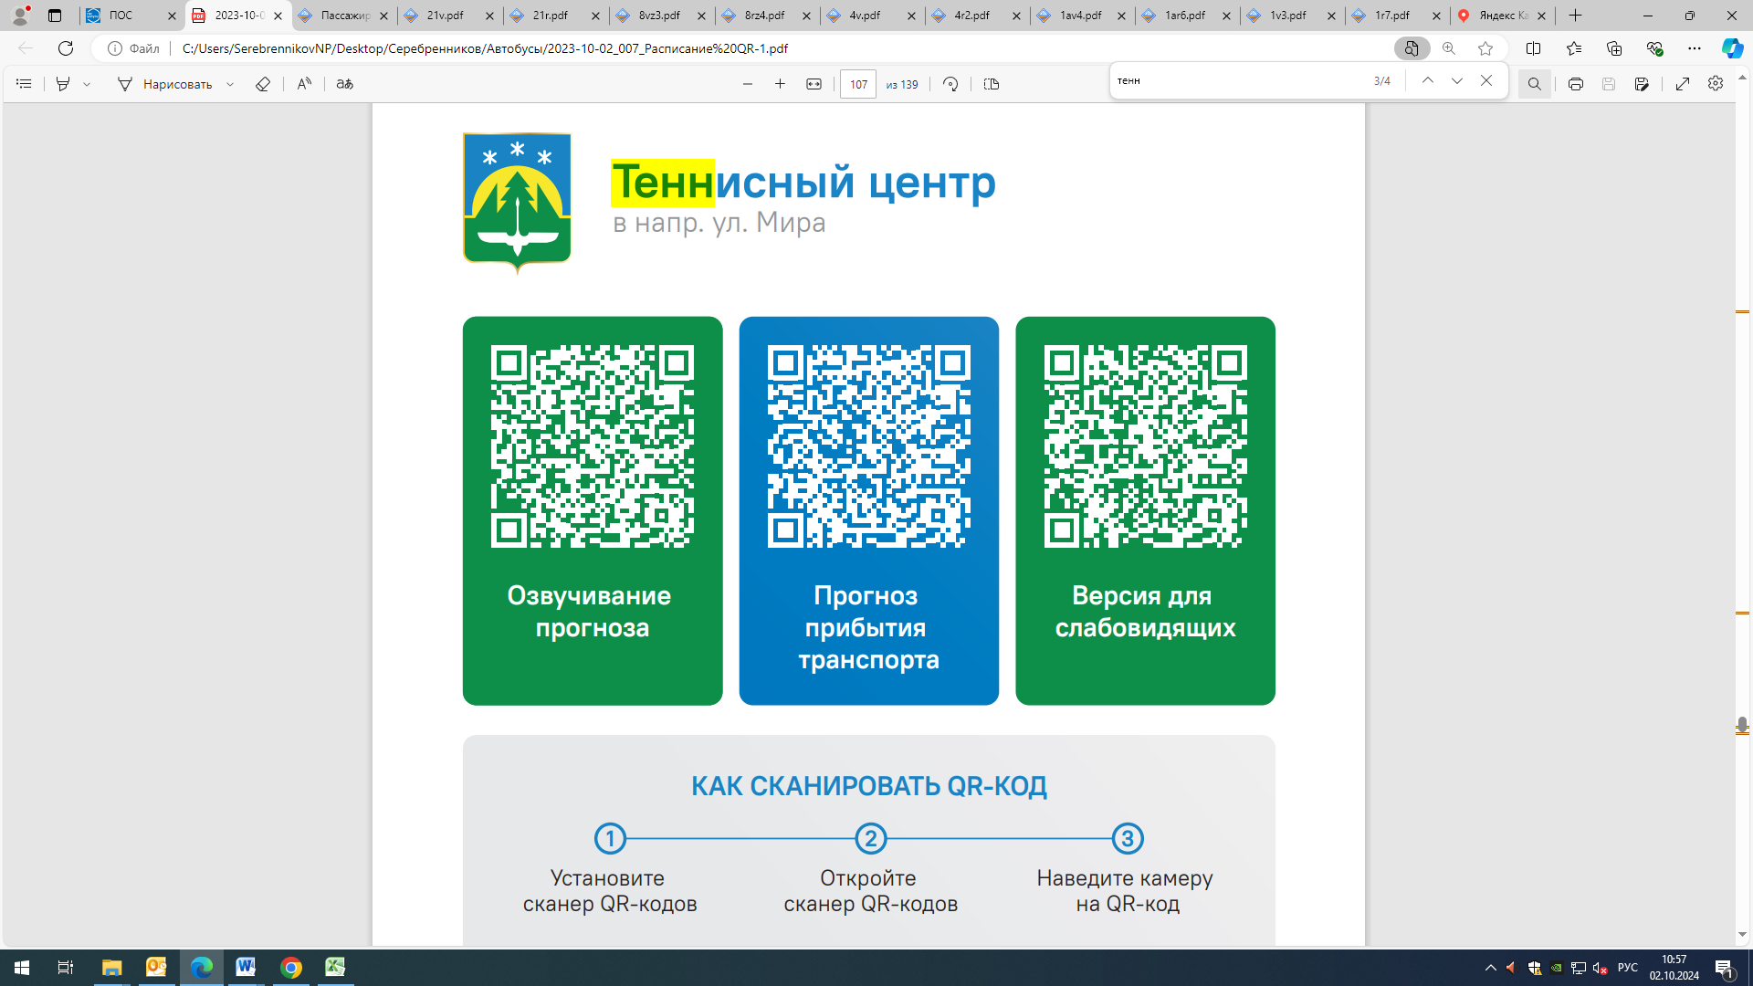

Контроль за осуществлением регулярных перевозок обеспечивает:
- управление транспорта, связи и дорог Администрации города Ханты-Мансийска, г: Ханты-Мансийск, ул Мира, 13, тел: 8 (3467) 39-39-07;
- отдел государственного автодорожного надзора по ХМАО – Югре, г: Ханты-Мансийск, ул: Шевченко 36А, тел: (3467) 32-64-60;
- МО МВД России «Ханты-Мансийский» г: Ханты-Мансийск, ул: Дзержинского дом 11, телефоны дежурной части (3467) 398-104, 398-103, 102 и 112

