  Югорская звезда |  |  |  |  |  |  |  |  | А
По регулируемым тарифам
Номер маршрута | Конечный остановочный пункт | ДНИ | Время начала и окончания движения | Временной график отправления транспортных средств от остановочного пункта
1А | Авторечвокзал (по Объездной) | Будни | 6:15-21:40 | 6:15, 7:15, 8:00, 8:35, 8:55, 9:35, 10:45, 11:30, 12:35, 13:15, 14:15, 15:15, 16:35, 17:00, 17:35, 18:30, 18:35, 19:35, 20:05, 20:20, 21:05, 21:40
 |  | Выходные | 7:00-20:55 | 7:00, 7:35, 8:35, 9:15, 10:15, 10:55, 11:55, 12:55, 13:35, 14:35, 15:25, 16:15, 17:00, 17:25, 17:55, 18:45, 19:15, 20:20, 20:55
4 | мкр. Береговая зона | Будни | 6:25-22:15 | 6:25, 6:55, 7:25, 7:45, 8:10, 8:30, 8:50, 9:10, 9:25, 9:45, 10:30, 11:25, 11:45, 12:25, 12:55, 13:35, 13:45, 14:25, 14:55, 15:45, 16:00, 16:25, 16:50, 17:05, 17:25, 17:55, 18:05, 18:25, 18:50, 19:30, 19:50, 20:10, 20:45, 21:25, 22:15
 |  | Выходные | 6:25-21:25 | 6:25, 7:25, 8:25, 9:25, 10:25, 11:25, 12:25, 13:25, 13:55, 14:25, 15:25, 15:55, 16:25, 17:25, 18:25, 19:25, 20:25, 21:25
5 | Ледовый дворец | Будни  с 01.06 по 31.08 | 5:10-23:35 | 5:10, 5:45, 6:25, 6:35, 6:55, 7:25, 7:45, 8:15, 8:25, 8:35, 8:50, 9:05, 9:25, 9:45, 9:55, 10:05, 10:25, 10:45, 11:05, 11:25, 11:45, 12:05, 12:25, 12:45, 13:05, 13:25, 13:45, 14:05, 14:25, 14:45, 15:05, 15:25, 15:45, 16:05, 16:25, 16:40, 16:55, 17:10, 17:25, 17:40, 17:55, 18:10, 18:25, 18:40, 18:55, 19:10, 19:25, 19:45, 20:05, 20:25, 20:40, 21:05, 21:25, 21:40, 21:55, 22:25, 22:55, 23:35
 |  | Выходные  с 01.06 по 31.08 | 5:10-23:35 | 5:10, 5:45, 6:25, 6:55, 7:25, 7:45, 8:25, 8:45, 9:05, 9:25, 9:45, 10:05, 10:25, 10:45, 11:05, 11:25, 11:45, 12:05, 12:25, 12:45, 13:05, 13:25, 13:45, 14:05, 14:25, 14:45, 15:05, 15:25, 15:45, 16:05, 16:25, 16:45, 17:05, 17:25, 17:45, 18:05, 18:25, 18:45, 19:05, 19:25, 19:45, 20:05, 20:25, 20:45, 21:05, 21:25, 21:40, 21:55, 22:25, 22:55, 23:35
 |  | Будни  с 01.09 по 31.05 | 5:10-23:35 | 5:10, 5:45, 6:25, 6:35, 6:45, 6:55, 7:05, 7:15, 7:25, 7:45, 7:55, 8:15, 8:25, 8:35, 8:50, 9:05, 9:25, 9:45, 10:05, 10:25, 10:45, 11:05, 11:25, 11:45, 12:05, 12:25, 12:40, 12:55, 13:10, 13:25, 13:45, 14:05, 14:25, 14:45, 15:05, 15:25, 15:40, 15:55, 16:10, 16:25, 16:40, 16:55, 17:10, 17:25, 17:40, 17:55, 18:10, 18:25, 18:40, 18:55, 19:10, 19:25, 19:45, 20:05, 20:25, 20:40, 20:55, 21:10, 21:25, 21:40, 21:55, 22:25, 22:55, 23:35
 |  | Выходные  с 01.09 по 31.05 | 5:10-23:35 | 5:10, 5:45, 6:25, 6:35, 6:55, 7:25, 7:45, 8:15, 8:25, 8:35, 8:50, 9:05, 9:25, 9:45, 9:55, 10:05, 10:25, 10:45, 11:05, 11:25, 11:45, 12:05, 12:25, 12:45, 13:05, 13:25, 13:45, 14:05, 14:25, 14:45, 15:05, 15:25, 15:45, 16:05, 16:25, 16:40, 16:55, 17:10, 17:25, 17:40, 17:55, 18:10, 18:25, 18:40, 18:55, 19:05, 19:25, 19:45, 20:05, 20:25, 20:40, 21:05, 21:25, 21:40, 21:55, 22:25, 22:55, 23:35
По нерегулируемым тарифам
Номер маршрута | Конечный остановочный пункт | ДНИ | Время начала и окончания движения | Интервал отправления транспортных средств от остановочного пункта
8К | Гимназия №1 |  |  | до 10:00 | 10:00 -11:00 | 11:00 -15:00 | 15:00 -16:00 | 16:00 – 20:00 |  | после 20:00
 |  | Будни | 6:30-22:00 | 15 | 20 | 15 | 20 | 15 |  | 20
 |  | Суббота | 6:30-22:00 | 20 | 25 | 20 | 25 | 20 |  | 25
 |  | Воскресенье | 6:30-21:00 | 20 | 25 | 25 | 25 | 25 |  | 30
9К | мкр. Береговая зона |  |  | до 10:00 | 10:00 -11:00 | 11:00 -15:00 | 15:00 -16:00 | 16:00 – 20:00 |  | после 20:00
 |  | Будни | 6:30-22:00 | 15 | 20 | 15 | 20 | 15 |  | 20
 |  | Суббота | 6:30-22:00 | 20 | 25 | 20 | 25 | 20 |  | 25
 |  | Воскресенье | 6:30-21:00 | 20 | 25 | 25 | 25 | 25 |  | 30
13К | мкр. Береговая зона |  |  | до 10:00 | 10:00 -11:00 | 11:00 -15:00 | 15:00 -16:00 | 16:00 – 20:00 |  | после 20:00
 |  | Будни | 6:30-22:00 | 15 | 20 | 15 | 20 | 15 |  | 20
 |  | Суббота | 6:30-22:00 | 20 | 25 | 20 | 25 | 20 |  | 25
 |  | Воскресенье | 6:30-21:00 | 20 | 25 | 25 | 25 | 25 |  | 30
Прогноз прибытия пассажирского транспорта
в вашем мобильном телефоне
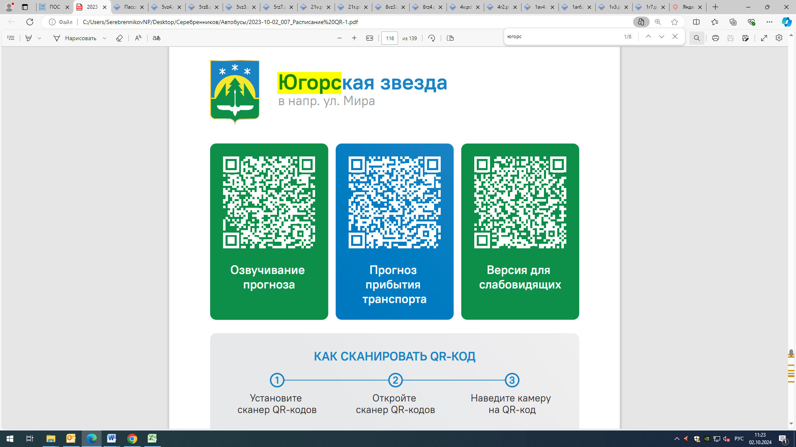

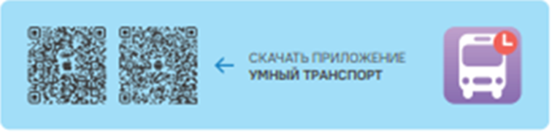

Контроль за осуществлением регулярных перевозок обеспечивает:
- управление транспорта, связи и дорог Администрации города Ханты-Мансийска, г: Ханты-Мансийск, ул Мира, 13, тел: 8 (3467) 39-39-07;
- отдел государственного автодорожного надзора по ХМАО – Югре, г: Ханты-Мансийск, ул: Шевченко 36А, тел: (3467) 32-64-60;
- МО МВД России «Ханты-Мансийский» г: Ханты-Мансийск, ул: Дзержинского дом 11, телефоны дежурной части (3467) 398-104, 398-103, 102 и 112

