  Микрорайон |  |  |  |  |  |  |  |  |  | А
По регулируемым тарифам
Номер маршрута | Конечный остановочный пункт | ДНИ | Время начала и окончания движения | Временной график отправления транспортных средств от остановочного пункта
4 | мкр. Береговая зона | Будни | 6:30-22:20 | 6:30, 7:00, 7:30, 7:50, 8:15, 8:35, 8:55, 9:15, 9:30, 9:50, 10:35, 11:30, 11:50, 12:30, 13:00, 13:40, 13:50, 14:30, 15:00, 15:50, 16:05, 16:30, 16:55, 17:10, 17:30, 18:00, 18:10, 18:30, 18:55, 19:35, 19:55, 20:15, 20:50, 21:30, 22:20
 |  | Выходные | 6:30-21:30 | 6:30, 7:30, 8:30, 9:30, 10:30, 11:30, 12:30, 13:30, 14:00, 14:30, 15:30, 16:00, 16:30, 17:30, 18:30, 19:30, 20:30, 21:30
5 | Ледовый дворец | Будни  с 01.06 по 31.08 | 5:15-23:40 | 5:15, 5:50, 6:30, 6:40, 7:00, 7:30, 7:50, 8:20, 8:30, 8:40, 8:55, 9:10, 9:30, 9:50, 10:00, 10:10, 10:30, 10:50, 11:10, 11:30, 11:50, 12:10, 12:30, 12:50, 13:10, 13:30, 13:50, 14:10, 14:30, 14:50, 15:10, 15:30, 15:50, 16:10, 16:30, 16:45, 17:00, 17:15, 17:30, 17:45, 18:00, 18:15, 18:30, 18:45, 19:00, 19:15, 19:30, 19:50, 20:10, 20:30, 20:45,  21:10, 21:30, 21:45, 22:00, 22:30, 23:00, 23:40
 |  | Выходные  с 01.06 по 31.08 | 5:15-23:40 | 5:15, 5:50, 6:30, 7:00, 7:30, 7:50, 8:30, 8:50, 9:10, 9:30, 9:50, 10:10, 10:30, 10:50, 11:10, 11:30, 11:50, 12:10, 12:30, 12:50, 13:10, 13:30, 13:50, 14:10, 14:30, 14:50, 15:10, 15:30, 15:50, 16:10, 16:30, 16:50, 17:10, 17:30, 17:50, 18:10, 18:30, 18:50, 19:10, 19:30, 19:50, 20:10, 20:30, 20:50, 21:10, 21:30, 21:45, 22:00, 22:30, 23:00, 23:40
 |  | Будни  с 01.09 по 31.05 | 5:15-23:40 | 5:15, 5:50, 6:30, 6:40, 6:50, 7:00, 7:10, 7:20, 7:30, 7:50, 8:00, 8:20, 8:30, 8:40, 8:55, 9:10, 9:30, 9:50, 10:10, 10:30, 10:50, 11:10, 11:30, 11:50, 12:10, 12:30, 12:45, 13:00, 13:15, 13:30, 13:50, 14:10, 14:30, 14:50, 15:10, 15:30, 15:45, 16:00, 16:15, 16:30, 16:45, 17:00, 17:15, 17:30, 17:45, 18:00, 18:15, 18:30, 18:45, 19:00, 19:15, 19:30, 19:50, 20:10, 20:30, 20:45, 21:00, 21:15, 21:30, 21:45, 22:00, 22:30, 23:00, 23:40
 |  | Выходные  с 01.09 по 31.05 | 5:15-23:40 | 5:15, 5:50, 6:30, 6:40, 7:00, 7:30, 7:50, 8:20, 8:30, 8:40, 8:55, 9:10, 9:30, 9:50, 10:00, 10:10, 10:30, 10:50, 11:10, 11:30, 11:50, 12:10, 12:30, 12:50, 13:10, 13:30, 13:50, 14:10, 14:30, 14:50, 15:10, 15:30, 15:50, 16:10, 16:30, 16:45, 17:00, 17:15, 17:30, 17:45, 18:00, 18:15, 18:30, 18:45, 19:00, 19:10, 19:30, 19:50, 20:10, 20:30, 20:45,  21:10, 21:30, 21:45, 22:00, 22:30, 23:00, 23:40
8 | ОМК | Будни | 6:11-22:51 | 6:11, 6:41, 7:16, 7:46, 8:11, 8:21, 8:51, 9:11, 9:36, 10:31, 11:21, 12:21, 12:51, 13:31, 14:01, 15:11, 16:11, 16:26, 16:51, 17:26, 17:51, 18:26, 18:51, 19:31, 19:51, 21:21, 22:51
 |  | Выходные | 6:41-22:31 | 6:41, 7:51, 8:21, 8:51, 9:31, 10:31, 11:21, 11:51, 12:21, 12:51, 13:51, 14:51, 15:51, 16:51, 17:51, 18:36, 19:11, 21:19, 21:21, 22:31
21 | Ключевая | Будни | 7:14-22:44 | 7:14, 7:34, 7:54, 8:14, 8:34, 8:54, 9:14, 9:34, 9:54, 10:24, 10:54, 11:29, 11:54, 12:24, 13:24, 13:59, 14:59, 15:34, 15:54, 16:34, 16:54, 17:14, 17:34, 17:54, 18:14, 18:34, 18:54, 19:14, 19:34, 19:54, 20:14, 20:54, 20:14, 21:54, 22:44
 |  | Выходные | 7:14-22:44 | 7:14, 7:54, 8:54, 9:34, 9:54, 11:29, 12:24, 13:24, 13:59, 14:59, 15:34, 16:34, 17:14, 17:54, 18:14, 18:54, 19:34, 19:54, 21:09, 22:44
77А | Сельхозтехника | Будни | 6:25-21:45 | 6:25, 6:55, 7:25, 7:45, 8:10, 8:30, 8:45, 9:05, 9:25, 9:45, 10:25, 11:05, 11:25, 12:25, 13:05, 14:05, 14:45, 15:45, 16:25, 16:45, 17:05, 17:25, 17:45, 18:05, 18:25, 18:45, 19:05, 19:25, 20:05, 20:25, 21:05, 21:45
 |  | Выходные | 7:25-21:55 | 7:25, 8:25, 9:05, 10:05, 10:45, 11:45, 12:25, 13:25, 14:25, 16:05, 16:25, 17:45, 18:05, 18:25, 19:25, 19:55, 20:25, 21:55
По нерегулируемым тарифам
Номер маршрута | Конечный остановочный пункт | ДНИ | Время начала и окончания движения | Интервал отправления транспортных средств от остановочного пункта
7К | ТД «Сатурн» |  |  | до 10:00 | 10:00 -11:00 | 11:00 -15:00 | 15:00 -16:00 | 16:00 – 20:00 | после 20:00
 |  | Будни | 6:30-22:00 | 15 | 20 | 15 | 20 | 15 | 20
 |  | Суббота | 6:30-22:00 | 20 | 25 | 20 | 25 | 20 | 25
 |  | Воскресенье | 6:30-21:00 | 20 | 25 | 25 | 25 | 25 | 30
9К | мкр. Береговая зона |  |  | до 10:00 | 10:00 -11:00 | 11:00 -15:00 | 15:00 -16:00 | 16:00 – 20:00 | после 20:00
 |  | Будни | 6:30-22:00 | 15 | 20 | 15 | 20 | 15 | 20
 |  | Суббота | 6:30-22:00 | 20 | 25 | 20 | 25 | 20 | 25
 |  | Воскресенье | 6:30-21:00 | 20 | 25 | 25 | 25 | 25 | 30
13 | мкр. Береговая зона |  |  | до 10:00 | 10:00 -11:00 | 11:00 -15:00 | 15:00 -16:00 | 16:00 – 20:00 | после 20:00
 |  | Будни | 6:30-22:00 | 15 | 20 | 15 | 20 | 15 | 20
 |  | Суббота | 6:30-22:00 | 20 | 25 | 20 | 25 | 20 | 25
 |  | Воскресенье | 6:30-21:00 | 20 | 25 | 25 | 25 | 25 | 30
26К | Гимназия №1 |  |  | до 10:00 | 10:00 -11:00 | 11:00 -15:00 | 15:00 -16:00 | 16:00 – 20:00 | после 20:00
 |  | Будни | 6:30-22:00 | 15 | 20 | 15 | 20 | 15 | 20
 |  | Суббота | 6:30-22:00 | 20 | 25 | 20 | 25 | 20 | 25
 |  | Воскресенье | 6:30-21:00 | 20 | 25 | 25 | 25 | 25 | 30
Прогноз прибытия пассажирского транспорта
в вашем мобильном телефоне
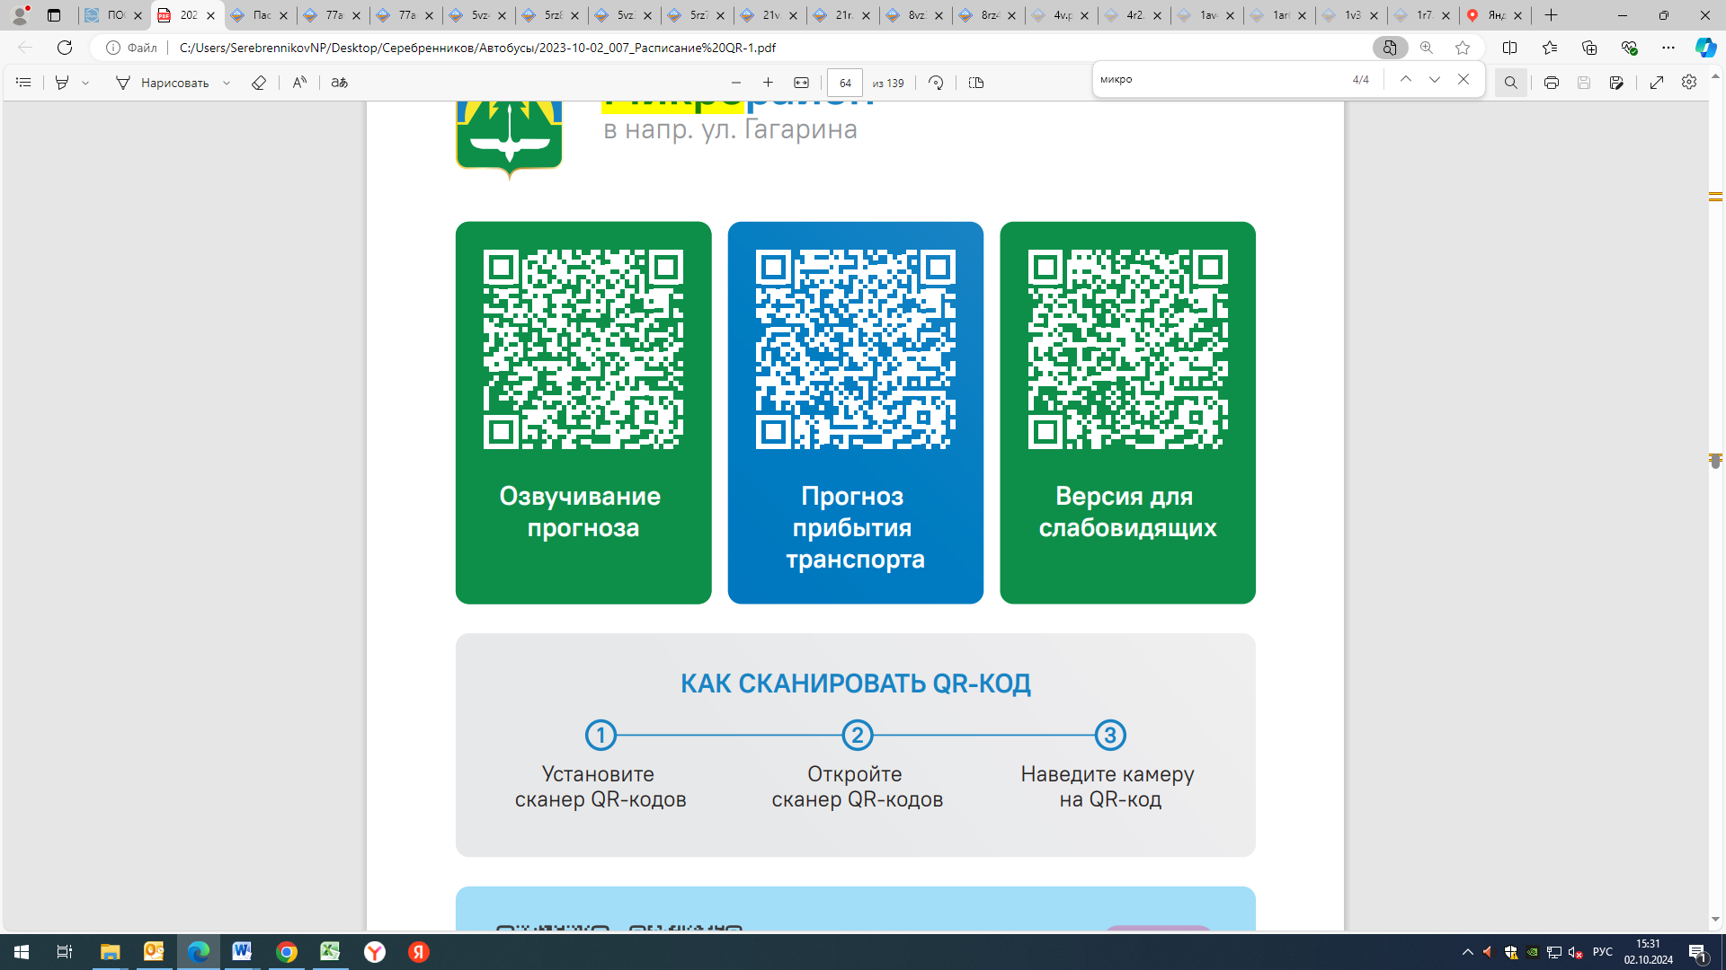



Контроль за осуществлением регулярных перевозок обеспечивает:
- управление транспорта, связи и дорог Администрации города Ханты-Мансийска, г: Ханты-Мансийск, ул Мира, 13, тел: 8 (3467) 39-39-07;
- отдел государственного автодорожного надзора по ХМАО – Югре, г: Ханты-Мансийск, ул: Шевченко 36А, тел: (3467) 32-64-60;
- МО МВД России «Ханты-Мансийский» г: Ханты-Мансийск, ул: Дзержинского дом 11, телефоны дежурной части (3467) 398-104, 398-103, 102 и 112

