  Доронина |  |  |  |  |  |  |  |  |  | А
По регулируемым тарифам
Номер маршрута | Конечный остановочный пункт | ДНИ | Время начала и окончания движения | Временной график отправления транспортных средств от остановочного пункта
4 | мкр. Береговая зона | Будни | 6:32-22:22 | 6:32, 7:02, 7:32, 7:52, 8:17, 8:37, 8:57, 9:17, 9:32, 9:52, 10:37, 11:32, 11:52, 12:32, 13:02, 13:42, 13:52, 14:32, 15:02, 15:52, 16:07, 16:32, 16:57, 17:12, 17:32, 18:02, 18:12, 18:32. 18:57, 19:37, 19:57, 20:17, 20:52, 21:32, 22:22
 |  | Выходные | 6:32-21:32 | 6:32, 7:32, 8:32, 9:32, 10:32, 11:32, 12:32, 13:32, 14:02, 14:32, 15:32, 16:02, 16:32, 17:32, 18:32, 19:32, 20:32, 21:32
5 | Ледовый дворец | Будни  с 01.06 по 31.08 | 5:17-23:42 | 5:17, 5:52, 6:32, 6:42, 7:02, 7:32, 7:52, 8:22, 8:32, 8:42, 8:57, 9:12, 9:32, 9:52, 10:02, 10:12, 10:32, 10:52, 11:12, 11:32, 11:52, 12:12, 12:32, 12:52, 13:12, 13:32, 13:52, 14:12, 14:32, 14:52, 15:12, 15:32, 15:52, 16:12, 16:32, 16:47, 17:02, 17:17, 17:32, 17:47, 18:02, 18:17, 18:32, 18:47, 19:02, 19:17, 19:32, 19:52, 20:12, 20:32, 20:47, 21:12, 21:32, 21:47, 22:02, 22:32, 23:02, 23:42
 |  | Выходные  с 01.06 по 31.08 | 5:17-23:42 | 5:17, 5:52, 6:32, 7:02, 7:32, 7:52, 8:32, 8:52, 9:12, 9:32, 9:52, 10:12, 10:32, 10:52, 11:12, 11:32, 11:52, 12:12, 12:32, 12:52, 13:12, 13:32, 13:52, 14:12, 14:32, 14:52, 15:12, 15:32, 15:52, 16:12, 16:32, 16:52, 17:12, 17:32, 17:52, 18:12, 18:32, 18:52, 19:12, 19:32, 19:52, 20:12, 20:32, 20:52, 21:12, 21:32, 21:47, 22:02, 22:32, 23:02, 23:42
 |  | Будни  с 01.09 по 31.05 | 5:17-23:42 | 5:17, 5:52, 6:32, 6:42, 6:52, 7:02, 7:12, 7:22, 7:32, 7:52, 8:02, 8:22, 8:32, 8:42, 8:57, 9:12, 9:32, 9:52, 10:12, 10:32, 10:52, 11:12, 11:32, 11:52, 12:12, 12:32, 12:47, 13:02, 13:17, 13:32, 13:52, 14:12, 14:32, 14:52, 15:12, 15:32, 15:47, 16:02, 16:17, 16:32, 16:47, 17:02, 17:17, 17:32, 17:47, 18:02, 18:17, 18:32, 18:47, 19:02, 19:17, 19:32, 19:52, 20:12, 20:32, 20:47, 21:02, 21:17, 21:32, 21:47, 22:02, 22:32, 23:02, 23:42
 |  | Выходные  с 01.09 по 31.05 | 5:17-23:42 | 5:17, 5:52, 6:32, 6:42, 7:02, 7:32, 7:52, 8:22, 8:32, 8:42, 8:57, 9:12, 9:32, 9:52, 10:02, 10:12, 10:32, 10:52, 11:12, 11:32, 11:52, 12:12, 12:32, 12:52, 13:12, 13:32, 13:52, 14:12, 14:32, 14:52, 15:12, 15:32, 15:52, 16:12, 16:32, 16:47, 17:02, 17:17, 17:32, 17:47, 18:02, 18:17, 18:32, 18:47, 19:02, 19:12, 19:32, 19:52, 20:12, 20:32, 20:47, 21:12, 21:32, 21:47, 22:02, 22:32, 23:02, 23:42
8 | ОМК | Будни | 6:12-22:52 | 6:12, 6:42, 7:17, 7:47, 8:12, 8:22, 8:52, 9:12, 9:37, 10:32, 11:22, 12:22, 12:52, 13:32, 14:02, 15:12, 16:12, 16:27, 16:52, 17:27, 17:52, 18:27, 18:52, 19:32, 19:52, 21:22, 22:52
 |  | Выходные | 6:42-22:32 | 6:42, 7:52, 8:22, 8:52, 9:32, 10:32, 11:22, 11:52, 12:22, 12:52, 13:52, 14:52, 15:52, 16:52, 17:52, 18:37, 19:12, 21:20, 21:22, 22:32
21 | Ключевая | Будни | 7:15-22:45 | 7:15, 7:35, 7:55, 8:15, 8:35, 8:55, 9:15, 9:35, 9:55, 10:25, 10:55, 11:30, 11:55, 12:25, 13:25, 14:00, 15:00, 15:35, 15:55, 16:35, 16:55, 17:15, 17:35, 17:55, 18:15, 18:35, 18:55, 19:15, 19:35, 19:55, 20:15, 20:55, 20:15, 21:55, 22:45
 |  | Выходные | 7:15-22:45 | 7:15, 7:55, 8:55, 9:35, 9:55, 11:30, 12:25, 13:25, 14:00, 15:00, 15:35, 16:35, 17:15, 17:55, 18:15, 18:55, 19:35, 19:55, 21:10, 22:45
77А | Сельхозтехника | Будни | 6:26-21:46 | 6:26, 6:56, 7:26, 7:46, 8:11, 8:31, 8:46, 9:06, 9:26, 9:46, 10:26, 11:06, 11:26, 12:26, 13:06, 14:06, 14:46, 15:46, 16:26, 16:46, 17:06, 17:26, 17:46, 18:06, 18:26, 18:46, 19:06, 19:26, 20:06, 20:26, 21:06, 21:46
 |  | Выходные | 7:26-21:56 | 7:26, 8:26, 9:06, 10:06, 10:46, 11:46, 12:26, 13:26, 14:26, 16:06, 16:26, 17:46, 18:06, 18:26, 19:26, 19:56, 20:26, 21:56
По нерегулируемым тарифам
Номер маршрута | Конечный остановочный пункт | ДНИ | Время начала и окончания движения | Интервал отправления транспортных средств от остановочного пункта
7К | ТД «Сатурн» |  |  | до 10:00 | 10:00 -11:00 | 11:00 -15:00 | 15:00 -16:00 | 16:00 – 20:00 | после 20:00
 |  | Будни | 6:30-22:00 | 15 | 20 | 15 | 20 | 15 | 20
 |  | Суббота | 6:30-22:00 | 20 | 25 | 20 | 25 | 20 | 25
 |  | Воскресенье | 6:30-21:00 | 20 | 25 | 25 | 25 | 25 | 30
9К | мкр. Береговая зона |  |  | до 10:00 | 10:00 -11:00 | 11:00 -15:00 | 15:00 -16:00 | 16:00 – 20:00 | после 20:00
 |  | Будни | 6:30-22:00 | 15 | 20 | 15 | 20 | 15 | 20
 |  | Суббота | 6:30-22:00 | 20 | 25 | 20 | 25 | 20 | 25
 |  | Воскресенье | 6:30-21:00 | 20 | 25 | 25 | 25 | 25 | 30
13К | мкр. Береговая зона |  |  | до 10:00 | 10:00 -11:00 | 11:00 -15:00 | 15:00 -16:00 | 16:00 – 20:00 | после 20:00
 |  | Будни | 6:30-22:00 | 15 | 20 | 15 | 20 | 15 | 20
 |  | Суббота | 6:30-22:00 | 20 | 25 | 20 | 25 | 20 | 25
 |  | Воскресенье | 6:30-21:00 | 20 | 25 | 25 | 25 | 25 | 30
26К | Гимназия №1 |  |  | до 10:00 | 10:00 -11:00 | 11:00 -15:00 | 15:00 -16:00 | 16:00 – 20:00 | после 20:00
 |  | Будни | 6:30-22:00 | 15 | 20 | 15 | 20 | 15 | 20
 |  | Суббота | 6:30-22:00 | 20 | 25 | 20 | 25 | 20 | 25
 |  | Воскресенье | 6:30-21:00 | 20 | 25 | 25 | 25 | 25 | 30
Прогноз прибытия пассажирского транспорта
в вашем мобильном телефоне

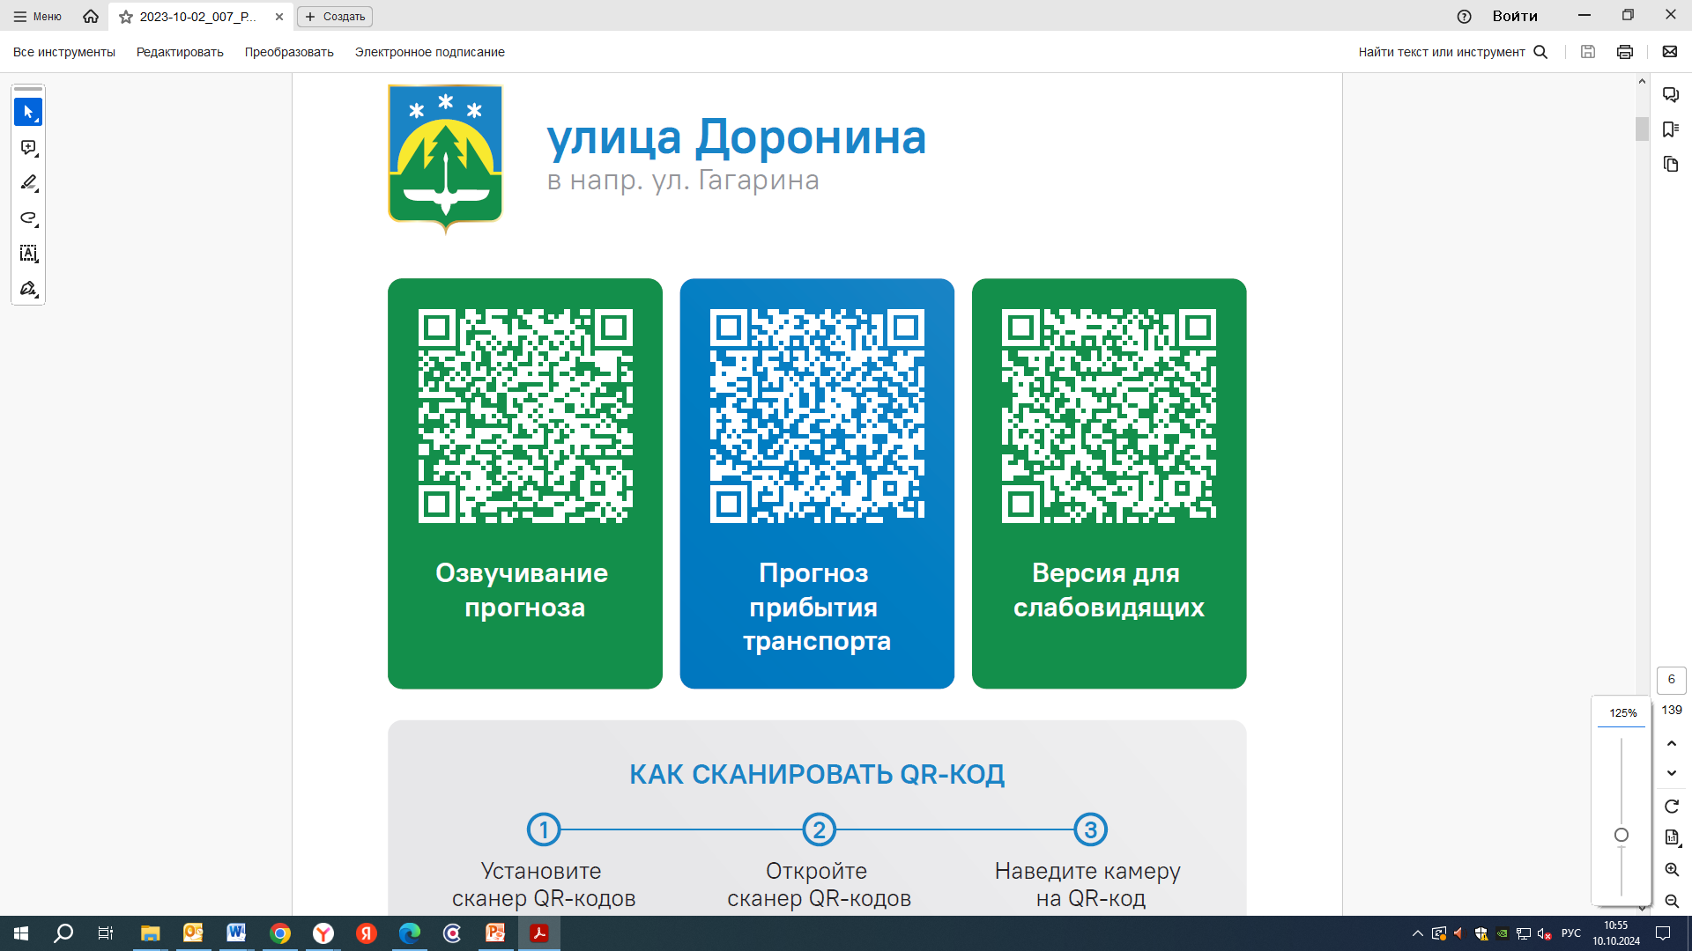



Контроль за осуществлением регулярных перевозок обеспечивает:
- управление транспорта, связи и дорог Администрации города Ханты-Мансийска, г: Ханты-Мансийск, ул Мира, 13, тел: 8 (3467) 39-39-07;
- отдел государственного автодорожного надзора по ХМАО – Югре, г: Ханты-Мансийск, ул: Шевченко 36А, тел: (3467) 32-64-60;
- МО МВД России «Ханты-Мансийский» г: Ханты-Мансийск, ул: Дзержинского дом 11, телефоны дежурной части (3467) 398-104, 398-103, 102 и 112

