  Поликлиника |  |  |  |  |  |  |  |  | А
По регулируемым тарифам
Номер маршрута | Конечный остановочный пункт | ДНИ | Время начала и окончания движения | Временной график отправления транспортных средств от остановочного пункта
1 | ОМК | Будни | 6:52-23:17 | 6:54, 7:39, 7:59, 8:29, 8:52, 9:19, 9:34, 10:14, 10:54, 11:09, 11:54, 12:54, 13:59, 14:59, 15:34, 16:24, 17:24, 18:09, 18:24, 19:09, 19:49, 20:09, 20:49, 21:24, 21:49, 22:24, 23:19
 |  | Выходные | 7:09-22:24 | 7:09, 8:09, 8:49, 9:49, 10:29, 11:29, 12:29, 13:29, 14:09, 15:09, 15:49, 16:49, 17:29, 18:09, 18:29, 19:09, 19:49, 20:49, 21:24, 22:24
1А | ОМК | Будни | 6:19-21:56 | 6:19, 7:06, 8:06, 8:51, 9:26, 9:46, 10:26, 11:36, 12:21, 13:26, 14:06, 15:06, 16:06, 17:26, 17:51, 18:26, 19:21, 19:26, 20:26, 20:56, 21:11, 21:56
 |  | Выходные | 7:51-21:46 | 7:51, 8:26, 9:26, 10:06, 11:06, 11:46, 12:46, 13:46, 14:26, 15:26, 16:16, 17:06, 17:51, 18:16, 18:46, 19:36, 20:06, 21:11, 21:46
2 | Мелиораторов | ежедневно | 7:13-19:33 | 7:13, 8:21, 9:21, 10:13, 12:13, 13:13, 14:13, 15:13, 17:23, 18:33, 19:33
4 | ОМК | Будни | 6:38-22:38 | 6:38, 6:58, 7:18, 7:38, 8:03, 8:18, 8:38, 8:58, 9:18, 9:38, 9:58, 10:38, 10:58, 11:38, 12:38, 12:58, 13:38, 14:08, 14:58, 15:38, 16:18, 16:38, 16:58, 17:18, 17:38, 17:58, 18:18, 18:38, 19:03, 19:18, 19:58, 20:38, 20:58, 21:28, 21:58, 22:38,
 |  | Выходные | 6:38-22:38 | 6:38, 7:38, 8:38, 9:38, 10:38, 11:38, 12:38, 13:38, 14:38, 15:08, 15:38, 16:38, 17:08, 17:38, 18:38, 19:38, 20:38, 21:38, 22:38
5 | Мкр. Восточный | Будни  с 01.06 по 31.08 | 6:09-23:14 | 6:09, 6:49, 7:09, 7:41, 7:51, 8:11, 8:19, 8:29, 8:39, 8:49, 9:09, 9:34, 9:44, 9:59, 10:09, 10:29, 10:44, 10:59, 11:09, 11:19, 11:29, 11:49, 12:09, 12:29, 12:49, 13:09, 13:29, 13:49, 14:09, 14:29, 14:49, 15:09, 15:29, 15:49, 16:09, 16:29, 16:49, 17:09, 17:29, 17:44, 17:59, 18:14, 18:34, 18:44, 18:59, 19:14, 19:29, 19:44, 19:59, 20:14, 20:29, 20:49, 21:09, 21:29, 21:44, 21:59, 22:29, 22:59, 23:14
 |  | Выходные  с 01.06 по 31.08 | 6:09-23:44 | 6:09, 6:49, 7:09, 7:41, 8:11, 8:29, 8:49, 9:09, 9:29, 9:49, 10:09, 10:29, 10:49, 11:09, 11:29, 11:49, 12:09, 12:29, 12:49, 13:09, 13:29, 13:49, 14:09, 14:29, 14:49, 15:09, 15:29, 15:49, 16:09, 16:29, 16:49, 17:09,  17:29, 17:49, 18:09, 18:29, 18:49, 19:09, 19:29, 19:49, 20:09, 20:29, 20:49, 21:09, 21:29, 21:44, 22:09, 22:29, 22:59, 23:44
 |  | Будни  с 01.09 по 31.05 | 6:09-00:14 | 6:09, 6:49, 7:09, 7:41, 7:51, 8:09, 8:19, 8:29, 8:39, 8:49, 9:09, 9:19, 9:34, 9:44, 9:54, 10:09, 10:29, 10:49, 11:09, 11:19, 11:29, 11:49, 12:09, 12:29, 12:49, 13:09, 13:29, 13:44, 13:59, 14:14, 14:29, 14:49, 15:09, 15:29, 15:49, 16:09, 16:29, 16:44, 16:59, 17:14, 17:29, 17:44, 17:59, 18:14, 18:29, 18:44, 18:59, 19:14, 19:29, 19:44, 19:59, 20:14, 20:29, 20:49, 21:09, 21:29, 21:44, 21:59, 22:14, 22:29, 22:44, 22:59, 23:44, 23:59, 0:14
 |  | Выходные с 01.09 по 31.05 | 6:49-00:14 | 6:49, 7:09, 7:41, 7:51, 8:11, 8:29, 8:49, 9:09, 9:34, 9:44, 9:54, 10:09, 10:29, 10:44, 10:59, 11:09, 11:19,  11:29, 11:49, 12:09, 12:29, 12:49, 13:09, 13:29, 13:49, 14:09, 14:29, 14:49, 15:09, 15:29, 16:09, 16:09, 16:29, 16:49, 17:09, 17:29, 17:44, 17:59, 18:14, 18:29, 18:44, 18:59, 19:14, 19:29, 19:44, 19:59, 20:14, 20:29, 20:49, 21:09, 21:29, 21:44, 21:59, 22:29, 22:59, 23:14, 23:44, 0:14
8 | ОМК | Будни | 6:23-23:03 | 6:23, 6:53, 7:28, 7:58, 8:23, 8:33, 9:03, 9:23, 9:48, 10:43, 11:33, 12:33, 13:03, 13:43, 14:13, 15:23, 16:23, 16:38, 17:03, 17:38, 18:03, 18:38, 19:03, 19:43, 20:03, 21:33, 23:03
 |  | Выходные | 6:53-22:43 | 6:53, 8:03, 8:33, 9:03, 9:43, 10:43, 11:33, 12:03, 12:33, 13:03, 14:03, 15:03, 16:03, 17:03, 18:03, 18:49, 19:23, 21:31, 21:33, 22:43
21 | Теннисный центр | Будни | 6:44-22:14 | 6:44, 7:04, 7:24, 7:44, 8:04, 8:24, 8:44, 9:04, 9:24, 9:54, 10:24, 10:59, 11:24, 11:54, 12:54, 13:29, 14:29, 15:04, 15:24, 16:04, 16:24, 16:44, 17:04, 17:24, 17:44, 18:04, 18:24, 18:44, 19:04, 19:24, 19:44, 20:24, 20:39, 21:24, 22:14
 |  | Выходные | 6:44-22:14 | 6:44, 7:24, 8:24, 9:04, 9:24, 10:59, 11:54, 12:54, 13:29, 14:29, 15:04, 16:04, 16:44, 17:24, 17:44, 18:24, 19:04, 19:24, 20:39, 22:14
77 | Сельхозтехника | Будни | 7:44-22:14 | 7:44, 8:29, 8:39, 9:16, 9:44, 10:39, 11:14, 12:04, 13:29, 14:11, 14:56, 15:49, 16:19, 17:09, 17:49, 18:19, 18:54, 19:04, 19:59, 20:09, 20:59, 21:14, 22:14
 |  | Выходные | 7:49-22:14 | 7:49, 8:19, 8:39, 9:16, 9:49, 10:39, 11:14, 12:04, 13:09, 14:04, 14:36, 15:39, 16:19, 17:09, 17:39, 18:09, 18:41, 19:04, 19:34, 20:09, 20:49, 21:14, 22:14
77А | Районная поликлиника | Будни | 6:41-21:40 | 6:41, 7:01, 7:31, 8:01, 8:21, 8:46, 9:06, 9:21, 9:41, 10:01, 10:21, 11:01, 12:01, 13:01, 13:41, 14:41,  15:21, 16:21, 17:01, 17:21, 17:41, 18:01, 18:21, 18:41, 19:01, 19:21, 19:41, 20:01, 20:41, 21:01, 21:40
 |  | Выходные | 8:01-22:31 | 8:01, 9:01, 9:41, 10:41, 11:21, 12:21, 13:01, 14:01, 15:01, 16:41, 17:01, 18:21, 18:41, 19:01, 20:01,  20:31, 21:01, 22:31
По нерегулируемым тарифам
Номер маршрута | Конечный остановочный пункт | ДНИ | Время начала и окончания движения | Интервал отправления транспортных средств от остановочного пункта
7К | Назымская экспедиция |  |  | до 10:00 | 10:00 -11:00 | 11:00 -15:00 | 15:00 -16:00 | 16:00 – 20:00 |  | после 20:00
 |  | Будни | 6:30-22:00 | 15 | 20 | 15 | 20 | 15 |  | 20
 |  | Суббота | 6:30-22:00 | 20 | 25 | 20 | 25 | 20 |  | 25
 |  | Воскресенье | 6:30-21:00 | 20 | 25 | 25 | 25 | 25 |  | 30
8К | ОМК |  |  | до 10:00 | 10:00 -11:00 | 11:00 -15:00 | 15:00 -16:00 | 16:00 – 20:00 |  | после 20:00
 |  | Будни | 6:30-22:00 | 15 | 20 | 15 | 20 | 15 |  | 20
 |  | Суббота | 6:30-22:00 | 20 | 25 | 20 | 25 | 20 |  | 25
 |  | Воскресенье | 6:30-21:00 | 20 | 25 | 25 | 25 | 25 |  | 30
9К | Аэропорт |  |  | до 10:00 | 10:00 -11:00 | 11:00 -15:00 | 15:00 -16:00 | 16:00 – 20:00 |  | после 20:00
 |  | Будни | 6:30-22:00 | 15 | 20 | 15 | 20 | 15 |  | 20
 |  | Суббота | 6:30-22:00 | 20 | 25 | 20 | 25 | 20 |  | 25
 |  | Воскресенье | 6:30-21:00 | 20 | 25 | 25 | 25 | 25 |  | 30
26К | Теннисный центр |  |  | до 10:00 | 10:00 -11:00 | 11:00 -15:00 | 15:00 -16:00 | 16:00 – 20:00 |  | после 20:00
 |  | Будни | 6:30-22:00 | 15 | 20 | 15 | 20 | 15 |  | 20
 |  | Суббота | 6:30-22:00 | 20 | 25 | 20 | 25 | 20 |  | 25
 |  | Воскресенье | 6:30-21:00 | 20 | 25 | 25 | 25 | 25 |  | 30
Прогноз прибытия пассажирского транспорта
в вашем мобильном телефоне

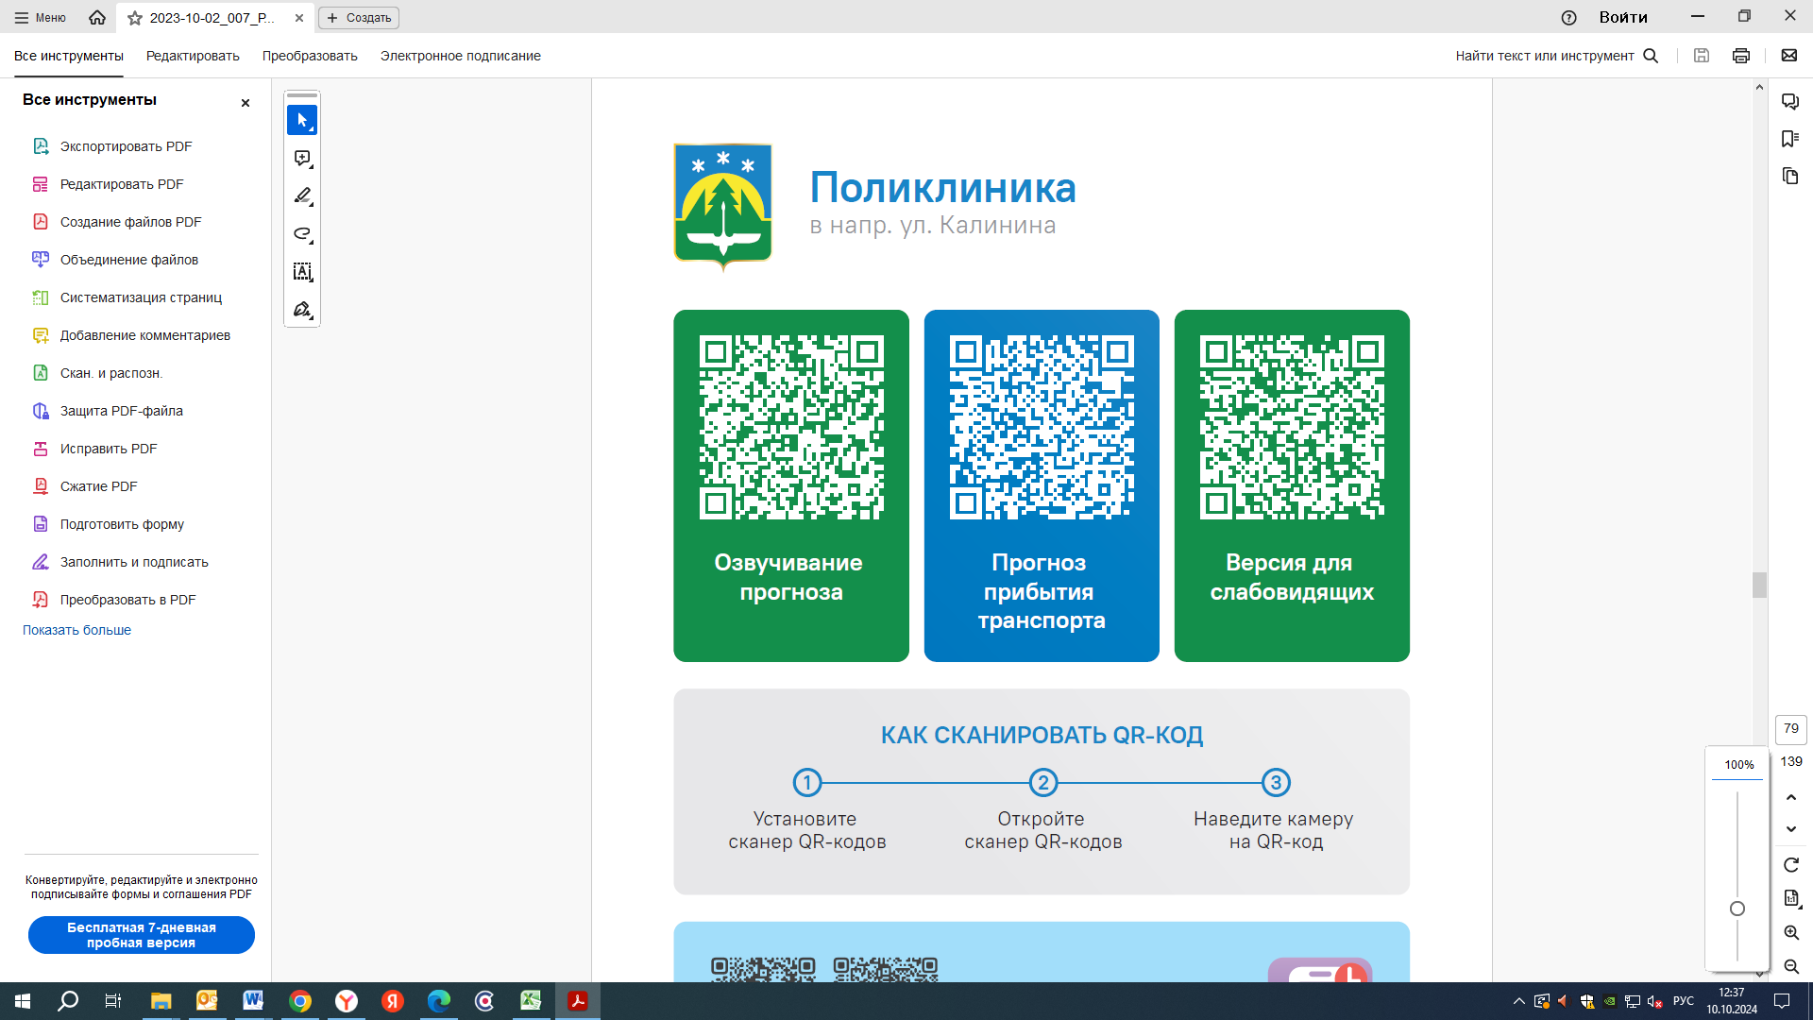



Контроль за осуществлением регулярных перевозок обеспечивает:
- управление транспорта, связи и дорог Администрации города Ханты-Мансийска, г: Ханты-Мансийск, ул Мира, 13, тел: 8 (3467) 39-39-07;
- отдел государственного автодорожного надзора по ХМАО – Югре, г: Ханты-Мансийск, ул: Шевченко 36А, тел: (3467) 32-64-60;
- МО МВД России «Ханты-Мансийский» г: Ханты-Мансийск, ул: Дзержинского дом 11, телефоны дежурной части (3467) 398-104, 398-103, 102 и 112

