  Поликлиника |  |  |  |  |  |  |  |  |  | А
По регулируемым тарифам
Номер маршрута | Конечный остановочный пункт | ДНИ | Время начала и окончания движения | Временной график отправления транспортных средств от остановочного пункта
1 | Автореч-вокзал (по Гагарина) | Будни | 6:07-22:32 | 6:07, 6:52, 7:12, 7:42, 8:05, 8:32, 8:47, 9:27, 10:07, 10:22, 11:07, 12:07, 13:12, 14:12, 14:47, 15:37, 16:37, 17:22, 17:37, 18:22, 19:02, 19:22, 20:02, 20:37, 21:02, 21:37, 22:32
 |  | Выходные | 6:22-21:37 | 6:22, 7:22, 8:02, 9:02, 9:42, 10:42, 11:42, 12:42, 13:22, 14:22, 15:02, 16:02, 16:42, 17:22, 17:42, 18:22, 19:02, 20:02, 20:37, 21:37
1А | Автореч-вокзал (по Объездной) | Будни | 6:19-21:44 | 6:19, 7:19, 8:04, 8:39, 8:59, 9:39, 10:49, 11:34, 12:39, 13:19, 14:19, 15:19, 16:39, 17:04, 17:39, 18:34, 18:39, 19:39, 20:09, 20:24, 21:09, 21:44
 |  | Выходные | 7:04-20:59 | 7:04, 7:39, 8:39, 9:19, 10:19, 10:59, 11:59, 12:59, 13:39, 14:39, 15:29, 16:19, 17:04, 17:29, 17:59, 18:49, 19:19, 20:24, 20:59
2 | Сельхозтехника | ежедневно | 6:49-18:59 | 6:49, 7:49, 8:49, 9:49, 11:49, 12:49, 13:49, 14:49, 16:59, 17:59, 18:59
4 | мкр. Береговая зона | Будни | 6:37-22:27 | 6:37, 7:07, 7:37, 7:57, 8:22, 8:42, 9:02, 9:22, 9:37, 9:57, 10:42, 11:37, 11:57, 12:37, 13:07, 13:47, 13:57, 14:37, 15:07, 15:57, 16:12, 16:37, 17:02, 17:17, 17:37, 18:07, 18:17, 18:37, 19:02, 19:42, 20:02, 20:22, 20:57, 21:37, 22:27
 |  | Выходные | 6:37-21:37 | 6:37, 7:37, 8:37, 9:37, 10:37, 11:37, 12:37, 13:37, 14:07, 14:37, 15:37, 16:07, 16:37, 17:37, 18:37, 19:37, 20:37, 21:37
5 | Ледовый дворец | Будни  с 01.06 по 31.08 | 5:22-23:47 | 5:22, 5:57, 6:37, 6:47, 7:07, 7:37, 7:57, 8:27, 8:37, 8:47, 9:02, 9:17, 9:37, 9:57, 10:07, 10:17, 10:37, 10:57, 11:17, 11:37, 11:57, 12:17, 12:37, 12:57, 13:17, 13:37, 13:57, 14:17, 14:37, 14:57, 15:17, 15:37, 15:57, 16:17, 16:37, 16:52, 17:07, 17:22, 17:37, 17:52, 18:07, 18:22, 18:37, 18:52, 19:07, 19:22, 19:37, 19:57, 20:17, 20:37, 20:52, 21:17, 21:37, 21:52, 22:07, 22:37, 23:07, 23:47
 |  | Выходные  с 01.06 по 31.08 | 5:22-23:47 | 5:22, 5:57, 6:37, 7:07, 7:37, 7:57, 8:37, 8:57, 9:17, 9:37, 9:57, 10:17, 10:37, 10:57, 11:17, 11:37, 11:57, 12:17, 12:37, 12:57, 13:17, 13:37, 13:57, 14:17, 14:37, 14:57, 15:17, 15:37, 15:57, 16:17, 16:37, 16:57, 17:17, 17:37, 17:57, 18:17, 18:37, 18:57, 19:17, 19:37, 19:57, 20:17, 20:37, 20:57, 21:17, 21:37, 21:52, 22:07, 22:37, 23:07, 23:47
 |  | Будни  с 01.09 по 31.05 | 5:22-23:47 | 5:22, 5:57, 6:37, 6:47, 6:57, 7:07, 7:17, 7:27, 7:37, 7:57, 8:07, 8:27, 8:37, 8:47, 9:02, 9:17, 9:37, 9:57, 10:17, 10:37, 10:57, 11:17, 11:37, 11:57, 12:17, 12:37, 12:52, 13:07, 13:22, 13:37, 13:57, 14:17, 14:37, 14:57, 15:17, 15:37, 15:52, 16:07, 16:22, 16:37, 16:52, 17:07, 17:22, 17:37, 17:52, 18:07, 18:22, 18:37, 18:52, 19:07, 19:22, 19:37, 19:57, 20:17, 20:37, 20:52, 21:07, 21:22, 21:37, 21:52, 22:07, 22:37, 23:07, 23:47
 |  | Выходные  с 01.09 по 31.05 | 5:22-23:47 | 5:22, 5:57, 6:37, 6:47, 7:07, 7:37, 7:57, 8:27, 8:37, 8:47, 9:02, 9:17, 9:37, 9:57, 10:07, 10:17, 10:37, 10:57, 11:17, 11:37, 11:57, 12:17, 12:37, 12:57, 13:17, 13:37, 13:57, 14:17, 14:37, 14:57, 15:17, 15:37, 15:57, 16:17, 16:37, 16:52, 17:07, 17:22, 17:37, 17:52, 18:07, 18:22, 18:37, 18:52, 19:07, 19:17, 19:37, 19:57, 20:17, 20:37, 20:52, 21:17, 21:37, 21:52, 22:07, 22:37, 23:07, 23:47
21 | Ключевая | Будни | 7:20-22:50 | 7:20, 7:40, 8:00, 8:20, 8:40, 9:00, 9:20, 9:40, 10:00, 10:30, 11:00, 11:35, 12:00, 12:30, 13:30, 14:05, 15:05, 15:40, 16:00, 16:40, 17:00, 17:20, 17:40, 18:00, 18:20, 18:40, 19:00, 19:20, 19:40, 20:00, 20:20, 21:00, 20:20, 22:00, 22:50
 |  | Выходные | 7:20-22:50 | 7:20, 8:00, 9:00, 9:40, 10:00, 11:35, 12:30, 13:30, 14:05, 15:05, 15:40, 16:40, 17:20, 18:00, 18:20, 19:00, 19:40, 20:00, 21:15, 22:50
77А | Сельхозтехника | Будни | 6:30-21:50 | 6:30, 7:00, 7:30, 7:50, 8:15, 8:35, 8:50, 9:10, 9:30, 9:50, 10:30, 11:10, 11:30, 12:30, 13:10, 14:10, 14:50, 15:50, 16:30, 16:50, 17:10, 17:30, 17:50, 18:10, 18:30, 18:50, 19:10, 19:30, 20:10, 20:30, 21:10, 21:50
 |  | Выходные | 7:30-22:00 | 7:30, 8:30, 9:10, 10:10, 10:50, 11:50, 12:30, 13:30, 14:30, 16:10, 16:30, 17:50, 18:10, 18:30, 19:30, 20:00, 20:30, 22:00
По нерегулируемым тарифам
Номер маршрута | Конечный остановочный пункт | ДНИ | Время начала и окончания движения | Интервал отправления транспортных средств от остановочного пункта
7К | ТД «Сатурн» |  |  | до 10:00 | 10:00 -11:00 | 11:00 -15:00 | 15:00 -16:00 | 16:00 – 20:00 | после 20:00
 |  | Будни | 6:30-22:00 | 15 | 20 | 15 | 20 | 15 | 20
 |  | Суббота | 6:30-22:00 | 20 | 25 | 20 | 25 | 20 | 25
 |  | Воскресенье | 6:30-21:00 | 20 | 25 | 25 | 25 | 25 | 30
8К | Гимназия №1 |  |  | до 10:00 | 10:00 -11:00 | 11:00 -15:00 | 15:00 -16:00 | 16:00 – 20:00 | после 20:00
 |  | Будни | 6:30-22:00 | 15 | 20 | 15 | 20 | 15 | 20
 |  | Суббота | 6:30-22:00 | 20 | 25 | 20 | 25 | 20 | 25
 |  | Воскресенье | 6:30-21:00 | 20 | 25 | 25 | 25 | 25 | 30
9К | мкр. Береговая зона |  |  | до 10:00 | 10:00 -11:00 | 11:00 -15:00 | 15:00 -16:00 | 16:00 – 20:00 | после 20:00
 |  | Будни | 6:30-22:00 | 15 | 20 | 15 | 20 | 15 | 20
 |  | Суббота | 6:30-22:00 | 20 | 25 | 20 | 25 | 20 | 25
 |  | Воскресенье | 6:30-21:00 | 20 | 25 | 25 | 25 | 25 | 30
13К | мкр. Береговая зона |  |  | до 10:00 | 10:00 -11:00 | 11:00 -15:00 | 15:00 -16:00 | 16:00 – 20:00 | после 20:00
 |  | Будни | 6:30-22:00 | 15 | 20 | 15 | 20 | 15 | 20
 |  | Суббота | 6:30-22:00 | 20 | 25 | 20 | 25 | 20 | 25
 |  | Воскресенье | 6:30-21:00 | 20 | 25 | 25 | 25 | 25 | 30
26К | Гимназия №1 |  |  | до 10:00 | 10:00 -11:00 | 11:00 -15:00 | 15:00 -16:00 | 16:00 – 20:00 | после 20:00
 |  | Будни | 6:30-22:00 | 15 | 20 | 15 | 20 | 15 | 20
 |  | Суббота | 6:30-22:00 | 20 | 25 | 20 | 25 | 20 | 25
 |  | Воскресенье | 6:30-21:00 | 20 | 25 | 25 | 25 | 25 | 30
Прогноз прибытия пассажирского транспорта
в вашем мобильном телефоне

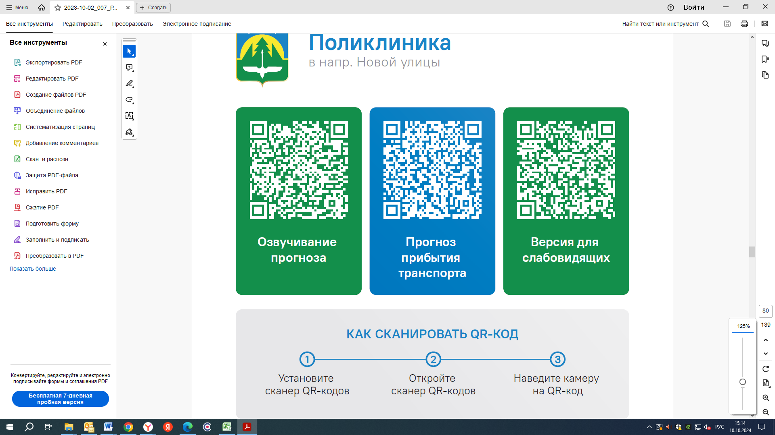



Контроль за осуществлением регулярных перевозок обеспечивает:
- управление транспорта, связи и дорог Администрации города Ханты-Мансийска, г: Ханты-Мансийск, ул Мира, 13, тел: 8 (3467) 39-39-07;
- отдел государственного автодорожного надзора по ХМАО – Югре, г: Ханты-Мансийск, ул: Шевченко 36А, тел: (3467) 32-64-60;
- МО МВД России «Ханты-Мансийский» г: Ханты-Мансийск, ул: Дзержинского дом 11, телефоны дежурной части (3467) 398-104, 398-103, 102 и 112

