  Школа №5 |  |  |  |  |  |  |  |  |  | А
По регулируемым тарифам
Номер маршрута | Конечный остановочный пункт | ДНИ | Время начала и окончания движения | Временной график отправления транспортных средств от остановочного пункта
1 | Автореч вокзал  (по Гагарина) | Будни | 6:09-22:34 | 6:09, 6:54, 7:14, 7:44, 8:07, 8:34, 8:49, 9:29, 10:09, 10:24, 11:09, 12:09, 13:14, 14:14, 14:49, 15:39, 16:39, 17:24, 17:39, 18:24, 19:04, 19:24, 20:04, 20:39, 21:04, 21:39, 22:34
 |  | Выходные | 6:24-21:39 | 6:24, 7:24, 8:04, 9:04, 9:44, 10:44, 11:44, 12:44, 13:24, 14:24, 15:04, 16:04, 16:44, 17:24, 17:44, 18:24, 19:04, 20:04, 20:39, 21:39
1А | Автореч вокзал  (по Объездной) | Будни | 6:21-21:46 | 6:21, 7:21, 8:06, 8:41, 9:01, 9:41, 10:51, 11:36, 12:41, 13:21, 14:21, 15:21, 16:41, 17:06, 17:41, 18:36, 18:41, 19:41, 20:11, 20:26, 21:11, 21:46
 |  | Выходные | 7:06-21:01 | 7:06, 7:41, 8:41, 9:21, 10:21, 11:01, 12:01, 13:01, 13:41, 14:41, 15:31, 16:21, 17:06, 17:31, 18:01, 18:51, 19:21, 20:26, 21:01
2 | Сельхозтехника | ежедневно | 6:51-19:01 | 6:51, 7:51, 8:51, 9:51, 11:51, 12:51, 13:51, 14:51, 17:01, 18:01, 19:01
4 | мкр. Береговая зона | Будни | 6:39-22:29 | 6:39, 7:09, 7:39, 7:59, 8:24, 8:44, 9:04, 9:24, 9:39, 9:59, 10:44, 11:39, 11:59, 12:39, 13:09, 13:49, 13:59, 14:39, 15:09, 15:59, 16:14, 16:39, 17:04, 17:19, 17:39, 18:09, 18:19, 18:39, 19:04, 19:44, 20:04, 20:24, 20:59, 21:39, 22:29
 |  | Выходные | 6:39-21:39 | 6:39, 7:39, 8:39, 9:39, 10:39, 11:39, 12:39, 13:39, 14:09, 14:39, 15:39, 16:09, 16:39, 17:39, 18:39, 19:39, 20:39, 21:39
5 | Ледовый дворец | Будни  с 01.06 по 31.08 | 5:24-23:49 | 5:24, 5:59, 6:39, 6:49, 7:09, 7:39, 7:59, 8:29, 8:39, 8:49, 9:04, 9:19, 9:39, 9:59, 10:09, 10:19, 10:39, 10:59, 11:19, 11:39, 11:59, 12:19, 12:39, 12:59, 13:19, 13:39, 13:59, 14:19, 14:39, 14:59, 15:19, 15:39, 15:59, 16:19, 16:39, 16:54, 17:09, 17:24, 17:39, 17:54, 18:09, 18:24, 18:39, 18:54, 19:09, 19:24, 19:39, 19:59, 20:19, 20:39, 20:54, 21:19, 21:39, 21:54, 22:09, 22:39, 23:09, 23:49
 |  | Выходные  с 01.06 по 31.08 | 5:24-23:49 | 5:24, 5:59, 6:39, 7:09, 7:39, 7:59, 8:39, 8:59, 9:19, 9:39, 9:59, 10:19, 10:39, 10:59, 11:19, 11:39, 11:59, 12:19, 12:39, 12:59, 13:19, 13:39, 13:59, 14:19, 14:39, 14:59, 15:19, 15:39, 15:59, 16:19, 16:39, 16:59, 17:19, 17:39, 17:59, 18:19, 18:39, 18:59, 19:19, 19:39, 19:59, 20:19, 20:39, 20:59, 21:19, 21:39, 21:54, 22:09, 22:39, 23:09, 23:49
 |  | Будни  с 01.09 по 31.05 | 5:24-23:49 | 5:24, 5:59, 6:39, 6:49, 6:59, 7:09, 7:19, 7:29, 7:39, 7:59, 8:09, 8:29, 8:39, 8:49, 9:04, 9:19, 9:39, 9:59, 10:19, 10:39, 10:59, 11:19, 11:39, 11:59, 12:19, 12:39, 12:54, 13:09, 13:24, 13:39, 13:59, 14:19, 14:39, 14:59, 15:19, 15:39, 15:54, 16:09, 16:24, 16:39, 16:54, 17:09, 17:24, 17:39, 17:54, 18:09, 18:24, 18:39, 18:54, 19:09, 19:24, 19:39, 19:59, 20:19, 20:39, 20:54, 21:09, 21:24, 21:39, 21:54, 22:09, 22:39, 23:09, 23:49
 |  | Выходные  с 01.09 по 31.05 | 5:24-23:49 | 5:24, 5:59, 6:39, 6:49, 7:09, 7:39, 7:59, 8:29, 8:39, 8:49, 9:04, 9:19, 9:39, 9:59, 10:09, 10:19, 10:39, 10:59, 11:19, 11:39, 11:59, 12:19, 12:39, 12:59, 13:19, 13:39, 13:59, 14:19, 14:39, 14:59, 15:19, 15:39, 15:59, 16:19, 16:39, 16:54, 17:09, 17:24, 17:39, 17:54, 18:09, 18:24, 18:39, 18:54, 19:09, 19:19, 19:39, 19:59, 20:19, 20:39, 20:54, 21:19, 21:39, 21:54, 22:09, 22:39, 23:09, 23:49
21 | Ключевая | Будни | 7:22-22:52 | 7:22, 7:42, 8:02, 8:22, 8:42, 9:02, 9:22, 9:42, 10:02, 10:32, 11:02, 11:37, 12:02, 12:32, 13:32, 14:07, 15:07, 15:42, 16:02, 16:42, 17:02, 17:22, 17:42, 18:02, 18:22, 18:42, 19:02, 19:22, 19:42, 20:02, 20:22, 21:02, 20:22, 22:02, 22:52
 |  | Выходные | 7:22-22:52 | 7:22, 8:02, 9:02, 9:42, 10:02, 11:37, 12:32, 13:32, 14:07, 15:07, 15:42, 16:42, 17:22, 18:02, 18:22, 19:02, 19:42, 20:02, 21:17, 22:52
77 | Сельхозтехника | Будни | 7:46-22:16 | 7:46, 8:31, 8:41, 9:18, 9:46, 10:41, 11:16, 12:06, 13:31, 14:13, 14:58, 15:51, 16:21, 17:11, 17:51, 18:21, 18:56, 19:06, 20:01, 20:11, 21:01, 21:16, 22:16
 |  | Выходные | 7:51-22:16 | 7:51, 8:21, 8:41, 9:18, 9:51, 10:41, 11:16, 12:06, 13:11, 14:06, 14:38, 15:41, 16:21, 17:11, 17:41, 18:11, 18:43, 19:06, 19:36, 20:11, 20:51, 21:16, 22:16
77А | Сельхозтехника | Будни | 6:33-21:53 | 6:33, 7:03, 7:33, 7:53, 8:18, 8:38, 8:53, 9:13, 9:33, 9:53, 10:33, 11:13, 11:33, 12:33, 13:13, 14:13, 14:53, 15:53, 16:33, 16:53, 17:13, 17:33, 17:53, 18:13, 18:33, 18:53, 19:13, 19:33, 20:13, 20:33, 21:13, 21:53
 |  | Выходные | 7:33-22:03 | 7:33, 8:33, 9:13, 10:13, 10:53, 11:53, 12:33, 13:33, 14:33, 16:13, 16:33, 17:53, 18:13, 18:33, 19:33, 20:03, 20:33, 22:03
По нерегулируемым тарифам
Номер маршрута | Конечный остановочный пункт | ДНИ | Время начала и окончания движения | Интервал отправления транспортных средств от остановочного пункта
7К | ТД «Сатурн» |  |  | до 10:00 | 10:00 -11:00 | 11:00 -15:00 | 15:00 -16:00 | 16:00 – 20:00 | после 20:00
 |  | Будни | 6:30-22:00 | 15 | 20 | 15 | 20 | 15 | 20
 |  | Суббота | 6:30-22:00 | 20 | 25 | 20 | 25 | 20 | 25
 |  | Воскресенье | 6:30-21:00 | 20 | 25 | 25 | 25 | 25 | 30
8К | Гимназия №1 |  |  | до 10:00 | 10:00 -11:00 | 11:00 -15:00 | 15:00 -16:00 | 16:00 – 20:00 | после 20:00
 |  | Будни | 6:30-22:00 | 15 | 20 | 15 | 20 | 15 | 20
 |  | Суббота | 6:30-22:00 | 20 | 25 | 20 | 25 | 20 | 25
 |  | Воскресенье | 6:30-21:00 | 20 | 25 | 25 | 25 | 25 | 30
9К | мкр. Береговая зона |  |  | до 10:00 | 10:00 -11:00 | 11:00 -15:00 | 15:00 -16:00 | 16:00 – 20:00 | после 20:00
 |  | Будни | 6:30-22:00 | 15 | 20 | 15 | 20 | 15 | 20
 |  | Суббота | 6:30-22:00 | 20 | 25 | 20 | 25 | 20 | 25
 |  | Воскресенье | 6:30-21:00 | 20 | 25 | 25 | 25 | 25 | 30
26К | Гимназия №1 |  |  | до 10:00 | 10:00 -11:00 | 11:00 -15:00 | 15:00 -16:00 | 16:00 – 20:00 | после 20:00
 |  | Будни | 6:30-22:00 | 15 | 20 | 15 | 20 | 15 | 20
 |  | Суббота | 6:30-22:00 | 20 | 25 | 20 | 25 | 20 | 25
 |  | Воскресенье | 6:30-21:00 | 20 | 25 | 25 | 25 | 25 | 30
Прогноз прибытия пассажирского транспорта
в вашем мобильном телефоне

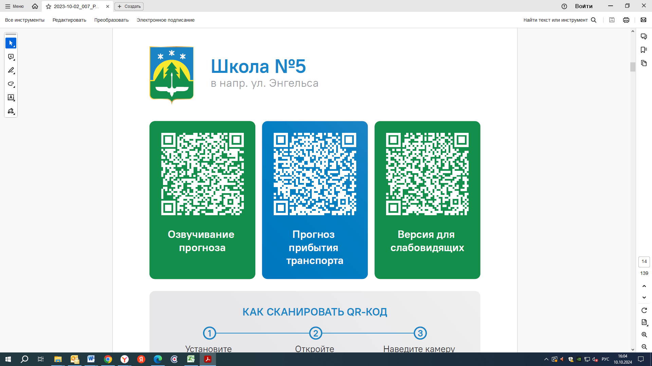



Контроль за осуществлением регулярных перевозок обеспечивает:
- управление транспорта, связи и дорог Администрации города Ханты-Мансийска, г: Ханты-Мансийск, ул Мира, 13, тел: 8 (3467) 39-39-07;
- отдел государственного автодорожного надзора по ХМАО – Югре, г: Ханты-Мансийск, ул: Шевченко 36А, тел: (3467) 32-64-60;
- МО МВД России «Ханты-Мансийский» г: Ханты-Мансийск, ул: Дзержинского дом 11, телефоны дежурной части (3467) 398-104, 398-103, 102 и 112

