  Горпищекомбинат |  |  |  |  |  |  |  |  |  | А
По регулируемым тарифам
Номер маршрута | Конечный остановочный пункт | ДНИ | Время начала и окончания движения | Временной график отправления транспортных средств от остановочного пункта
1 | Автореч вокзал  (по Гагарина) | Будни | 6:13-22:38 | 6:13, 6:58, 7:18, 7:48, 8:11, 8:38, 8:53, 9:33, 10:13, 10:28, 11:13, 12:13, 13:18, 14:18, 14:53, 15:43, 16:43, 17:28, 17:43, 18:28, 19:08, 19:28, 20:08, 20:43, 21:08, 21:43, 22:38
 |  | Выходные | 6:28-21:43 | 6:28, 7:28, 8:08, 9:08, 9:48, 10:48, 11:48, 12:48, 13:28, 14:28, 15:08, 16:08, 16:48, 17:28, 17:48, 18:28, 19:08, 20:08, 20:43, 21:43
1А | Автореч вокзал  (по Объездной) | Будни | 6:25-21:50 | 6:25, 7:25, 8:10, 8:45, 9:05, 9:45, 10:55, 11:40, 12:45, 13:25, 14:25, 15:25, 16:45, 17:10, 17:45, 18:40, 18:45, 19:45, 20:15, 20:30, 21:15, 21:50
 |  | Выходные | 7:10-21:05 | 7:10, 7:45, 8:45, 9:25, 10:25, 11:05, 12:05, 13:05, 13:45, 14:45, 15:35, 16:25, 17:10, 17:35, 18:05, 18:55, 19:25, 20:30, 21:05
2 | Сельхозтехника | ежедневно | 6:55-19:05 | 6:55, 7:55, 8:55, 9:55, 11:55, 12:55, 13:55, 14:55, 17:05, 18:05, 19:05
4 | мкр. Береговая зона | Будни | 6:42-22:32 | 6:42, 7:12, 7:42, 8:02, 8:27, 8:47, 9:07, 9:27, 9:42, 10:02, 10:47, 11:42, 12:02, 12:42, 13:12, 13:52, 14:02, 14:42, 15:12, 16:02, 16:17, 16:42, 17:07, 17:22, 17:42, 18:12, 18:22, 18:42, 19:07, 19:47, 20:07, 20:27, 21:02, 21:42, 22:32
 |  | Выходные | 6:42-21:42 | 6:42, 7:42, 8:42, 9:42, 10:42, 11:42, 12:42, 13:42, 14:12, 14:42, 15:42, 16:12, 16:42, 17:42, 18:42, 19:42, 20:42, 21:42
5 | Ледовый дворец | Будни  с 01.06 по 31.08 | 5:27-23:52 | 5:27, 6:02, 6:42, 6:52, 7:12, 7:42, 8:02, 8:32, 8:42, 8:52, 9:07, 9:22, 9:42, 10:02, 10:12, 10:22, 10:42, 11:02, 11:22, 11:42, 12:02, 12:22, 12:42, 13:02, 13:22, 13:42, 14:02, 14:22, 14:42, 15:02, 15:22, 15:42, 16:02, 16:22, 16:42, 16:57, 17:12, 17:27, 17:42, 17:57, 18:12, 18:27, 18:42, 18:57, 19:12, 19:27, 19:42, 20:02, 20:22, 20:42, 20:57, 21:22, 21:42, 21:57, 22:12, 22:42, 23:12, 23:52
 |  | Выходные  с 01.06 по 31.08 | 5:27-23:52 | 5:27, 6:02, 6:42, 7:12, 7:42, 8:02, 8:42, 9:02, 9:22, 9:42, 10:02, 10:22, 10:42, 11:02, 11:22, 11:42, 12:02, 12:22, 12:42, 13:02, 13:22, 13:42, 14:02, 14:22, 14:42, 15:02, 15:22, 15:42, 16:02, 16:22, 16:42, 17:02, 17:22, 17:42, 18:02, 18:22, 18:42, 19:02, 19:22, 19:42, 20:02, 20:22, 20:42, 21:02, 21:22, 21:42, 21:57, 22:12, 22:42, 23:12, 23:52
 |  | Будни  с 01.09 по 31.05 | 5:27-23:52 | 5:27, 6:02, 6:42, 6:52, 7:02, 7:12, 7:22, 7:32, 7:42, 8:02, 8:12, 8:32, 8:42, 8:52, 9:07, 9:22, 9:42, 10:02, 10:22, 10:42, 11:02, 11:22, 11:42, 12:02, 12:22, 12:42, 12:57, 13:12, 13:27, 13:42, 14:02, 14:22, 14:42, 15:02, 15:22, 15:42, 15:57, 16:12, 16:27, 16:42, 16:57, 17:12, 17:27, 17:42, 17:57, 18:12, 18:27, 18:42, 18:57, 19:12, 19:27, 19:42, 20:02, 20:22, 20:42, 20:57, 21:12, 21:27, 21:42, 21:57, 22:12, 22:42, 23:12, 23:52
 |  | Выходные  с 01.09 по 31.05 | 5:27-23:52 | 5:27, 6:02, 6:42, 6:52, 7:12, 7:42, 8:02, 8:32, 8:42, 8:52, 9:07, 9:22, 9:42, 10:02, 10:12, 10:22, 10:42, 11:02, 11:22, 11:42, 12:02, 12:22, 12:42, 13:02, 13:22, 13:42, 14:02, 14:22, 14:42, 15:02, 15:22, 15:42, 16:02, 16:22, 16:42, 16:57, 17:12, 17:27, 17:42, 17:57, 18:12, 18:27, 18:42, 18:57, 19:12, 19:22, 19:42, 20:02, 20:22, 20:42, 20:57, 21:22, 21:42, 21:57, 22:12, 22:42, 23:12, 23:52
21 | Ключевая | Будни | 7:25-22:55 | 7:25, 7:45, 8:05, 8:25, 8:45, 9:05, 9:25, 9:45, 10:05, 10:35, 11:05, 11:40, 12:05, 12:35, 13:35, 14:10, 15:10, 15:45, 16:05, 16:45, 17:05, 17:25, 17:45, 18:05, 18:25, 18:45, 19:05, 19:25, 19:45, 20:05, 20:25, 21:05, 20:25, 22:05, 22:55
 |  | Выходные | 7:25-22:55 | 7:25, 8:05, 9:05, 9:45, 10:05, 11:40, 12:35, 13:35, 14:10, 15:10, 15:45, 16:45, 17:25, 18:05, 18:25, 19:05, 19:45, 20:05, 21:20, 22:55
77 | Сельхозтехника | Будни | 7:46-22:16 | 7:49, 8:34, 8:44, 9:21, 9:49, 10:44, 11:19, 12:09, 13:34, 14:16, 15:01, 15:54, 16:24, 17:14, 17:54, 18:24, 18:59, 19:09, 20:04, 20:14, 21:04, 21:19, 22:19
 |  | Выходные | 7:54-22:19 | 7:54, 8:24, 8:44, 9:21, 9:54, 10:44, 11:19, 12:09, 13:14, 14:09, 14:41, 15:44, 16:24, 17:14, 17:44, 18:14, 18:46, 19:09, 19:39, 20:14, 20:54, 21:19, 22:19
77А | Сельхозтехника | Будни | 6:37-21:57 | 6:37, 7:07, 7:37, 7:57, 8:22, 8:42, 8:57, 9:17, 9:37, 9:57, 10:37, 11:17, 11:37, 12:37, 13:17, 14:17, 14:57, 15:57, 16:37, 16:57, 17:17, 17:37, 17:57, 18:17, 18:37, 18:57, 19:17, 19:37, 20:17, 20:37, 21:17, 21:57
 |  | Выходные | 7:37-22:07 | 7:37, 8:37, 9:17, 10:17, 10:57, 11:57, 12:37, 13:37, 14:37, 16:17, 16:37, 17:57, 18:17, 18:37, 19:37, 20:07, 20:37, 22:07
По нерегулируемым тарифам
Номер маршрута | Конечный остановочный пункт | ДНИ | Время начала и окончания движения | Интервал отправления транспортных средств от остановочного пункта
7К | ТД «Сатурн» |  |  | до 10:00 | 10:00 -11:00 | 11:00 -15:00 | 15:00 -16:00 | 16:00 – 20:00 | после 20:00
 |  | Будни | 6:30-22:00 | 15 | 20 | 15 | 20 | 15 | 20
 |  | Суббота | 6:30-22:00 | 20 | 25 | 20 | 25 | 20 | 25
 |  | Воскресенье | 6:30-21:00 | 20 | 25 | 25 | 25 | 25 | 30
8К | Гимназия №1 |  |  | до 10:00 | 10:00 -11:00 | 11:00 -15:00 | 15:00 -16:00 | 16:00 – 20:00 | после 20:00
 |  | Будни | 6:30-22:00 | 15 | 20 | 15 | 20 | 15 | 20
 |  | Суббота | 6:30-22:00 | 20 | 25 | 20 | 25 | 20 | 25
 |  | Воскресенье | 6:30-21:00 | 20 | 25 | 25 | 25 | 25 | 30
9К | мкр. Береговая зона |  |  | до 10:00 | 10:00 -11:00 | 11:00 -15:00 | 15:00 -16:00 | 16:00 – 20:00 | после 20:00
 |  | Будни | 6:30-22:00 | 15 | 20 | 15 | 20 | 15 | 20
 |  | Суббота | 6:30-22:00 | 20 | 25 | 20 | 25 | 20 | 25
 |  | Воскресенье | 6:30-21:00 | 20 | 25 | 25 | 25 | 25 | 30
26К | Гимназия №1 |  |  | до 10:00 | 10:00 -11:00 | 11:00 -15:00 | 15:00 -16:00 | 16:00 – 20:00 | после 20:00
 |  | Будни | 6:30-22:00 | 15 | 20 | 15 | 20 | 15 | 20
 |  | Суббота | 6:30-22:00 | 20 | 25 | 20 | 25 | 20 | 25
 |  | Воскресенье | 6:30-21:00 | 20 | 25 | 25 | 25 | 25 | 30
Прогноз прибытия пассажирского транспорта
в вашем мобильном телефоне

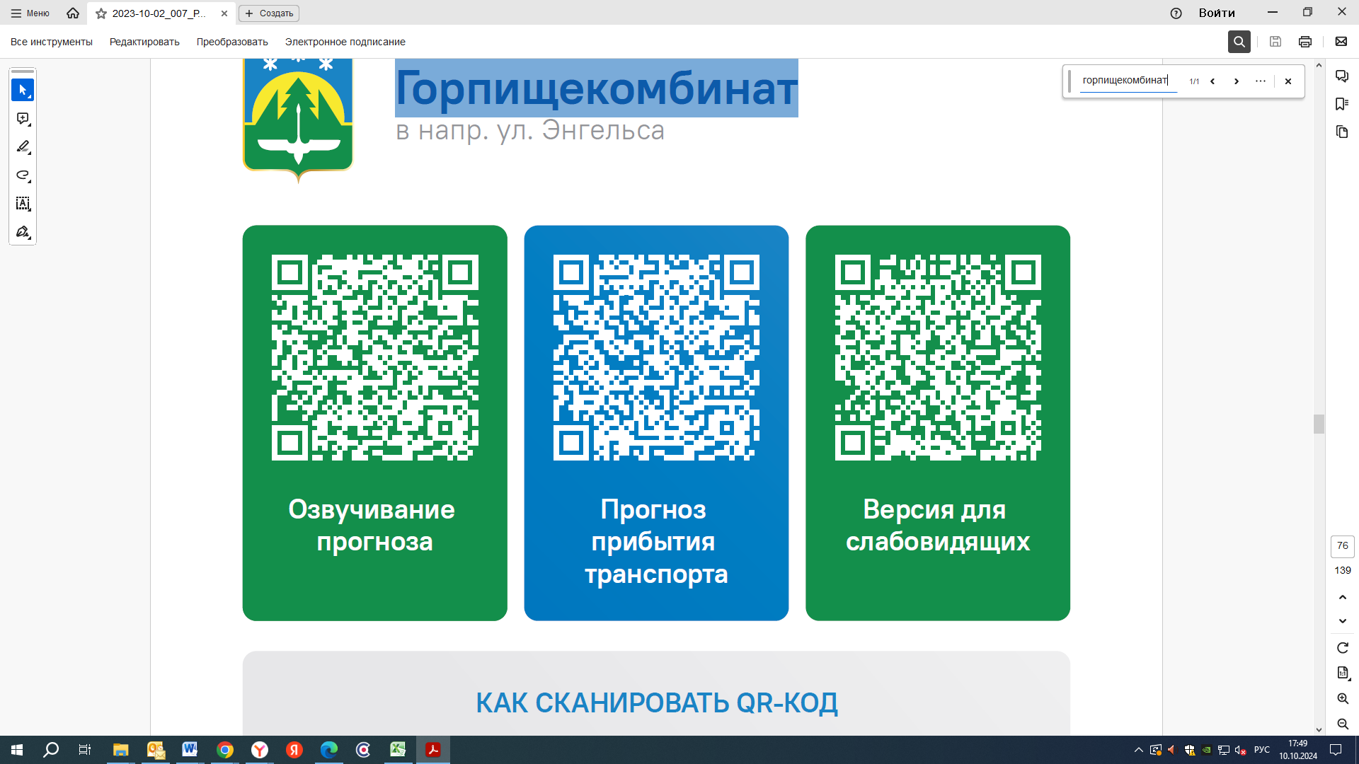



Контроль за осуществлением регулярных перевозок обеспечивает:
- управление транспорта, связи и дорог Администрации города Ханты-Мансийска, г: Ханты-Мансийск, ул Мира, 13, тел: 8 (3467) 39-39-07;
- отдел государственного автодорожного надзора по ХМАО – Югре, г: Ханты-Мансийск, ул: Шевченко 36А, тел: (3467) 32-64-60;
- МО МВД России «Ханты-Мансийский» г: Ханты-Мансийск, ул: Дзержинского дом 11, телефоны дежурной части (3467) 398-104, 398-103, 102 и 112

