  Главпочтамт |  |  |  |  |  |  |  |  | А
По регулируемым тарифам
Номер маршрута | Конечный остановочный пункт | ДНИ | Время начала и окончания движения | Временной график отправления транспортных средств от остановочного пункта
1А | Учхоз | Будни | 6:13-21:50 | 6:13, 7:00, 8:00, 8:45, 9:20, 9:40, 10:20, 11:30, 12:15, 13:20, 14:00, 15:00, 16:00, 17:20, 17:45, 18:20, 19:15, 19:20, 20:20, 20:50, 21:05, 21:50
 |  | Выходные | 7:45-21:40 | 7:45, 8:20, 9:20, 10:00, 11:00, 11:40, 12:40, 13:40, 14:20, 15:20, 16:10, 17:00, 17:45, 18:10, 18:40, 19:30, 20:00, 21:05, 21:40
4 | ОМК | Будни | 6:32-22:32 | 6:32, 6:52, 7:12, 7:32, 7:57, 8:12, 8:32, 8:52, 9:12, 9:32, 9:52, 10:32, 10:52, 11:32, 12:32, 12:52, 13:32, 14:02, 14:52, 15:32, 16:12, 16:32, 16:52, 17:12, 17:32, 17:52, 18:12, 18:32, 18:57, 19:12, 19:52, 20:32, 20:52, 21:22, 21:52, 22:32
 |  | Выходные | 6:32-22:32 | 6:32, 7:32, 8:32, 9:32, 10:32, 11:32, 12:32, 13:32, 14:32, 15:02, 15:32, 16:32, 17:02, 17:32, 18:32, 19:32, 20:32, 21:32, 22:32
5 | Мкр. Восточный | Будни  с 01.06 по 31.08 | 6:02-23:07 | 6:02, 6:42, 7:02, 7:34, 7:44, 8:04, 8:12, 8:22, 8:32, 8:42, 9:02, 9:27, 9:37, 9:52, 10:02, 10:22, 10:37, 10:52, 11:02, 11:12, 11:22, 11:42, 12:02, 12:22, 12:42, 13:02, 13:22, 13:42, 14:02, 14:22, 14:42, 15:02, 15:22, 15:42, 16:02, 16:22, 16:42, 17:02, 17:22, 17:37, 17:52, 18:07, 18:27, 18:37, 18:52, 19:07, 19:22, 19:37, 19:52, 20:07, 20:22, 20:42, 21:02, 21:22, 21:37, 21:52, 22:22, 22:52, 23:07
 |  | Выходные  с 01.06 по 31.08 | 6:02-23:07 | 6:02, 6:42, 7:02, 7:34, 8:04, 8:22, 8:42, 9:02, 9:22, 9:42, 10:02, 10:22, 10:42, 11:02, 11:22, 11:42, 12:02, 12:22, 12:42, 13:02, 13:22, 13:42, 14:02, 14:22, 14:42, 15:02, 15:22, 15:42, 16:02, 16:22, 16:42, 17:02, 17:22, 17:42, 18:02, 18:22, 18:42, 19:02, 19:22, 19:42, 20:02, 20:22, 20:42, 21:02, 21:22, 21:37, 22:02, 22:22, 22:52, 23:37
 |  | Будни  с 01.09 по 31.05 | 6:02-00:07 | 6:02, 6:42, 7:02, 7:34, 7:44, 8:02, 8:12, 8:22, 8:32, 8:42, 9:02, 9:12, 9:27, 9:37, 9:47, 10:02, 10:22, 10:42, 11:02, 11:12, 11:22, 11:42, 12:02, 12:22, 12:42, 13:02, 13:22, 13:37, 13:52, 14:07, 14:22, 14:42, 15:02, 15:22, 15:42, 16:02, 16:22, 16:37, 16:52, 17:07, 17:22, 17:37, 17:52, 18:07, 18:22, 18:37, 18:52, 19:07, 19:22, 19:37, 19:52, 20:07, 20:22, 20:42, 21:02, 21:22, 21:37, 21:52, 22:07, 22:22, 22:37, 22:52, 23:37, 23:52, 0:07
 |  | Выходные с 01.09 по 31.05 | 6:42-00:07 | 6:42, 7:02, 7:34, 7:44, 8:04, 8:22, 8:42, 9:02, 9:27, 9:37, 9:47, 10:02, 10:22, 10:37, 10:52, 11:02, 11:12, 11:22, 11:42, 12:02, 12:22, 12:42, 13:02, 13:22, 13:42, 14:02, 14:22, 14:42, 15:02, 15:22, 16:02, 16:02, 16:22, 16:42, 17:02, 17:22, 17:37, 17:52, 18:07, 18:22, 18:37, 18:52, 19:07, 19:22, 19:37, 19:52, 20:07, 20:22, 20:42, 21:02, 21:22, 21:37, 21:52, 22:22, 22:52, 23:07, 23:37, 0:07
8 | ОМК | Будни | 6:17-22:57 | 6:17, 6:47, 7:22, 7:52, 8:17, 8:27, 8:57, 9:17, 9:42, 10:37, 11:27, 12:27, 12:57, 13:37, 14:07, 15:17, 16:17, 16:32, 16:57, 17:32, 17:57, 18:32, 18:57, 19:37, 19:57, 21:27, 22:57
 |  | Выходные | 6:47-22:37 | 6:47, 7:57, 8:27, 8:57, 9:37, 10:37, 11:27, 11:57, 12:27, 12:57, 13:57, 14:57, 15:57, 16:57, 17:57, 18:42, 19:17, 21:25, 21:27, 22:37
21 | Теннисный центр | Будни | 6:38-22:08 | 6:38, 6:58, 7:18, 7:38, 7:58, 8:18, 8:38, 8:58, 9:18, 9:48, 10:18, 10:53, 11:18, 11:48, 12:48, 13:23, 14:23, 14:58, 15:18, 15:58, 16:18, 16:38, 16:58, 17:18, 17:38, 17:58, 18:18, 18:38, 18:58, 19:18, 19:38, 20:18, 20:33, 21:18, 22:08
 |  | Выходные | 6:38-22:08 | 6:38, 7:18, 8:18, 8:58, 9:18, 10:53, 11:48, 12:48, 13:23, 14:23, 14:58, 15:58, 16:38, 17:18, 17:38, 18:18, 18:58, 19:18, 20:33, 22:08
77 | Сельхозтехника | Будни | 7:38-22:08 | 7:38, 8:23, 8:33, 9:10, 9:38, 10:33, 11:08, 11:58, 13:23, 14:05, 14:50, 15:43, 16:13, 17:03, 17:43, 18:13, 18:48, 18:58, 19:53, 20:03, 20:53, 21:08, 22:08
 |  | Выходные | 7:38-22:08 | 7:43, 8:13, 8:33, 9:10, 9:43, 10:33, 11:08, 11:58, 13:03, 13:58, 14:30, 15:33, 16:13, 17:03, 17:33, 18:03, 18:35, 18:58, 19:28, 20:03, 20:43, 21:08, 22:08
По нерегулируемым тарифам
Номер маршрута | Конечный остановочный пункт | ДНИ | Время начала и окончания движения | Интервал отправления транспортных средств от остановочного пункта
7К | Назымская экспедиция |  |  | до 10:00 | 10:00 -11:00 | 11:00 -15:00 | 15:00 -16:00 | 16:00 – 20:00 |  | после 20:00
 |  | Будни | 6:30-22:00 | 15 | 20 | 15 | 20 | 15 |  | 20
 |  | Суббота | 6:30-22:00 | 20 | 25 | 20 | 25 | 20 |  | 25
 |  | Воскресенье | 6:30-21:00 | 20 | 25 | 25 | 25 | 25 |  | 30
8К | ОМК |  |  | до 10:00 | 10:00 -11:00 | 11:00 -15:00 | 15:00 -16:00 | 16:00 – 20:00 |  | после 20:00
 |  | Будни | 6:30-22:00 | 15 | 20 | 15 | 20 | 15 |  | 20
 |  | Суббота | 6:30-22:00 | 20 | 25 | 20 | 25 | 20 |  | 25
 |  | Воскресенье | 6:30-21:00 | 20 | 25 | 25 | 25 | 25 |  | 30
9К | Аэропорт |  |  | до 10:00 | 10:00 -11:00 | 11:00 -15:00 | 15:00 -16:00 | 16:00 – 20:00 |  | после 20:00
 |  | Будни | 6:30-22:00 | 15 | 20 | 15 | 20 | 15 |  | 20
 |  | Суббота | 6:30-22:00 | 20 | 25 | 20 | 25 | 20 |  | 25
 |  | Воскресенье | 6:30-21:00 | 20 | 25 | 25 | 25 | 25 |  | 30
13К | База Ханты-Мансийскгаз |  |  | до 10:00 | 10:00 -11:00 | 11:00 -15:00 | 15:00 -16:00 | 16:00 – 20:00 |  | после 20:00
 |  | Будни | 6:30-22:00 | 15 | 20 | 15 | 20 | 15 |  | 20
 |  | Суббота | 6:30-22:00 | 20 | 25 | 20 | 25 | 20 |  | 25
 |  | Воскресенье | 6:30-21:00 | 20 | 25 | 25 | 25 | 25 |  | 30
26К | Теннисный центр |  |  | до 10:00 | 10:00 -11:00 | 11:00 -15:00 | 15:00 -16:00 | 16:00 – 20:00 |  | после 20:00
 |  | Будни | 6:30-22:00 | 15 | 20 | 15 | 20 | 15 |  | 20
 |  | Суббота | 6:30-22:00 | 20 | 25 | 20 | 25 | 20 |  | 25
 |  | Воскресенье | 6:30-21:00 | 20 | 25 | 25 | 25 | 25 |  | 30
Прогноз прибытия пассажирского транспорта
в вашем мобильном телефоне

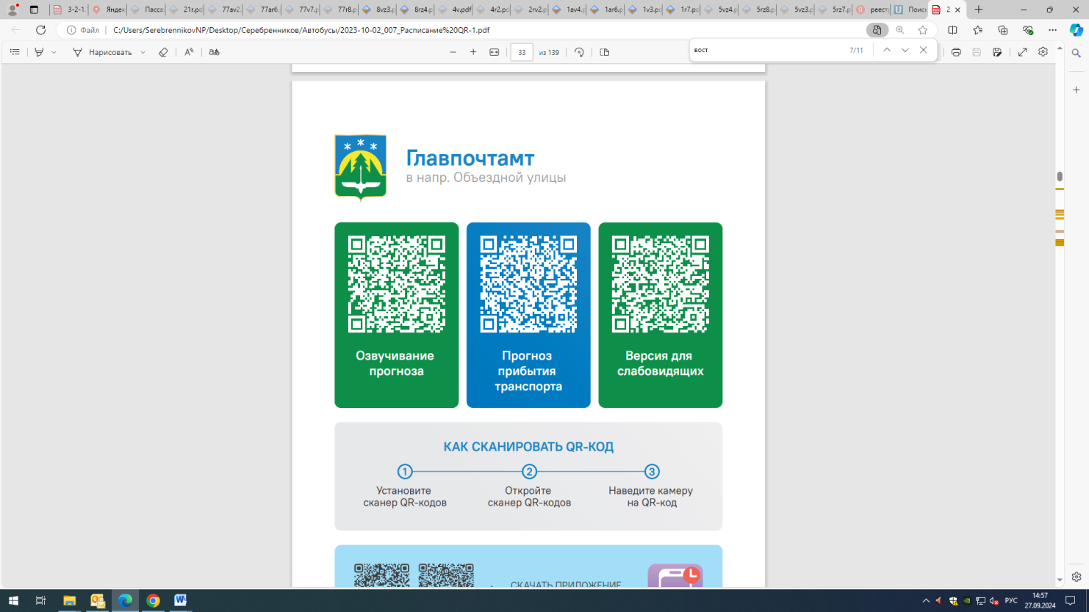



Контроль за осуществлением регулярных перевозок обеспечивает:
- управление транспорта, связи и дорог Администрации города Ханты-Мансийска, г: Ханты-Мансийск, ул Мира, 13, тел: 8 (3467) 39-39-07;
- отдел государственного автодорожного надзора по ХМАО – Югре, г: Ханты-Мансийск, ул: Шевченко 36А, тел: (3467) 32-64-60;
- МО МВД России «Ханты-Мансийский» г: Ханты-Мансийск, ул: Дзержинского дом 11, телефоны дежурной части 8 (3467) 398-104, 398-103, 102 и 112

