  Школа №1 |  |  |  |  |  |  |  |  | А
По регулируемым тарифам
Номер маршрута | Конечный остановочный пункт | ДНИ | Время начала и окончания движения | Временной график отправления транспортных средств от остановочного пункта
1 | Автореч вокзал  (по Гагарина) | Будни | 6:11-22:36 | 6:11, 6:56, 7:16, 7:46, 8:09, 8:36, 8:51, 9:31, 10:11, 10:26, 11:11, 12:11, 13:16, 14:16, 14:51, 15:41, 16:41, 17:26, 17:41, 18:26, 19:06, 19:26, 20:06, 20:41, 21:06, 21:41, 22:36
 |  | Выходные | 6:26-21:41 | 6:26, 7:26, 8:06, 9:06, 9:46, 10:46, 11:46, 12:46, 13:26, 14:26, 15:06, 16:06, 16:46, 17:26, 17:46, 18:26, 19:06, 20:06, 20:41, 21:41
1А | Автореч вокзал  (по Объездной) | Будни | 6:23-21:48 | 6:23, 7:23, 8:08, 8:43, 9:03, 9:43, 10:53, 11:38, 12:43, 13:23, 14:23, 15:23, 16:43, 17:08, 17:43, 18:38, 18:43, 19:43, 20:13, 20:28, 21:13, 21:48
 |  | Выходные | 7:08-21:03 | 7:08, 7:43, 8:43, 9:23, 10:23, 11:03, 12:03, 13:03, 13:43, 14:43, 15:33, 16:23, 17:08, 17:33, 18:03, 18:53, 19:23, 20:28, 21:03
2 | Сельхозтехника | ежедневно | 6:53-19:03 | 6:53, 7:53, 8:53, 9:53, 11:53, 12:53, 13:53, 14:53, 17:03, 18:03, 19:03
4 | мкр. Береговая зона | Будни | 6:41-22:31 | 6:41, 7:11, 7:41, 8:01, 8:26, 8:46, 9:06, 9:26, 9:41, 10:01, 10:46, 11:41, 12:01, 12:41, 13:11, 13:51, 14:01, 14:41, 15:11, 16:01, 16:16, 16:41, 17:06, 17:21, 17:41, 18:11, 18:21, 18:41, 19:06, 19:46, 20:06, 20:26, 21:01, 21:41, 22:31
 |  | Выходные | 6:41-21:41 | 6:41, 7:41, 8:41, 9:41, 10:41, 11:41, 12:41, 13:41, 14:11, 14:41, 15:41, 16:11, 16:41, 17:41, 18:41, 19:41, 20:41, 21:41
5 | Ледовый дворец | Будни  с 01.06 по 31.08 | 5:26-23:51 | 5:26, 6:01, 6:41, 6:51, 7:11, 7:41, 8:01, 8:31, 8:41, 8:51, 9:06, 9:21, 9:41, 10:01, 10:11, 10:21, 10:41, 11:01, 11:21, 11:41, 12:01, 12:21, 12:41, 13:01, 13:21, 13:41, 14:01, 14:21, 14:41, 15:01, 15:21, 15:41, 16:01, 16:21, 16:41, 16:56, 17:11, 17:26, 17:41, 17:56, 18:11, 18:26, 18:41, 18:56, 19:11, 19:26, 19:41, 20:01, 20:21, 20:41, 20:56, 21:21, 21:41, 21:56, 22:11, 22:41, 23:11, 23:51
 |  | Выходные  с 01.06 по 31.08 | 5:26-23:51 | 5:26, 6:01, 6:41, 7:11, 7:41, 8:01, 8:41, 9:01, 9:21, 9:41, 10:01, 10:21, 10:41, 11:01, 11:21, 11:41, 12:01, 12:21, 12:41, 13:01, 13:21, 13:41, 14:01, 14:21, 14:41, 15:01, 15:21, 15:41, 16:01, 16:21, 16:41, 17:01, 17:21, 17:41, 18:01, 18:21, 18:41, 19:01, 19:21, 19:41, 20:01, 20:21, 20:41, 21:01, 21:21, 21:41, 21:56, 22:11, 22:41, 23:11, 23:51
 |  | Будни  с 01.09 по 31.05 | 5:26-23:51 | 5:26, 6:01, 6:41, 6:51, 7:01, 7:11, 7:21, 7:31, 7:41, 8:01, 8:11, 8:31, 8:41, 8:51, 9:06, 9:21, 9:41, 10:01, 10:21, 10:41, 11:01, 11:21, 11:41, 12:01, 12:21, 12:41, 12:56, 13:11, 13:26, 13:41, 14:01, 14:21, 14:41, 15:01, 15:21, 15:41, 15:56, 16:11, 16:26, 16:41, 16:56, 17:11, 17:26, 17:41, 17:56, 18:11, 18:26, 18:41, 18:56, 19:11, 19:26, 19:41, 20:01, 20:21, 20:41, 20:56, 21:11, 21:26, 21:41, 21:56, 22:11, 22:41, 23:11, 23:51
 |  | Выходные  с 01.09 по 31.05 | 5:26-23:51 | 5:26, 6:01, 6:41, 6:51, 7:11, 7:41, 8:01, 8:31, 8:41, 8:51, 9:06, 9:21, 9:41, 10:01, 10:11, 10:21, 10:41, 11:01, 11:21, 11:41, 12:01, 12:21, 12:41, 13:01, 13:21, 13:41, 14:01, 14:21, 14:41, 15:01, 15:21, 15:41, 16:01, 16:21, 16:41, 16:56, 17:11, 17:26, 17:41, 17:56, 18:11, 18:26, 18:41, 18:56, 19:11, 19:21, 19:41, 20:01, 20:21, 20:41, 20:56, 21:21, 21:41, 21:56, 22:11, 22:41, 23:11, 23:51
21 | Ключевая | Будни | 7:24-22:54 | 7:24, 7:44, 8:04, 8:24, 8:44, 9:04, 9:24, 9:44, 10:04, 10:34, 11:04, 11:39, 12:04, 12:34, 13:34, 14:09, 15:09, 15:44, 16:04, 16:44, 17:04, 17:24, 17:44, 18:04, 18:24, 18:44, 19:04, 19:24, 19:44, 20:04, 20:24, 21:04, 20:24, 22:04, 22:54
 |  | Выходные | 7:24-22:52 | 7:24, 8:04, 9:04, 9:44, 10:04, 11:39, 12:34, 13:34, 14:09, 15:09, 15:44, 16:44, 17:24, 18:04, 18:24, 19:04, 19:44, 20:04, 21:19, 22:54
77 | Сельхозтехника | Будни | 7:48-22:18 | 7:48, 8:33, 8:43, 9:20, 9:48, 10:43, 11:18, 12:08, 13:33, 14:15, 15:00, 15:53, 16:23, 17:13, 17:53, 18:23, 18:58, 19:08, 20:03, 20:13, 21:03, 21:18, 22:18
 |  | Выходные | 7:53-22:18 | 7:53, 8:23, 8:43, 9:20, 9:53, 10:43, 11:18, 12:08, 13:13, 14:08, 14:40, 15:43, 16:23, 17:13, 17:43, 18:13, 18:45, 19:08, 19:38, 20:13, 20:53, 21:18, 22:18
77А | Сельхозтехника | Будни | 6:36-21:56 | 6:36, 7:06, 7:36, 7:56, 8:21, 8:41, 8:56, 9:16, 9:36, 9:56, 10:36, 11:16, 11:36, 12:36, 13:16, 14:16, 14:56, 15:56, 16:36, 16:56, 17:16, 17:36, 17:56, 18:16, 18:36, 18:56, 19:16, 19:36, 20:16, 20:36, 21:16, 21:56
 |  | Выходные | 7:36-22:06 | 7:36, 8:36, 9:16, 10:16, 10:56, 11:56, 12:36, 13:36, 14:36, 16:16, 16:36, 17:56, 18:16, 18:36, 19:36, 20:06, 20:36, 22:06
По нерегулируемым тарифам
Номер маршрута | Конечный остановочный пункт | ДНИ | Время начала и окончания движения | Интервал отправления транспортных средств от остановочного пункта
7К | ТД «Сатурн» |  |  | до 10:00 | 10:00 -11:00 | 11:00 -15:00 | 15:00 -16:00 | 16:00 – 20:00 |  | после 20:00
 |  | Будни | 6:30-22:00 | 15 | 20 | 15 | 20 | 15 |  | 20
 |  | Суббота | 6:30-22:00 | 20 | 25 | 20 | 25 | 20 |  | 25
 |  | Воскресенье | 6:30-21:00 | 20 | 25 | 25 | 25 | 25 |  | 30
8К | Гимназия №1 |  |  | до 10:00 | 10:00 -11:00 | 11:00 -15:00 | 15:00 -16:00 | 16:00 – 20:00 |  | после 20:00
 |  | Будни | 6:30-22:00 | 15 | 20 | 15 | 20 | 15 |  | 20
 |  | Суббота | 6:30-22:00 | 20 | 25 | 20 | 25 | 20 |  | 25
 |  | Воскресенье | 6:30-21:00 | 20 | 25 | 25 | 25 | 25 |  | 30
9К | мкр. Береговая зона |  |  | до 10:00 | 10:00 -11:00 | 11:00 -15:00 | 15:00 -16:00 | 16:00 – 20:00 |  | после 20:00
 |  | Будни | 6:30-22:00 | 15 | 20 | 15 | 20 | 15 |  | 20
 |  | Суббота | 6:30-22:00 | 20 | 25 | 20 | 25 | 20 |  | 25
 |  | Воскресенье | 6:30-21:00 | 20 | 25 | 25 | 25 | 25 |  | 30
  26К | Гимназия №1 |  |  | до 10:00 | 10:00 -11:00 | 11:00 -15:00 | 15:00 -16:00 | 16:00 – 20:00 |  | после 20:00
 |  | Будни | 6:30-22:00 | 15 | 20 | 15 | 20 | 15 |  | 20
 |  | Суббота | 6:30-22:00 | 20 | 25 | 20 | 25 | 20 |  | 25
 |  |   Воскресенье  Прогноз прибытия пассажирского транспорта  в вашем мобильном телефоне | 6:30-21:00 | 20 | 25 | 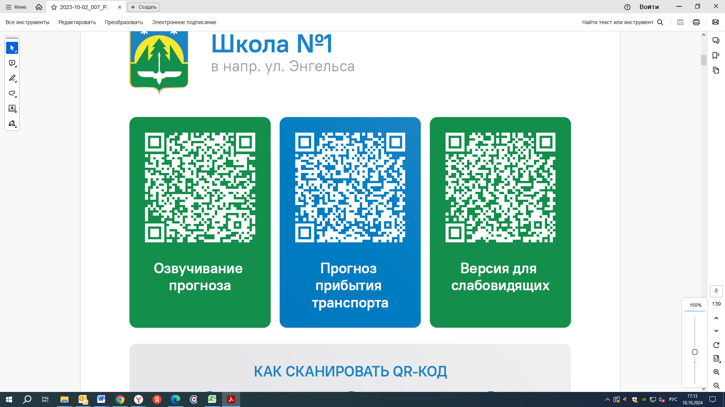  25 | 25 | 25 |  | 30
Контроль за осуществлением регулярных перевозок обеспечивает:
- управление транспорта, связи и дорог Администрации города Ханты-Мансийска, г: Ханты-Мансийск, ул Мира, 13, тел: 8 (3467) 39-39-07;
- отдел государственного автодорожного надзора по ХМАО – Югре, г: Ханты-Мансийск, ул: Шевченко 36А, тел: (3467) 32-64-60;
- МО МВД России «Ханты-Мансийский» г: Ханты-Мансийск, ул: Дзержинского дом 11, телефоны дежур ной части (3467) 398-104, 398-103, 102 и 112

