  Трансагенство |  |  |  |  |  |  |  |  |  | А
По регулируемым тарифам
Номер маршрута | Конечный остановочный пункт | ДНИ | Время начала и окончания движения | Временной график отправления транспортных средств от остановочного пункта
1 | Автореч вокзал  (по Гагарина) | Будни | 6:16-22:41 | 6:16, 7:01, 7:21, 7:51, 8:14, 8:41, 8:56, 9:36, 10:16, 10:31, 11:16, 12:16, 13:21, 14:21, 14:56, 15:46, 16:46, 17:31, 17:46, 18:31, 19:11, 19:31, 20:11, 20:46, 21:11, 21:46, 22:41
 |  | Выходные | 6:31-21:46 | 6:31, 7:31, 8:11, 9:11, 9:51, 10:51, 11:51, 12:51, 13:31, 14:31, 15:11, 16:11, 16:51, 17:31, 17:51, 18:31, 19:11, 20:11, 20:46, 21:46
4 | мкр. Береговая зона | Будни | 6:43-22:33 | 6:43, 7:13, 7:43, 8:03, 8:28, 8:48, 9:08, 9:28, 9:43, 10:03, 10:48, 11:43, 12:03, 12:43, 13:13, 13:53, 14:03, 14:43, 15:13, 16:03, 16:18, 16:43, 17:08, 17:23, 17:43, 18:13, 18:23, 18:43, 19:08, 19:48, 20:08, 20:28, 21:03, 21:43, 22:33
 |  | Выходные | 6:43-21:43 | 6:43, 7:43, 8:43, 9:43, 10:43, 11:43, 12:43, 13:43, 14:13, 14:43, 15:43, 16:13, 16:43, 17:43, 18:43, 19:43, 20:43, 21:43
5 | Ледовый дворец | Будни  с 01.06 по 31.08 | 5:29-23:54 | 5:29, 6:04, 6:44, 6:54, 7:14, 7:44, 8:04, 8:34, 8:44, 8:54, 9:09, 9:24, 9:44, 10:04, 10:14, 10:24, 10:44, 11:04, 11:24, 11:44, 12:04, 12:24, 12:44, 13:04, 13:24, 13:44, 14:04, 14:24, 14:44, 15:04, 15:24, 15:44, 16:04, 16:24, 16:44, 16:59, 17:14, 17:29, 17:44, 17:59, 18:14, 18:29, 18:44, 18:59, 19:14, 19:29, 19:44, 20:04, 20:24, 20:44, 20:59, 21:24, 21:44, 21:59, 22:14, 22:44, 23:14, 23:54
 |  | Выходные  с 01.06 по 31.08 | 5:29-23:54 | 5:29, 6:04, 6:44, 7:14, 7:44, 8:04, 8:44, 9:04, 9:24, 9:44, 10:04, 10:24, 10:44, 11:04, 11:24, 11:44, 12:04, 12:24, 12:44, 13:04, 13:24, 13:44, 14:04, 14:24, 14:44, 15:04, 15:24, 15:44, 16:04, 16:24, 16:44, 17:04, 17:24, 17:44, 18:04, 18:24, 18:44, 19:04, 19:24, 19:44, 20:04, 20:24, 20:44, 21:04, 21:24, 21:44, 21:59, 22:14, 22:44, 23:14, 23:54
 |  | Будни  с 01.09 по 31.05 | 5:29-23:54 | 5:29, 6:04, 6:44, 6:54, 7:04, 7:14, 7:24, 7:34, 7:44, 8:04, 8:14, 8:34, 8:44, 8:54, 9:09, 9:24, 9:44, 10:04, 10:24, 10:44, 11:04, 11:24, 11:44, 12:04, 12:24, 12:44, 12:59, 13:14, 13:29, 13:44, 14:04, 14:24, 14:44, 15:04, 15:24, 15:44, 15:59, 16:14, 16:29, 16:44, 16:59, 17:14, 17:29, 17:44, 17:59, 18:14, 18:29, 18:44, 18:59, 19:14, 19:29, 19:44, 20:04, 20:24, 20:44, 20:59, 21:14, 21:29, 21:44, 21:59, 22:14, 22:44, 23:14, 23:54
 |  | Выходные  с 01.09 по 31.05 | 5:29-23:54 | 5:29, 6:04, 6:44, 6:54, 7:14, 7:44, 8:04, 8:34, 8:44, 8:54, 9:09, 9:24, 9:44, 10:04, 10:14, 10:24, 10:44, 11:04, 11:24, 11:44, 12:04, 12:24, 12:44, 13:04, 13:24, 13:44, 14:04, 14:24, 14:44, 15:04, 15:24, 15:44, 16:04, 16:24, 16:44, 16:59, 17:14, 17:29, 17:44, 17:59, 18:14, 18:29, 18:44, 18:59, 19:14, 19:24, 19:44, 20:04, 20:24, 20:44, 20:59, 21:24, 21:44, 21:59, 22:14, 22:44, 23:14, 23:54
21 | Ключевая | Будни | 7:27-22:57 | 7:27, 7:47, 8:07, 8:27, 8:47, 9:07, 9:27, 9:47, 10:07, 10:37, 11:07, 11:42, 12:07, 12:37, 13:37, 14:12, 15:12, 15:47, 16:07, 16:47, 17:07, 17:27, 17:47, 18:07, 18:27, 18:47, 19:07, 19:27, 19:47, 20:07, 20:27, 21:07, 20:27, 22:07, 22:57
 |  | Выходные | 7:27-22:57 | 7:27, 8:07, 9:07, 9:47, 10:07, 11:42, 12:37, 13:37, 14:12, 15:12, 15:47, 16:47, 17:27, 18:07, 18:27, 19:07, 19:47, 20:07, 21:22, 22:57
77 | Гимназия №1 | Будни | 6:41-21:21 | 6:41, 7:11, 7:31, 8:11, 8:51, 9:41, 10:11, 11:11, 12:26, 13:11, 13:51, 14:36, 15:16, 16:11, 16:41, 17:11, 17:31, 18:11, 18:41, 19:16, 19:56, 20:21, 21:21
 |  | Выходные | 6:41-21:21 | 6:41, 7:11, 7:31, 8:11, 8:51, 9:41, 10:11, 11:11, 12:16, 13:11, 13:31, 14:36, 15:16, 16:11, 16:41, 17:11, 17:31, 18:11, 18:41, 19:16, 19:56, 20:21, 21:21
По нерегулируемым тарифам
Номер маршрута | Конечный остановочный пункт | ДНИ | Время начала и окончания движения | Интервал отправления транспортных средств от остановочного пункта
7К | ТД «Сатурн» |  |  | до 10:00 | 10:00 -11:00 | 11:00 -15:00 | 15:00 -16:00 | 16:00 – 20:00 | после 20:00
 |  | Будни | 6:30-22:00 | 15 | 20 | 15 | 20 | 15 | 20
 |  | Суббота | 6:30-22:00 | 20 | 25 | 20 | 25 | 20 | 25
 |  | Воскресенье | 6:30-21:00 | 20 | 25 | 25 | 25 | 25 | 30
8К | Гимназия №1 |  |  | до 10:00 | 10:00 -11:00 | 11:00 -15:00 | 15:00 -16:00 | 16:00 – 20:00 | после 20:00
 |  | Будни | 6:30-22:00 | 15 | 20 | 15 | 20 | 15 | 20
 |  | Суббота | 6:30-22:00 | 20 | 25 | 20 | 25 | 20 | 25
 |  | Воскресенье | 6:30-21:00 | 20 | 25 | 25 | 25 | 25 | 30
9К | мкр. Береговая зона |  |  | до 10:00 | 10:00 -11:00 | 11:00 -15:00 | 15:00 -16:00 | 16:00 – 20:00 | после 20:00
 |  | Будни | 6:30-22:00 | 15 | 20 | 15 | 20 | 15 | 20
 |  | Суббота | 6:30-22:00 | 20 | 25 | 20 | 25 | 20 | 25
 |  | Воскресенье | 6:30-21:00 | 20 | 25 | 25 | 25 | 25 | 30
13К | мкр. Береговая зона |  |  | до 10:00 | 10:00 -11:00 | 11:00 -15:00 | 15:00 -16:00 | 16:00 – 20:00 | после 20:00
 |  | Будни | 6:30-22:00 | 15 | 20 | 15 | 20 | 15 | 20
 |  | Суббота | 6:30-22:00 | 20 | 25 | 20 | 25 | 20 | 25
 |  | Воскресенье | 6:30-21:00 | 20 | 25 | 25 | 25 | 25 | 30
26К | Гимназия №1 |  |  | до 10:00 | 10:00 -11:00 | 11:00 -15:00 | 15:00 -16:00 | 16:00 – 20:00 | после 20:00
 |  | Будни | 6:30-22:00 | 15 | 20 | 15 | 20 | 15 | 20
 |  | Суббота | 6:30-22:00 | 20 | 25 | 20 | 25 | 20 | 25
 |  | Воскресенье | 6:30-21:00 | 20 | 25 | 25 | 25 | 25 | 30
Прогноз прибытия пассажирского транспорта
в вашем мобильном телефоне

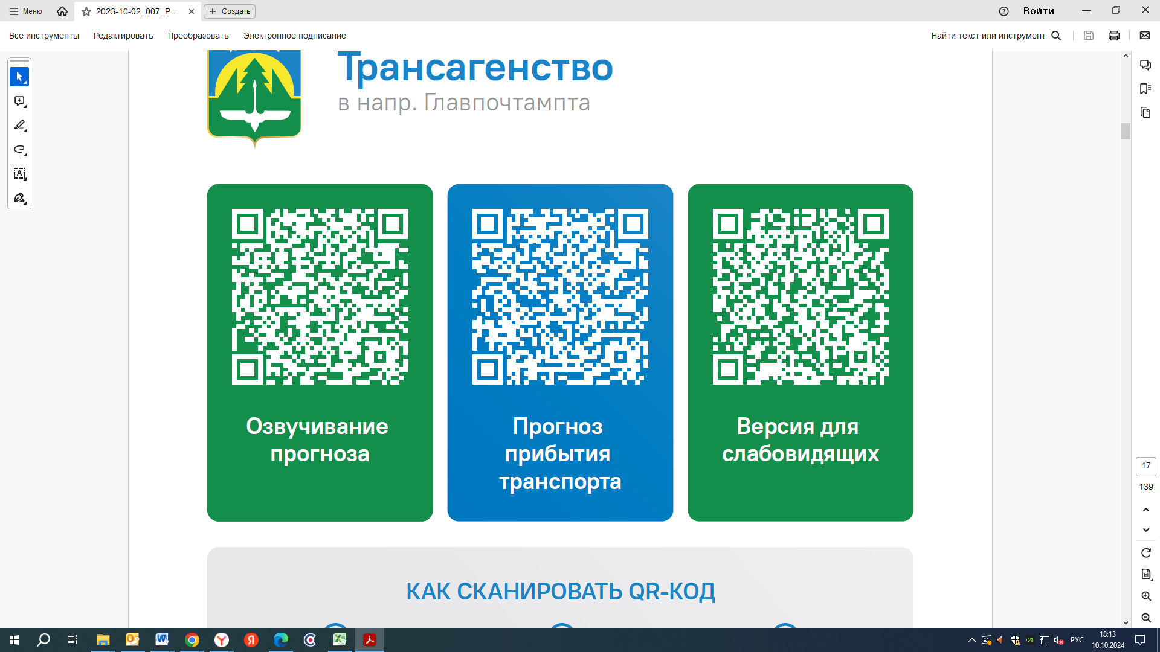



Контроль за осуществлением регулярных перевозок обеспечивает:
- управление транспорта, связи и дорог Администрации города Ханты-Мансийска, г: Ханты-Мансийск, ул Мира, 13, тел: 8 (3467) 39-39-07;
- отдел государственного автодорожного надзора по ХМАО – Югре, г: Ханты-Мансийск, ул: Шевченко 36А, тел: (3467) 32-64-60;
- МО МВД России «Ханты-Мансийский» г: Ханты-Мансийск, ул: Дзержинского дом 11, телефоны дежурной части (3467) 398-104, 398-103, 102 и 112

