  Главпочтамт |  |  |  |  |  |  |  |  |  | А
По регулируемым тарифам
Номер маршрута | Конечный остановочный пункт | ДНИ | Время начала и окончания движения | Временной график отправления транспортных средств от остановочного пункта
1 | Автореч вокзал  (по Гагарина) | Будни | 6:18-22:43 | 6:18, 7:03, 7:23, 7:53, 8:16, 8:43, 8:58, 9:38, 10:18, 10:33, 11:18, 12:18, 13:23, 14:23, 14:58, 15:48, 16:48, 17:33, 17:48, 18:33, 19:13, 19:33, 20:13, 20:48, 21:13, 21:48, 22:43
 |  | Выходные | 6:33-21:48 | 6:33, 7:33, 8:13, 9:13, 9:53, 10:53, 11:53, 12:53, 13:33, 14:33, 15:13, 16:13, 16:53, 17:33, 17:53, 18:33, 19:13, 20:13, 20:48, 21:48
4 | мкр. Береговая зона | Будни | 6:44-22:34 | 6:44, 7:14, 7:44, 8:04, 8:29, 8:49, 9:09, 9:29, 9:44, 10:04, 10:49, 11:44, 12:04, 12:44, 13:14, 13:54, 14:04, 14:44, 15:14, 16:04, 16:19, 16:44, 17:09, 17:24, 17:44, 18:14, 18:24, 18:44, 19:09, 19:49, 20:09, 20:29, 21:04, 21:44, 22:34
 |  | Выходные | 6:44-21:44 | 6:44, 7:44, 8:44, 9:44, 10:44, 11:44, 12:44, 13:44, 14:14, 14:44, 15:44, 16:14, 16:44, 17:44, 18:44, 19:44, 20:44, 21:44
5 | Ледовый дворец | Будни  с 01.06 по 31.08 | 5:31-23:56 | 5:31, 6:06, 6:46, 6:56, 7:16, 7:46, 8:06, 8:36, 8:46, 8:56, 9:11, 9:26, 9:46, 10:06, 10:16, 10:26, 10:46, 11:06, 11:26, 11:46, 12:06, 12:26, 12:46, 13:06, 13:26, 13:46, 14:06, 14:26, 14:46, 15:06, 15:26, 15:46, 16:06, 16:26, 16:46, 17:01, 17:16, 17:31, 17:46, 18:01, 18:16, 18:31, 18:46, 19:01, 19:16, 19:31, 19:46, 20:06, 20:26, 20:46, 21:01, 21:26, 21:46, 22:01, 22:16, 22:46, 23:16, 23:56
 |  | Выходные  с 01.06 по 31.08 | 5:31-23:56 | 5:31, 6:06, 6:46, 7:16, 7:46, 8:06, 8:46, 9:06, 9:26, 9:46, 10:06, 10:26, 10:46, 11:06, 11:26, 11:46, 12:06, 12:26, 12:46, 13:06, 13:26, 13:46, 14:06, 14:26, 14:46, 15:06, 15:26, 15:46, 16:06, 16:26, 16:46, 17:06, 17:26, 17:46, 18:06, 18:26, 18:46, 19:06, 19:26, 19:46, 20:06, 20:26, 20:46, 21:06, 21:26, 21:46, 22:01, 22:16, 22:46, 23:16, 23:56
 |  | Будни  с 01.09 по 31.05 | 5:31-23:56 | 5:31, 6:06, 6:46, 6:56, 7:06, 7:16, 7:26, 7:36, 7:46, 8:06, 8:16, 8:36, 8:46, 8:56, 9:11, 9:26, 9:46, 10:06, 10:26, 10:46, 11:06, 11:26, 11:46, 12:06, 12:26, 12:46, 13:01, 13:16, 13:31, 13:46, 14:06, 14:26, 14:46, 15:06, 15:26, 15:46, 16:01, 16:16, 16:31, 16:46, 17:01, 17:16, 17:31, 17:46, 18:01, 18:16, 18:31, 18:46, 19:01, 19:16, 19:31, 19:46, 20:06, 20:26, 20:46, 21:01, 21:16, 21:31, 21:46, 22:01, 22:16, 22:46, 23:16, 23:56
 |  | Выходные  с 01.09 по 31.05 | 5:31-23:54 | 5:31, 6:06, 6:46, 6:56, 7:16, 7:46, 8:06, 8:36, 8:46, 8:56, 9:11, 9:26, 9:46, 10:06, 10:16, 10:26, 10:46, 11:06, 11:26, 11:46, 12:06, 12:26, 12:46, 13:06, 13:26, 13:46, 14:06, 14:26, 14:46, 15:06, 15:26, 15:46, 16:06, 16:26, 16:46, 17:01, 17:16, 17:31, 17:46, 18:01, 18:16, 18:31, 18:46, 19:01, 19:16, 19:26, 19:46, 20:06, 20:26, 20:46, 21:01, 21:26, 21:46, 22:01, 22:16, 22:46, 23:16, 23:56
21 | Ключевая | Будни | 7:28-22:58 | 7:28, 7:48, 8:08, 8:28, 8:48, 9:08, 9:28, 9:48, 10:08, 10:38, 11:08, 11:43, 12:08, 12:38, 13:38, 14:13, 15:13, 15:48, 16:08, 16:48, 17:08, 17:28, 17:48, 18:08, 18:28, 18:48, 19:08, 19:28, 19:48, 20:08, 20:28, 21:08, 20:28, 22:08, 22:58
 |  | Выходные | 7:28-22:58 | 7:28, 8:08, 9:08, 9:48, 10:08, 11:43, 12:38, 13:38, 14:13, 15:13, 15:48, 16:48, 17:28, 18:08, 18:28, 19:08, 19:48, 20:08, 21:23, 22:58
77 | Гимназия №1 | Будни | 6:42-21:22 | 6:42, 7:12, 7:32, 8:12, 8:52, 9:42, 10:12, 11:12, 12:27, 13:12, 13:52, 14:37, 15:17, 16:12, 16:42, 17:12, 17:32, 18:12, 18:42, 19:17, 19:57, 20:22, 21:22
 |  | Выходные | 6:42-21:22 | 6:42, 7:12, 7:32, 8:12, 8:52, 9:42, 10:12, 11:12, 12:17, 13:12, 13:32, 14:37, 15:17, 16:12, 16:42, 17:12, 17:32, 18:12, 18:42, 19:17, 19:57, 20:22, 21:22
По нерегулируемым тарифам
Номер маршрута | Конечный остановочный пункт | ДНИ | Время начала и окончания движения | Интервал отправления транспортных средств от остановочного пункта
7К | ТД «Сатурн» |  |  | до 10:00 | 10:00 -11:00 | 11:00 -15:00 | 15:00 -16:00 | 16:00 – 20:00 | после 20:00
 |  | Будни | 6:30-22:00 | 15 | 20 | 15 | 20 | 15 | 20
 |  | Суббота | 6:30-22:00 | 20 | 25 | 20 | 25 | 20 | 25
 |  | Воскресенье | 6:30-21:00 | 20 | 25 | 25 | 25 | 25 | 30
8К | Гимназия №1 |  |  | до 10:00 | 10:00 -11:00 | 11:00 -15:00 | 15:00 -16:00 | 16:00 – 20:00 | после 20:00
 |  | Будни | 6:30-22:00 | 15 | 20 | 15 | 20 | 15 | 20
 |  | Суббота | 6:30-22:00 | 20 | 25 | 20 | 25 | 20 | 25
 |  | Воскресенье | 6:30-21:00 | 20 | 25 | 25 | 25 | 25 | 30
9К | мкр. Береговая зона |  |  | до 10:00 | 10:00 -11:00 | 11:00 -15:00 | 15:00 -16:00 | 16:00 – 20:00 | после 20:00
 |  | Будни | 6:30-22:00 | 15 | 20 | 15 | 20 | 15 | 20
 |  | Суббота | 6:30-22:00 | 20 | 25 | 20 | 25 | 20 | 25
 |  | Воскресенье | 6:30-21:00 | 20 | 25 | 25 | 25 | 25 | 30
13К | мкр. Береговая зона |  |  | до 10:00 | 10:00 -11:00 | 11:00 -15:00 | 15:00 -16:00 | 16:00 – 20:00 | после 20:00
 |  | Будни | 6:30-22:00 | 15 | 20 | 15 | 20 | 15 | 20
 |  | Суббота | 6:30-22:00 | 20 | 25 | 20 | 25 | 20 | 25
 |  | Воскресенье | 6:30-21:00 | 20 | 25 | 25 | 25 | 25 | 30
26К | Гимназия №1 |  |  | до 10:00 | 10:00 -11:00 | 11:00 -15:00 | 15:00 -16:00 | 16:00 – 20:00 | после 20:00
 |  | Будни | 6:30-22:00 | 15 | 20 | 15 | 20 | 15 | 20
 |  | Суббота | 6:30-22:00 | 20 | 25 | 20 | 25 | 20 | 25
 |  | Воскресенье | 6:30-21:00 | 20 | 25 | 25 | 25 | 25 | 30
Прогноз прибытия пассажирского транспорта
в вашем мобильном телефоне

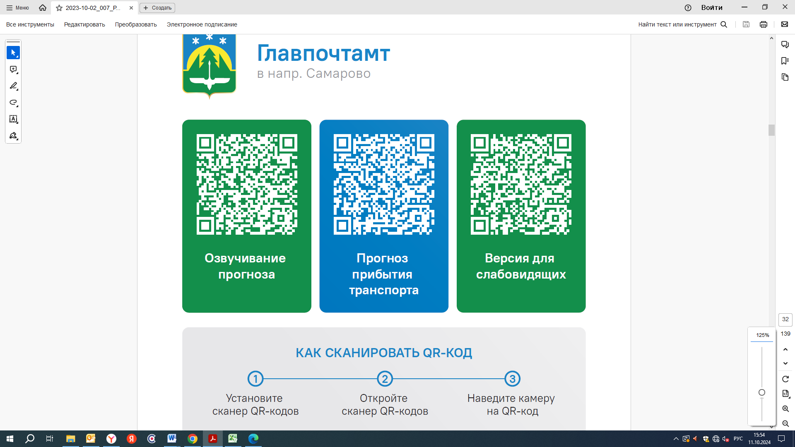



Контроль за осуществлением регулярных перевозок обеспечивает:
- управление транспорта, связи и дорог Администрации города Ханты-Мансийска, г: Ханты-Мансийск, ул Мира, 13, тел: 8 (3467) 39-39-07;
- отдел государственного автодорожного надзора по ХМАО – Югре, г: Ханты-Мансийск, ул: Шевченко 36А, тел: (3467) 32-64-60;
- МО МВД России «Ханты-Мансийский» г: Ханты-Мансийск, ул: Дзержинского дом 11, телефоны дежурной части (3467) 398-104, 398-103, 102 и 112

