  СУ - 967 |  |  |  |  | А
По регулируемым тарифам
Номер маршрута | Конечный остановочный пункт | ДНИ | Время начала и окончания движения | Временной график отправления транспортных средств от остановочного пункта
5 | Ледовый дворец | Будни  с 01.06 по 31.08 | 4:57-23:22 | 4:57, 5:32, 6:12, 6:22, 6:42, 7:12, 7:32, 8:02, 8:12, 8:22, 8:37, 8:52, 9:12, 9:32, 9:42, 9:52, 10:12, 10:32, 10:52, 11:12, 11:32, 11:52, 12:12, 12:32, 12:52, 13:12, 13:32, 13:52, 14:12, 14:32, 14:52, 15:12, 15:32, 15:52, 16:12, 16:27, 16:42, 16:57, 17:12, 17:27, 17:42, 17:57, 18:12, 18:27, 18:42, 18:57, 19:12, 19:32, 19:52, 20:12, 20:27, 20:52, 21:12, 21:27, 21:42, 22:12, 22:42, 23:22
 |  | Выходные  с 01.06 по 31.08 | 4:57-23:22 | 4:57, 5:32, 6:12, 6:42, 7:12, 7:32, 8:12, 8:32, 8:52, 9:12, 9:32, 9:52, 10:12, 10:32, 10:52, 11:12, 11:32, 11:52, 12:12, 12:32, 12:52, 13:12, 13:32, 13:52, 14:12, 14:32, 14:52, 15:12, 15:32, 15:52, 16:12, 16:32, 16:52, 17:12, 17:32, 17:52, 18:12, 18:32, 18:52, 19:12, 19:32, 19:52, 20:12, 20:32, 20:52, 21:12, 21:27, 21:42, 22:12, 22:42, 23:22
 |  | Будни  с 01.09 по 31.05 | 4:57-23:22 | 4:57, 5:32, 6:12, 6:22, 6:32, 6:42, 6:52, 7:02, 7:12, 7:32, 7:42, 8:02, 8:12, 8:22, 8:37, 8:52, 9:12, 9:32, 9:52, 10:12, 10:32, 10:52, 11:12, 11:32, 11:52, 12:12, 12:27, 12:42, 12:57, 13:12, 13:32, 13:52, 14:12, 14:32, 14:52, 15:12, 15:27, 15:42, 15:57, 16:12, 16:27, 16:42, 16:57, 17:12, 17:27, 17:42, 17:57, 18:12, 18:27, 18:42, 18:57, 19:12, 19:32, 19:52, 20:12, 20:27, 20:42, 20:57, 21:12, 21:27, 21:42, 22:12, 22:42, 23:22
 |  | Выходные  с 01.09 по 31.05 | 4:57-23:22 | 4:57, 5:32, 6:12, 6:22, 6:42, 7:12, 7:32, 8:02, 8:12, 8:22, 8:37, 8:52, 9:12, 9:32, 9:42, 9:52, 10:12, 10:32, 10:52, 11:12, 11:32, 11:52, 12:12, 12:32, 12:52, 13:12, 13:32, 13:52, 14:12, 14:32, 14:52, 15:12, 15:32, 15:52, 16:12, 16:27, 16:42, 16:57, 17:12, 17:27, 17:42, 17:57, 18:12, 18:27, 18:42, 18:52, 19:12, 19:32, 19:52, 20:12, 20:27,  20:52, 21:12, 21:27, 21:42, 22:12, 22:42, 23:22
Прогноз прибытия пассажирского транспорта
в вашем мобильном телефоне

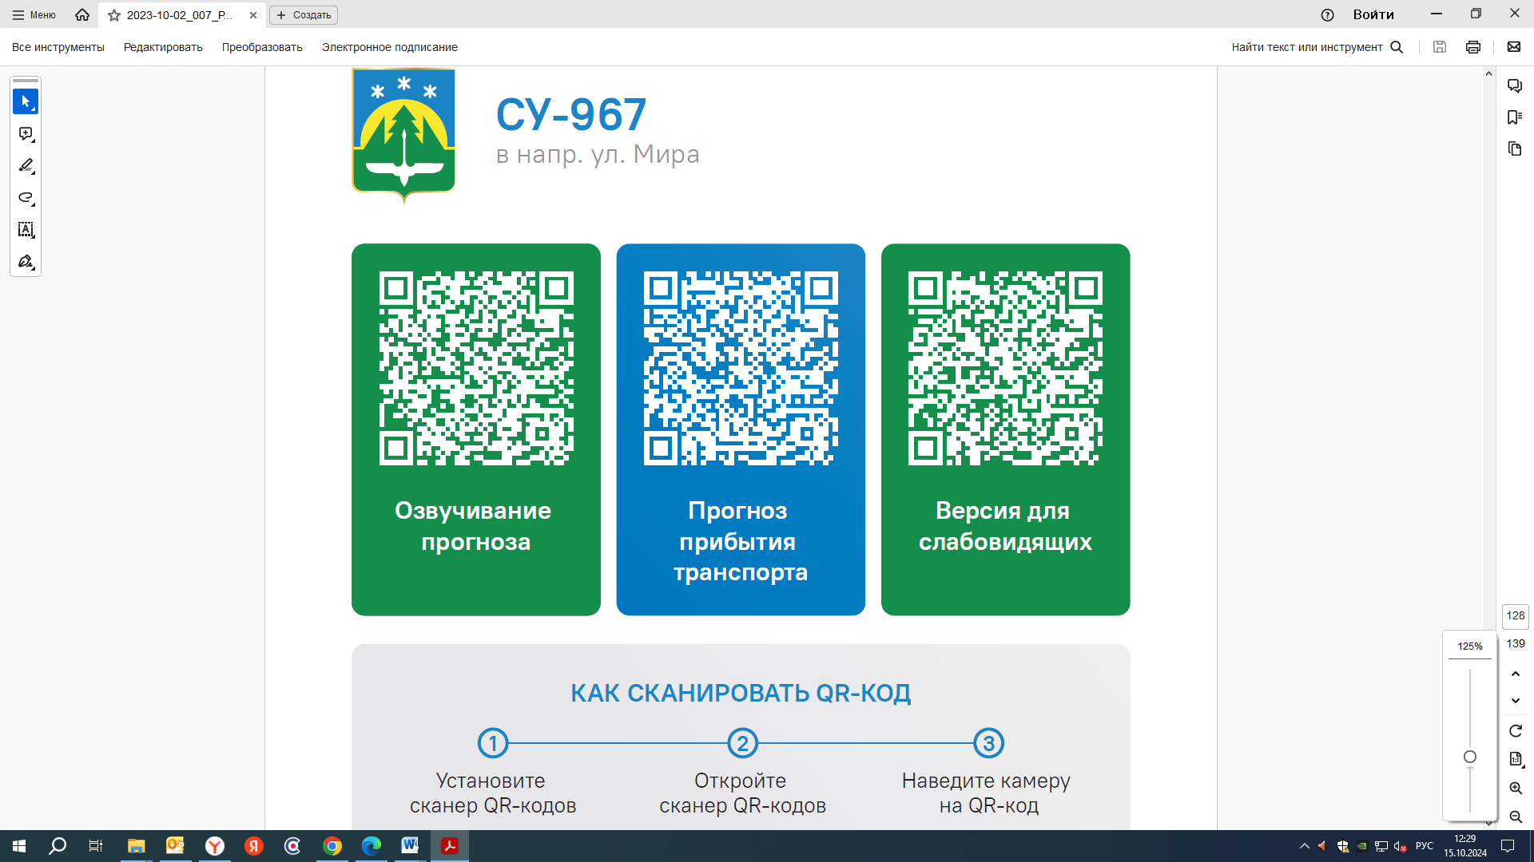

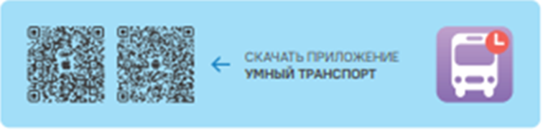

Контроль за осуществлением регулярных перевозок обеспечивает:
- управление транспорта, связи и дорог Администрации города Ханты-Мансийска, г: Ханты-Мансийск, ул Мира, 13, тел: 8 (3467) 39-39-07;
- отдел государственного автодорожного надзора по ХМАО – Югре, г: Ханты-Мансийск, ул: Шевченко 36А, тел: (3467) 32-64-60;
- МО МВД России «Ханты-Мансийский» г: Ханты-Мансийск, ул: Дзержинского дом 11, телефоны дежурной части 8 (3467) 398-104, 398-103, 102 и 112

