  Городок Геологов |  |  |  |  |  |  |  |  | А
По регулируемым тарифам
Номер маршрута | Конечный остановочный пункт | ДНИ | Время начала и окончания движения | Временной график отправления транспортных средств от остановочного пункта
1 | Автореч вокзал  (по Гагарина) | Будни | 6:22-22:47 | 6:22, 7:07, 7:27, 7:57, 8:20, 8:47, 9:02, 9:42, 10:22, 10:37, 11:22, 12:22, 13:27, 14:27, 15:02, 15:52, 16:52, 17:37, 17:52, 18:37, 19:17, 19:37, 20:17, 20:52, 21:17, 21:52, 22:47
 |  | Выходные | 6:37-21:52 | 6:37, 7:37, 8:17, 9:17, 9:57, 10:57, 11:57, 12:57, 13:37, 14:37, 15:17, 16:17, 16:57, 17:37, 17:57, 18:37, 19:17, 20:17, 20:52, 21:52
4 | мкр. Береговая зона | Будни | 6:49-22:39 | 6:49, 7:19, 7:49, 8:09, 8:34, 8:54, 9:14, 9:34, 9:49, 10:09, 10:54, 11:49, 12:09, 12:49, 13:19, 13:59, 14:09, 14:49, 15:19, 16:09, 16:24, 16:49, 17:14, 17:29, 17:49, 18:19, 18:29, 18:49, 19:14, 19:54, 20:14, 20:34, 21:09, 21:49, 22:39
 |  | Выходные | 6:49-21:49 | 6:49, 7:49, 8:49, 9:49, 10:49, 11:49, 12:49, 13:49, 14:19, 14:49, 15:49, 16:19, 16:49, 17:49, 18:49, 19:49, 20:49, 21:49
5 | Ледовый дворец | Будни  с 01.06 по 31.08 | 5:36-00:01 | 5:36, 6:11, 6:51, 7:01, 7:21, 7:51, 8:11, 8:41, 8:51, 9:01, 9:16, 9:31, 9:51, 10:11, 10:21, 10:31, 10:51, 11:11, 11:31, 11:51, 12:11, 12:31, 12:51, 13:11, 13:31, 13:51, 14:11, 14:31, 14:51, 15:11, 15:31, 15:51, 16:11, 16:31, 16:51, 17:06, 17:21, 17:36, 17:51, 18:06, 18:21, 18:36, 18:51, 19:06, 19:21, 19:36, 19:51, 20:11, 20:31, 20:51, 21:06, 21:31, 21:51, 22:06, 22:21, 22:51, 23:21, 0:01
 |  | Выходные  с 01.06 по 31.08 | 5:36-00:01 | 5:36, 6:11, 6:51, 7:21, 7:51, 8:11, 8:51, 9:11, 9:31, 9:51, 10:11, 10:31, 10:51, 11:11, 11:31, 11:51, 12:11, 12:31, 12:51, 13:11, 13:31, 13:51, 14:11, 14:31, 14:51, 15:11, 15:31, 15:51, 16:11, 16:31, 16:51, 17:11, 17:31, 17:51, 18:11, 18:31, 18:51, 19:11, 19:31, 19:51, 20:11, 20:31, 20:51, 21:11, 21:31, 21:51, 22:06, 22:21, 22:51, 23:21, 0:01
 |  | Будни  с 01.09 по 31.05 | 5:36-00:01 | 5:36, 6:11, 6:51, 7:01, 7:11, 7:21, 7:31, 7:41, 7:51, 8:11, 8:21, 8:41, 8:51, 9:01, 9:16, 9:31, 9:51, 10:11, 10:31, 10:51, 11:11, 11:31, 11:51, 12:11, 12:31, 12:51, 13:06, 13:21, 13:36, 13:51, 14:11, 14:31, 14:51, 15:11, 15:31, 15:51, 16:06, 16:21, 16:36, 16:51, 17:06, 17:21, 17:36, 17:51, 18:06, 18:21, 18:36, 18:51, 19:06, 19:21, 19:36, 19:51, 20:11, 20:31, 20:51, 21:06, 21:21, 21:36, 21:51, 22:06, 22:21, 22:51, 23:21, 0:01
 |  | Выходные  с 01.09 по 31.05 | 5:36-00:01 | 5:36, 6:11, 6:51, 7:01, 7:21, 7:51, 8:11, 8:41, 8:51, 9:01, 9:16, 9:31, 9:51, 10:11, 10:21, 10:31, 10:51, 11:11, 11:31, 11:51, 12:11, 12:31, 12:51, 13:11, 13:31, 13:51, 14:11, 14:31, 14:51, 15:11, 15:31, 15:51, 16:11, 16:31, 16:51, 17:06, 17:21, 17:36, 17:51, 18:06, 18:21, 18:36, 18:51, 19:06, 19:21, 19:31, 19:51, 20:11, 20:31, 20:51, 21:06, 21:31, 21:51, 22:06, 22:21, 22:51, 23:21, 0:01
21 | Ключевая | Будни | 7:31-23:01 | 7:31, 7:51, 8:11, 8:31, 8:51, 9:11, 9:31, 9:51, 10:11, 10:41, 11:11, 11:46, 12:11, 12:41, 13:41, 14:16, 15:16, 15:51, 16:11, 16:51, 17:11, 17:31, 17:51, 18:11, 18:31, 18:51, 19:11, 19:31, 19:51, 20:11, 20:31, 21:11, 20:31, 22:11, 23:01
 |  | Выходные | 7:31-23:01 | 7:31, 8:11, 9:11, 9:51, 10:11, 11:46, 12:41, 13:41, 14:16, 15:16, 15:51, 16:51, 17:31, 18:11, 18:31, 19:11, 19:51, 20:11, 21:26, 23:01
77 | Гимназия №1 | Будни | 6:46-21:26 | 6:46, 7:16, 7:36, 8:16, 8:56, 9:46, 10:16, 11:16, 12:31, 13:16, 13:56, 14:41, 15:21, 16:16, 16:46, 17:16, 17:36, 18:16, 18:46, 19:21, 20:01, 20:26, 21:26
 |  | Выходные | 6:46-21:26 | 6:46, 7:16, 7:36, 8:16, 8:56, 9:46, 10:16, 11:16, 12:21, 13:16, 13:36, 14:41, 15:21, 16:16, 16:46, 17:16, 17:36, 18:16, 18:46, 19:21, 20:01, 20:26, 21:26
По нерегулируемым тарифам
Номер маршрута | Конечный остановочный пункт | ДНИ | Время начала и окончания движения | Интервал отправления транспортных средств от остановочного пункта
7К | ТД «Сатурн» |  |  | до 10:00 | 10:00 -11:00 | 11:00 -15:00 | 15:00 -16:00 | 16:00 – 20:00 |  | после 20:00
 |  | Будни | 6:30-22:00 | 15 | 20 | 15 | 20 | 15 |  | 20
 |  | Суббота | 6:30-22:00 | 20 | 25 | 20 | 25 | 20 |  | 25
 |  | Воскресенье | 6:30-21:00 | 20 | 25 | 25 | 25 | 25 |  | 30
8К | Гимназия №1 |  |  | до 10:00 | 10:00 -11:00 | 11:00 -15:00 | 15:00 -16:00 | 16:00 – 20:00 |  | после 20:00
 |  | Будни | 6:30-22:00 | 15 | 20 | 15 | 20 | 15 |  | 20
 |  | Суббота | 6:30-22:00 | 20 | 25 | 20 | 25 | 20 |  | 25
 |  | Воскресенье | 6:30-21:00 | 20 | 25 | 25 | 25 | 25 |  | 30
13К | мкр. Береговая зона |  |  | до 10:00 | 10:00 -11:00 | 11:00 -15:00 | 15:00 -16:00 | 16:00 – 20:00 |  | после 20:00
 |  | Будни | 6:30-22:00 | 15 | 20 | 15 | 20 | 15 |  | 20
 |  | Суббота | 6:30-22:00 | 20 | 25 | 20 | 25 | 20 |  | 25
 |  | Воскресенье | 6:30-21:00 | 20 | 25 | 25 | 25 | 25 |  | 30
  26К | Гимназия №1 |  |  | до 10:00 | 10:00 -11:00 | 11:00 -15:00 | 15:00 -16:00 | 16:00 – 20:00 |  | после 20:00
 |  | Будни | 6:30-22:00 | 15 | 20 | 15 | 20 | 15 |  | 20
 |  | Суббота | 6:30-22:00 | 20 | 25 | 20 | 25 | 20 |  | 25
 |  |   Воскресенье  Прогноз прибытия пассажирского транспорта  в вашем мобильном телефоне | 6:30-21:00 | 20 | 25 | 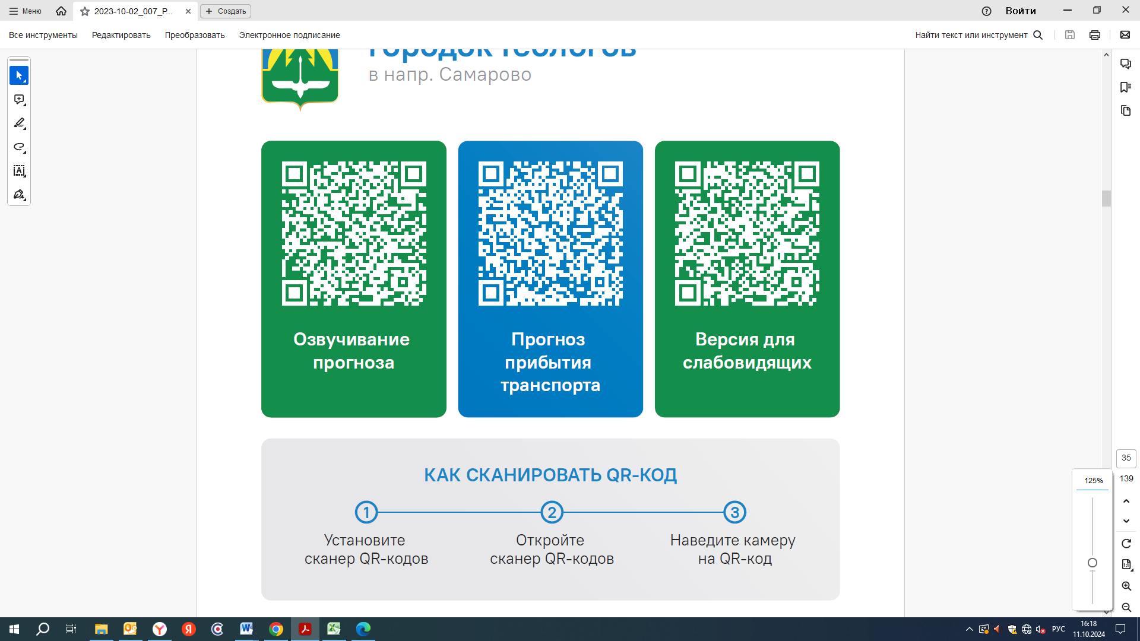  25 | 25 | 25 |  | 30
Контроль за осуществлением регулярных перевозок обеспечивает:
- управление транспорта, связи и дорог Администрации города Ханты-Мансийска, г: Ханты-Мансийск, ул Мира, 13, тел: 8 (3467) 39-39-07;
- отдел государственного автодорожного надзора по ХМАО – Югре, г: Ханты-Мансийск, ул: Шевченко 36А, тел: (3467) 32-64-60;
- МО МВД России «Ханты-Мансийский» г: Ханты-Мансийск, ул: Дзержинского дом 11, телефоны дежур ной части (3467) 398-104, 398-103, 102 и 112

