  мкр. Южный |  |  |  |  |  |  |  |  | А
По регулируемым тарифам
Номер маршрута | Конечный остановочный пункт | ДНИ | Время начала и окончания движения | Временной график отправления транспортных средств от остановочного пункта
1А | Авторечвокзал (по Объездной) | Будни | 6:40-22:05 | 6:40, 7:40, 8:25, 9:00, 9:20, 10:00, 11:10, 11:55, 13:00, 13:40, 14:40, 15:40, 17:00, 17:25, 18:00, 18:55, 19:00, 20:00, 20:30, 20:45, 21:30, 22:05
 |  | Выходные | 7:25-21:20 | 7:25, 8:00, 9:00, 9:40, 10:40, 11:20, 12:20, 13:20, 14:00, 15:00, 15:50, 16:40, 17:25, 17:50, 18:20, 19:10, 19:40, 20:45, 21:20
5 | Мкр. Восточный | Будни  с 01.06 по 31.08 | 5:42-22:47 | 5:42, 6:22, 6:42, 7:14, 7:24, 7:44, 7:52, 8:02, 8:12, 8:22, 8:42, 9:07, 9:17, 9:32, 9:42, 10:02, 10:17, 10:32, 10:42, 10:52, 11:02, 11:22, 11:42, 12:02, 12:22, 12:42, 13:02, 13:22, 13:42, 14:02, 14:22, 14:42, 15:02, 15:22, 15:42, 16:02, 16:22, 16:42, 17:02, 17:17, 17:32, 17:47, 18:07, 18:17, 18:32, 18:47, 19:02, 19:17, 19:32, 19:47, 20:02, 20:22, 20:42, 21:02, 21:17, 21:32, 22:02, 22:32, 22:47
 |  | Выходные  с 01.06 по 31.08 | 5:42-23:17 | 5:42, 6:22, 6:42, 7:14, 7:44, 8:02, 8:22, 8:42, 9:02, 9:22, 9:42, 10:02, 10:22, 10:42, 11:02, 11:22, 11:42, 12:02, 12:22, 12:42, 13:02, 13:22, 13:42, 14:02, 14:22, 14:42, 15:02, 15:22, 15:42, 16:02, 16:22, 16:42, 17:02, 17:22, 17:42, 18:02, 18:22, 18:42, 19:02, 19:22, 19:42, 20:02, 20:22, 20:42, 21:02, 21:17, 21:42, 22:02, 22:32, 23:17
 |  | Будни  с 01.09 по 31.05 | 5:42-23:47 | 5:42, 6:22, 6:42, 7:14, 7:24, 7:42, 7:52, 8:02, 8:12, 8:22, 8:42, 8:52, 9:07, 9:17, 9:27, 9:42, 10:02, 10:22, 10:42, 10:52, 11:02, 11:22, 11:42, 12:02, 12:22, 12:42, 13:02, 13:17, 13:32, 13:47, 14:02, 14:22, 14:42, 15:02, 15:22, 15:42, 16:02, 16:17, 16:32, 16:47, 17:02, 17:17, 17:32, 17:47, 18:02, 18:17, 18:32, 18:47, 19:02, 19:17, 19:32, 19:47, 20:02, 20:22, 20:42, 21:02, 21:17, 21:32, 21:47, 22:02, 22:17, 22:32, 23:17, 23:32, 23:47
 |  | Выходные  с 01.09 по 31.05 | 6:22-23:47 | 6:22, 6:42, 7:14, 7:24, 7:44, 8:02, 8:22, 8:42, 9:07, 9:17, 9:27, 9:42, 10:02, 10:17, 10:32, 10:42, 10:52, 11:02, 11:22, 11:42, 12:02, 12:22, 12:42, 13:02, 13:22, 13:42, 14:02, 14:22, 14:42, 15:02, 15:42, 15:42, 16:02, 16:22, 16:42, 17:02, 17:17, 17:32, 17:47, 18:02, 18:17, 18:32, 18:47, 19:02, 19:17, 19:32, 19:47, 20:02, 20:22, 20:42, 21:02, 21:17, 21:32, 22:02, 22:32, 22:47, 23:17, 23:47
77 | Сельхозтехника | Будни | 7:13-21:50 | 7:13, 7:58, 8:15, 8:45, 9:20, 10:15, 10:50, 11:40, 13:05, 13:40, 14:25, 15:25, 15:55, 16:45, 17:25, 17:55, 18:23, 18:40, 19:35, 19:45, 20:35, 20:50, 21:50
 |  | Выходные | 7:25-21:50 | 7:25, 7:55, 8:15, 8:45, 9:25, 10:15, 10:50, 11:40, 12:45, 13:40, 14:05, 15:15, 15:55, 16:45, 17:15, 17:45, 18:10, 18:40, 19:10, 19:45, 20:25, 20:50, 21:50
По нерегулируемым тарифам
Номер маршрута | Конечный остановочный пункт | ДНИ | Время начала и окончания движения | Интервал отправления транспортных средств от остановочного пункта
8К | ОМК | Будни | 6:30-22:00 | 15 | 20 | 15 | 20 | 15 |  | 20
 |  | Суббота | 6:30-22:00 | 20 | 25 | 20 | 25 | 20 |  | 25
 |  | Воскресенье | 6:30-21:00 | 20 | 25 | 25 | 25 | 25 |  | 30
Номер маршрута | Конечный остановочный пункт | ДНИ | Время начала и окончания движения | Интервал отправления транспортных средств от остановочного пункта
9К | мкр. Береговая зона | Будни | 6:30-22:00 | 15 | 20 | 15 | 20 | 15 |  | 20
 |  | Суббота | 6:30-22:00 | 20 | 25 | 20 | 25 | 20 |  | 25
 |  | Воскресенье | 6:30-21:00 | 20 | 25 | 25 | 25 | 25 |  | 30
Номер маршрута | Конечный остановочный пункт | ДНИ | Время начала и окончания движения | Интервал отправления транспортных средств от остановочного пункта
26К | Теннисный центр | Будни | 6:30-22:00 | 15 | 20 | 15 | 20 | 15 |  | 20
 |  | Суббота | 6:30-22:00 | 20 | 25 | 20 | 25 | 20 |  | 25
 |  | Воскресенье | 6:30-21:00 | 20 | 25 | 25 | 25 | 25 |  | 30
Прогноз прибытия пассажирского транспорта
в вашем мобильном телефоне

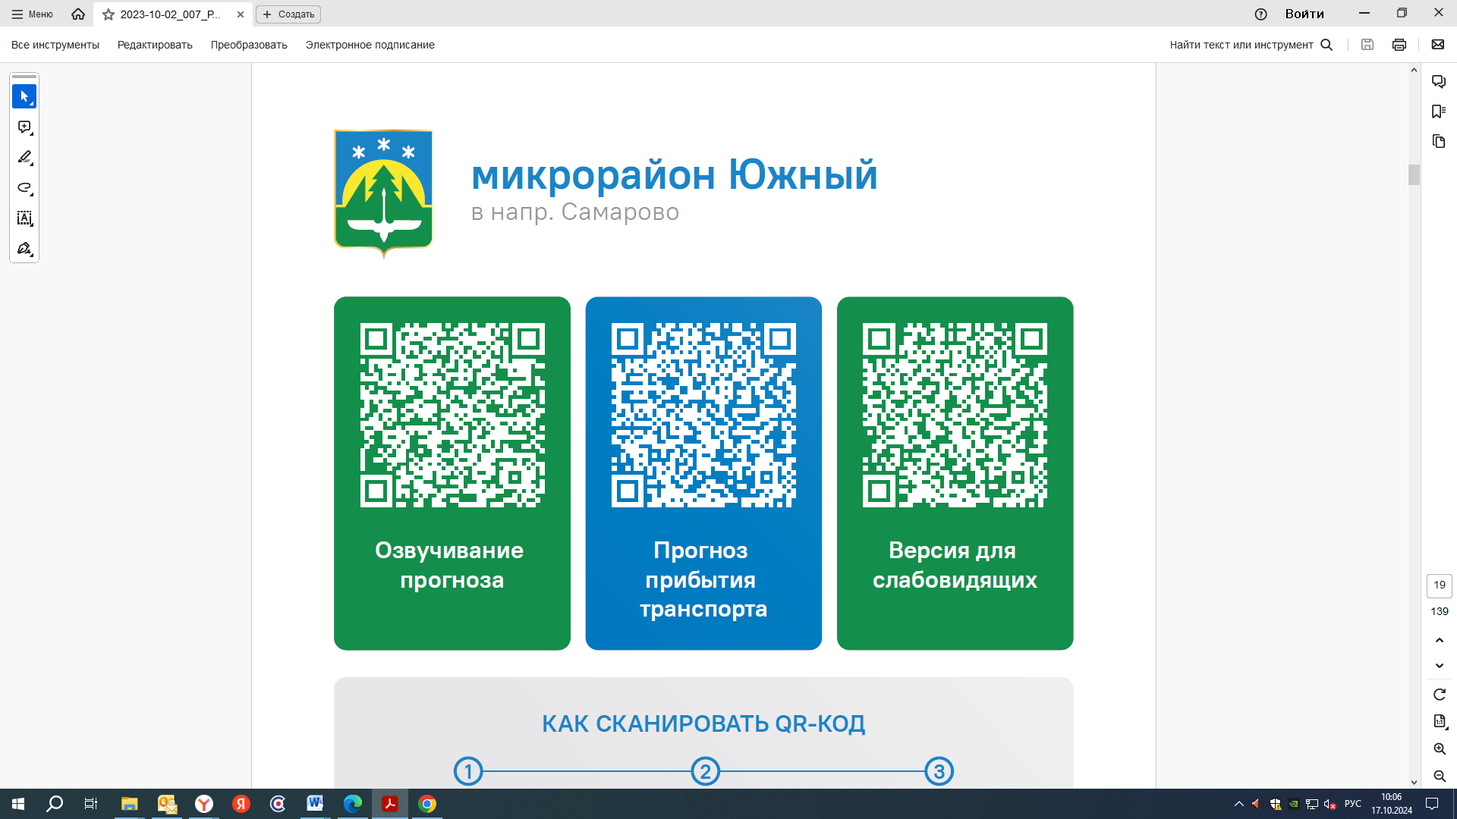


Контроль за осуществлением регулярных перевозок обеспечивает:
- управление транспорта, связи и дорог Администрации города Ханты-Мансийска, г: Ханты-Мансийск, ул Мира, 13, тел: 8 (3467) 39-39-07;
- отдел государственного автодорожного надзора по ХМАО – Югре, г: Ханты-Мансийск, ул: Шевченко 36А, тел: (3467) 32-64-60;
- МО МВД России «Ханты-Мансийский» г: Ханты-Мансийск, ул: Дзержинского дом 11, телефоны дежурной части 8 (3467) 398-104, 398-103, 102 и 112

