  мкр. Солнечный |  |  |  |  | А
По регулируемым тарифам
Номер маршрута | Конечный остановочный пункт | ДНИ | Время начала и окончания движения | Временной график отправления транспортных средств от остановочного пункта
5 | Ледовый дворец | Будни с 01.06 по 31.08 | 4:54-23:19 | 4:54, 5:29, 6:09, 6:19, 6:39, 7:09, 7:29, 7:59, 8:09, 8:19, 8:34, 8:49, 9:09, 9:29, 9:39, 9:49, 10:09, 10:29, 10:49, 11:09, 11:29, 11:49, 12:09, 12:29, 12:49, 13:09, 13:29, 13:49, 14:09, 14:29, 14:49, 15:09, 15:29, 15:49, 16:09, 16:24, 16:39, 16:54, 17:09, 17:24, 17:39, 17:54, 18:09, 18:24, 18:39, 18:54, 19:09, 19:29, 19:49, 20:09, 20:24, 20:49, 21:09, 21:24, 21:39, 22:09, 22:39, 23:19
 |  | Выходные с 01.06 по 31.08 | 4:54-23:19 | 4:54, 5:29, 6:09, 6:39, 7:09, 7:29, 8:09, 8:29, 8:49, 9:09, 9:29, 9:49, 10:09, 10:29, 10:49, 11:09,  11:29, 11:49, 12:09, 12:29, 12:49, 13:09, 13:29, 13:49, 14:09, 14:29, 14:49, 15:09, 15:29, 15:49, 16:09, 16:29, 16:49, 17:09, 17:29, 17:49, 18:09, 18:29, 18:49, 19:09, 19:29, 19:49, 20:09, 20:29, 20:49, 21:09, 21:24, 21:39, 22:09, 22:39, 23:19
 |  | Будни с 01.09 по 31.05 | 4:54-23:19 | 4:54, 5:29, 6:09, 6:19, 6:29, 6:39, 6:49, 6:59, 7:09, 7:29, 7:39, 7:59, 8:09, 8:19, 8:34, 8:49, 9:09, 9:29, 9:49, 10:09, 10:29, 10:49, 11:09, 11:29, 11:49, 12:09, 12:24, 12:39, 12:54, 13:09, 13:29, 13:49, 14:09, 14:29, 14:49, 15:09, 15:24, 15:39, 15:54, 16:09, 16:24, 16:39, 16:54, 17:09, 17:24, 17:39, 17:54, 18:09, 18:24, 18:39, 18:54, 19:09, 19:29, 19:49, 20:09, 20:24, 20:39, 20:54, 21:09, 21:24, 21:39, 22:09, 22:39, 23:19
 |  | Выходные с 01.09 по 31.05 | 4:54-23:19 | 4:54, 5:29, 6:09, 6:19, 6:39, 7:09, 7:29, 7:59, 8:09, 8:19, 8:34, 8:49, 9:09, 9:29, 9:39, 9:49, 10:09, 10:29, 10:49, 11:09, 11:29, 11:49, 12:09, 12:29, 12:49, 13:09, 13:29, 13:49, 14:09, 14:29, 14:49, 15:09, 15:29, 15:49, 16:09, 16:24, 16:39, 16:54, 17:09, 17:24, 17:39, 17:54, 18:09, 18:24, 18:39, 18:49, 19:09, 19:29, 19:49, 20:09, 20:24, 20:49, 21:09, 21:24, 21:39, 22:09, 22:39, 23:19
Прогноз прибытия пассажирского транспорта
в вашем мобильном телефоне


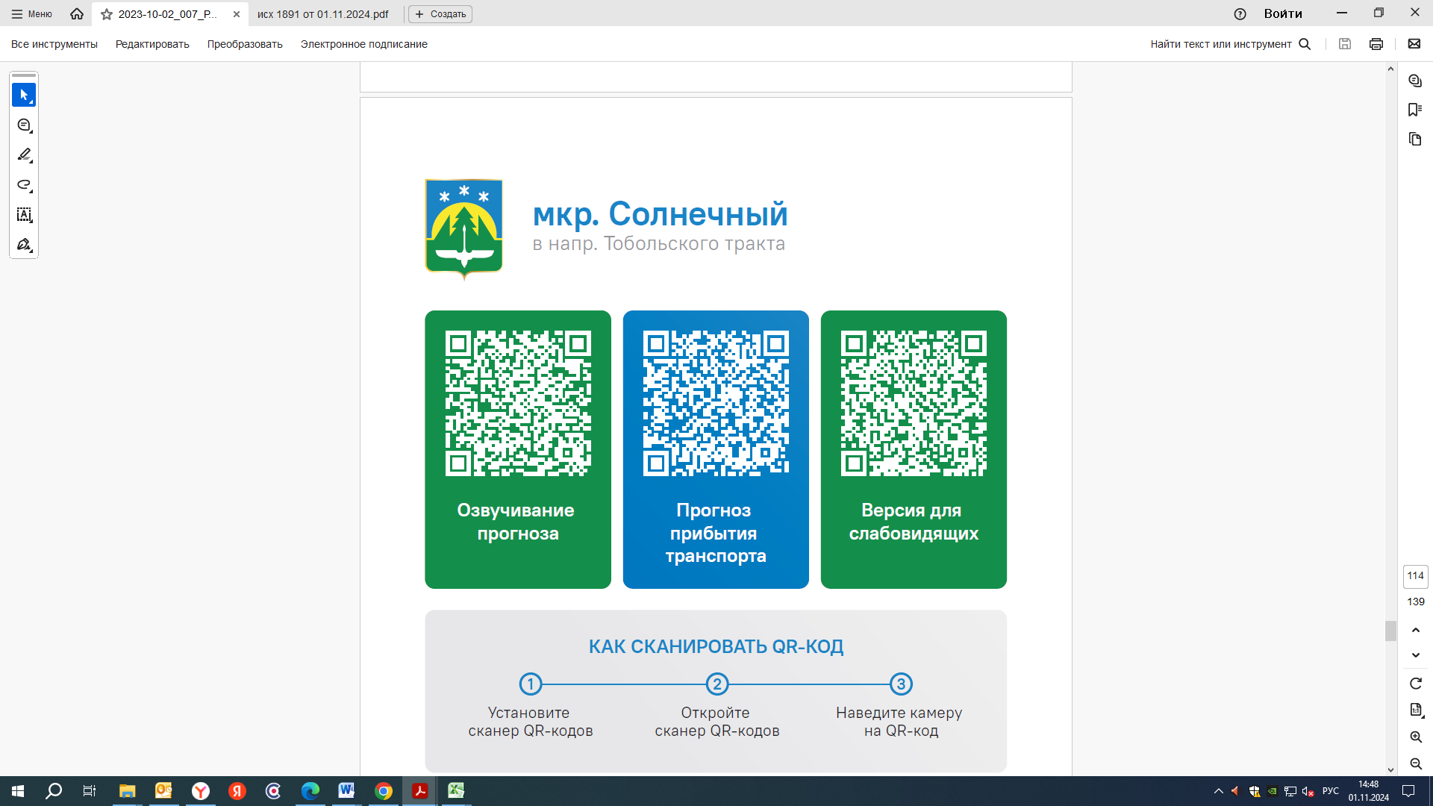


Контроль за осуществлением регулярных перевозок обеспечивает:
- управление транспорта, связи и дорог Администрации города Ханты-Мансийска, г: Ханты-Мансийск, ул Мира, 13, тел: 8 (3467) 39-39-07;
- отдел государственного автодорожного надзора по ХМАО – Югре, г: Ханты-Мансийск, ул: Шевченко 36А, тел: (3467) 32-64-60;
- МО МВД России «Ханты-Мансийский» г: Ханты-Мансийск, ул: Дзержинского дом 11, телефоны дежурной части 8 (3467) 398-104, 398-103, 102 и 112

