  Русский двор |  |  |  |  |  |  |  |  | А
По регулируемым тарифам
Номер маршрута | Конечный остановочный пункт | ДНИ | Время начала и окончания движения | Временной график отправления транспортных средств от остановочного пункта
5 | Ледовый дворец | Будни  с 01.06 по 31.08 | 05:04-23:29 | 5:04, 5:39, 6:19, 6:29, 6:49, 7:19, 7:39, 8:09, 8:19, 8:29, 8:44, 8:59, 9:19, 9:39, 9:49, 9:59, 10:19, 10:39, 10:59, 11:19, 11:39, 11:59, 12:19, 12:39, 12:59, 13:19, 13:39, 13:59, 14:19, 14:39, 14:59, 15:19, 15:39, 15:59, 16:19, 16:34, 16:49, 17:04, 17:19, 17:34, 17:49, 18:04, 18:19, 18:34, 18:49, 19:04, 19:19, 19:39, 19:59, 20:19, 20:34, 20:59, 21:19, 21:34, 21:49, 22:19, 22:49, 23:29
 |  | Выходные  с 01.06 по 31.08 | 5:04-23:29 | 5:04, 5:39, 6:19, 6:49, 7:19, 7:39, 8:19, 8:39, 8:59, 9:19, 9:39, 9:59, 10:19, 10:39, 10:59, 11:19,  11:39, 11:59, 12:19, 12:39, 12:59, 13:19, 13:39, 13:59, 14:19, 14:39, 14:59, 15:19, 15:39, 15:59, 16:19, 16:39, 16:59, 17:19, 17:39, 17:59, 18:19, 18:39, 18:59, 19:19, 19:39, 19:59, 20:19, 20:39, 20:59, 21:19, 21:34, 21:49, 22:19, 22:49, 23:29
 |  | Будни  с 01.09 по 31.05 | 5:04-23:29 | 5:04, 5:39, 6:19, 6:29, 6:39, 6:49, 6:59, 7:09, 7:19, 7:39, 7:49, 8:09, 8:19, 8:29, 8:44, 8:59, 9:19,  9:39, 9:59, 10:19, 10:39, 10:59, 11:19, 11:39, 11:59, 12:19, 12:34, 12:49, 13:04, 13:19, 13:39, 13:59, 14:19, 14:39, 14:59, 15:19, 15:34, 15:49, 16:04, 16:19, 16:34, 16:49, 17:04, 17:19, 17:34, 17:49, 18:04, 18:19, 18:34, 18:49, 19:04, 19:19, 19:39, 19:59, 20:19, 20:34, 20:49, 21:04, 21:19, 21:34, 21:49, 22:19, 22:49, 23:29
 |  | Выходные  с 01.09 по 31.05 | 5:04-23:29 | 5:04, 5:39, 6:19, 6:29, 6:49, 7:19, 7:39, 8:09, 8:19, 8:29, 8:44, 8:59, 9:19, 9:39, 9:49, 9:59, 10:19, 10:39, 10:59, 11:19, 11:39, 11:59, 12:19, 12:39, 12:59, 13:19, 13:39, 13:59, 14:19, 14:39, 14:59, 15:19, 15:39, 15:59, 16:19, 16:34, 16:49, 17:04, 17:19, 17:34, 17:49, 18:04, 18:19, 18:34, 18:49, 18:59, 19:19, 19:39, 19:59, 20:19, 20:34, 20:59, 21:19, 21:34, 21:49, 22:19, 22:49, 23:29
По нерегулируемым тарифам
Номер маршрута | Конечный остановочный пункт | ДНИ | Время начала и окончания движения | Интервал отправления транспортных средств от остановочного пункта
9К | мкр. Береговая зона |  |  | до 10:00 | 10:00 -11:00 | 11:00 -15:00 | 15:00 -16:00 | 16:00 – 20:00 |  | после 20:00
 |  | Будни | 6:30-22:00 | 15 | 20 | 15 | 20 | 15 |  | 20
 |  | Суббота | 6:30-22:00 | 20 | 25 | 20 | 25 | 20 |  | 25
 |  | Воскресенье | 6:30-21:00 | 20 | 25 | 25 | 25 | 25 |  | 30
Прогноз прибытия пассажирского транспорта
в вашем мобильном телефоне

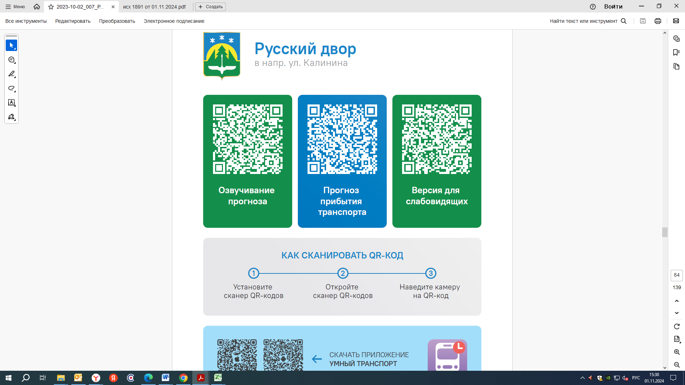



Контроль за осуществлением регулярных перевозок обеспечивает:
- управление транспорта, связи и дорог Администрации города Ханты-Мансийска, г: Ханты-Мансийск, ул Мира, 13, тел: 8 (3467) 39-39-07;
- отдел государственного автодорожного надзора по ХМАО – Югре, г: Ханты-Мансийск, ул: Шевченко 36А, тел: (3467) 32-64-60;
- МО МВД России «Ханты-Мансийский» г: Ханты-Мансийск, ул: Дзержинского дом 11, телефоны дежурной части 8 (3467) 398-104, 398-103, 102 и 112

