  Биатлонный центр |  |  |  |  |  |  |  |  | А
По регулируемым тарифам
Номер маршрута | Конечный остановочный пункт | ДНИ | Время начала и окончания движения | Временной график отправления транспортных средств от остановочного пункта
1 | Авторечвокзал  (по Гагарина) | Будни | 6:23-22:48 | 6:23, 7:08, 7:28, 7:58, 8:21, 8:48, 9:03, 9:43, 10:23, 10:38, 11:23, 12:23, 13:28, 14:28, 15:03,  15:53, 16:53, 17:38, 17:53, 18:38, 19:18, 19:38, 20:18, 20:53, 21:18, 21:53, 22:48
 |  | Выходные | 6:38-21:53 | 6:38, 7:38, 8:18, 9:18, 9:58, 10:58, 11:58, 12:58, 13:38, 14:38, 15:18, 16:18, 16:58, 17:38, 17:58, 18:38, 19:18, 20:18, 20:53, 21:53
4 | мкр. Береговая зона | Будни | 6:51-22:41 | 6:51, 7:21, 7:51, 8:11, 8:36, 8:56, 9:16, 9:51, 10:11, 10:56, 11:51, 12:11, 12:51, 13:06, 13:31, 14:01, 14:21, 14:51, 15:26, 15:46, 16:11, 16:51, 17:16, 17:31, 17:51, 18:21, 18:31, 18:51, 19:16, 19:56, 20:16, 20:36, 21:11, 21:51, 22:41
 |  | Выходные | 6:51-22:41 | 6:51, 7:51, 8:11, 8:56, 9:51, 10:56, 11:51, 12:51, 13:06, 14:01, 14:51, 15:46, 16:51, 17:51, 18:51, 19:56, 20:36, 21:51, 22:41
5 | Ледовый дворец | Будни  с 01.06 по 31.08 | 5:38-00:03 | 5:38, 6:13, 6:53, 7:03, 7:23, 7:53, 8:13, 8:43, 8:53, 9:03, 9:18, 9:33, 9:53, 10:13, 10:23, 10:33, 10:53, 11:13, 11:33, 11:53, 12:13, 12:33, 12:53, 13:13, 13:33, 13:53, 14:13, 14:33, 14:53, 15:13, 15:33, 15:53, 16:13, 16:33, 16:53, 17:08, 17:23, 17:38, 17:53, 18:08, 18:23, 18:38, 18:53, 19:08, 19:23, 19:38, 19:53, 20:13, 20:33, 20:53, 21:08, 21:33, 21:53, 22:08, 22:23, 22:53, 23:23, 0:03
 |  | Выходные  с 01.06 по 31.08 | 5:38-00:03 | 5:38, 6:13, 6:53, 7:23, 7:53, 8:13, 8:53, 9:13, 9:33, 9:53, 10:13, 10:33, 10:53, 11:13, 11:33, 11:53, 12:13, 12:33, 12:53, 13:13, 13:33, 13:53, 14:13, 14:33, 14:53, 15:13, 15:33, 15:53, 16:13, 16:33, 16:53, 17:13, 17:33, 17:53, 18:13, 18:33, 18:53, 19:13, 19:33, 19:53, 20:13, 20:33, 20:53, 21:13, 21:33, 21:53, 22:08, 22:23, 22:53, 23:23, 0:03
 |  | Будни  с 01.09 по 31.05 | 5:38-00:03 | 5:38, 6:13, 6:53, 7:03, 7:13, 7:23, 7:33, 7:43, 7:53, 8:13, 8:23, 8:43, 8:53, 9:03, 9:18, 9:33, 9:53, 10:13, 10:33, 10:53, 11:13, 11:33, 11:53, 12:13, 12:33, 12:53, 13:08, 13:23, 13:38, 13:53, 14:13, 14:33, 14:53, 15:13, 15:33, 15:53, 16:08, 16:23, 16:38, 16:53, 17:08, 17:23, 17:38, 17:53, 18:08, 18:23, 18:38, 18:53, 19:08, 19:23, 19:38, 19:53, 20:13, 20:33, 20:53, 21:08, 21:23, 21:38, 21:53, 22:08, 22:23, 22:53, 23:23, 0:03
 |  | Выходные  с 01.09 по 31.05 | 5:38-00:03 | 5:38, 6:13, 6:53, 7:03, 7:23, 7:53, 8:13, 8:43, 8:53, 9:03, 9:18, 9:33, 9:53, 10:13, 10:23, 10:33, 10:53, 11:13, 11:33, 11:53, 12:13, 12:33, 12:53, 13:13, 13:33, 13:53, 14:13, 14:33, 14:53, 15:13, 15:33, 15:53, 16:13, 16:33, 16:53, 17:08, 17:23, 17:38, 17:53, 18:08, 18:23, 18:38, 18:53, 19:08, 19:23, 19:33, 19:53, 20:13, 20:33, 20:53, 21:08, 21:33, 21:53, 22:08, 22:23, 22:53, 23:23, 0:03
21 | Ключевая | Будни | 7:32-23:02 | 7:32, 7:52, 8:12, 8:32, 8:52, 9:12, 9:32, 9:52, 10:12, 10:42, 11:12, 11:47, 12:12, 12:42, 13:42, 14:17, 15:17, 15:52, 16:12, 16:52, 17:12, 17:32, 17:52, 18:12, 18:32, 18:52, 19:12, 19:32, 19:52, 20:12, 20:32, 21:12, 20:32, 22:12, 23:02
 |  | Выходные | 7:32-23:02 | 7:32, 8:12, 9:12, 9:52, 10:12, 11:47, 12:42, 13:42, 14:17, 15:17, 15:52, 16:52, 17:32, 18:12, 18:32, 19:12, 19:52, 20:12, 21:27, 23:02
77 | Гимназия №1 | Будни | 6:48-21:28 | 6:48, 7:18, 7:38, 8:18, 8:58, 9:48, 10:18, 11:18, 12:33, 13:18, 13:58, 14:43, 15:23, 16:18, 16:48, 17:18, 17:38, 18:18, 18:48, 19:23, 20:03, 20:28, 21:28
 |  | Выходные | 6:48-21:28 | 6:48, 7:18, 7:38, 8:18, 8:58, 9:48, 10:18, 11:18, 12:23, 13:18, 13:38, 14:43, 15:23, 16:18, 16:48, 17:18, 17:38, 18:18, 18:48, 19:23, 20:03, 20:28, 21:28
По нерегулируемым тарифам
Номер маршрута | Конечный остановочный пункт | ДНИ | Время начала и окончания движения | Интервал отправления транспортных средств от остановочного пункта
7К | ТД «Сатурн» |  |  | до 10:00 | 10:00 -11:00 | 11:00 -15:00 | 15:00 -16:00 | 16:00 – 20:00 |  | после 20:00
 |  | Будни | 6:30-22:00 | 15 | 20 | 15 | 20 | 15 |  | 20
 |  | Суббота | 6:30-22:00 | 20 | 25 | 20 | 25 | 20 |  | 25
 |  | Воскресенье | 6:30-21:00 | 20 | 25 | 25 | 25 | 25 |  | 30
8К | Гимназия №1 |  |  | до 10:00 | 10:00 -11:00 | 11:00 -15:00 | 15:00 -16:00 | 16:00 – 20:00 |  | после 20:00
 |  | Будни | 6:30-22:00 | 15 | 20 | 15 | 20 | 15 |  | 20
 |  | Суббота | 6:30-22:00 | 20 | 25 | 20 | 25 | 20 |  | 25
 |  | Воскресенье | 6:30-21:00 | 20 | 25 | 25 | 25 | 25 |  | 30
13К | мкр. Береговая зона |  |  | до 10:00 | 10:00 -11:00 | 11:00 -15:00 | 15:00 -16:00 | 16:00 – 20:00 |  | после 20:00
 |  | Будни | 6:30-22:00 | 15 | 20 | 15 | 20 | 15 |  | 20
 |  | Суббота | 6:30-22:00 | 20 | 25 | 20 | 25 | 20 |  | 25
 |  | Воскресенье | 6:30-21:00 | 20 | 25 | 25 | 25 | 25 |  | 30
  26К | Гимназия №1 |  |  | до 10:00 | 10:00 -11:00 | 11:00 -15:00 | 15:00 -16:00 | 16:00 – 20:00 |  | после 20:00
 |  | Будни | 6:30-22:00 | 15 | 20 | 15 | 20 | 15 |  | 20
 |  | Суббота | 6:30-22:00 | 20 | 25 | 20 | 25 | 20 |  | 25
 |  |   Воскресенье  Прогноз прибытия пассажирского транспорта  в вашем мобильном телефоне | 6:30-21:00 | 20 | 25 | 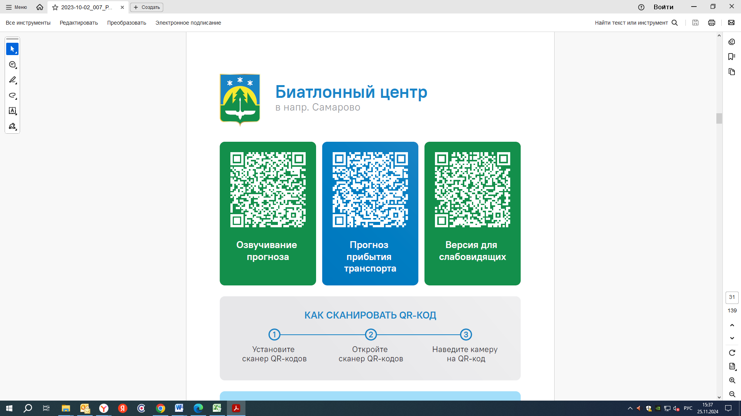  25 | 25 | 25 |  | 30
Контроль за осуществлением регулярных перевозок обеспечивает:
- управление транспорта, связи и дорог Администрации города Ханты-Мансийска, г: Ханты-Мансийск, ул Мира, 13, тел: 8 (3467) 39-39-07;
- отдел государственного автодорожного надзора по ХМАО – Югре, г: Ханты-Мансийск, ул: Шевченко 36А, тел: 8 (3467) 32-64-60;
- МО МВД России «Ханты-Мансийский» г: Ханты-Мансийск, ул: Дзержинского дом 11, телефоны дежур ной части 8 (3467) 398-104, 398-103, 102 и 112

