  Медицинская академия |  |  |  |  |  |  |  |  | А
По регулируемым тарифам
Номер маршрута | Конечный остановочный пункт | ДНИ | Время начала и окончания движения | Временной график отправления транспортных средств от остановочного пункта
1 | ОМК | Будни | 6:20-21:57 | 6:20, 7:07, 8:07, 8:52, 9:27, 9:47, 10:27, 11:37, 12:22, 13:27, 14:07, 15:07, 16:07, 17:27, 17:52, 18:27, 19:22, 19:27, 20:27, 20:57, 21:12, 21:57
 |  | Выходные | 7:52-21:47 | 7:52, 8:27, 9:27, 10:07, 11:07, 11:47, 12:47, 13:47, 14:27, 15:27, 16:17, 17:07, 17:52, 18:17, 18:47, 19:37, 20:07, 21:12, 21:47
1А | ОМК | Будни | 6:55-23:20 | 6:55, 7:40, 8:00, 8:30, 8:53, 9:20, 9:35, 10:15, 10:55, 11:10, 11:55, 12:55, 14:00, 15:00, 15:35, 16:25, 17:25, 18:10, 18:25, 19:10, 19:50, 20:10, 20:50, 21:25, 21:50, 22:25, 23:20
 |  | Выходные | 7:10-22:25 | 7:10, 8:10, 8:50, 9:50, 10:30, 11:30, 12:30, 13:30, 14:10, 15:10, 15:50, 16:50, 17:30, 18:10, 18:30, 19:10, 19:50, 20:50, 21:25, 22:25
2 | Мелиораторов | ежедневно | 7:14-19:34 | 7:14, 8:22, 9:22, 10:14, 12:14, 13:14, 14:14, 15:14, 17:24, 18:34, 19:34,
4 | ОМК | Будни | 6:39-22:39 | 6:39, 6:59, 7:19, 7:39, 8:04, 8:19, 8:39, 8:59, 9:19, 9:39, 9:59, 10:39, 10:59, 11:39, 12:39, 12:59, 13:39, 14:09, 14:59, 15:39, 16:19, 16:39, 16:59, 17:19, 17:39, 17:59, 18:19, 18:39, 19:04, 19:19, 19:59, 20:39, 20:59, 21:29, 21:59, 22:39
 |  | Выходные | 6:39-22:39 | 6:39, 7:39, 8:39, 9:39, 10:39, 11:39, 12:39, 13:39, 14:39, 15:09, 15:39, 16:39, 17:09, 17:39, 18:39, 19:39, 20:39, 21:39, 22:39
5 | Мкр. Восточный | Будни  с 01.06 по 31.08 | 6:10-23:15 | 6:10, 6:50, 7:10, 7:42, 7:52, 8:12, 8:20, 8:30, 8:40, 8:50, 9:10, 9:35, 9:45, 10:00, 10:10, 10:30, 10:45, 11:00, 11:10, 11:20, 11:30, 11:50, 12:10, 12:30, 12:50, 13:10, 13:30, 13:50, 14:10, 14:30, 14:50, 15:10, 15:30, 15:50, 16:10, 16:30, 16:50, 17:10, 17:30, 17:45, 18:00, 18:15, 18:35, 18:45, 19:00, 19:15, 19:30, 19:45, 20:00, 20:15, 20:30, 20:50, 21:10, 21:30, 21:45, 22:00, 22:30, 23:00, 23:15
 |  | Выходные  с 01.06 по 31.08 | 6:10-23:45 | 6:10, 6:50, 7:10, 7:42, 8:12, 8:30, 8:50, 9:10, 9:30, 9:50, 10:10, 10:30, 10:50, 11:10, 11:30, 11:50, 12:10, 12:30, 12:50, 13:10, 13:30, 13:50, 14:10, 14:30, 14:50, 15:10, 15:30, 15:50, 16:10, 16:30, 16:50, 17:10, 17:30, 17:50, 18:10, 18:30, 18:50, 19:10, 19:30, 19:50, 20:10, 20:30, 20:50, 21:10, 21:30, 21:45, 22:10, 22:30, 23:00, 23:45
 |  | Будни  с 01.09 по 31.05 | 6:10-00:15 | 6:10, 6:50, 7:10, 7:42, 7:52, 8:10, 8:20, 8:30, 8:40, 8:50, 9:10, 9:20, 9:35, 9:45, 9:55, 10:10, 10:30, 10:50, 11:10, 11:20, 11:30, 11:50, 12:10, 12:30, 12:50, 13:10, 13:30, 13:45, 14:00, 14:15, 14:30, 14:50, 15:10, 15:30, 15:50, 16:10, 16:30, 16:45, 17:00, 17:15, 17:30, 17:45, 18:00, 18:15, 18:30, 18:45, 19:00, 19:15, 19:30, 19:45, 20:00, 20:15, 20:30, 20:50, 21:10, 21:30, 21:45, 22:00, 22:15, 22:30, 22:45, 23:00, 23:45, 0:00, 0:15
 |  | Выходные с 01.09 по 31.05 | 6:50-00:15 | 6:50, 7:10, 7:42, 7:52, 8:12, 8:30, 8:50, 9:10, 9:35, 9:45, 9:55, 10:10, 10:30, 10:45, 11:00, 11:10, 11:20, 11:30, 11:50, 12:10, 12:30, 12:50, 13:10, 13:30, 13:50, 14:10, 14:30, 14:50, 15:10, 15:30, 16:10, 16:10, 16:30, 16:50, 17:10, 17:30, 17:45, 18:00, 18:15, 18:30, 18:45, 19:00, 19:15, 19:30, 19:45, 20:00, 20:15, 20:30, 20:50, 21:10, 21:30, 21:45, 22:00, 22:30, 23:00, 23:15, 23:45, 0:15
8 | ОМК | Будни | 6:24-23:04 | 6:24, 6:54, 7:29, 7:59, 8:24, 8:34, 9:04, 9:24, 9:49, 10:44, 11:34, 12:34, 13:04, 13:44, 14:14, 15:24, 16:24, 16:39, 17:04, 17:39, 18:04, 18:39, 19:04, 19:44, 20:04, 21:34, 23:04
 |  | Выходные | 6:54-22:44 | 6:54, 8:04, 8:34, 9:04, 9:44, 10:44, 11:34, 12:04, 12:34, 13:04, 14:04, 15:04, 16:04, 17:04, 18:04, 18:49, 19:24, 21:32, 21:34, 22:44
21 | Теннисный центр | Будни | 6:46-22:15 | 6:45, 7:05, 7:25, 7:45, 8:05, 8:25, 8:45, 9:05, 9:25, 9:55, 10:25, 11:00, 11:25, 11:55, 12:55, 13:30, 14:30, 15:05, 15:25, 16:05, 16:25, 16:45, 17:05, 17:25, 17:45, 18:05, 18:25, 18:45, 19:05, 19:25, 19:45, 20:25, 20:40, 21:25, 22:15
 |  | Выходные | 6:45-22:15 | 6:45, 7:25, 8:25, 9:05, 9:25, 11:00, 11:55, 12:55, 13:30, 14:30, 15:05, 16:05, 16:45, 17:25, 17:45, 18:25, 19:05, 19:25, 20:40, 22:15
77А | Районная поликлиника | Будни | 6:42-21:42 | 6:42, 7:02, 7:32, 8:02, 8:22, 8:47, 9:07, 9:22, 9:42, 10:02, 10:22, 11:02, 12:02, 13:02, 13:42, 14:42, 15:22, 16:22, 17:02, 17:22, 17:42, 18:02, 18:22, 18:42, 19:02, 19:22, 19:42, 20:02, 20:42, 21:02, 21:42
 |  | Выходные | 8:02-22:32 | 8:02, 9:02, 9:42, 10:42, 11:22, 12:22, 13:02, 14:02, 15:02, 16:42, 17:02, 18:22, 18:42, 19:02, 20:02, 20:32, 21:02, 22:32
По нерегулируемым тарифам
Номер маршрута | Конечный остановочный пункт | ДНИ | Время начала и окончания движения | Интервал отправления транспортных средств от остановочного пункта
7К | Назымская экспедиция |  |  | до 10:00 | 10:00 -11:00 | 11:00 -15:00 | 15:00 -16:00 | 16:00 – 20:00 |  | после 20:00
 |  | Будни | 6:30-22:00 | 15 | 20 | 15 | 20 | 15 |  | 20
 |  | Суббота | 6:30-22:00 | 20 | 25 | 20 | 25 | 20 |  | 25
 |  | Воскресенье | 6:30-21:00 | 20 | 25 | 25 | 25 | 25 |  | 30
9К | Аэропорт |  |  | до 10:00 | 10:00 -11:00 | 11:00 -15:00 | 15:00 -16:00 | 16:00 – 20:00 |  | после 20:00
 |  | Будни | 6:30-22:00 | 15 | 20 | 15 | 20 | 15 |  | 20
 |  | Суббота | 6:30-22:00 | 20 | 25 | 20 | 25 | 20 |  | 25
 |  | Воскресенье | 6:30-21:00 | 20 | 25 | 25 | 25 | 25 |  | 30
13К | База Ханты-Мансийскгаз |  |  | до 10:00 | 10:00 -11:00 | 11:00 -15:00 | 15:00 -16:00 | 16:00 – 20:00 |  | после 20:00
 |  | Будни | 6:30-22:00 | 15 | 20 | 15 | 20 | 15 |  | 20
 |  | Суббота | 6:30-22:00 | 20 | 25 | 20 | 25 | 20 |  | 25
 |  | Воскресенье | 6:30-21:00 | 20 | 25 | 25 | 25 | 25 |  | 30
26К | Теннисный центр |  |  | до 10:00 | 10:00 -11:00 | 11:00 -15:00 | 15:00 -16:00 | 16:00 – 20:00 |  | после 20:00
 |  | Будни | 6:30-22:00 | 15 | 20 | 15 | 20 | 15 |  | 20
 |  | Суббота | 6:30-22:00 | 20 | 25 | 20 | 25 | 20 |  | 25
 |  | Воскресенье | 6:30-21:00 | 20 | 25 | 25 | 25 | 25 |  | 30
Прогноз прибытия пассажирского транспорта
в вашем мобильном телефоне

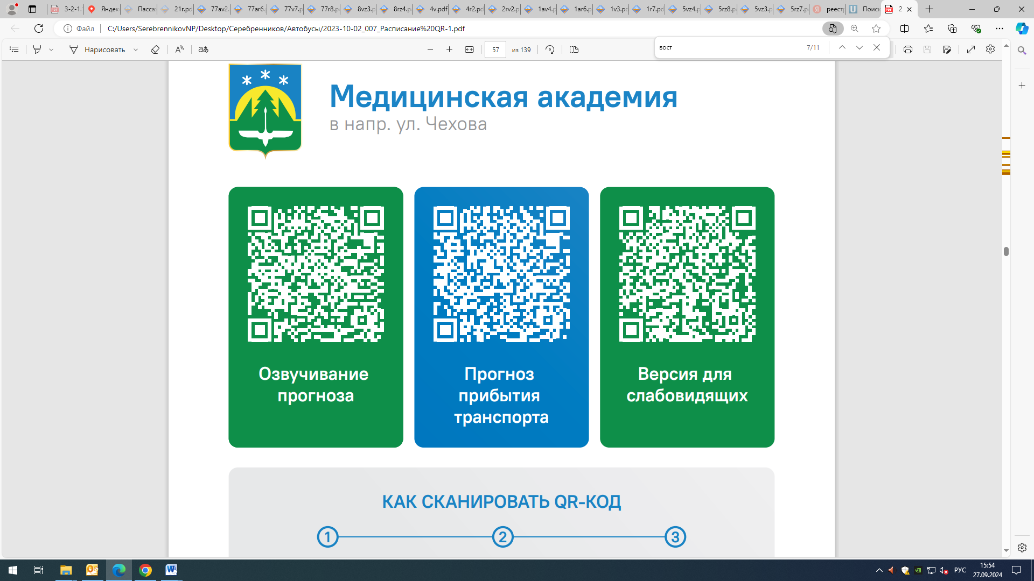



Контроль за осуществлением регулярных перевозок обеспечивает:
- управление транспорта, связи и дорог Администрации города Ханты-Мансийска, г: Ханты-Мансийск, ул Мира, 13, тел: 8 (3467) 39-39-07;
- отдел государственного автодорожного надзора по ХМАО – Югре, г: Ханты-Мансийск, ул: Шевченко 36А, тел: (3467) 32-64-60;
- МО МВД России «Ханты-Мансийский» г: Ханты-Мансийск, ул: Дзержинского дом 11, телефоны дежурной части 8 (3467) 398-104, 398-103, 102 и 112

