  Студенческий городок |  |  |  |  |  |  |  |  | А
По регулируемым тарифам
Номер маршрута | Конечный остановочный пункт | ДНИ | Время начала и окончания движения | Временной график отправления транспортных средств от остановочного пункта
5 | Ледовый дворец | Будни  с 01.06 по 31.08 | 05:07-23:32 | 5:07, 5:42, 6:22, 6:32, 6:52, 7:22, 7:42, 8:12, 8:22, 8:32, 8:47, 9:02, 9:22, 9:42, 9:52, 10:02, 10:22, 10:42, 11:02, 11:22, 11:42, 12:02, 12:22, 12:42, 13:02, 13:22, 13:42, 14:02, 14:22, 14:42, 15:02, 15:22, 15:42, 16:02, 16:22, 16:37, 16:52, 17:07, 17:22, 17:37, 17:52, 18:07, 18:22, 18:37, 18:52, 19:07, 19:22, 19:42, 20:02, 20:22, 20:37, 21:02, 21:22, 21:37, 21:52, 22:22, 22:52, 23:32
 |  | Выходные  с 01.06 по 31.08 | 5:07-23:32 | 5:07, 5:42, 6:22, 6:52, 7:22, 7:42, 8:22, 8:42, 9:02, 9:22, 9:42, 10:02, 10:22, 10:42, 11:02, 11:22, 11:42, 12:02, 12:22, 12:42, 13:02, 13:22, 13:42, 14:02, 14:22, 14:42, 15:02, 15:22, 15:42, 16:02, 16:22, 16:42, 17:02, 17:22, 17:42, 18:02, 18:22, 18:42, 19:02, 19:22, 19:42, 20:02, 20:22, 20:42, 21:02, 21:22, 21:37, 21:52, 22:22, 22:52, 23:32
 |  | Будни  с 01.09 по 31.05 | 5:07-23:32 | 5:07, 5:42, 6:22, 6:32, 6:42, 6:52, 7:02, 7:12, 7:22, 7:42, 7:52, 8:12, 8:22, 8:32, 8:47, 9:02, 9:22,  9:42, 10:02, 10:22, 10:42, 11:02, 11:22, 11:42, 12:02, 12:22, 12:37, 12:52, 13:07, 13:22, 13:42, 14:02, 14:22, 14:42, 15:02, 15:22, 15:37, 15:52, 16:07, 16:22, 16:37, 16:52, 17:07, 17:22, 17:37, 17:52, 18:07, 18:22, 18:37, 18:52, 19:07, 19:22, 19:42, 20:02, 20:22, 20:37, 20:52, 21:07, 21:22, 21:37, 21:52, 22:22, 22:52, 23:32
 |  | Выходные  с 01.09 по 31.05 | 5:07-23:32 | 5:07, 5:42, 6:22, 6:32, 6:52, 7:22, 7:42, 8:12, 8:22, 8:32, 8:47, 9:02, 9:22, 9:42, 9:52, 10:02, 10:22, 10:42, 11:02, 11:22, 11:42, 12:02, 12:22, 12:42, 13:02, 13:22, 13:42, 14:02, 14:22, 14:42, 15:02, 15:22, 15:42, 16:02, 16:22, 16:37, 16:52, 17:07, 17:22, 17:37, 17:52, 18:07, 18:22, 18:37, 18:52, 19:02, 19:22, 19:42, 20:02, 20:22, 20:37, 21:02, 21:22, 21:37, 21:52, 22:22, 22:52, 23:32
По нерегулируемым тарифам
Номер маршрута | Конечный остановочный пункт | ДНИ | Время начала и окончания движения | Интервал отправления транспортных средств от остановочного пункта
9К | мкр. Береговая зона |  |  | до 10:00 | 10:00 -11:00 | 11:00 -15:00 | 15:00 -16:00 | 16:00 – 20:00 |  | после 20:00
 |  | Будни | 6:30-22:00 | 15 | 20 | 15 | 20 | 15 |  | 20
 |  | Суббота | 6:30-22:00 | 20 | 25 | 20 | 25 | 20 |  | 25
 |  | Воскресенье | 6:30-21:00 | 20 | 25 | 25 | 25 | 25 |  | 30
Номер маршрута | Конечный остановочный пункт | ДНИ | Время начала и окончания движения | Интервал отправления транспортных средств от остановочного пункта
13К | мкр. Береговая зона |  |  | до 10:00 | 10:00 -11:00 | 11:00 -15:00 | 15:00 -16:00 | 16:00 – 20:00 |  | после 20:00
 |  | Будни | 6:30-22:00 | 15 | 20 | 15 | 20 | 15 |  | 20
 |  | Суббота | 6:30-22:00 | 20 | 25 | 20 | 25 | 20 |  | 25
Прогноз прибытия пассажирского транспорта
в вашем мобильном телефоне


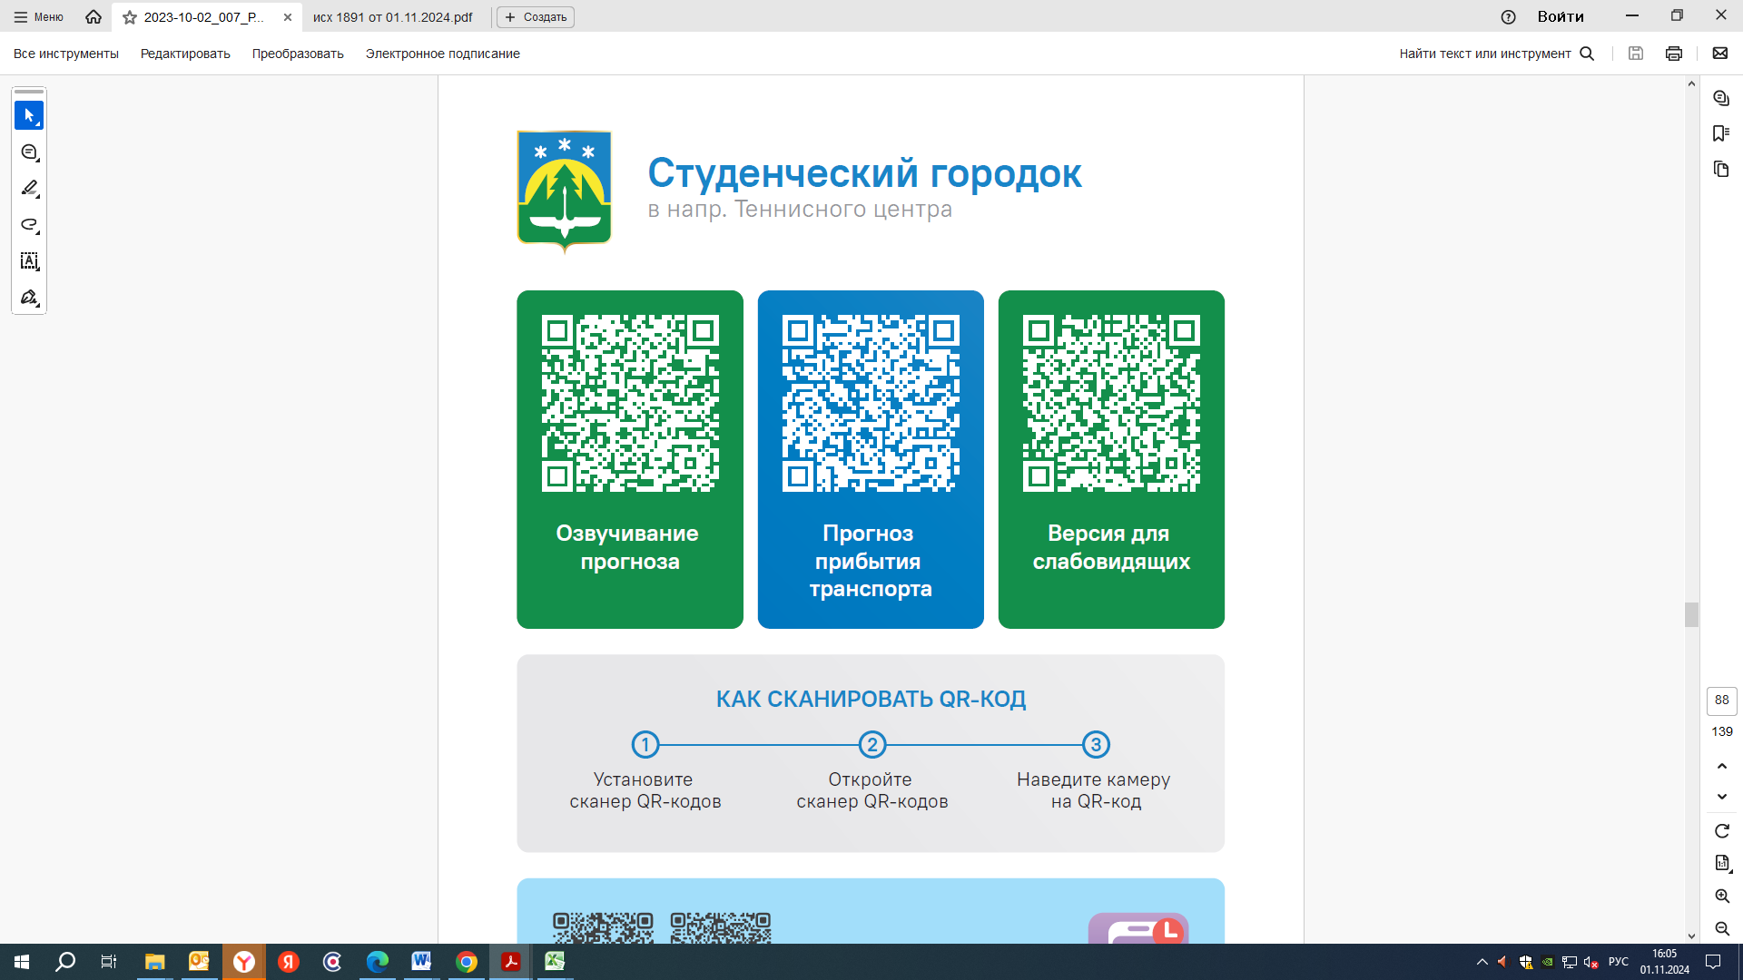


Контроль за осуществлением регулярных перевозок обеспечивает:
- управление транспорта, связи и дорог Администрации города Ханты-Мансийска, г: Ханты-Мансийск, ул Мира, 13, тел: 8 (3467) 39-39-07;
- отдел государственного автодорожного надзора по ХМАО – Югре, г: Ханты-Мансийск, ул: Шевченко 36А, тел: (3467) 32-64-60;
- МО МВД России «Ханты-Мансийский» г: Ханты-Мансийск, ул: Дзержинского дом 11, телефоны дежурной части 8 (3467) 398-104, 398-103, 102 и 112

