  Спортивная |  |  |  |  |  |  |  |  | А
По регулируемым тарифам
Номер маршрута | Конечный остановочный пункт | ДНИ | Время начала и окончания движения | Временной график отправления транспортных средств от остановочного пункта
1 | Авторечвокзал  (по Гагарина) | Будни | 6:24-22:49 | 6:24, 7:09, 7:29, 7:59, 8:22, 8:49, 9:04, 9:44, 10:24, 10:39, 11:24, 12:24, 13:29, 14:29, 15:04,  15:54, 16:54, 17:39, 17:54, 18:39, 19:19, 19:39, 20:19, 20:54, 21:19, 21:54, 22:49
 |  | Выходные | 6:39-21:54 | 6:39, 7:39, 8:19, 9:19, 9:59, 10:59, 11:59, 12:59, 13:39, 14:39, 15:19, 16:19, 16:59, 17:39,  17:59, 18:39, 19:19, 20:19, 20:54, 21:54
4 | мкр. Береговая зона | Будни | 6:53-22:43 | 6:53, 7:23, 7:53, 8:13, 8:38, 8:58, 9:18, 9:53, 10:13, 10:58, 11:53, 12:13, 12:53, 13:08, 13:33, 14:03, 14:23, 14:53, 15:28, 15:48, 16:13, 16:53, 17:18, 17:33, 17:53, 18:23, 18:33, 18:53, 19:18, 19:58, 20:18, 20:38, 21:13, 21:53, 22:43
 |  | Выходные | 6:53-22:43 | 6:53, 7:53, 8:13, 8:58, 9:53, 10:58, 11:53, 12:53, 13:08, 14:03, 14:53, 15:48, 16:53, 17:53, 18:53, 19:58, 20:38, 21:53, 22:43
5 | Ледовый дворец | Будни  с 01.06 по 31.08 | 5:40-00:05 | 5:40, 6:15, 6:55, 7:05, 7:25, 7:55, 8:15, 8:45, 8:55, 9:05, 9:20, 9:35, 9:55, 10:15, 10:25, 10:35, 10:55, 11:15, 11:35, 11:55, 12:15, 12:35, 12:55, 13:15, 13:35, 13:55, 14:15, 14:35, 14:55, 15:15, 15:35, 15:55, 16:15, 16:35, 16:55, 17:10, 17:25, 17:40, 17:55, 18:10, 18:25, 18:40, 18:55, 19:10, 19:25, 19:40, 19:55, 20:15, 20:35, 20:55, 21:10, 21:35, 21:55, 22:10, 22:25, 22:55, 23:25, 0:05
 |  | Выходные  с 01.06 по 31.08 | 5:40-00:05 | 5:40, 6:15, 6:55, 7:25, 7:55, 8:15, 8:55, 9:15, 9:35, 9:55, 10:15, 10:35, 10:55, 11:15, 11:35, 11:55, 12:15, 12:35, 12:55, 13:15, 13:35, 13:55, 14:15, 14:35, 14:55, 15:15, 15:35, 15:55, 16:15, 16:35, 16:55, 17:15, 17:35, 17:55, 18:15, 18:35, 18:55, 19:15, 19:35, 19:55, 20:15, 20:35, 20:55, 21:15, 21:35, 21:55, 22:10, 22:25, 22:55, 23:25, 0:05
 |  | Будни  с 01.09 по 31.05 | 5:40-00:05 | 5:40, 6:15, 6:55, 7:05, 7:15, 7:25, 7:35, 7:45, 7:55, 8:15, 8:25, 8:45, 8:55, 9:05, 9:20, 9:35, 9:55, 10:15, 10:35, 10:55, 11:15, 11:35, 11:55, 12:15, 12:35, 12:55, 13:10, 13:25, 13:40, 13:55, 14:15, 14:35, 14:55, 15:15, 15:35, 15:55, 16:10, 16:25, 16:40, 16:55, 17:10, 17:25, 17:40, 17:55, 18:10, 18:25, 18:40, 18:55, 19:10, 19:25, 19:40, 19:55, 20:15, 20:35, 20:55, 21:10, 21:25, 21:40, 21:55, 22:10, 22:25, 22:55, 23:25, 0:05
 |  | Выходные  с 01.09 по 31.05 | 5:40-00:05 | 5:40, 6:15, 6:55, 7:05, 7:25, 7:55, 8:15, 8:45, 8:55, 9:05, 9:20, 9:35, 9:55, 10:15, 10:25, 10:35, 10:55, 11:15, 11:35, 11:55, 12:15, 12:35, 12:55, 13:15, 13:35, 13:55, 14:15, 14:35, 14:55, 15:15, 15:35, 15:55, 16:15, 16:35, 16:55, 17:10, 17:25, 17:40, 17:55, 18:10, 18:25, 18:40, 18:55, 19:10, 19:25, 19:35, 19:55, 20:15, 20:35, 20:55, 21:10, 21:35, 21:55, 22:10, 22:25, 22:55, 23:25, 0:05
21 | Ключевая | Будни | 7:33-23:03 | 7:33, 7:53, 8:13, 8:33, 8:53, 9:13, 9:33, 9:53, 10:13, 10:53, 11:13, 11:53, 12:43, 13:43, 14:13, 14:33, 15:18, 15:53, 16:13, 16:43, 17:13, 17:33, 17:53, 18:13, 18:33, 18:53, 19:13, 19:33, 19:53, 20:13, 20:33, 21:13, 21:33, 22:13, 23:03
 |  | Выходные | 7:33-23:03 | 7:33, 8:13, 9:13, 9:53, 10:13, 11:48, 12:43, 13:43, 14:18, 15:18, 15:53, 16:53, 17:33, 18:13, 18:33,  19:13, 19:53, 20:13, 21:28, 23:03
77 | Гимназия №1 | Будни | 6:49-21:39 | 6:49, 7:19, 7:39, 8:14, 8:59, 9:09, 9:46, 10:19, 11:19, 12:34, 12:59, 13:29, 13:59, 14:26, 14:44, 15:26, 15:53,  16:19, 17:39, 18:09, 18:39, 19:36, 20:09, 20:59, 21:19, 21:39
 |  | Выходные | 6:49-21:29 | 6:49, 7:19, 7:39, 8:19, 8:59, 9:49, 10:19, 11:19, 12:24, 13:19, 13:39, 14:44, 15:24, 16:19, 16:49, 17:19, 17:39, 18:19, 18:49, 19:24, 20:04, 20:29, 21:29
По нерегулируемым тарифам
Номер маршрута | Конечный остановочный пункт | ДНИ | Время начала и окончания движения | Интервал отправления транспортных средств от остановочного пункта
7К | ТД «Сатурн» |  |  | до 10:00 | 10:00 -11:00 | 11:00 -15:00 | 15:00 -16:00 | 16:00 – 20:00 |  | после 20:00
 |  | Будни | 6:30-22:00 | 15 | 20 | 15 | 20 | 15 |  | 20
 |  | Суббота | 6:30-22:00 | 20 | 25 | 20 | 25 | 20 |  | 25
 |  | Воскресенье | 6:30-21:00 | 20 | 25 | 25 | 25 | 25 |  | 30
8К | Гимназия №1 |  |  | до 10:00 | 10:00 -11:00 | 11:00 -15:00 | 15:00 -16:00 | 16:00 – 20:00 |  | после 20:00
 |  | Будни | 6:30-22:00 | 15 | 20 | 15 | 20 | 15 |  | 20
 |  | Суббота | 6:30-22:00 | 20 | 25 | 20 | 25 | 20 |  | 25
 |  | Воскресенье | 6:30-21:00 | 20 | 25 | 25 | 25 | 25 |  | 30
13К | мкр. Береговая зона |  |  | до 10:00 | 10:00 -11:00 | 11:00 -15:00 | 15:00 -16:00 | 16:00 – 20:00 |  | после 20:00
 |  | Будни | 6:30-22:00 | 15 | 20 | 15 | 20 | 15 |  | 20
 |  | Суббота | 6:30-22:00 | 20 | 25 | 20 | 25 | 20 |  | 25
 |  | Воскресенье | 6:30-21:00 | 20 | 25 | 25 | 25 | 25 |  | 30
  26К | Гимназия №1 |  |  | до 10:00 | 10:00 -11:00 | 11:00 -15:00 | 15:00 -16:00 | 16:00 – 20:00 |  | после 20:00
 |  | Будни | 6:30-22:00 | 15 | 20 | 15 | 20 | 15 |  | 20
 |  | Суббота | 6:30-22:00 | 20 | 25 | 20 | 25 | 20 |  | 25
 |  |   Воскресенье  Прогноз прибытия пассажирского транспорта  в вашем мобильном телефоне | 6:30-21:00 | 20 | 25 | 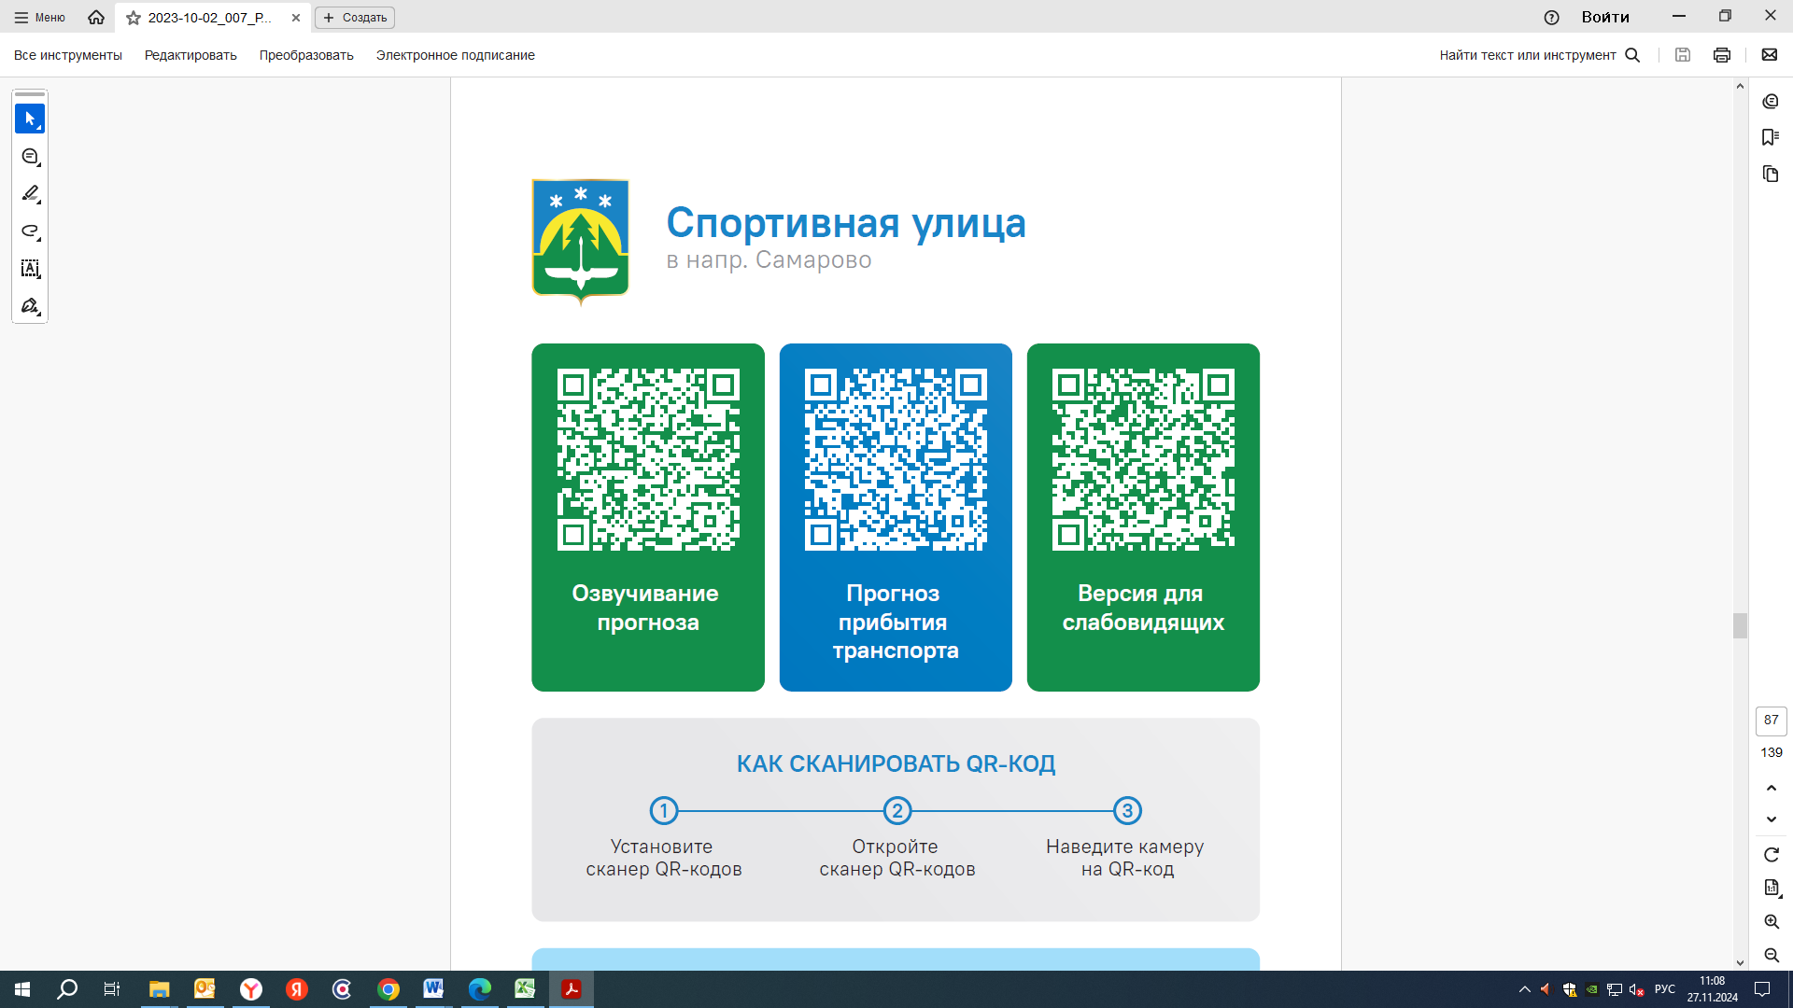  25 | 25 | 25 |  | 30
Контроль за осуществлением регулярных перевозок обеспечивает:
- управление транспорта, связи и дорог Администрации города Ханты-Мансийска, г: Ханты-Мансийск, ул Мира, 13, тел: 8 (3467) 39-39-07;
- отдел государственного автодорожного надзора по ХМАО – Югре, г: Ханты-Мансийск, ул: Шевченко 36А, тел: 8 (3467) 32-64-60;
- МО МВД России «Ханты-Мансийский» г: Ханты-Мансийск, ул: Дзержинского дом 11, телефоны дежур ной части 8 (3467) 398-104, 398-103, 102 и 112

