  Школа №3 |  |  |  |  |  |  |  |  | А
По регулируемым тарифам
Номер маршрута | Конечный остановочный пункт | ДНИ | Время начала и окончания движения | Временной график отправления транспортных средств от остановочного пункта
2 | Мелиораторов | ежедневно | 7:15-19:35 | 7:15, 8:23, 9:23, 10:15, 12:15, 13:15, 14:15, 15:15, 17:25, 18:35, 19:35,
4 | ОМК | Будни | 6:41-22:41 | 6:41, 7:01, 7:21, 7:41, 8:06, 8:21, 8:41, 9:01, 9:21, 9:41, 10:01, 10:41, 11:01, 11:41, 12:41, 13:01, 13:41, 14:11, 15:01, 15:41, 16:21, 16:41, 17:01, 17:21, 17:41, 18:01, 18:21, 18:41, 19:06, 19:21, 20:01, 20:41, 21:01, 21:31, 22:01, 22:41
 |  | Выходные | 6:41-22:41 | 6:41, 7:41, 8:41, 9:41, 10:41, 11:41, 12:41, 13:41, 14:41, 15:11, 15:41, 16:41, 17:11, 17:41, 18:41, 19:41, 20:41, 21:41, 22:41
5 | Мкр. Восточный | Будни  с 01.06 по 31.08 | 6:12-23:17 | 6:12, 6:52, 7:12, 7:44, 7:54, 8:14, 8:22, 8:32, 8:42, 8:52, 9:12, 9:37, 9:47, 10:02, 10:12, 10:32, 10:47, 11:02, 11:12, 11:22, 11:32, 11:52, 12:12, 12:32, 12:52, 13:12, 13:32, 13:52, 14:12, 14:32, 14:52, 15:12, 15:32, 15:52, 16:12, 16:32, 16:52, 17:12, 17:32, 17:47, 18:02, 18:17, 18:37, 18:47, 19:02, 19:17, 19:32, 19:47, 20:02, 20:17, 20:32,  20:52, 21:12, 21:32, 21:47, 22:02, 22:32, 23:02, 23:17
 |  | Выходные  с 01.06 по 31.08 | 6:12-23:47 | 6:12, 6:52, 7:12, 7:44, 8:14, 8:32, 8:52, 9:12, 9:32, 9:52, 10:12, 10:32, 10:52, 11:12, 11:32, 11:52, 12:12, 12:32, 12:52, 13:12, 13:32, 13:52, 14:12, 14:32, 14:52, 15:12, 15:32, 15:52, 16:12, 16:32, 16:52, 17:12, 17:32, 17:52, 18:12, 18:32, 18:52, 19:12, 19:32, 19:52, 20:12, 20:32, 20:52, 21:12, 21:32, 21:47, 22:12, 22:32, 23:02, 23:47
 |  | Будни  с 01.09 по 31.05 | 6:12-00:17 | 6:12, 6:52, 7:12, 7:44, 7:54, 8:12, 8:22, 8:32, 8:42, 8:52, 9:12, 9:22, 9:37, 9:47, 9:57, 10:12, 10:32, 10:52, 11:12, 11:22, 11:32, 11:52, 12:12, 12:32, 12:52, 13:12, 13:32, 13:47, 14:02, 14:17, 14:32, 14:52, 15:12, 15:32, 15:52, 16:12, 16:32, 16:47, 17:02, 17:17, 17:32, 17:47, 18:02, 18:17, 18:32, 18:47, 19:02, 19:17, 19:32, 19:47, 20:02,  20:17, 20:32, 20:52, 21:12, 21:32, 21:47, 22:02, 22:17, 22:32, 22:47, 23:02, 23:47, 0:02, 0:17
 |  | Выходные с 01.09 по 31.05 | 6:52-00:17 | 6:52, 7:12, 7:44, 7:54, 8:14, 8:32, 8:52, 9:12, 9:37, 9:47, 9:57, 10:12, 10:32, 10:47, 11:02, 11:12, 11:22, 11:32, 11:52, 12:12, 12:32, 12:52, 13:12, 13:32, 13:52, 14:12, 14:32, 14:52, 15:12, 15:32, 16:12, 16:12, 16:32, 16:52,  17:12, 17:32, 17:47, 18:02, 18:17, 18:32, 18:47, 19:02, 19:17, 19:32, 19:47, 20:02, 20:17, 20:32, 20:52, 21:12, 21:32, 21:47, 22:02, 22:32, 23:02, 23:17, 23:47, 0:17
21 | Теннисный центр | Будни | 6:47-22:17 | 6:47, 7:07, 7:27, 7:47, 8:07, 8:27, 8:47, 9:07, 9:27, 9:57, 10:27, 11:02, 11:27, 11:57, 12:57, 13:32, 14:32, 15:07, 15:27, 16:07, 16:27, 16:47, 17:07, 17:27, 17:47, 18:07, 18:27, 18:47, 19:07, 19:27, 19:47, 20:27, 20:42, 21:27, 22:17
 |  | Выходные | 6:47-22:17 | 6:47, 7:27, 8:27, 9:07, 9:27, 11:02, 11:57, 12:57, 13:32, 14:32, 15:07, 16:07, 16:47, 17:27, 17:47, 18:27, 19:07, 19:27, 20:42, 22:17
77А | Районная поликлиника | Будни | 6:44-21:44 | 6:44, 7:04, 7:34, 8:04, 8:24, 8:49, 9:09, 9:24, 9:44, 10:04, 10:24, 11:04, 12:04, 13:04, 13:44, 14:44, 15:24, 16:24, 17:04, 17:24, 17:44, 18:04, 18:24, 18:44, 19:04, 19:24, 19:44, 20:04, 20:44, 21:04, 21:44
 |  | Выходные | 8:04-22:34 | 8:04, 9:04, 9:44, 10:44, 11:24, 12:24, 13:04, 14:04, 15:04, 16:44, 17:04, 18:24, 18:44, 19:04, 20:04, 20:34, 21:04, 22:34
По нерегулируемым тарифам
Номер маршрута | Конечный остановочный пункт | ДНИ | Время начала и окончания движения | Интервал отправления транспортных средств от остановочного пункта
9К | Аэропорт |  |  | до 10:00 | 10:00 -11:00 | 11:00 -15:00 | 15:00 -16:00 | 16:00 – 20:00 |  | после 20:00
 |  | Будни | 6:30-22:00 | 15 | 20 | 15 | 20 | 15 |  | 20
 |  | Суббота | 6:30-22:00 | 20 | 25 | 20 | 25 | 20 |  | 25
 |  | Воскресенье | 6:30-21:00 | 20 | 25 | 25 | 25 | 25 |  | 30
13 | База Ханты-Мансийскгаз |  |  | до 10:00 | 10:00 -11:00 | 11:00 -15:00 | 15:00 -16:00 | 16:00 – 20:00 |  | после 20:00
 |  | Будни | 6:30-22:00 | 15 | 20 | 15 | 20 | 15 |  | 20
 |  | Суббота | 6:30-22:00 | 20 | 25 | 20 | 25 | 20 |  | 25
 |  | Воскресенье | 6:30-21:00 | 20 | 25 | 25 | 25 | 25 |  | 30
26К | Теннисный центр |  |  | до 10:00 | 10:00 -11:00 | 11:00 -15:00 | 15:00 -16:00 | 16:00 – 20:00 |  | после 20:00
 |  | Будни | 6:30-22:00 | 15 | 20 | 15 | 20 | 15 |  | 20
 |  | Суббота | 6:30-22:00 | 20 | 25 | 20 | 25 | 20 |  | 25
 |  | Воскресенье | 6:30-21:00 | 20 | 25 | 25 | 25 | 25 |  | 30
Прогноз прибытия пассажирского транспорта
в вашем мобильном телефоне

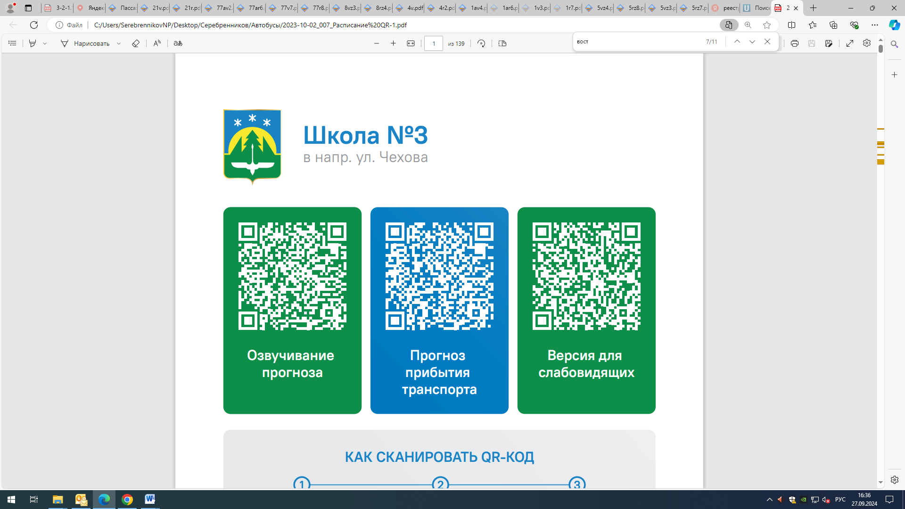



Контроль за осуществлением регулярных перевозок обеспечивает:
- управление транспорта, связи и дорог Администрации города Ханты-Мансийска, г: Ханты-Мансийск, ул Мира, 13, тел: 8 (3467) 39-39-07;
- отдел государственного автодорожного надзора по ХМАО – Югре, г: Ханты-Мансийск, ул: Шевченко 36А, тел: (3467) 32-64-60;
- МО МВД России «Ханты-Мансийский» г: Ханты-Мансийск, ул: Дзержинского дом 11, телефоны дежурной части (3467) 398-104, 398-103, 102 и 112

