  Школа №2 |  |  |  |  |  |  |  |  | А
По регулируемым тарифам
Номер маршрута | Конечный остановочный пункт | ДНИ | Время начала и окончания движения | Временной график отправления транспортных средств от остановочного пункта
1 | ОМК | Будни | 6:35-23:00 | 6:35, 7:20, 7:40, 8:10, 8:33, 9:00, 9:15, 9:55, 10:35, 10:50, 11:35, 12:35, 13:40, 14:40, 15:15,  16:05, 17:05, 17:50, 18:05, 18:50, 19:30, 19:50, 20:30, 21:05, 21:30, 22:05, 23:00
 |  | Выходные | 6:50-22:05 | 6:50, 7:50, 8:30, 9:30, 10:10, 11:10, 12:10, 13:10, 13:50, 14:50, 15:30, 16:30, 17:10, 17:50, 18:10, 18:50, 19:30, 20:30, 21:05, 22:05
4 | мкр. Береговая зона | Будни | 7:03-22:53 | 7:03, 7:33, 8:03, 8:23, 8:48, 9:08, 9:28, 10:03, 10:23, 11:08, 12:03, 12:23, 13:03, 13:18, 13:43,  14:13, 14:33, 15:03, 15:38, 15:58, 16:23, 17:03, 17:28, 17:43, 18:03, 18:33, 18:43, 19:03, 19:27, 20:08, 20:28, 20:48, 21:23, 22:03, 22:53
 |  | Выходные | 7:03-22:53 | 7:03, 8:03, 8:23, 9:08, 10:03, 11:08, 12:03, 13:03, 13:18, 14:13, 15:03, 15:58, 17:03, 18:03, 19:03, 20:08, 20:48, 22:03, 22:53
5 | Ледовый дворец | Будни  с 01.06 по 31.08 | 5:51-0:16 | 5:51, 6:26, 7:06, 7:16, 7:36, 8:06, 8:26, 8:56, 9:06, 9:16, 9:31, 9:46, 10:06, 10:26, 10:36, 10:46, 11:06, 11:26, 11:46, 12:06, 12:26, 12:46, 13:06, 13:26, 13:46, 14:06, 14:26, 14:46, 15:06, 15:26, 15:46, 16:06, 16:26, 16:46, 17:06, 17:21, 17:36, 17:51, 18:06, 18:21, 18:36, 18:51, 19:06, 19:21, 19:36, 19:51, 20:06, 20:26, 20:46, 21:06, 21:21, 21:46, 22:06, 22:21, 22:36, 23:06, 23:36, 0:16
 |  | Выходные  с 01.06 по 31.08 | 5:51-0:16 | 5:51, 6:26, 7:06, 7:36, 8:06, 8:26, 9:06, 9:26, 9:46, 10:06, 10:26, 10:46, 11:06, 11:26, 11:46, 12:06, 12:26, 12:46, 13:06, 13:26, 13:46, 14:06, 14:26, 14:46, 15:06, 15:26, 15:46, 16:06, 16:26, 16:46, 17:06, 17:26, 17:46, 18:06, 18:26, 18:46, 19:06, 19:26, 19:46, 20:06, 20:26, 20:46, 21:06, 21:26, 21:46, 22:06, 22:21, 22:36, 23:06, 23:36, 0:16
 |  | Будни  с 01.09 по 31.05 | 5:51-00:16 | 5:51, 6:26, 7:06, 7:16, 7:26, 7:36, 7:46, 7:56, 8:06, 8:26, 8:36, 8:56, 9:06, 9:16, 9:31, 9:46, 10:06, 10:26, 10:46, 11:06, 11:26, 11:46, 12:06, 12:26, 12:46, 13:06, 13:21, 13:36, 13:51, 14:06, 14:26, 14:46, 15:06, 15:26, 15:46, 16:06, 16:21, 16:36, 16:51, 17:06, 17:21, 17:36, 17:51, 18:06, 18:21, 18:36, 18:51, 19:06, 19:21, 19:36, 19:51, 20:06, 20:26, 20:46, 21:06, 21:21, 21:36, 21:51, 22:06, 22:21, 22:36, 23:06, 23:36, 0:16
 |  | Выходные с 01.09 по 31.05 | 5:51-00:16 | 5:51, 6:26, 7:06, 7:16, 7:36, 8:06, 8:26, 8:56, 9:06, 9:16, 9:31, 9:46, 10:06, 10:26, 10:36, 10:46, 11:06, 11:26, 11:46, 12:06, 12:26, 12:46, 13:06, 13:26, 13:46, 14:06, 14:26, 14:46, 15:06, 15:26, 15:46, 16:06, 16:26, 16:46, 17:06, 17:21, 17:36, 17:51, 18:06, 18:21, 18:36, 18:51, 19:06, 19:21, 19:36, 19:46, 20:06, 20:26, 20:46, 21:06, 21:21, 21:46, 22:06, 22:21, 22:36, 23:06, 23:36, 0:16
77 | Гимназия №1 | Будни | 7:00-21:40 | 7:00, 7:37, 7:50, 8:37, 9:10, 10:00, 10:30, 11:30, 12:45, 13:30, 14:10, 15:02, 15:35, 16:30, 17:07, 17:37, 17:57, 18:30, 19:00, 19:35, 20:15, 20:40, 21:40
 |  | Выходные | 7:00-21:40 | 7:00, 7:30, 7:50, 8:37, 9:10, 10:00, 10:30, 11:30, 12:35, 13:30, 13:57, 14:55, 15:35, 16:30, 17:00, 17:30, 17:57, 18:30, 19:00, 19:35, 20:15, 20:40, 21:40
По нерегулируемым тарифам
Номер маршрута | Конечный остановочный пункт | ДНИ | Время начала и окончания движения | Интервал отправления транспортных средств от остановочного пункта
8К | Гимназия №1 |  |  | до 10:00 | 10:00 -11:00 | 11:00 -15:00 | 15:00 -16:00 | 16:00 – 20:00 |  | после 20:00
 |  | Будни | 6:30-22:00 | 15 | 20 | 15 | 20 | 15 |  | 20
 |  | Суббота | 6:30-22:00 | 20 | 25 | 20 | 25 | 20 |  | 25
 |  | Воскресенье | 6:30-21:00 | 20 | 25 | 25 | 25 | 25 |  | 30
13К | мкр. Береговая зона |  |  | до 10:00 | 10:00 -11:00 | 11:00 -15:00 | 15:00 -16:00 | 16:00 – 20:00 |  | после 20:00
 |  | Будни | 6:30-22:00 | 15 | 20 | 15 | 20 | 15 |  | 20
 |  | Суббота | 6:30-22:00 | 20 | 25 | 20 | 25 | 20 |  | 25
 |  | Воскресенье | 6:30-21:00 | 20 | 25 | 25 | 25 | 25 |  | 30
26К | Гимназия №1 |  |  | до 10:00 | 10:00 -11:00 | 11:00 -15:00 | 15:00 -16:00 | 16:00 – 20:00 |  | после 20:00
 |  | Будни | 6:30-22:00 | 15 | 20 | 15 | 20 | 15 |  | 20
 |  | Суббота | 6:30-22:00 | 20 | 25 | 20 | 25 | 20 |  | 25
 |  | Воскресенье | 6:30-21:00 | 20 | 25 | 25 | 25 | 25 |  | 30
Прогноз прибытия пассажирского транспорта
в вашем мобильном телефоне

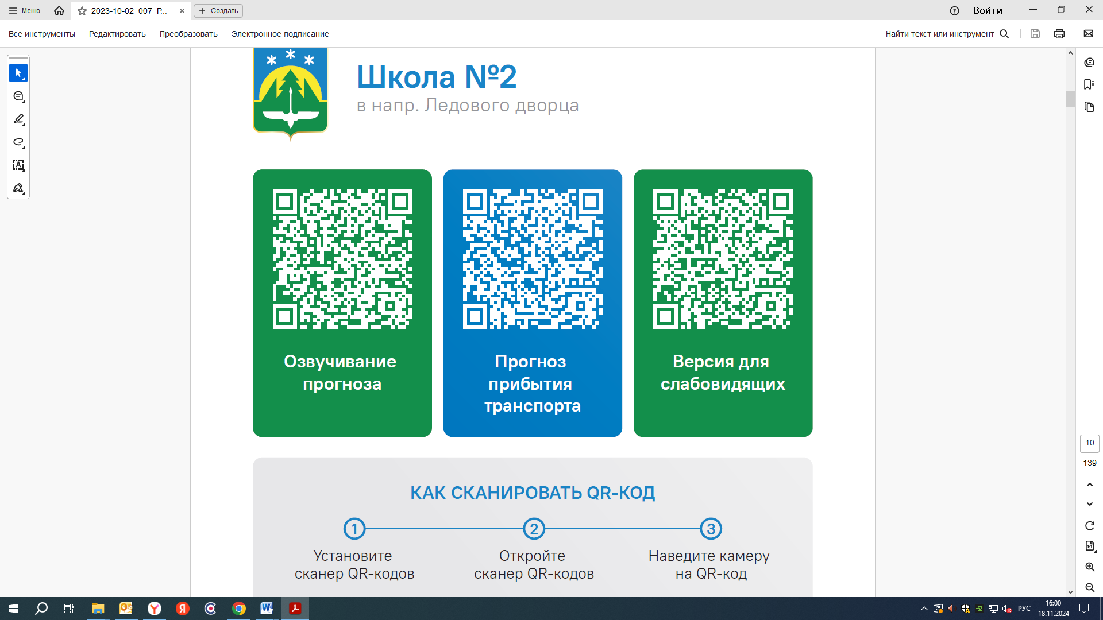


Контроль за осуществлением регулярных перевозок обеспечивает:
- управление транспорта, связи и дорог Администрации города Ханты-Мансийска, г: Ханты-Мансийск, ул Мира, 13, тел: 8 (3467) 39-39-07;
- отдел государственного автодорожного надзора по ХМАО – Югре, г: Ханты-Мансийск, ул: Шевченко 36А, тел: (3467) 32-64-60;
- МО МВД России «Ханты-Мансийский» г: Ханты-Мансийск, ул: Дзержинского дом 11, телефоны дежурной части 8 (3467) 398-104, 398-103, 102 и 112

