  Водолечебница |  |  |  |  |  |  |  |  | А
По регулируемым тарифам
Номер маршрута | Конечный остановочный пункт | ДНИ | Время начала и окончания движения | Временной график отправления транспортных средств от остановочного пункта
2 | Мелиораторов | ежедневно | 7:17-19:37 | 7:17, 8:25, 9:25, 10:17, 12:17, 13:17, 14:17, 15:17, 17:27, 18:37, 19:37,
4 | ОМК | Будни | 6:43-22:43 | 6:43, 7:03, 7:23, 7:43, 8:08, 8:23, 8:43, 9:03, 9:23, 9:43, 10:03, 10:43, 11:03, 11:43, 12:43, 13:03, 13:43, 14:13, 15:03, 15:43, 16:23, 16:43, 17:03, 17:23, 17:43, 18:03, 18:23, 18:43, 19:08, 19:23, 20:03, 20:43, 21:03, 21:33, 22:03, 22:43
 |  | Выходные | 6:43-22:43 | 6:43, 7:43, 8:43, 9:43, 10:43, 11:43, 12:43, 13:43, 14:43, 15:13, 15:43, 16:43, 17:13, 17:43, 18:43, 19:43, 20:43, 21:43, 22:43
5 | Мкр. Восточный | Будни  с 01.06 по 31.08 | 6:14-23:19 | 6:14, 6:54, 7:14, 7:46, 7:56, 8:16, 8:24, 8:34, 8:44, 8:54, 9:14, 9:39, 9:49, 10:04, 10:14, 10:34, 10:49, 11:04, 11:14, 11:24, 11:34, 11:54, 12:14, 12:34, 12:54, 13:14, 13:34, 13:54, 14:14, 14:34, 14:54, 15:14, 15:34, 15:54, 16:14, 16:34, 16:54, 17:14, 17:34, 17:49, 18:04, 18:19, 18:39, 18:49, 19:04, 19:19, 19:34, 19:49, 20:04, 20:19, 20:34,  20:54, 21:14, 21:34, 21:49, 22:04, 22:34, 23:04, 23:19
 |  | Выходные  с 01.06 по 31.08 | 6:14-23:49 | 6:14, 6:54, 7:14, 7:46, 8:16, 8:34, 8:54, 9:14, 9:34, 9:54, 10:14, 10:34, 10:54, 11:14, 11:34, 11:54, 12:14, 12:34, 12:54, 13:14, 13:34, 13:54, 14:14, 14:34, 14:54, 15:14, 15:34, 15:54, 16:14, 16:34, 16:54, 17:14, 17:34, 17:54, 18:14, 18:34, 18:54, 19:14, 19:34, 19:54, 20:14, 20:34, 20:54, 21:14, 21:34, 21:49, 22:14, 22:34, 23:04, 23:49
 |  | Будни  с 01.09 по 31.05 | 6:14-00:19 | 6:14, 6:54, 7:14, 7:46, 7:56, 8:14, 8:24, 8:34, 8:44, 8:54, 9:14, 9:24, 9:39, 9:49, 9:59, 10:14, 10:34, 10:54, 11:14, 11:24, 11:34, 11:54, 12:14, 12:34, 12:54, 13:14, 13:34, 13:49, 14:04, 14:19, 14:34, 14:54, 15:14, 15:34, 15:54, 16:14, 16:34, 16:49, 17:04, 17:19, 17:34, 17:49, 18:04, 18:19, 18:34, 18:49, 19:04, 19:19, 19:34, 19:49, 20:04,  20:19, 20:34, 20:54, 21:14, 21:34, 21:49, 22:04, 22:19, 22:34, 22:49, 23:04, 23:49, 0:04, 0:19
 |  | Выходные с 01.09 по 31.05 | 6:54-00:19 | 6:54, 7:14, 7:46, 7:56, 8:16, 8:34, 8:54, 9:14, 9:39, 9:49, 9:59, 10:14, 10:34, 10:49, 11:04, 11:14, 11:24, 11:34, 11:54, 12:14, 12:34, 12:54, 13:14, 13:34, 13:54, 14:14, 14:34, 14:54, 15:14, 15:34, 16:14, 16:14, 16:34, 16:54,  17:14, 17:34, 17:49, 18:04, 18:19, 18:34, 18:49, 19:04, 19:19, 19:34, 19:49, 20:04, 20:19, 20:34, 20:54, 21:14, 21:34, 21:49, 22:04, 22:34, 23:04, 23:19, 23:49, 0:19
21 | Теннисный центр | Будни | 6:49-22:19 | 6:49, 7:09, 7:29, 7:49, 8:09, 8:29, 8:49, 9:09, 9:29, 9:59, 10:29, 11:04, 11:29, 11:59, 12:59, 13:34, 14:34, 15:09, 15:29, 16:09, 16:29, 16:49, 17:09, 17:29, 17:49, 18:09, 18:29, 18:49, 19:09, 19:29, 19:49, 20:29, 20:44, 21:29, 22:19
 |  | Выходные | 6:49-22:19 | 6:49, 7:29, 8:29, 9:09, 9:29, 11:04, 11:59, 12:59, 13:34, 14:34, 15:09, 16:09, 16:49, 17:29, 17:49, 18:29, 19:09, 19:29, 20:44, 22:19
77А | Районная поликлиника | Будни | 6:46-21:46 | 6:46, 7:06, 7:36, 8:06, 8:26, 8:51, 9:11, 9:26, 9:46, 10:06, 10:26, 11:06, 12:06, 13:06, 13:46, 14:46, 15:26, 16:26, 17:06, 17:26, 17:46, 18:06, 18:26, 18:46, 19:06, 19:26, 19:46, 20:06, 20:46, 21:06, 21:46
 |  | Выходные | 8:06-22:36 | 8:06, 9:06, 9:46, 10:46, 11:26, 12:26, 13:06, 14:06, 15:06, 16:46, 17:06, 18:26, 18:46, 19:06, 20:06, 20:36, 21:06, 22:36
По нерегулируемым тарифам
Номер маршрута | Конечный остановочный пункт | ДНИ | Время начала и окончания движения | Интервал отправления транспортных средств от остановочного пункта
9К | Аэропорт |  |  | до 10:00 | 10:00 -11:00 | 11:00 -15:00 | 15:00 -16:00 | 16:00 – 20:00 |  | после 20:00
 |  | Будни | 6:30-22:00 | 15 | 20 | 15 | 20 | 15 |  | 20
 |  | Суббота | 6:30-22:00 | 20 | 25 | 20 | 25 | 20 |  | 25
 |  | Воскресенье | 6:30-21:00 | 20 | 25 | 25 | 25 | 25 |  | 30
13 | База Ханты-Мансийскгаз |  |  | до 10:00 | 10:00 -11:00 | 11:00 -15:00 | 15:00 -16:00 | 16:00 – 20:00 |  | после 20:00
 |  | Будни | 6:30-22:00 | 15 | 20 | 15 | 20 | 15 |  | 20
 |  | Суббота | 6:30-22:00 | 20 | 25 | 20 | 25 | 20 |  | 25
 |  | Воскресенье | 6:30-21:00 | 20 | 25 | 25 | 25 | 25 |  | 30
26К | Теннисный центр |  |  | до 10:00 | 10:00 -11:00 | 11:00 -15:00 | 15:00 -16:00 | 16:00 – 20:00 |  | после 20:00
 |  | Будни | 6:30-22:00 | 15 | 20 | 15 | 20 | 15 |  | 20
 |  | Суббота | 6:30-22:00 | 20 | 25 | 20 | 25 | 20 |  | 25
 |  | Воскресенье | 6:30-21:00 | 20 | 25 | 25 | 25 | 25 |  | 30
Прогноз прибытия пассажирского транспорта
в вашем мобильном телефоне

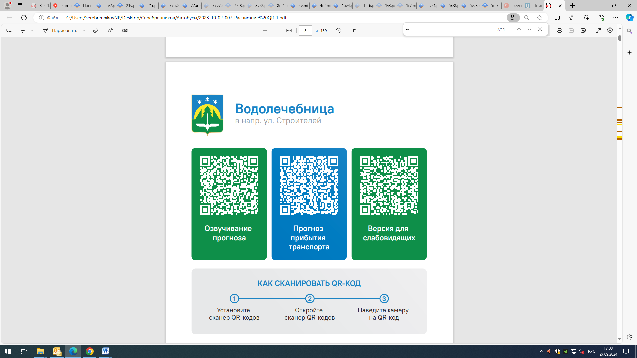



Контроль за осуществлением регулярных перевозок обеспечивает:
- управление транспорта, связи и дорог Администрации города Ханты-Мансийска, г: Ханты-Мансийск, ул Мира, 13, тел: 8 (3467) 39-39-07;
- отдел государственного автодорожного надзора по ХМАО – Югре, г: Ханты-Мансийск, ул: Шевченко 36А, тел: (3467) 32-64-60;
- МО МВД России «Ханты-Мансийский» г: Ханты-Мансийск, ул: Дзержинского дом 11, телефоны дежурной части (3467) 398-104, 398-103, 102 и 112

