  Школа №2 |  |  |  |  |  |  |  |  | А
По регулируемым тарифам
Номер маршрута | Конечный остановочный пункт | ДНИ | Время начала и окончания движения | Временной график отправления транспортных средств от остановочного пункта
1А | Авторечвокзал | Будни | 6:42-22:07 | 6:42, 7:42, 8:27, 9:02, 9:22, 10:02, 11:12, 11:57, 13:02, 13:42, 14:42, 15:42, 17:02, 17:27, 18:02,  18:57, 19:02, 20:02, 20:32, 20:47, 21:32, 22:07
 |  | Выходные | 7:27-21:22 | 7:27, 8:02, 9:02, 9:42, 10:42, 11:22, 12:22, 13:22, 14:02, 15:02, 15:52, 16:42, 17:27, 17:52, 18:22, 19:12, 19:42, 20:47, 21:22
4 | ОМК | Будни | 6:07-22:11 | 6:07, 6:27, 6:47, 7:13, 7:43, 8:13, 8:33, 8:58, 9:18, 9:38, 10:13, 10:33, 11:23, 12:13, 12:33,  13:13, 13:28, 13:53, 14:23, 14:43, 15:13, 15:48, 16:08, 16:33, 17:13, 17:38, 17:53, 18:13, 18:43, 18:53, 19:13, 19:38, 20:18, 20:58, 21:33, 22:11
 |  | Выходные | 6:27-22:13 | 6:27, 7:13, 8:13, 8:33, 9:18, 10:13, 11:23, 12:13, 13:13, 13:28, 14:23, 15:13, 16:08, 17:13, 18:13, 19:13, 20:18, 20:58, 22:13
5 | Мкр. Восточный | Будни  с 01.06 по 31.08 | 5:44-22:49 | 5:44, 6:24, 6:44, 7:16, 7:26, 7:46, 7:54, 8:04, 8:14, 8:24, 8:44, 9:09, 9:19, 9:34, 9:44, 10:04, 10:19, 10:34, 10:44, 10:54, 11:04, 11:24, 11:44, 12:04, 12:24, 12:44, 13:04, 13:24, 13:44, 14:04, 14:24, 14:44, 15:04, 15:24, 15:44, 16:04, 16:24, 16:44, 17:04, 17:19, 17:34, 17:49, 18:09, 18:19, 18:34, 18:49, 19:04, 19:19, 19:34, 19:49, 20:04, 20:24, 20:44, 21:04, 21:19, 21:34, 22:04, 22:34, 22:49
 |  | Выходные  с 01.06 по 31.08 | 5:44-23:16 | 5:44, 6:24, 6:44, 7:16, 7:46, 8:04, 8:24, 8:44, 9:04, 9:24, 9:44, 10:04, 10:24, 10:44, 11:04, 11:24,  11:44, 12:04, 12:24, 12:44, 13:04, 13:24, 13:44, 14:04, 14:24, 14:44, 15:04, 15:24, 15:44, 16:04, 16:24, 16:44, 17:04, 17:24, 17:44, 18:04, 18:24, 18:44, 19:04, 19:24, 19:44, 20:04, 20:24, 20:44, 21:04, 21:19, 21:44, 22:04, 22:34, 23:19
 |  | Будни  с 01.09 по 31.05 | 5:44-23:49 | 5:44, 6:24, 6:44, 7:16, 7:26, 7:44, 7:54, 8:04, 8:14, 8:24, 8:44, 8:54, 9:09, 9:19, 9:29, 9:44, 10:04, 10:24, 10:44, 10:54, 11:04, 11:24, 11:44, 12:04, 12:24, 12:44, 13:04, 13:19, 13:34, 13:49, 14:04, 14:24, 14:44, 15:04, 15:24, 15:44, 16:04, 16:19, 16:34, 16:49, 17:04, 17:19, 17:34, 17:49, 18:04, 18:19, 18:34, 18:49, 19:04, 19:19, 19:34, 19:49, 20:04, 20:24, 20:44, 21:04, 21:19, 21:34, 21:49, 22:04, 22:19, 22:34, 23:19, 23:34, 23:49
 |  | Выходные с 01.09 по 31.05 | 6:24-23:49 | 6:24, 6:44, 7:16, 7:26, 7:46, 8:04, 8:24, 8:44, 9:09, 9:19, 9:29, 9:44, 10:04, 10:19, 10:34, 10:44, 10:54, 11:04, 11:24, 11:44, 12:04, 12:24, 12:44, 13:04, 13:24, 13:44, 14:04, 14:24, 14:44, 15:04, 15:44, 15:44, 16:04, 16:24, 16:44, 17:04, 17:19, 17:34, 17:49, 18:04, 18:19, 18:34, 18:49, 19:04, 19:19, 19:34, 19:49, 20:04, 20:24, 20:44, 21:04, 21:19, 21:34, 22:04, 22:34, 22:49, 23:19, 23:49
77 | Сельхозтехника | Будни | 7:16-21:51 | 7:16, 8:01, 8:18, 8:48, 9:23, 10:18, 10:53, 11:43, 13:08, 13:43, 14:28, 15:28, 15:58, 16:48, 17:28, 17:58, 18:26, 18:43, 19:38, 19:48, 20:38, 20:53, 21:53
 |  | Выходные | 7:00-21:40 | 7:28, 7:58, 8:18, 8:48, 9:28, 10:18, 10:53, 11:43, 12:48, 13:43, 14:08, 15:18, 15:58, 16:48, 17:18, 17:48, 18:13, 18:43, 19:13, 19:48, 20:28, 20:53, 21:53
По нерегулируемым тарифам
Номер маршрута | Конечный остановочный пункт | ДНИ | Время начала и окончания движения | Интервал отправления транспортных средств от остановочного пункта
8К | ОМК |  |  | до 10:00 | 10:00 -11:00 | 11:00 -15:00 | 15:00 -16:00 | 16:00 – 20:00 |  | после 20:00
 |  | Будни | 6:30-22:00 | 15 | 20 | 15 | 20 | 15 |  | 20
 |  | Суббота | 6:30-22:00 | 20 | 25 | 20 | 25 | 20 |  | 25
 |  | Воскресенье | 6:30-21:00 | 20 | 25 | 25 | 25 | 25 |  | 30
13К | База Ханты-МансийскГаз |  |  | до 10:00 | 10:00 -11:00 | 11:00 -15:00 | 15:00 -16:00 | 16:00 – 20:00 |  | после 20:00
 |  | Будни | 6:30-22:00 | 15 | 20 | 15 | 20 | 15 |  | 20
 |  | Суббота | 6:30-22:00 | 20 | 25 | 20 | 25 | 20 |  | 25
 |  | Воскресенье | 6:30-21:00 | 20 | 25 | 25 | 25 | 25 |  | 30
26К | Теннисный центр |  |  | до 10:00 | 10:00 -11:00 | 11:00 -15:00 | 15:00 -16:00 | 16:00 – 20:00 |  | после 20:00
 |  | Будни | 6:30-22:00 | 15 | 20 | 15 | 20 | 15 |  | 20
 |  | Суббота | 6:30-22:00 | 20 | 25 | 20 | 25 | 20 |  | 25
 |  | Воскресенье | 6:30-21:00 | 20 | 25 | 25 | 25 | 25 |  | 30
Прогноз прибытия пассажирского транспорта
в вашем мобильном телефоне

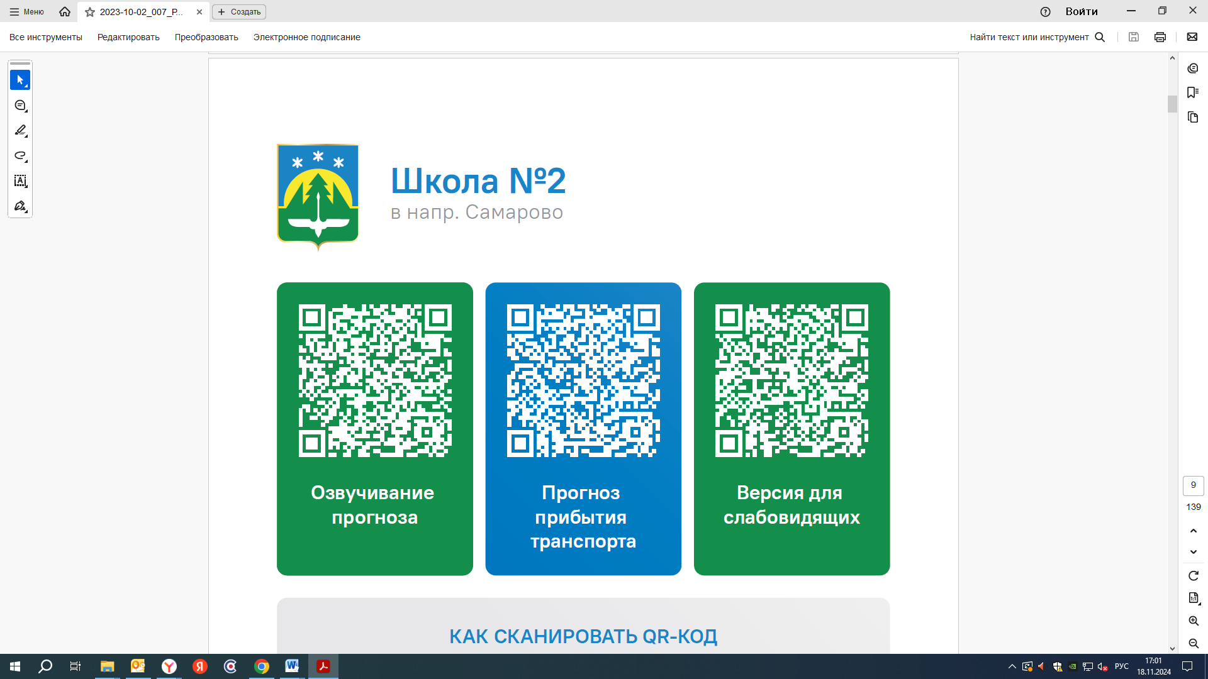


Контроль за осуществлением регулярных перевозок обеспечивает:
- управление транспорта, связи и дорог Администрации города Ханты-Мансийска, г: Ханты-Мансийск, ул Мира, 13, тел: 8 (3467) 39-39-07;
- отдел государственного автодорожного надзора по ХМАО – Югре, г: Ханты-Мансийск, ул: Шевченко 36А, тел: (3467) 32-64-60;
- МО МВД России «Ханты-Мансийский» г: Ханты-Мансийск, ул: Дзержинского дом 11, телефоны дежурной части 8 (3467) 398-104, 398-103, 102 и 112

