  мкр. Южный |  |  |  |  |  |  |  |  | А
По регулируемым тарифам
Номер маршрута | Конечный остановочный пункт | ДНИ | Время начала и окончания движения | Временной график отправления транспортных средств от остановочного пункта
1 | ОМК | Будни | 6:38-23:03 | 6:38, 7:23, 7:43, 8:13, 8:36, 9:03, 9:18, 9:58, 10:38, 10:53, 11:38, 12:38, 13:43, 14:43, 15:18,  16:08, 17:08, 17:53, 18:08, 18:53, 19:33, 19:53, 20:33, 21:08, 21:33, 22:08, 23:03
 |  | Выходные | 6:53-22:08 | 6:53, 7:53, 8:33, 9:33, 10:13, 11:13, 12:13, 13:13, 13:53, 14:53, 15:33, 16:33, 17:13, 17:53, 18:13, 18:53, 19:33, 20:33, 21:08, 22:08
5 | Ледовый дворец | Будни  с 01.06 по 31.08 | 5:53-0:18 | 5:53, 6:28, 7:08, 7:18, 7:38, 8:08, 8:28, 8:58, 9:08, 9:18, 9:33, 9:48, 10:08, 10:28, 10:38, 10:48, 11:08, 11:28, 11:48, 12:08, 12:28, 12:48, 13:08, 13:28, 13:48, 14:08, 14:28, 14:48, 15:08, 15:28, 15:48, 16:08, 16:28, 16:48, 17:08, 17:23, 17:38, 17:53, 18:08, 18:23, 18:38, 18:53, 19:08, 19:23, 19:38, 19:53, 20:08, 20:28, 20:48, 21:08, 21:23, 21:48, 22:08, 22:23, 22:38, 23:08, 23:38, 0:18
 |  | Выходные  с 01.06 по 31.08 | 5:53-0:18 | 5:53, 6:28, 7:08, 7:38, 8:08, 8:28, 9:08, 9:28, 9:48, 10:08, 10:28, 10:48, 11:08, 11:28, 11:48, 12:08, 12:28, 12:48, 13:08, 13:28, 13:48, 14:08, 14:28, 14:48, 15:08, 15:28, 15:48, 16:08, 16:28, 16:48, 17:08, 17:28, 17:48, 18:08, 18:28, 18:48, 19:08, 19:28, 19:48, 20:08, 20:28, 20:48, 21:08, 21:28, 21:48, 22:08, 22:23, 22:38, 23:08, 23:38, 0:18
 |  | Будни  с 01.09 по 31.05 | 5:53-00:18 | 5:53, 6:28, 7:08, 7:18, 7:28, 7:38, 7:48, 7:58, 8:08, 8:28, 8:38, 8:58, 9:08, 9:18, 9:33, 9:48, 10:08, 10:28, 10:48, 11:08, 11:28, 11:48, 12:08, 12:28, 12:48, 13:08, 13:23, 13:38, 13:53, 14:08, 14:28, 14:48, 15:08, 15:28, 15:48, 16:08, 16:23, 16:38, 16:53, 17:08, 17:23, 17:38, 17:53, 18:08, 18:23, 18:38, 18:53, 19:08, 19:23, 19:38, 19:53, 20:08, 20:28, 20:48, 21:08, 21:23, 21:38, 21:53, 22:08, 22:23, 22:38, 23:08, 23:38, 0:18
 |  | Выходные с 01.09 по 31.05 | 5:53-00:18 | 5:53, 6:28, 7:08, 7:18, 7:38, 8:08, 8:28, 8:58, 9:08, 9:18, 9:33, 9:48, 10:08, 10:28, 10:38, 10:48, 11:08, 11:28, 11:48, 12:08, 12:28, 12:48, 13:08, 13:28, 13:48, 14:08, 14:28, 14:48, 15:08, 15:28, 15:48, 16:08, 16:28, 16:48, 17:08, 17:23, 17:38, 17:53, 18:08, 18:23, 18:38, 18:53, 19:08, 19:23, 19:38, 19:48, 20:08, 20:28, 20:48, 21:08, 21:23, 21:48, 22:08, 22:23, 22:38, 23:08, 23:38, 0:18
По нерегулируемым тарифам
Номер маршрута | Конечный остановочный пункт | ДНИ | Время начала и окончания движения | Интервал отправления транспортных средств от остановочного пункта
8К | Гимназия №1 |  |  | до 10:00 | 10:00 -11:00 | 11:00 -15:00 | 15:00 -16:00 | 16:00 – 20:00 |  | после 20:00
 |  | Будни | 6:30-22:00 | 15 | 20 | 15 | 20 | 15 |  | 20
 |  | Суббота | 6:30-22:00 | 20 | 25 | 20 | 25 | 20 |  | 25
 |  | Воскресенье | 6:30-21:00 | 20 | 25 | 25 | 25 | 25 |  | 30
9К | Аэропорт |  |  | до 10:00 | 10:00 -11:00 | 11:00 -15:00 | 15:00 -16:00 | 16:00 – 20:00 |  | после 20:00
 |  | Будни | 6:30-22:00 | 15 | 20 | 15 | 20 | 15 |  | 20
 |  | Суббота | 6:30-22:00 | 20 | 25 | 20 | 25 | 20 |  | 25
 |  | Воскресенье | 6:30-21:00 | 20 | 25 | 25 | 25 | 25 |  | 30
Прогноз прибытия пассажирского транспорта
в вашем мобильном телефоне

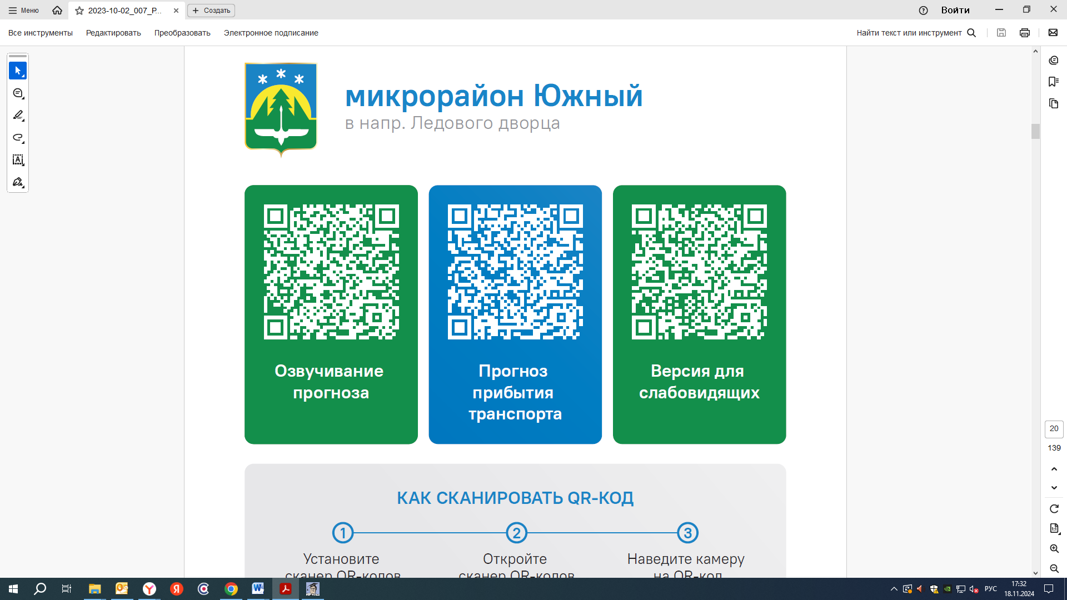


Контроль за осуществлением регулярных перевозок обеспечивает:
- управление транспорта, связи и дорог Администрации города Ханты-Мансийска, г: Ханты-Мансийск, ул Мира, 13, тел: 8 (3467) 39-39-07;
- отдел государственного автодорожного надзора по ХМАО – Югре, г: Ханты-Мансийск, ул: Шевченко 36А, тел: (3467) 32-64-60;
- МО МВД России «Ханты-Мансийский» г: Ханты-Мансийск, ул: Дзержинского дом 11, телефоны дежурной части 8 (3467) 398-104, 398-103, 102 и 112

