  Техучасток |  |  |  |  |  |  |  |  | А
По регулируемым тарифам
Номер маршрута | Конечный остановочный пункт | ДНИ | Время начала и окончания движения | Временной график отправления транспортных средств от остановочного пункта
1 | ОМК | Будни | 6:39-23:04 | 6:39, 7:24, 7:44, 8:14, 8:37, 9:04, 9:19, 9:59, 10:39, 10:54, 11:39, 12:39, 13:44, 14:44, 15:19,  16:09, 17:09, 17:54, 18:09, 18:54, 19:34, 19:54, 20:34, 21:09, 21:34, 22:09, 23:04
 |  | Выходные | 6:54-22:09 | 6:54, 7:54, 8:34, 9:34, 10:14, 11:14, 12:14, 13:14, 13:54, 14:54, 15:34, 16:34, 17:14, 17:54, 18:14, 18:54, 19:34, 20:34, 21:09, 22:09
5 | Ледовый дворец | Будни  с 01.06 по 31.08 | 5:55-0:20 | 5:55, 6:30, 7:10, 7:20, 7:40, 8:10, 8:30, 9:00, 9:10, 9:20, 9:35, 9:50, 10:10, 10:30, 10:40, 10:50, 11:10, 11:30, 11:50, 12:10, 12:30, 12:50, 13:10, 13:30, 13:50, 14:10, 14:30, 14:50, 15:10, 15:30, 15:50, 16:10, 16:30, 16:50, 17:10, 17:25, 17:40, 17:55, 18:10, 18:25, 18:40, 18:55, 19:10, 19:25, 19:40, 19:55, 20:10, 20:30, 20:50, 21:10, 21:25, 21:50, 22:10, 22:25, 22:40, 23:10, 23:40, 0:20
 |  | Выходные  с 01.06 по 31.08 | 5:55-0:20 | 5:55, 6:30, 7:10, 7:40, 8:10, 8:30, 9:10, 9:30, 9:50, 10:10, 10:30, 10:50, 11:10, 11:30, 11:50, 12:10, 12:30, 12:50, 13:10, 13:30, 13:50, 14:10, 14:30, 14:50, 15:10, 15:30, 15:50, 16:10, 16:30, 16:50, 17:10, 17:30, 17:50, 18:10, 18:30, 18:50, 19:10, 19:30, 19:50, 20:10, 20:30, 20:50, 21:10, 21:30, 21:50, 22:10, 22:25, 22:40, 23:10, 23:40, 0:20
 |  | Будни  с 01.09 по 31.05 | 5:55-00:20 | 5:55, 6:30, 7:10, 7:20, 7:30, 7:40, 7:50, 8:00, 8:10, 8:30, 8:40, 9:00, 9:10, 9:20, 9:35, 9:50, 10:10, 10:30, 10:50, 11:10, 11:30, 11:50, 12:10, 12:30, 12:50, 13:10, 13:25, 13:40, 13:55, 14:10, 14:30, 14:50, 15:10, 15:30, 15:50, 16:10, 16:25, 16:40, 16:55, 17:10, 17:25, 17:40, 17:55, 18:10, 18:25, 18:40, 18:55, 19:10, 19:25, 19:40, 19:55, 20:10, 20:30, 20:50, 21:10, 21:25, 21:40, 21:55, 22:10, 22:25, 22:40, 23:10, 23:40, 0:20
 |  | Выходные с 01.09 по 31.05 | 5:55-00:20 | 5:55, 6:30, 7:10, 7:20, 7:40, 8:10, 8:30, 9:00, 9:10, 9:20, 9:35, 9:50, 10:10, 10:30, 10:40, 10:50, 11:10, 11:30, 11:50, 12:10, 12:30, 12:50, 13:10, 13:30, 13:50, 14:10, 14:30, 14:50, 15:10, 15:30, 15:50, 16:10, 16:30, 16:50, 17:10, 17:25, 17:40, 17:55, 18:10, 18:25, 18:40, 18:55, 19:10, 19:25, 19:40, 19:50, 20:10, 20:30, 20:50, 21:10, 21:25, 21:50, 22:10, 22:25, 22:40, 23:10, 23:40, 0:20
По нерегулируемым тарифам
Номер маршрута | Конечный остановочный пункт | ДНИ | Время начала и окончания движения | Интервал отправления транспортных средств от остановочного пункта
8К | Гимназия №1 |  |  | до 10:00 | 10:00 -11:00 | 11:00 -15:00 | 15:00 -16:00 | 16:00 – 20:00 |  | после 20:00
 |  | Будни | 6:30-22:00 | 15 | 20 | 15 | 20 | 15 |  | 20
 |  | Суббота | 6:30-22:00 | 20 | 25 | 20 | 25 | 20 |  | 25
 |  | Воскресенье | 6:30-21:00 | 20 | 25 | 25 | 25 | 25 |  | 30
9К | Аэропорт |  |  | до 10:00 | 10:00 -11:00 | 11:00 -15:00 | 15:00 -16:00 | 16:00 – 20:00 |  | после 20:00
 |  | Будни | 6:30-22:00 | 15 | 20 | 15 | 20 | 15 |  | 20
 |  | Суббота | 6:30-22:00 | 20 | 25 | 20 | 25 | 20 |  | 25
 |  | Воскресенье | 6:30-21:00 | 20 | 25 | 25 | 25 | 25 |  | 30
Прогноз прибытия пассажирского транспорта
в вашем мобильном телефоне

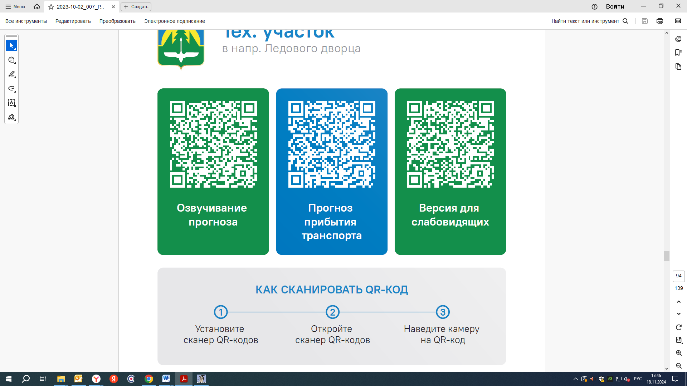


Контроль за осуществлением регулярных перевозок обеспечивает:
- управление транспорта, связи и дорог Администрации города Ханты-Мансийска, г: Ханты-Мансийск, ул Мира, 13, тел: 8 (3467) 39-39-07;
- отдел государственного автодорожного надзора по ХМАО – Югре, г: Ханты-Мансийск, ул: Шевченко 36А, тел: (3467) 32-64-60;
- МО МВД России «Ханты-Мансийский» г: Ханты-Мансийск, ул: Дзержинского дом 11, телефоны дежурной части 8 (3467) 398-104, 398-103, 102 и 112

