  Доронина |  |  |  |  |  |  |  |  | А
По регулируемым тарифам
Номер маршрута | Конечный остановочный пункт | ДНИ | Время начала и окончания движения | Временной график отправления транспортных средств от остановочного пункта
2 | Мелиораторов | ежедневно | 7:19-19:39 | 7:19, 8:27, 9:27, 10:19, 12:19, 13:19, 14:19, 15:19, 17:29, 18:39, 19:39,
4 | ОМК | Будни | 6:45-22:45 | 6:45, 7:05, 7:25, 7:45, 8:10, 8:25, 8:45, 9:05, 9:25, 9:45, 10:05, 10:45, 11:05, 11:45, 12:45, 13:05, 13:45, 14:15, 15:05, 15:45, 16:25, 16:45, 17:05, 17:25, 17:45, 18:05, 18:25, 18:45, 19:10, 19:25, 20:05, 20:45, 21:05, 21:35, 22:05, 22:45
 |  | Выходные | 6:45-22:45 | 6:45, 7:45, 8:45, 9:45, 10:45, 11:45, 12:45, 13:45, 14:45, 15:15, 15:45, 16:45, 17:15, 17:45, 18:45, 19:45, 20:45, 21:45, 22:45
5 | Мкр. Восточный | Будни  с 01.06 по 31.08 | 6:16-23:21 | 6:16, 6:56, 7:16, 7:48, 7:56, 8:18, 8:26, 8:36, 8:46, 8:56, 9:16, 9:41, 9:51, 10:06, 10:16, 10:36, 10:51, 11:06, 11:16, 11:26, 11:36, 11:56, 12:16, 12:36, 12:56, 13:16, 13:36, 13:56, 14:16, 14:36, 14:56, 15:16, 15:36, 15:56, 16:16, 16:36, 16:56, 17:16, 17:36, 17:51, 18:06, 18:21, 18:41, 18:51, 19:06, 19:21, 19:36, 19:51, 20:06, 20:21, 20:36,  20:56, 21:16, 21:36, 21:51, 22:06, 22:36, 23:06, 23:21
 |  | Выходные  с 01.06 по 31.08 | 6:16-23:51 | 6:16, 6:56, 7:16, 7:48, 8:18, 8:36, 8:56, 9:16, 9:36, 9:56, 10:16, 10:36, 10:56, 11:16, 11:36, 11:56, 12:16, 12:36, 12:56, 13:16, 13:36, 13:56, 14:16, 14:36, 14:56, 15:16, 15:36, 15:56, 16:16, 16:36, 16:56, 17:16, 17:36, 17:56, 18:16, 18:36, 18:56, 19:16, 19:36, 19:56, 20:16, 20:36, 20:56, 21:16, 21:36, 21:51, 22:16, 22:36, 23:06, 23:51
 |  | Будни  с 01.09 по 31.05 | 6:16-00:21 | 6:16, 6:56, 7:16, 7:48, 7:58, 8:16, 8:26, 8:36, 8:46, 8:56, 9:16, 9:26, 9:41, 9:51, 10:01, 10:16, 10:36, 10:56, 11:16, 11:26, 11:36, 11:56, 12:16, 12:36, 12:56, 13:16, 13:36, 13:51, 14:06, 14:21, 14:36, 14:56, 15:16, 15:36, 15:56, 16:16, 16:36, 16:51, 17:06, 17:21, 17:36, 17:51, 18:06, 18:21, 18:36, 18:51, 19:06, 19:21, 19:36, 19:51, 20:06,  20:21, 20:36, 20:56, 21:16, 21:36, 21:51, 22:06, 22:21, 22:36, 22:51, 23:06, 23:51, 0:06, 0:21
 |  | Выходные с 01.09 по 31.05 | 6:56-00:21 | 6:56, 7:16, 7:48, 7:58, 8:18, 8:36, 8:56, 9:16, 9:41, 9:51, 10:01, 10:16, 10:36, 10:51, 11:06, 11:16, 11:26, 11:36, 11:56, 12:16, 12:36, 12:56, 13:16, 13:36, 13:56, 14:16, 14:36, 14:56, 15:16, 15:36, 16:16, 16:16, 16:36, 16:56,  17:16, 17:36, 17:51, 18:06, 18:21, 18:36, 18:51, 19:06, 19:21, 19:36, 19:51, 20:06, 20:21, 20:36, 20:56, 21:16, 21:36, 21:51, 22:06, 22:36, 23:06, 23:21, 23:51, 0:21
21 | Теннисный центр | Будни | 6:50-22:20 | 6:50, 7:10, 7:30, 7:50, 8:10, 8:30, 8:50, 9:10, 9:30, 10:00, 10:30, 11:05, 11:30, 12:00, 13:00, 13:35, 14:35, 15:10, 15:30, 16:10, 16:30, 16:50, 17:10, 17:30, 17:50, 18:10, 18:30, 18:50, 19:10, 19:30, 19:50, 20:30, 20:45, 21:30, 22:20
 |  | Выходные | 6:50-22:20 | 6:50, 7:30, 8:30, 9:10, 9:30, 11:05, 12:00, 13:00, 13:35, 14:35, 15:10, 16:10, 16:50, 17:30, 17:50, 18:30, 19:10, 19:30, 20:45, 22:20
77А | Районная поликлиника | Будни | 6:47-21:47 | 6:47, 7:07, 7:37, 8:07, 8:27, 8:52, 9:12, 9:27, 9:47, 10:07, 10:27, 11:07, 12:07, 13:07, 13:47, 14:47, 15:27, 16:27, 17:07, 17:27, 17:47, 18:07, 18:27, 18:47, 19:07, 19:27, 19:47, 20:07, 20:47, 21:07, 21:47
 |  | Выходные | 8:07-22:37 | 8:07, 9:07, 9:47, 10:47, 11:27, 12:27, 13:07, 14:07, 15:07, 16:47, 17:07, 18:27, 18:47, 19:07, 20:07, 20:37, 21:07, 22:37
По нерегулируемым тарифам
Номер маршрута | Конечный остановочный пункт | ДНИ | Время начала и окончания движения | Интервал отправления транспортных средств от остановочного пункта
9К | Аэропорт |  |  | до 10:00 | 10:00 -11:00 | 11:00 -15:00 | 15:00 -16:00 | 16:00 – 20:00 |  | после 20:00
 |  | Будни | 6:30-22:00 | 15 | 20 | 15 | 20 | 15 |  | 20
 |  | Суббота | 6:30-22:00 | 20 | 25 | 20 | 25 | 20 |  | 25
 |  | Воскресенье | 6:30-21:00 | 20 | 25 | 25 | 25 | 25 |  | 30
13 | База Ханты-Мансийскгаз |  |  | до 10:00 | 10:00 -11:00 | 11:00 -15:00 | 15:00 -16:00 | 16:00 – 20:00 |  | после 20:00
 |  | Будни | 6:30-22:00 | 15 | 20 | 15 | 20 | 15 |  | 20
 |  | Суббота | 6:30-22:00 | 20 | 25 | 20 | 25 | 20 |  | 25
 |  | Воскресенье | 6:30-21:00 | 20 | 25 | 25 | 25 | 25 |  | 30
26К | Теннисный центр |  |  | до 10:00 | 10:00 -11:00 | 11:00 -15:00 | 15:00 -16:00 | 16:00 – 20:00 |  | после 20:00
 |  | Будни | 6:30-22:00 | 15 | 20 | 15 | 20 | 15 |  | 20
 |  | Суббота | 6:30-22:00 | 20 | 25 | 20 | 25 | 20 |  | 25
 |  | Воскресенье | 6:30-21:00 | 20 | 25 | 25 | 25 | 25 |  | 30
Прогноз прибытия пассажирского транспорта
в вашем мобильном телефоне

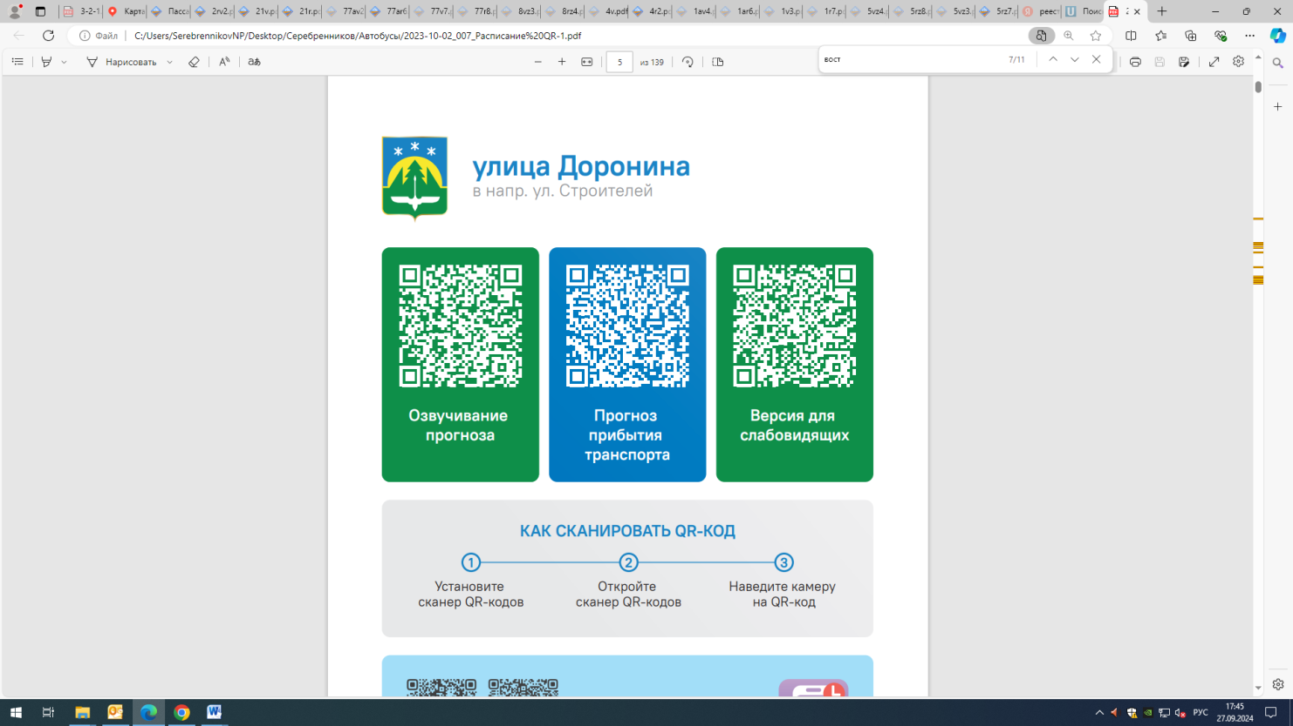



Контроль за осуществлением регулярных перевозок обеспечивает:
- управление транспорта, связи и дорог Администрации города Ханты-Мансийска, г: Ханты-Мансийск, ул Мира, 13, тел: 8 (3467) 39-39-07;
- отдел государственного автодорожного надзора по ХМАО – Югре, г: Ханты-Мансийск, ул: Шевченко 36А, тел: (3467) 32-64-60;
- МО МВД России «Ханты-Мансийский» г: Ханты-Мансийск, ул: Дзержинского дом 11, телефоны дежурной части (3467) 398-104, 398-103, 102 и 112

