  Телецентр |  |  |  |  |  |  |  |  | А
По регулируемым тарифам
Номер маршрута | Конечный остановочный пункт | ДНИ | Время начала и окончания движения | Временной график отправления транспортных средств от остановочного пункта
1 | Авторечвокзал  (по Гагарина) | Будни | 6:25-22:50 | 6:25, 7:10, 7:30, 8:00, 8:23, 8:50, 9:05, 9:45, 10:25, 10:40, 11:25, 12:25, 13:30, 14:30, 15:05,  15:55, 16:55, 17:40, 17:55, 18:40, 19:20, 19:40, 20:20, 20:55, 21:20, 21:55, 22:50
 |  | Выходные | 6:40-21:55 | 6:40, 7:40, 8:20, 9:20, 10:00, 11:00, 12:00, 13:00, 13:40, 14:40, 15:20, 16:20, 17:00, 17:40, 18:00,  18:40, 19:20, 20:20, 20:55, 21:55
4 | мкр. Береговая зона | Будни | 6:55-22:45 | 6:55, 7:25, 7:55, 8:15, 8:40, 9:00, 9:20, 9:55, 10:15, 11:00, 11:55, 12:15, 12:55, 13:10, 13:35, 14:05, 14:25, 14:55, 15:30, 15:50, 16:15, 16:55, 17:20, 17:35, 17:55, 18:25, 18:35, 18:55, 19:20, 20:00, 20:20, 20:40, 21:15, 21:55, 22:45
 |  | Выходные | 6:55-22:45 | 6:55, 7:55, 8:15, 9:00, 9:55, 11:00, 11:55, 12:55, 13:10, 14:05, 14:55, 15:50, 16:55, 17:55, 18:55, 20:00, 20:40, 21:55, 22:45
5 | Ледовый дворец | Будни  с 01.06 по 31.08 | 5:42-00:07 | 5:42, 6:17, 6:57, 7:07, 7:27, 7:57, 8:17, 8:47, 8:57, 9:07, 9:22, 9:37, 9:57, 10:17, 10:27, 10:37, 10:57, 11:17, 11:37, 11:57, 12:17, 12:37, 12:57, 13:17, 13:37, 13:57, 14:17, 14:37, 14:57, 15:17, 15:37, 15:57, 16:17, 16:37, 16:57, 17:12, 17:27, 17:42, 17:57, 18:12, 18:27, 18:42, 18:57, 19:12, 19:27, 19:42, 19:57, 20:17, 20:37, 20:57, 21:12, 21:37, 21:57, 22:12, 22:27, 22:57, 23:27, 0:07
 |  | Выходные  с 01.06 по 31.08 | 5:42-00:07 | 5:42, 6:17, 6:57, 7:27, 7:57, 8:17, 8:57, 9:17, 9:37, 9:57, 10:17, 10:37, 10:57, 11:17, 11:37, 11:57, 12:17, 12:37, 12:57, 13:17, 13:37, 13:57, 14:17, 14:37, 14:57, 15:17, 15:37, 15:57, 16:17, 16:37, 16:57, 17:17, 17:37, 17:57, 18:17, 18:37, 18:57, 19:17, 19:37, 19:57, 20:17, 20:37, 20:57, 21:17, 21:37, 21:57, 22:12, 22:27, 22:57, 23:27, 0:07
 |  | Будни  с 01.09 по 31.05 | 5:42-00:07 | 5:42, 6:17, 6:57, 7:07, 7:17, 7:27, 7:37, 7:47, 7:57, 8:17, 8:27, 8:47, 8:57, 9:07, 9:22, 9:37, 9:57, 10:17, 10:37, 10:57, 11:17, 11:37, 11:57, 12:17, 12:37, 12:57, 13:12, 13:27, 13:42, 13:57, 14:17, 14:37, 14:57, 15:17, 15:37, 15:57, 16:12, 16:27, 16:42, 16:57, 17:12, 17:27, 17:42, 17:57, 18:12, 18:27, 18:42, 18:57, 19:12, 19:27, 19:42, 19:57, 20:17, 20:37, 20:57, 21:12, 21:27, 21:42, 21:57, 22:12, 22:27, 22:57, 23:27, 0:07
 |  | Выходные  с 01.09 по 31.05 | 5:42-00:07 | 5:42, 6:17, 6:57, 7:07, 7:27, 7:57, 8:17, 8:47, 8:57, 9:07, 9:22, 9:37, 9:57, 10:17, 10:27, 10:37, 10:57, 11:17, 11:37, 11:57, 12:17, 12:37, 12:57, 13:17, 13:37, 13:57, 14:17, 14:37, 14:57, 15:17, 15:37, 15:57, 16:17, 16:37, 16:57, 17:12, 17:27, 17:42, 17:57, 18:12, 18:27, 18:42, 18:57, 19:12, 19:27, 19:37, 19:57, 20:17, 20:37, 20:57, 21:12, 21:37, 21:57, 22:12, 22:27, 22:57, 23:27, 0:07
77 | Гимназия №1 | Будни | 6:51-21:41 | 6:51, 7:21, 7:41, 8:16, 9:01, 9:11, 9:48, 10:21, 11:21, 12:36, 13:01, 13:31, 14:01, 14:28, 14:46, 15:28, 15:55,  16:21, 17:41, 18:11, 18:41, 19:38, 20:11, 21:01, 21:21, 21:41
 |  | Выходные | 6:51-21:41 | 6:51, 7:21, 8:16, 8:54, 9:48, 10:21, 11:21, 12:36, 13:31, 14:21, 15:08, 15:41, 16:21, 17:01, 17:41, 18:21, 18:48,  19:41, 20:11, 21:01, 21:41
По нерегулируемым тарифам
Номер маршрута | Конечный остановочный пункт | ДНИ | Время начала и окончания движения | Интервал отправления транспортных средств от остановочного пункта
7К | ТД «Сатурн» |  |  | до 10:00 | 10:00 -11:00 | 11:00 -15:00 | 15:00 -16:00 | 16:00 – 20:00 |  | после 20:00
 |  | Будни | 6:30-22:00 | 15 | 20 | 15 | 20 | 15 |  | 20
 |  | Суббота | 6:30-22:00 | 20 | 25 | 20 | 25 | 20 |  | 25
 |  | Воскресенье | 6:30-21:00 | 20 | 25 | 25 | 25 | 25 |  | 30
8К | Гимназия №1 |  |  | до 10:00 | 10:00 -11:00 | 11:00 -15:00 | 15:00 -16:00 | 16:00 – 20:00 |  | после 20:00
 |  | Будни | 6:30-22:00 | 15 | 20 | 15 | 20 | 15 |  | 20
 |  | Суббота | 6:30-22:00 | 20 | 25 | 20 | 25 | 20 |  | 25
 |  | Воскресенье | 6:30-21:00 | 20 | 25 | 25 | 25 | 25 |  | 30
13К | мкр. Береговая зона |  |  | до 10:00 | 10:00 -11:00 | 11:00 -15:00 | 15:00 -16:00 | 16:00 – 20:00 |  | после 20:00
 |  | Будни | 6:30-22:00 | 15 | 20 | 15 | 20 | 15 |  | 20
 |  | Суббота | 6:30-22:00 | 20 | 25 | 20 | 25 | 20 |  | 25
 |  | Воскресенье | 6:30-21:00 | 20 | 25 | 25 | 25 | 25 |  | 30
  26К | Гимназия №1 |  |  | до 10:00 | 10:00 -11:00 | 11:00 -15:00 | 15:00 -16:00 | 16:00 – 20:00 |  | после 20:00
 |  | Будни | 6:30-22:00 | 15 | 20 | 15 | 20 | 15 |  | 20
 |  | Суббота | 6:30-22:00 | 20 | 25 | 20 | 25 | 20 |  | 25
 |  |   Воскресенье  Прогноз прибытия пассажирского транспорта  в вашем мобильном телефоне | 6:30-21:00 | 20 | 25 | 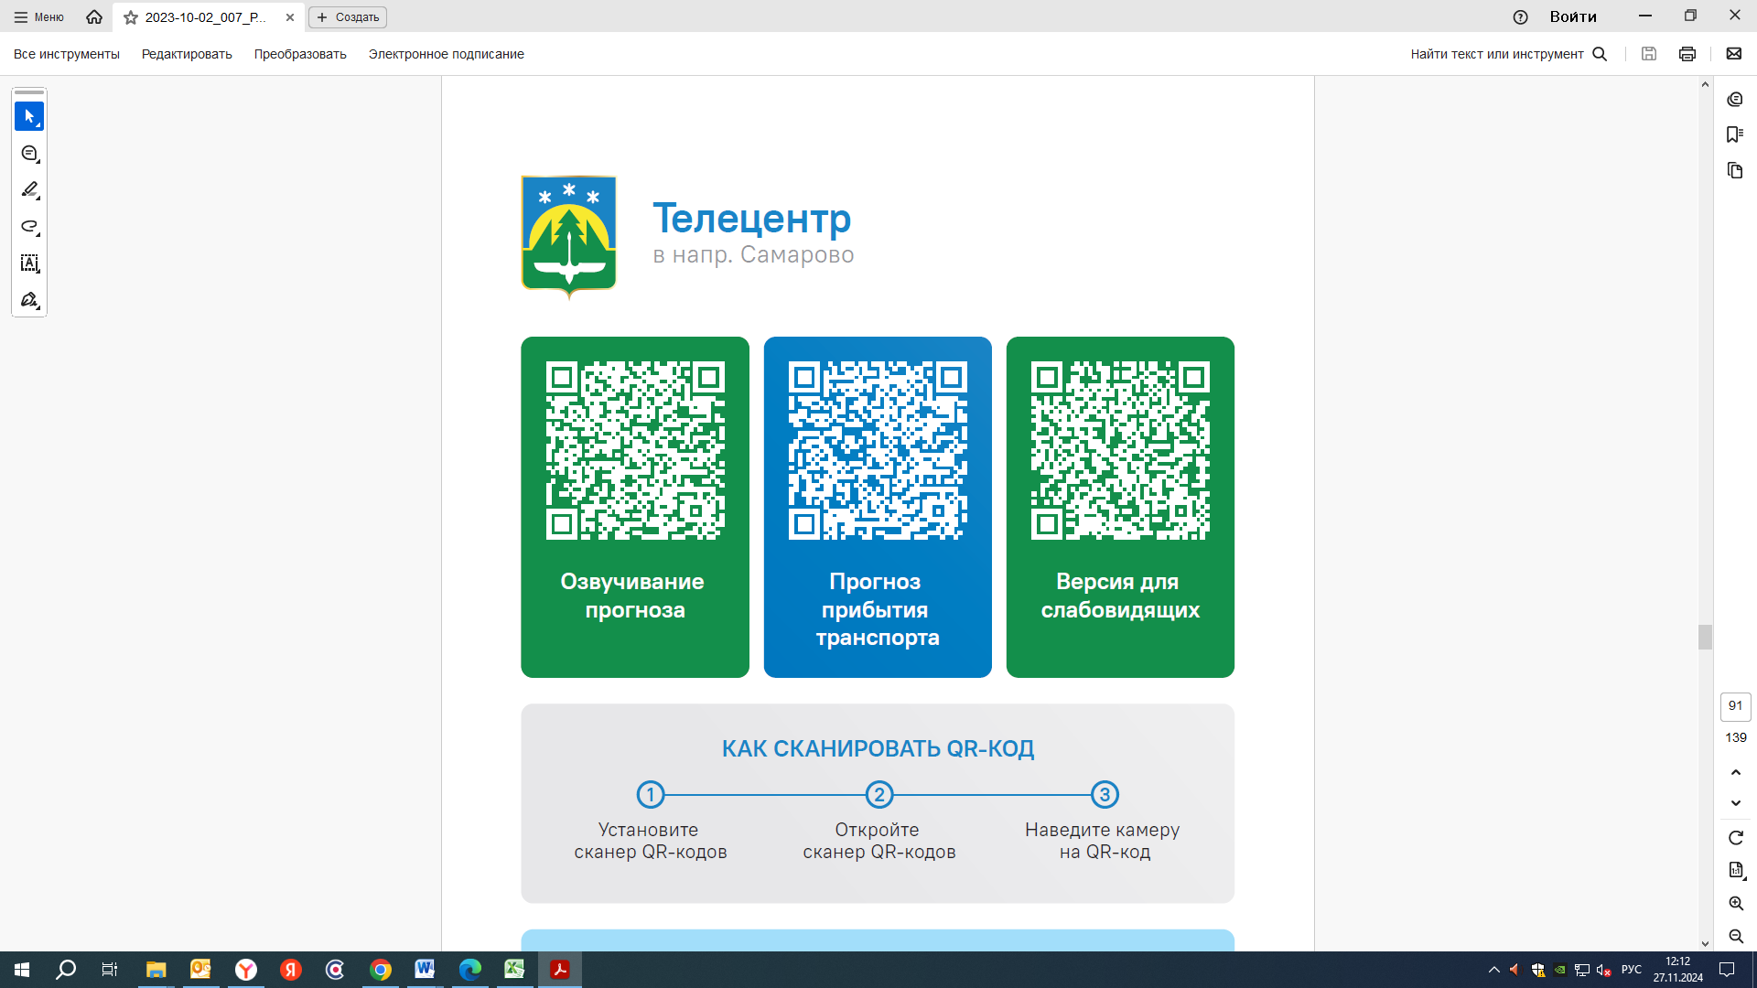  25 | 25 | 25 |  | 30
Контроль за осуществлением регулярных перевозок обеспечивает:
- управление транспорта, связи и дорог Администрации города Ханты-Мансийска, г: Ханты-Мансийск, ул Мира, 13, тел: 8 (3467) 39-39-07;
- отдел государственного автодорожного надзора по ХМАО – Югре, г: Ханты-Мансийск, ул: Шевченко 36А, тел: 8 (3467) 32-64-60;
- МО МВД России «Ханты-Мансийский» г: Ханты-Мансийск, ул: Дзержинского дом 11, телефоны дежур ной части 8 (3467) 398-104, 398-103, 102 и 112

