  КСК МУСТАНГ |  |  |  |  | А
По регулируемым тарифам
Номер маршрута | Конечный остановочный пункт | ДНИ | Время начала и окончания движения | Временной график отправления транспортных средств от остановочного пункта
5 | Мкр. Восточный | Будни  с 01.06 по 31.08 | 4:36-23:42 | 4:36, 5:51, 6:01, 6:37, 7:17, 7:37, 8:09, 8:19, 8:39, 8:47, 8:57, 9:07, 9:17, 9:37, 10:02, 10:12, 10:27, 10:37, 10:57, 11:12, 11:27, 11:37, 11:47, 11:57, 12:17, 12:37, 12:57, 13:17, 13:37, 13:57, 14:17, 14:37, 14:57, 15:17, 15:37, 15:57, 16:17, 16:37, 16:57, 17:17, 17:37, 17:57, 18:12, 18:27, 18:42, 19:02, 19:12, 19:27, 19:42, 19:57, 20:12, 20:27, 20:42, 20:57, 21:17, 21:37, 21:57, 22:12, 22:27, 22:57, 23:27, 23:42
 |  | Выходные  с 01.06 по 31.08 | 4:36-0:12 | 4:36, 6:37, 7:17, 7:37, 8:09, 8:39, 8:57, 9:17, 9:37, 9:57, 10:17, 10:37, 10:57, 11:17, 11:37, 11:57, 12:17, 12:37, 12:57, 13:17, 13:37, 13:57, 14:17, 14:37, 14:57, 15:17, 15:37, 15:57, 16:17, 16:37, 16:57, 17:17, 17:37, 17:57, 18:17, 18:37, 18:57, 19:17, 19:37, 19:57, 20:17, 20:37, 20:57, 21:17, 21:37, 21:57, 22:12, 22:37,22:57, 23:27, 0:12
 |  | Будни  с 01.09 по 31.05 | 4:36-0:42 | 4:36, 5:51, 6:01, 6:37, 7:17, 7:37, 8:09, 8:19, 8:37, 8:47, 8:57, 9:07, 9:17, 9:37, 9:47, 10:02, 10:12, 10:22, 10:37, 10:57, 11:17, 11:37, 11:47, 11:57, 12:17, 12:37, 12:57, 13:17, 13:37, 13:57, 14:12, 14:27, 14:42, 14:57, 15:17, 15:37, 15:57, 16:17, 16:37, 16:57, 17:12, 17:27, 17:42, 17:57, 18:12, 18:27, 18:42, 18:57, 19:12, 19:27, 19:42, 19:57, 20:12, 20:27, 20:42, 20:57, 21:17, 21:37, 21:57, 22:12, 22:27, 22:42, 22:57, 23:12, 23:27, 0:12, 0:27, 0:42
 |  | Выходные с 01.09 по 31.05 | 4:36-0:42 | 4:36, 7:17, 7:37, 8:09, 8:19, 8:39, 8:57, 9:17, 9:37, 10:02, 10:12, 10:22, 10:37, 10:57, 11:12, 11:27, 11:37, 11:47, 11:57, 12:17, 12:37, 12:57, 13:17, 13:37, 13:57, 14:17, 14:37, 14:57, 15:17, 15:37, 15:57, 16:37, 16:37, 16:57, 17:17, 17:37, 17:57, 18:12, 18:27, 18:42, 18:57, 19:12, 19:27, 19:42, 19:57, 20:12, 20:27, 20:42, 20:57, 21:170, 21:37, 21:57, 22:12, 22:27, 22:57, 23:27, 23:42, 0:12, 0:42
Прогноз прибытия пассажирского транспорта
в вашем мобильном телефоне
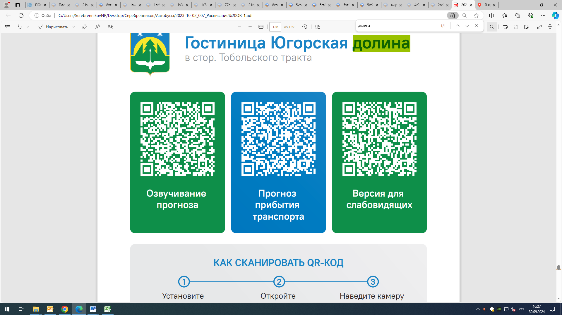



Контроль за осуществлением регулярных перевозок обеспечивает:
- управление транспорта, связи и дорог Администрации города Ханты-Мансийска, г: Ханты-Мансийск, ул Мира, 13, тел: 8 (3467) 39-39-07;
- отдел государственного автодорожного надзора по ХМАО – Югре, г: Ханты-Мансийск, ул: Шевченко 36А, тел: (3467) 32-64-60;
- МО МВД России «Ханты-Мансийский» г: Ханты-Мансийск, ул: Дзержинского дом 11, телефоны дежурной части (3467) 398-104, 398-103, 102 и 112

